From Father Jim

Dear Brothers and Sisters,

Since the announcement of the closing of Immaculate Conception School at the end of this school year, concerns and questions regarding the future of our school building have been raised. While that building is in need of maintenance and repair, parishioners are “spot on” in being grateful for the ministries we can look forward to accomplishing with that resource.

The school building is a treasured resource, owned by our parish. Through that building, generations of parishioners and non-parishioners received quality elementary education. Through that building, we have been able to provide a home for several other ministries to members of our community including: religious education, athletic association, Scouts (and other youth ministries), addiction recovery, and parish gatherings for community building and fundraising.

A steering committee will be formed to focus on how to best utilize this building to continue to support our parish ministries. Working closely with our parish leadership committees, plans will be developed to create a path forward for future use of the school, allowing these ministries to continue and provide some income to our parish. Please continue to pray for our parish community as we continue discerning where the Holy Spirit is leading us.

Fr. Jim Yeakel, OSFS
Pastor

We extend a warm welcome to the families who are newly registered:
Mr. and Mrs. Greg Keane
WELCOME
Ms. Suzanne Watson

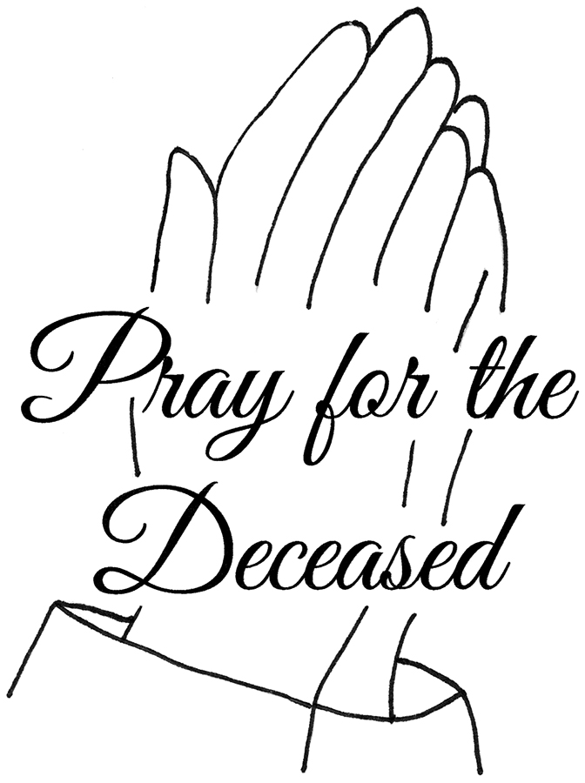
We extend our condolences and prayers to the families of those who have recently died.

February 24, 2020
8:30 am Anthony Sniadowski
February 25, 2020
8:30 am Genevieve Reif
February 26, 2020 Ash Wednesday
Fast and Abstinence
8:30 am Sheree Green (Living Intention)
10:00 am-------ICS Mass
12:00 pm-------(service)
6:30 pm (IC)---Kathleen Small
7:00 pm (SJ)---Charles A. Holt, Jr.
February 27, 2020 Thursday after Ash Wednesday
8:30 am Rosario Domingo
February 28, 2020 Friday after Ash Wednesday
8:30 am---------Edward Laye
February 29, 2020 Saturday after Ash Wednesday
8:30am---------Colin Catterton (Living Intention)
5:00 pm--------Anthony V. Sposato
March 1, 2020 First Sunday of Lent
7:00 am Sr. John Marie
8:30 am People of the Parish
9:00 am SJ Joseph Nickle
10:15 am Laura Puccia
12:00 pm Hugh Eleanor and Christopher Reilly

Daily Readings:
Seventh Sunday in Ordinary Time

Sunday..........Lv 19:1-2, 17-18; 1 Cor 3:16-23;
Mt 5:38-48
Monday..........Jas 3:13-18; Mk 9:14-29
Tuesday..........Jas 4:1-10; Mk 9:30-37
Wednesday..........Jl 2:12-18; 2 Cor 5:20─6:2;
Mt 6:1-6, 16-18
Thursday..........Dt 30:15-20; Lk 9:22-25
Friday..........Is 58:1-9a; Mt 9:14-15
Saturday.......... Is 58:9b-14; Lk 5:27-32

Ash Wednesday Mass Schedule
February 26, 2020
8:30am - ICC-Mass
10:00am - ICC - School Mass
12:00pm - ICC - Service
6:30pm - ICC - Mass
7:00pm - SJ - Mass
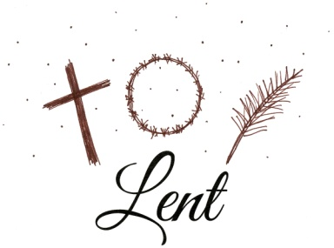

Lenten Opportunities
Lent begins THIS WEDNESDAY, Ash Wednesday, February 26th. We invite you to join us at any one of our many Lenten opportunities:
- Reconciliation Weekly- These times are available each weekend of Lent. There will be no confessions heard the weekend of Easter (April 11th and 12th).
- Saturdays - 4:10-4:50pm - ICC
- Sundays - 8:20-8:50am - SJ
- Lenten Penance Services- All are Welcome!
- March 10th (school) 10:00am
- March 11th (rel. ed) 6:30pm
- March 25th (Parish) 7:00pm
- By appointment: Call the Parish Center to schedule. There will be no confessions April 8th - 12th (Holy Week).
- Sunday Workshops- 1:30pm in IC Church-
“Anchored in the Scriptures”
- March 1st - Letter to Romans
- March 15th - Learn to Love the Bible
- April 5th - Letter to Peter
- Devotions- All are Welcome!
- Stations of the Cross - each Friday evening of Lent - 7:00pm - ICC
- Rosary - Daily after 8:30am mass
- Eucharistic Adoration - Sunday, March 1 & Sunday, April 5th from 1 -2pm
- Blessing of Food - Holy Saturday Morning - 11:00am - ICC Chapel
Liturgical Minister Schedules
Liturgical Ministers Next Week: Feb. 29th and Mar. 1st

5:00 pm
•Altar Servers: Heitz, M; Bradfield, G •EM’s: Eurenius, MA; Nickle, C •Lector: DePaola, A •Ushers: Peacock, E; Elwood, B

7:00 am
•Altar Servers: Jouridine, B •EMs: Sexton, A; Homola, S; Slavin, F • Lector: Smith, J • Ushers: Murphy, C

8:30 am
Altar Servers: Watkins, H; Watkins, D • EMs: Hicks, D; Gnanes, P; Gnanes, C • Lector: Watkins, R • Ushers: Dvorak, A; Schmitt, W; Maccari, A; Chicosky, S

9:00 am (SJ)
Altar Servers: Trout, L; Trout, M • EM’s: Vaccarini, C; Vadden, T; O’Donnell, M; Cattrell, D; Baker, H
• Lector: Vender, M • Ushers: O’Donnell, K; Schaible, J;
Vaccarini, J; Dallas, William

10:15 am
Altar Servers: Simbulan, Hendric; Simbulan, A • EM’s: Lonie, R; Lagarelli, M • Lector: Ruhmann, B • Ushers: Whitman, B; Anguish, S

12:00 noon
Altar Servers: Ortiz, G; Ortiz, V •EMs: Jiminez, C; Chamberlin, K; Cole, C • Lector: Ortiz, R
•Ushers: Gustavson, T

Readings for next week:
First Sunday of Lent

First Reading: Genesis 2:7-9, 3:1-7
This passage from Genesis narrates the creation of man, the temptation by the serpent, and the fall of Adam and Eve.

Second Reading: Romans 5:12-19
Paul tells the Romans that Adam’s disobedience brought sin and death to the world, but Christ’s dying on the cross for us will bring us salvation and life.

Gospel: Matthew 4:1-11
In preparation for His ministry, Jesus goes into the desert to fast and pray for 40 days. There He is tempted by the devil to give evidence of His miraculous powers, but Jesus resists the devil saying, “Away with you Satan! You shall do homage to the Lord your God; Him alone shall you adore.”

Immaculate Conception
School News
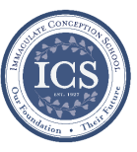
In the spirit of Giving: Preschool and Kindergarten are doing a fabulous job heading up donations for the Parish Outreach during the month of February!
Coming up…
Spring Musical: “Seussical Jr” It’s not too late! If your child would like to participate in our Spring Musical, “Seussical Jr,.” please contact Mrs. Karleen at kobrien@icschoolweb.org or Mrs. Kathleen Davis at katdavis1202@gmail.com. We are so excited about this fun and exciting musical!
****
Students will attend Ash Wednesday Mass at 10am on Wednesday, February 26th.
****
Science Fun Day for grades PK through 5th will be on Friday, February 28th. PK - 2nd graders will learn about polymers and have some fun with slime from 9am -10am.
3rd - 5th graders will experiment with dry ice and learn about states of matter from 10am - 11am.

Students’ Prayer
Loving Father, thank you that you are my creator, you know me better than anyone else. Help me to use the mind you have given me to learn and study effectively. May I learn with humility and grace. May I grow in wisdom as well as knowledge. Let me live a life of integrity in everything I do. May I grow in grace, and in the knowledge of our Lord and Savior Jesus Christ. To you be glory both now and for ever. In the name of the Father, the Son and the Holy Spirit, Amen.

Religious Education & Sacraments

First Communion: Anyone who missed the Parent/Child Meeting must contact the office at 410-392-3551.
Outreach: February donations: Spaghetti-o’s, baked beans, mini raviolis. For March: cereal and instant milk.
Children’s Liturgy: Please join us! All children 5-8 years old (under 5 accompanied by a parent, not a sibling!) are welcome.
We are looking for someone to take over coordinating Children’s Liturgy for the 10:15 Masses. If interested, please call Vickie Eichler at 410.392.3551.

Youth Ministry & Confirmation

CONFIRMATION

Past due are Sponsor Eligibility Forms and Patron Saint Forms.
- Next class is Sunday, Feb. 23rd, 8-10am, &
Wednesday, Feb. 26th, 6-8pm.
- We are now accepting knitted red stoles for Confirmation; contact Cheryl at 410-392-3551 for information.

YOUTH GROUP – Grades 9 thru 12
- We are having our Mardi Gras celebration today, February 23rd from 6 - 8pm.
YOUTH MINISTRY WISH LIST:
- We are asking for sodas (cans please!)

JUNIOR YOUTH GROUP – Grades 6 thru 8
Join us to grow in faith through fun and fellowship!
Please come and join the Youth Group on Feb. 23rd from 6-8 pm for our Mardi Gras celebration.

ADULT EDUCATION
Fr. Michael Connelly, OSFS will be here for a presentation on more of the letters from Peter, on Sunday, March 1st and April 5th at 1:00pm in the chapel at ICC.
Interested in a study group?
Several different opportunities are available. Call the Religion Office at (410) 392-3551. All Adult Education classes are over for the summer.
Adult Education classes –
Pivotal Players – St. Benedict and St. Augustine will start Monday, March 2nd at 6:30 pm and will repeat on Thursday, March 5th at 9:15 am. Please register for class and purchase your books ahead of time.
Book Study
Tuesday, Feb. 25th at 9:15 am in the parish center.

SOCIAL CONCERNS

Outreach
Please consider donating to the Outreach! Thank you so much to all of the angels who have donated!! Please continue to refer to the parish bulletin and parish social media posts for guidance on what Outreach is in need for at that time. Thank you for your help, generosity, prayers, & donations to this essential ministry!!

Food Items: baked beans, jam, jello

Non-Food Items: bath soap

PARISH EVENTS/INFORMATION

Weekly Church Collections: Week of Feb 16th
ICC $6,158
St. Jude $1,516
Online $3,940
Total Offertory $11,614

Keep up with regular offerings by giving electronically!!
Just as you rely upon receiving income on a regular basis, we rely on your regular contributions. We greatly appreciate the efforts of our parishioners to make consistent donations throughout the year! To assist you, the church provides a convenient electronic giving option for setting up regular contributions! Simply visit our website and click the Online Giving Button!

How does Online giving benefit you?
- It’s easy, convenient, and safe
- Allows you to give any amount, any time.
- Allows you to track your giving

How does Online giving benefit the parish?
- Creates consistency of giving
- Increases efficiency of processing giving

How to sign up?
- Visit www.iccparish.org
- Click “Go to Online Giving”
- Sign up! It’s that easy!

PARISH & FAMILY LIFE
Parish Coffee
Mar. 1st at St. Jude following 9am mass
and
Mar. 8th at ICC after 8:30 and 10:15 masses
Please join us!
PARISH EVENTS/INFORMATION
Community Kitchen: We look forward to seeing you at our next service date on April 24th. Your support of this Ministry with prayer, service, edible and financial donations is a blessing to so many. May you experience a holy Lenten Season and a joyful Easter!
PRAYER VIGIL
On Saturday, March 7th, from 4 - 5pm in the ICC chapel, we will have a prayer vigil for the students, staff, families, and parishioners of Immaculate Conception School in it’s final year. All are welcome. Please join us!
TIME TO GET YOUR SHAMROCK ON!
State Line Liquors in Elkton is hosting IRISH FEST Saturday, March 14th from 5-8pm. Music by the Seven Rings, Irish food from Blue Crab Grill, Irish beer, and much more will be offered. 50/50 raffle items will round out this evening of fun. Cost is $25.00 in advance or $30.00 at the door. For more information or to reserve your spot, call 1-800-446-9463 or 410-398-3838 by March 13th. Proceeds benefit Immaculate Conception Parish.

Saint Mark’s Will Rock You!
Saint Mark's will rock you at the spring musical performance of Queen and Ben Elton's "We Will Rock You." Performances will be February 28 & 29, 7:30 p.m. in the Saint Mark's Theater. Tickets are $10 for students/senior citizens, $13 for adults, and $5 for children under 10.

Sunday, February 23
8:00 AM--Confirmation Class PC
8:20 AM - Confessions - SJ
8:30 AM--Rel Ed.
8:30 AM - RCIA - CH
1:30 PM--Baptisms--IC
6:00 PM - HS Gathering - IC

Monday, February 24
9:00 AM - Novena - CH
6:00 PM - Adult Ed Program - PC
6:30 PM - Boys Varsity Basketball - gym
8:00 PM - AA Mtg -caf

Tuesday, February 25
9:00 AM - Holy Hour -CH
9:00 AM - Adult Ed Book study - PC
5:30 PM - Pre-JV Basketball - gym
6:30 PM - Girls Varsity Basketball -gym
6:30 PM - Handbell Rehearsal - IC
7:00 PM - K of C Meeting - PC
7:30 PM - Contemporary Rehearsal - IC

Wednesday, February 26
9:00 AM - Rosary Crusade - CH
9:30 AM - Cantor Rehearsal - IC
10:00 AM - ICS Mass - IC
1:00 PM - Leisure Club - PC
4:00 PM - Children’s Choir - PC
6:00 PM - Confirmation Class - PC
6:15 PM - Rel Ed
6:30 PM - JV Boys Basketball - gym
8:00 PM - Boys Varsity Basketball -gym

Thursday, February 27
9:00 AM - Rosary Crusade - CH
9:15 AM - Adult Ed Study program - PC
5:30 PM - Pre JV Basketball
6:30 PM - Girls Varsity Basketball
6:30 PM - Cantor Reh - IC
6:30 PM - Boy Scouts - PC /Cub Scouts - Caf
7:00 PM - Parish Choir - IC
7:00 PM - RCIA - PC

Friday, February 28
9:00 AM - Rosary Crusade - CH
7:00 PM - NA - Caf

Saturday, February 29
8:00 AM - Pack 120 Pinewood Derby - Caf
9:00 AM - Rosary Crusade - Ch
4:15 PM - Confessions - IC
7:00 PM - NA - Caf
community EVENTS/INFORMATION

Knights of Columbus
Bishop Becker Council 2427
Meetings: 2nd & 4th Tuesdays of the month at 7:00 pm at the Parish Center

LAOH (The Ladies Ancient Order of Hibernians)
The Ladies Ancient Order of Hibernians, Inc. Cecil County Division 1, an Irish Catholic Action group has meetings on the first Wednesdays of the month at 1:00pm in the Parish Center. Meetings run September through May. We are always looking for new members! If you are an Irish Catholic woman and want to serve your community, and learn more about your Irish heritage come join us! Please contact the historian, Betty Green at 410-392-5287

DIOCESE OF WILMINGTON CATECHETICAL DAY
ATTENTION ALL CATECHISTS!
The Office for Religious Education invites you to attend Catechetical Day on March 21 at St. Thomas More Academy with Bishop W. Francis Malooly.
Catechetical Day allows the opportunity to celebrate those who have been giving effective witness for years and are living the call within their religious education programs, families, and the larger community. Directors/Coordinators of Religious Education and Catechists will be honored for anniversary years of service. These years are: 5, 10, 15, 20, 25, 30, 35+.
This year's Catechetical Theme is "Stay With Us." Bob McCarty, D. Min. is the keynote speaker for the event.
For more information or to register, please call the Diocesan Office for Religious Education at 302-573-3130 or contact your Parish Religious Education Office. The deadline for registration is March 2, 2020. For more information please visit www.cdow.org/CatecheticalDay2020.

St. Michael the Archangel/Mary Mother of Peace Parish in Georgetown DE is seeking a part-time Director of Religious Education to develop, implement and evaluate all formal Religious Education in the Parish from 1st through 8th grade for approximately 300 students enrolled between our two churches in Millsboro and Georgetown. For more information, please email: DRE@SMAMMOP.COM by March 31, 2020.
Michael Kors and Coach Pocketbook Bingo
WHEN: Sunday, March 29, 2020- Doors Open at Noon
WHERE: St. Elizabeth Ann Seton Church, 345 Bear-Christiana Road. Bear, DE 19701
WHO: Must be 18 or older to enter. All proceeds benefit the Seton Council 7990 Knights of Columbus Charitable Works Programs. For information and tickets call Bill at 302-229-1926 or email: blm810@verizon.net
PRICING: $25.00 for 20 game packet. $10.00 for additional 20 game packets. Food and drinks available. 50/50 Raffle.

