**Mark your calendars! Advent Services:**

**Reconciliations:**

**Immaculate Conception:**

Saturdays, 4:10-4:50pm December 22

**St. Jude:**

Sundays, 8:20-8:50am December 16, & 23rd

**Additional Reconciliation Services: Open to all!**

7:00pm Tues, December 18th - IC Parish Service

**Christmas Masses:**

**Immaculate Conception Church**

**Christmas Eve, Monday, December 24**

**4:00pm Mass with Christmas Pageant**

Pageant begins at 3:40pm

**7:00pm Mass**

Carol prelude begins at 6:40pm with Contemporary Ensemble

**12:00 Midnight Mass**

Carol prelude begins at 11:30pm with the Parish Choir & Instrumentalists

**Christmas Day, Tuesday, December 25**

10:15am Mass

**St. Jude Mission Church**

**Christmas Eve, Monday, December 24**

**4:00pm Mass with Christmas Pageant**

Pageant begins at 3:40pm with Junior Choir singing

**10:00pm Mass**

Carol prelude begins at 9:40pm

**Christmas Day, Tuesday, December 25**

9:00am Mass

**Masses for the Solemnity of Mary**

Monday, December 31st 8:30am, 7:00pm Vigil - IC

Tuesday, January 1st 9:00am Mass - SJ

**Knights of Columbus ‘Giving Tree’ Fundraiser!**

Make sure to stop by the entrances of the churches at all masses this weekend to purchase a raffle ticket for your chance to win one of three Christmas trees full of ‘Scratch Off’ Lottery tickets! **Raffle tickets are $5 each or $20 for 5.**

1st Prize: $1,000 in Scratch-Off Tickets

2nd Prize: $750 in Scratch-Off Tickets

3rd Prize: $500 in Scratch-Off Tickets

Drawing to be held by the Knights on Christmas Day. All Proceeds will be going to ICC, ICS, and the Knights of Columbus. This raffle is not affiliated with the Maryland Lottery and/or the State of Maryland.



**December 17, 2018**

8:30 am Robert Dudley

**December 18, 2018**

8:30 am Jamie Leonardo

**December 19, 2018**

8:30 am Scott Hild

**December 20, 2018**

8:30 am Ahiles Gnanes

**December 21, 2018 St. Peter Canisius, Priest**

8:30 am Janice Hagans

**December 22, 2018**

8:30 am Ahiles Gnanes

5:00 pm Ida Onifer

**December 23, 2018 *Fourth Sunday of Advent***

7:00 am Ahiles Gnanes

8:30 am Rolando Najera

9:00 am SJ Joseph Berger Jr.

10:15 am Mathilde Seaman

12:00 pm People of the Parish



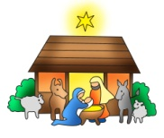**2018 Christmas Eve Pageants**

**We are** **planning our annual** Christmas Eve Nativity Pageants at St. Jude & Immaculate Conception Churches! Children grades K-3 can participate. Sign up early, space is limited!! The pageants will be performed before the 4pm Masses at Immaculate Conception and St. Jude’s Church on Christmas Eve. If interested, please contact the following with your child’s name, gender, and age no later than December 13th.

**Contact information:**

**St. Jude’s -** Dottie Dhamer at [sassydot1@comcast.net](mailto:sassydot1@comcast.net) (preferred) or 443-350-7186. (Practice is Sunday, December 16th after 9am Mass)

**ICC** - Kim Burnham at [ksburnham@comcast.net](mailto:ksburnham@comcast.net) (Practice is Saturday, December 22nd at 11:00am)

***Congratulations to those who were recently baptized:***

*Tegan Alma Marie Smith*

***We extend our condolences and prayers to the families of those who have recently died:***

*Ronald Steven Cimorose Sr.*

**Readings for next week:**

**Fourth Sunday in Advent**

**First Reading: Micah 5:1-4a**

Micah speaks of the ruler who will come from Bethlehem. He discusses how the people of Israel will be saved from corruption and live in peace.

**Second Reading: Hebrews 10:5-10**

Paul describes to the Hebrews how Jesus came into the world and offered to do God's will. We were saved through his sacrifice, the only offering sufficient for the sins of the world.

**Gospel: Luke 1:39-45**

Mary visited Elizabeth, whose baby stirred in her womb upon hearing Mary's greeting. Elizabeth filled with the Holy Spirit, cried out, "Blessed are you among women, and blessed is the fruit of your womb." Elizabeth was deeply overjoyed that the words God had spoken to Mary had now been fulfilled.

**We need help decorating for Christmas!** We will be decorating for Christmas at ICC on Sunday, December 23rd following the 12:00 Mass. Decorating at St. Jude will be on December 23rd after 9:00 mass. We need everyone to come join in! Please plan to stay and help! Thank you!

**Adoration for Vocations**

On the 1st Sunday of each month, exposition of the Blessed Sacrament occurs from 1pm-3pm in IC Chapel. Join us to pray for vocations to priesthood and religious life. The next opportunity is **January 6th.** Contact Dermott Mullan at 410-398-3368.

**Inspirational Quote of the Week:**

“In Christ we are all things; He is everything to us. If you have wounds to heal, He is a physician. If fever scorches you, He is a fountain. If you need help, He is strength; if you fear death, He is life.” -- Saint Ambrose

**ROTATING SHELTER:**

Immaculate Conception/St Jude will participate in the rotating Shelter for the homeless again this year. We will be partnering with Truth and Life Church (1924 W. Pulaski Hwy, Elkton) during the week of January 7-14. We will also host the Shelter the week of March 4-11, 2019 at Five Rivers Church (290 Whitehall Rd, Elkton.)

Many volunteers are needed! For information or to volunteer you can contact Carol and Bill Dale, 410-287-9548, or email [dales7@comcast.net](mailto:dales7@comcast.net).

Our parish has participated in this mission for the past 13 years with overwhelming support. We touch many lives performing this service to the neediest in our community. God bless and thanks to everyone!

**We invite you to join in praying the rosary in the chapel today after the 10:15 mass. Please join us as we pray to keep Christ in Christmas!**



**Does your child need to be Baptized?**

The next Baptism Class is **January 7th**, 7:00-8:30 pm in the Parish Center. It’s never too early to prepare for the Baptism of your child. Parents are required and Godparents are encouraged to attend. Contact the Parish Office to register at 410-398-1100.

**Daily Readings:**

***Third Sunday of Advent***

**Sunday**........................Zep 3:14-18a; Phil 4:4-7; Lk 3:10-18

**Monday**........................................Gn 49:2, 8-10; Mt 1:1-17

**Tuesday**..........................................Jer 23:5-8; Mt 1:18-25

**Wednesday**............................Jgs 13:2-7, 24-25a; Lk 1:5-25

**Thursday.***...........................................*Is 7:10-14; Lk 1:26-38

**Friday**.......................Sg 2:8-14 or Zep 3:14-18a; Lk 1:39-45

**Saturday**.......................................1 Sm 1:24-28; Lk 1:46-56

**Liturgical Ministers Next Week: *December 22nd & 23rd***

***5:00 pm***

**Altar Servers:** Nathan S, A.J. S •**EM’s:** Mary Anne S, Carol K

• **Lector:** *UNFILLED* • **Ushers:** Eileen P, Pat C, Bill B

***7:00 am***

**Altar Servers:** Benedict J • **EM’s:** Frank S, Ginnie D, Peter D

• **Lector:** James S • **Ushers:** Charles M, William C

***8:30 am***

**Altar Servers:** Sean M, Jeremy M • **EMs:** Peter G, Cecilia G, Don H •**Lector:** Mary K •**Ushers:** Anthony D Wendel S Anthony M, Steve C

***9:00 am (SJ)***

**Altar Servers:** Mitchell H, Alex L • **EM’s:** Deacon M, Peg O, Tom V, Narcy Z, Dorothy D • **Lector:** Helen B • **Ushers:** Kevin O, Bill D, Jule V, Jake S

***10:15 am***

**Altar Servers:** Hayden S, Ariane S • **EM’s:** Richard B, Elizabeth B, Kathy C, Ben F, Rita M • **Lector:** Francis C •**Ushers:** Bob W, Steve A

***12:00 noon***

**Altar Servers:** Alex F, Andrew F • **EMs:** Charles C, Corazon S, Grace B • **Lector:** Pat K • **Ushers:** Teresa G

**Children’s Liturgy of the Word**

Children’s Liturgy is for children ages 5-8 ONLY. Children who are not in this category are asked to stay in church.

**The catechist for Next week, December 23rd is:**

Justine Quirk

**Immaculate Conception**

**School News**

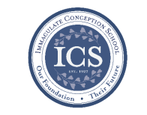**Walk-In Wednesdays** areevery Wednesday from 9:00am–11am. Spread the news! Tours are offered to those who wish to see the school in action!

**Story Time** is on Wednesday, **January 5th** at 10am in the PreK Room. Visit our Facebook page [www.facebook.com/icschoolmd](http://www.facebook.com/icschoolmd) and mark “Going” if you plan on attending. Space is limited, but all are welcome!

**In the spirit of Giving:** For the month of December, the 3rd and 4th grades continue heading up our outreach food donations.

**Last Week…**

**We had our annual** **ICS Christmas Concert** last Thursday. Family and friends enjoyed hearing vocal performances from students in Pre-K - 5th grade, as well as band performances from beginner and advanced bands. The hard work of the students and Miss D’Amico were beautifully showcased! It was a great way to get us all in the Christmas spirit!

**This Week...**

**The Secret Santa Shop for students** will be on **December 19th and 20th.** Students will have the opportunity to purchase small gifts throughout the school day. Younger students shop with the help of their older student “buddies”, and together we all get even more into the spirit of giving.

**Fifth grade will host** Special Persons’ Lunch at 11:15am on **Thursday, December 20th.**

**On Thursday, December 20th**, first grade and kindergarten will continue their tradition of watching “Polar Express”. Students can wear bathrobes or bring fuzzy blankets and enjoy cookies and hot chocolate while watching the movie together.

**Faith Formation**

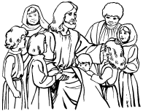**Religious Education & Sacraments**

**Religion Classes:** Advent/Christmas Prayer Service and Distribution of Report Cards will be **today,** **December 16th and on Wednesday, December 19th**.

**There will be no classes** on Sunday, **December 23rd** and Wednesday, **December 26th.**

**First Communion:** Parent orientation meeting is Monday, **January 28th.**

**Outreach Donations**: Please bring in Holiday Food for the Christmas Baskets ASAP.

**Youth Ministry & Confirmation**

#### whats-your-story

**CONFIRMATION**

Next class will be on:

**Sunday, January 6th and Wednesday, January 9th.**

**PAST DUE** – Sponsor Name, Sponsor Eligibility Form and Confirmation Saints Name.

**YOUTH GROUP**

Meeting: **Sunday, December 16th** at 6pm in the Youth Room. We will be working on crafts for the Pregnancy Center.

**Youth Group has also been asked to** **help decorate** ICC after 12:00pm mass on December 23rd or St. Jude’s after the 9:00am mass on December 23rd.

**YOUTH MINISTRY WISH LIST:**

Bottled water and sodas

**YOUNG ADULTS**

Contact Maddie Reese at [memreese1010@gmail.com](mailto:memreese1010@gmail.com) for updates.

**ADULT EDUCATION**

**Interested in a study group?** Many opportunities are available. Call the Parish Office at 410-392-3551.

**“Mary, a Biblical Walk with the Blessed Mother”** will be the next adult education class will begin on Monday, January 14th and repeat on Tuesday, January 15th.More information to follow.

**RESOURCES FOR THE SEASON:**

Visit the Parish Website at [iccparish.weconnect.com](http://www.iccparish.weconnect.com) and look under Resources to find Resources for Prayer, Scripture, etc.

**SOCIAL CONCERNS**

**Outreach**

Please consider donating non-perishable foods to the Outreach! Thank you so much for your help, generosity, prayers, & donations to this essential ministry!!

**We are in need of Food items such as: turkeys, green beans, fruit, stuffing, gravy, soup, baked beans, and cans of chef Boyardee pasta meals.**

**We are in need of personal hygiene items such as: toothpaste, toothbrushes, soap, shampoo, and deodorant.**

**Thank you!**

**PARISH & FAMILY LIFE**

**Parish Coffee**

Join us for Parish Coffee **January 6th** after 9:00 am Mass at St. Jude’s.

Join us for Parish Coffee **January 13th** after 10:15am Mass at ICC!

**PARISH EVENTS/INFORMATION**



*Thank you so much for your continued*

*generosity and support to your parish!*

**Weekly Church Collections: Week of Dec. 9th**

ICC $11,050.00

St. Jude--------------------- $1,872.00

Online $3,106.00

Total Offertory $16,028.00

***We offer electronic giving!***

**How does Online giving benefit you?**

1. It’s easy, convenient, and safe
2. Allows you to give any amount, any time.
3. Allows you to track your giving

**How does Online giving benefit the parish?**

1. Creates consistency of giving to help with financial planning
2. Increases efficiency of processing giving

**How to sign up?**

1. Visit iccparish.weconnect.com
2. Click “Go to Online Giving”
3. Sign up! It’s that easy!

**PARISH EVENTS/INFORMATION**

**St. Jude’s 50th Anniversary:**

Our parish will be celebrating the 50th Anniversary of St. Jude Church in 2019! The committee will be collecting pictures and stories to share. There will be a box at the entrance to the church where you can leave items you would like to share or you can drop them off at the parish center. Don’t forget to include your contact information so that the items can be returned to you! Please contact Cheryl Nickle at [youthministry@iccparish.org](mailto:youthministry@iccparish.org) with ideas or for more information about planning this celebration!

**limited supply!! Makes for the perfect Christmas Gift!!**

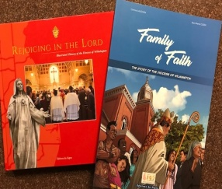We have **a limited supply** of two history books, “Rejoicing in the Lord,” and “Family of Faith” published by the Diocese to commemorate the 150th anniversary of the Catholic Diocese of Wilmington. “Rejoicing in the Lord” is a hard-cover, full-color coffee table book that features histories and never-before-seen photographs of all Catholic churches in Delaware and Maryland’s Eastern Shore, plus biographies of all nine Wilmington bishops, with important ministries and events highlights. “Family of Faith” is a 35-page, color diocesan history done in the comic book or graphic novel style.

**“Rejoicing in the Lord” is available for $30 each, and “Family of Faith” is sold for $12.** To purchase one or both books, please contact or visit the parish office Make sure to **purchase yours today!!**

**Year-End Donations:**

**I**n the course of year-end tax planning, you may find yourself considering extra donations. As you contemplate year-end gifts, please keep Immaculate Conception/St. Jude Parish in mind. We welcome your donations through the giving page on the church website at iccparish.org. or in the Parish office. Your generosity will be a great help to the parish and may benefit you as you prepare your taxes!

**Beautiful Hand-crafted bows for sale!**

**We have beautiful handmade Christmas bows** for sale after all masses at ICC this weekend! **Each bow is $5**. Make sure to stop by and get yours today!

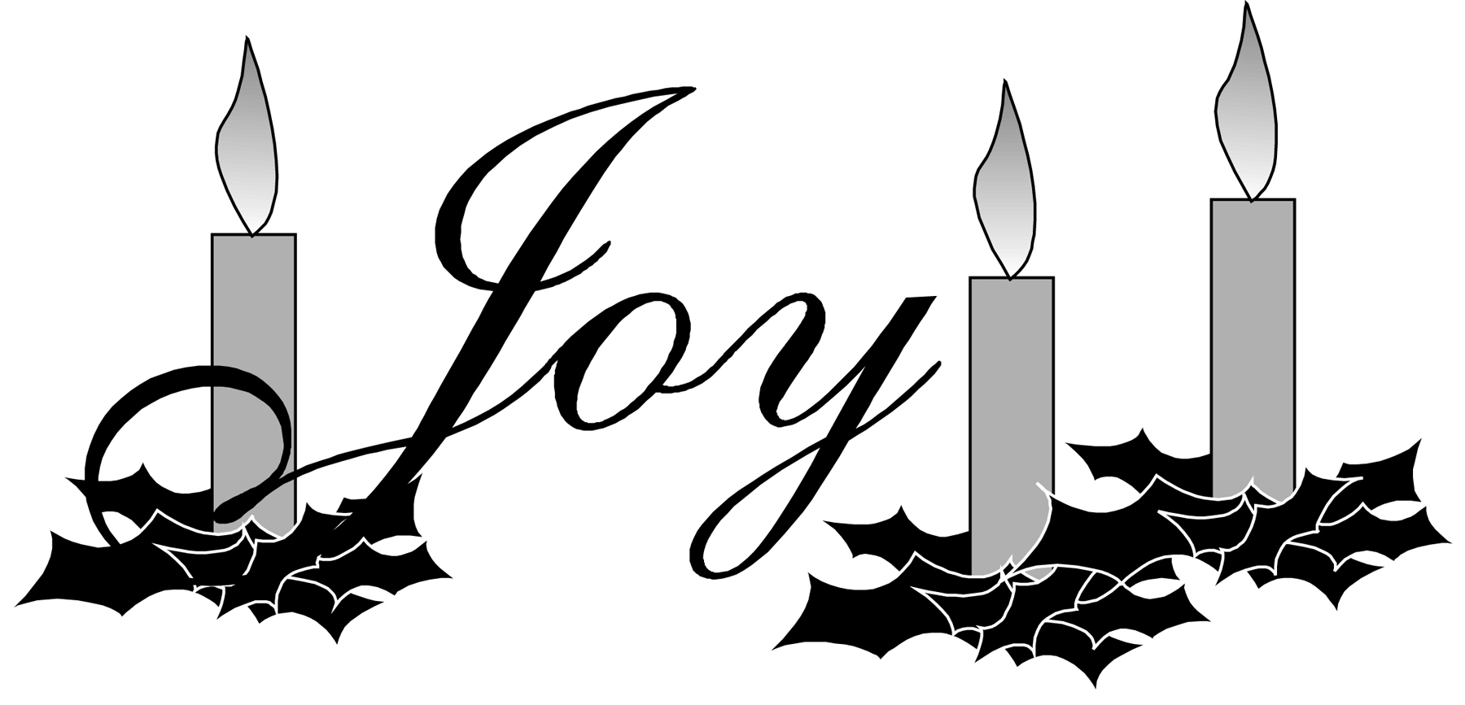



**Sunday, December 16**

8:20 AM - Confessions - SJ

8:30 AM - Religious Ed

10:30 AM - Baptisms - IC

6:00 PM - HS Gathering - PC

Monday, December 17

9:00 AM - Novena - CH

6:00 PM - Varsity Girls Basketball - gym

8:00 PM - AA Mtg - Caf

Tuesday, December 18

9:00 AM - Holy Hour – CH

9:15 AM - Adult Ed book club - PC

5:30 PM - Pre JV Basketball - gym

6:30 PM - Varsity Boys Basketball - gym

7:30 PM - Contemp Rehearsal - IC

Wednesday, December 19

9:00 AM - Rosary Crusade/SJ Novena-CH

9:30 AM - Cantor Rehearsal - IC

5:00 PM - Parish Council Mtg - PC

6:15 PM - Religious Ed

Thursday, December 20

9:00 AM - Rosary Crusade - CH

11:00 AM - 5th Gr Special Person Lunch- caf

6:30 PM - Varsity Girls Basketball - gym

6:30 PM - Boy Scout Meeting - PC

6:30 PM - Cub Scout Meeting - caf

6:30 PM - Cantor Rehearsal - IC

7:00 PM - RCIA - PC

7:00 PM - Parish Choir Rehearsal - IC

Friday, December 21

9:00 AM - Rosary Crusade - CH

5:30 PM - Pre- JV Basketball - gym

7:00 PM - NA – Caf

**Saturday, December 22**

9:00 AM - Rosary Crusade - CH

12:00 PM - Christmas Pageant Rehearsal-IC

4:15 PM - Confessions - IC

7:00 PM - NA – Caf

**COMMUNITY EVENTS/INFORMATION**

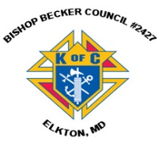**Knights of Columbus**

***Bishop Becker Council 2427***

**443-616-5370** or [**www.kofc2427.org**](http://www.kofc2427.org)

**Meetings:** 2nd & 4th Tuesdays of the month at 7:00 pm at the Parish Center

**LAOH (The Ladies Ancient Order of Hibernians)**

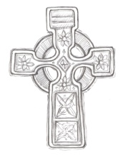The Ladies Ancient Order of Hibernians, Inc. Cecil County Division 1, an Irish Catholic Action group has meetings on the first Wednesdays of the month at 1:00pm in the ICC Parish Center. Meetings run September through May. We are always looking for new members! If you are an Irish Catholic woman and want to serve your community, and learn more about your Irish heritage come join us! Contact Janice White, President at 410-378-3493

***Worldwide Marriage Encounter*** - It has been said that the greatest gift you can give your children is two parents very much in love with each other. Polish up this gift and put a bow on it at a Worldwide Marriage Encounter Weekend! The next Marriage Encounter weekend with be March 1-3, 2019 in Rehoboth Beach, DE. For information, visit our website at [www.me-delmar.org](http://www.me-delmar.org) or to register for the weekend, please call Tony and Linda Massino at 302-220-9833. Don’t Delay! Your marriage deserves this *gift*!

**Make sure to check out the Dialog!!**

Next week, look for the Christmas Edition of The Dialog. In it you will find Bishop Malooly’s annual Christmas message to the people of Delaware and Maryland’s Eastern Shore, plus a special 150th anniversary tribute to priests in service to our diocese and parishes.

**Prayers for Vocations:**

John the Baptist went through the whole region of the Jordan, proclaiming “Prepare the way of the Lord!” Is God calling *you* to help prepare His way by serving as a priest or as a religious brother or sister? Contact Fr. Norm Carroll, Diocesan Director of Priestly and Religious Vocations at 302-573-3113 or [vocations@cdow.org](mailto:jcocucci@cdow.org) And check out our website: [www.cdow.org/vocations](http://www.cdow.org/vocations)! “For faithful and generous servant-leaders to prepare the way of the Lord through lives of priestly and religious ministry in the Church, we pray to the Lord!”