**Mark your calendars! Advent Services:**

**Reconciliation:**

**Immaculate Conception:**

Saturdays, 4:10-4:50pm December 8, 15, & 22

**St. Jude:**

Sundays, 8:20-8:50am December 2, 9, 16, 23rd

**Additional Reconciliation Services: Open to all!**

10:00am Tues, December 4th - ICC School Service

7:00pm Tues, December 18th - IC Parish Service

**Advent Liturgies:**

**Feast of Immaculate Conception**

December 7th: 10:00am - ICC School Service

December 7th: 7:00pm Vigil - St. Jude

**Feast Day of Immaculate Conception**

December 8th: 8:30am, 12:15pm - ICC

**Christmas Masses:**

**Immaculate Conception Church**

**Christmas Eve, Monday, December 24**

**4:00pm Mass with Christmas Pageant**

Pageant begins at 3:40pm

**7:00pm Mass**

Carol prelude begins at 6:40pm with Contemporary Ensemble

**12:00 Midnight Mass**

Carol prelude begins at 11:30pm with the Parish Choir & Instrumentalists

**Christmas Day, Tuesday, December 25**

10:15am Mass

**St. Jude Mission Church**

**Christmas Eve, Monday, December 24**

**4:00pm Mass with Christmas Pageant**

Pageant begins at 3:40pm with Junior Choir singing

**Angel 0310:00pm Mass**

Carol prelude begins at 9:40pm

**Christmas Day, Tuesday, December 25**

9:00am Mass

**Masses for the Solemnity of Mary**

Monday, December 31st 8:30am, 7:00pm Vigil - IC

Tuesday, January 1st 9:00am Mass - SJ



**Advent/Christmas Concert!**

**Join us NEXT WEEKEND, Sunday, December 9th** at 3:00pm at Immaculate Conception Church for a flute, harp, and keyboard concert to celebrate the Advent and Christmas seasons. We look forward to seeing you there!



**December 3, 2018 St. Francis Xavier, Priest**

8:30 am Emily Czarnecki

**December 4, 2018 St. John Damascene**

8:30 am Sr. Anna May McFeeley

**December 5, 2018**

8:30 am Quinn Rose Steward (Living Intention)

**December 6, 2018 St. Nicholas, Bishop**

8:30 am Alma Jose

**December 7, 2018 St. Ambrose, Bishop**

8:30 am Jacob Pratt

7:00 pm SJ Nancy Hosterman

**December 8, 2018 The Immaculate Conception of**

**the Blessed Virgin Mary**

8:30 am Patsy Rush

5:00 pm People of the Parish

**December 9, 2018 *Second Sunday of Advent***

7:00 am Edward Fischer Jr.

8:30 am Joe Amberg

9:00 am SJ Tobias Jenior

10:15 am Sean Locke

12:00 pm Herbert Guns



**Knights of Columbus ‘Giving Tree’ Fundraiser!**

Make sure to stop by the entrances of the churches at all masses this weekend to purchase a raffle ticket for your chance to win one of three Christmas trees full of “Scratch - Off” Lottery tickets! **Raffle tickets are $5 each or $20 for 5.**

1st Prize: $1,000 in Scratch-Off Tickets

2nd Prize: $750 in Scratch-Off Tickets

3rd Prize: $500 in Scratch-Off Tickets

Drawing to be held by the Knights on Christmas Day. All Proceeds will be going to ICC, ICS, and the Knights of Columbus. This raffle is not affiliated with the Maryland Lottery and/or the State of Maryland.

**angel tree gifts:**

**All Angel Tree gifts to be returned TODAY!!**

All Angel Trees gifts must be returned to either St. Jude’s or Immaculate Conception Church by Sunday, December 2nd! Please make sure that the gifts wrapped and the pink or blue angel is **securely** attached to the package(s). If you have multiple boxes, please tie them together! Thank you for being an Angel to someone in need this Christmas!!!

**Readings for next week:**

**Second Sunday in Advent**

**First Reading: Baruch 5:1-9**

Baruch tells Jerusalem to rejoice because of God's plan to bring his exiled people back to Jerusalem. He emphasizes God's power and describes his plan to lower mountains and fill gorges to make their journey easier.

**Second Reading: Philippians 1:4-6, 8-11**

Paul encourages the Philippians to love each other completely. He hopes that their love and understanding will continue to grow so that they are prepared for the return of Christ.

**Gospel: Luke 3:1-6**

Luke describes the work John the Baptist carried out to help people prepare for the birth of Jesus. Luke also discusses who was in power at the time, which helped historians to figure out the exact dates of certain events, including Jesus' birth.

**Adoration for Vocations**

On the 1st Sunday of each month, exposition of the Blessed Sacrament occurs from 1pm-3pm in IC Chapel. Join us to pray for vocations to priesthood and religious life. The next opportunity is TODAY **December 2nd.** Contact Dermott Mullan at 410-398-3368.

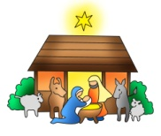

**2018 Christmas Eve Pageants**

**We are** **planning our annual** Christmas Eve Nativity Pageants at St. Jude & Immaculate Conception Churches! Children grades K-3 can participate. Sign up early, space is limited!! The pageants will be performed before the 4pm Masses at Immaculate Conception and St. Jude’s Church on Christmas Eve. If interested, please contact the following with your child’s name, gender, and age no later than December 13th.

**Contact information:**

**St. Jude’s -** Dottie Dhamer at [sassydot1@comcast.net](mailto:sassydot1@comcast.net) (preferred) or 443-350-7186. (Practice is Sunday, December 23rd after Mass)

**ICC** - Kim Burnham at [ksburnham@comcast.net](mailto:ksburnham@comcast.net) (Practice is Saturday, December 22nd at 11:00am)

***We extend our condolences and prayers to the families of those who have recently died:***

*Mrs. Patricia Flower*

*Mr. Steven Hardy*

*Mrs. Betty Murray*

***Congratulations to those who were recently baptized:***

*Noah Michael Lewis*

*Lucas Xavier Magaw*

*Marguerite Sharon Partridge*

*Aspen Marie Smith*



**Does your child need to be Baptized?**

The next Baptism Class is **January 7th**, 7:00-8:30 pm in the Parish Center. It’s never too early to prepare for the Baptism of your child. Parents are required and Godparents are encouraged to attend. Contact the Parish Office to register at 410-398-1100.

**Daily Readings:**

***First Sunday of Advent***

**Sunday**...Jer 33:14-16; 1 Thes 3:12-4:2; Lk 21:25-28, 34-36

**Monday**..................................................Is 2:1-5; Mt 8:5-11

**Tuesday**.........................................Is 11:1-10; Lk 10:21-244

**Wednesday**..................................Is 25:6-10a; Mt 15:29-37

**Thursday.***.....................................*Is 26:1-6; Mt 7:21, 24-27

**Friday** ............................................Is 29:17-24; Mt 9:27-31

**Saturday**..........Gn 3:9-15, 20; Eph 1:3-6, 11-12; Lk 1:26-38

**Liturgical Ministers Next Week: *December 8th & 9th***

***5:00 pm***

**Altar Servers:** Donovan O, Grace B •**EM’s:** Carol K, Julie M, Diana B • **Lector:** Edward R • **Ushers:** Eileen P, Pat C, Bill B

***7:00 am***

**Altar Servers:** Benedict J • **EM’s:** Frank S, *UNFILLED*

• **Lector:** William K • **Ushers:** Charles M, William C

***8:30 am***

**Altar Servers:** Henry W, Damian W • **EMs:** Mary Ann E, Mary Ann H, Don H •**Lector:** Rachel W •**Ushers:** Anthony D Wendel S Anthony M, Steve C

***9:00 am (SJ)***

**Altar Servers:** Luke T, Matthew T • **EM’s:** Dorothy D, Mary Ann S, Lester F, Dorothy F, Narcy Z • **Lector:** Michele C •**Ushers:** Kevin O, Bill D, Jule V, Jake S

***10:15 am***

**Altar Servers:** Elizabeth R, Mason H • **EM’s:** Rita M, Ben F, Gwen D, David L, Richard L • **Lector:** Helen B •**Ushers:** Bob W, James D, Steve A

***12:00 noon***

**Altar Servers:** Andrew F, Alex F • **EMs:** Corazon S, Grace B, Pat K • **Lector:** Frank E • **Ushers:** Charles C

**Children’s Liturgy of the Word**

Children’s Liturgy is for children ages 5-8 ONLY. Children who are not in this category are asked to stay in church.

**The catechist for Next week, December 9th is:**

Lynn O’Brien

**Immaculate Conception**

**School News**

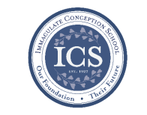**Walk-In Wednesdays** areevery Wednesday from 9:00am–11am. Spread the news! Tours are offered to those who wish to see the school in action!

**Story Time** is on Wednesday, **December 5th** at 10am in the PreK Room. Visit our Facebook page [www.facebook.com/icschoolmd](http://www.facebook.com/icschoolmd) and mark “Going” if you plan on attending. Space is limited, but all are welcome!

**Last Week…**

**Curtis Blues:** Curtis Blues came to teach our students about the multicultural roots of rock and rap! It was an extremely educational and FUN event! Chris was definitely able to make music come alive!

**Thanksgiving Prayer Service:** Kindergarten and 1st grade classes led a Thanksgiving Prayer Service in the school gym. This is always an adorable occasion!

**Coming up…**

**First Friday in Elkton** The Children’s Choir will be singing Christmas carols on **Dec. 7th** between 5-8pm around downtown Elkton!

**Alumni and Friends** are invited to celebrate Homecoming at the North Street Hotel at 8pm on Friday Dec. 7th! Please contact Jacqueline Lockwood or visit their Facebook page for more info: [www.facebook.com/groups/ics.alumni.friends](http://www.facebook.com/groups/ics.alumni.friends)

**Thursday, December 13th at 6:00pm:** Immaculate Conception School is having our annual Christmas concert featuring our Prek-5th grades and our beginner and advance bands! This is always a festive & entertaining evening!

**ICS Basketball Registration:**

We are still looking for 5th and 6th grade girls for the JV Basketball team!! All other teams are FULL!! Thank you to everyone for their support of CYM Athletics! Athlete registration is available on our school website, [www.icschoolweb.org](http://www.icschoolweb.org) under the community tab. Please contact Michelle Riddle at [icshawkssports@gmail.com](mailto:icshawkssports@gmail.com) for more information or with any questions.

**Faith Formation**

**Religious Education & Sacraments**

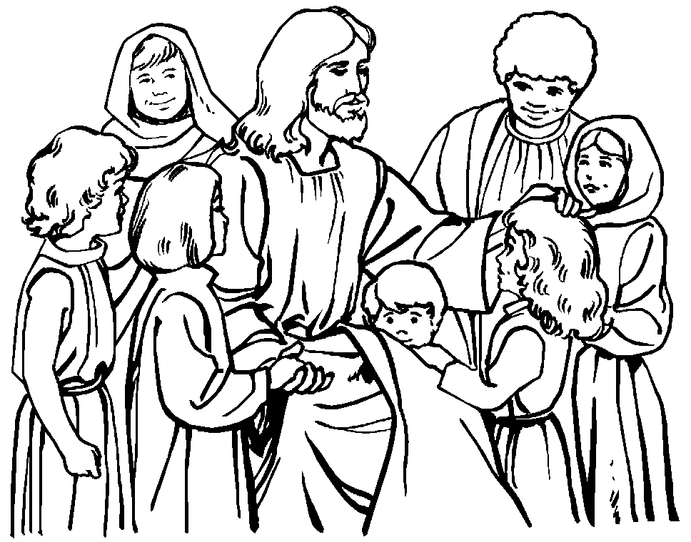

**Religion Classes:** Classes resume **today** Sunday, December 2nd.

**First Reconciliation** – Congratulations to those who recently celebrated First Reconciliation.

**Outreach Donations**: Please bring in Holiday Food for the Christmas Baskets.

**Youth Ministry & Confirmation**

#### whats-your-story

**CONFIRMATION**

Next class will be on:

Class will be on Sunday, December 2nd at 8:30 am and 6:30 pm in the Parish Center and Wednesday, December 5th at 6:15 pm in the Parish Center.

**YOUTH GROUP**

Is meeting tonight at 6pm in the Youth Room. We will be decorating Christmas cookies and watching a Christmas movie, bring a friend.

**YOUTH MINISTRY WISH LIST:**

Bottled water and sodas

**YOUNG ADULTS**

Contact Maddie Reese at [memreese1010@gmail.com](mailto:memreese1010@gmail.com) for updates.

**ADULT EDUCATION**

**Interested in a study group?** Many opportunities are available. Call the Parish Office at 410-392-3551.

**RESOURCES FOR THE SEASON:**

-Go to the Parish Website at [iccparish.weconnect.com](http://www.iccparish.weconnect.com) and look under Resources to find Resources for Prayer, Scripture, etc.

**SOCIAL CONCERNS**

**Outreach**

Please consider donating non-perishable foods to the Outreach! Thank you so much for your help, generosity, prayers, & donations to this essential ministry!!

**THANK YOU to all who so generously gave to our Thanksgiving Program!! Thank you also to Acme and Kirkwood Pest for your help feeding those in need!**

**We have begun collecting Christmas food! Please consider donating turkeys, green beans, corn, stuffing, gravy, mashed potatoes, etc. Thank you!**

**PARISH & FAMILY LIFE**

**Parish Coffee**

Join us for Parish Coffee **Today, December 2nd** after 9:00 am Mass at St. Jude’s.

Join us for Parish Coffee **December 9th** after 10:15am Mass at ICC!

**PARISH EVENTS/INFORMATION**



*Thank you so much for your continued*

*generosity and support to your parish!*

**Weekly Church Collections: Week of Nov. 25th**

ICC $8,040.00

St. Jude--------------------- $1,686.00

Online $3,329.00

Total Offertory $13,055.00

***We offer electronic giving!***

**How does Online giving benefit you?**

1. It’s easy, convenient, and safe
2. Allows you to give any amount, any time.
3. Allows you to track your giving

**How does Online giving benefit the parish?**

1. Creates consistency of giving to help with financial planning
2. Increases efficiency of processing giving

**How to sign up?**

1. Visit iccparish.weconnect.com
2. Click “Go to Online Giving”
3. Sign up! It’s that easy!

**PARISH EVENTS/INFORMATION**

**St. Jude’s 50th Anniversary:**

Our parish will be celebrating the 50th Anniversary of St. Jude Church in 2019! The committee will be collecting pictures and stories to share. There will be a box at the entrance to the church where you can leave items you would like to share or you can drop them off at the parish center. Don’t forget to put include your contact information so that the items can be returned to you! Please contact Cheryl Nickle at [youthministry@iccparish.org](mailto:youthministry@iccparish.org) with ideas or for more information about planning this celebration!

**limited supply!! Makes for the perfect Christmas Gift!!**

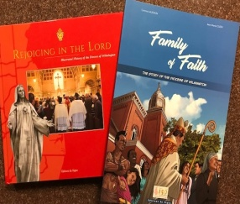We have **a limited supply** of two history books, “Rejoicing in the Lord,” and “Family of Faith” published by the Diocese to commemorate the 150th anniversary of the Catholic Diocese of Wilmington. “Rejoicing in the Lord” is a hard-cover, full-color coffee table book that features histories and never-before-seen photographs of all Catholic churches in Delaware and Maryland’s Eastern Shore, plus biographies of all nine Wilmington bishops, with important ministries and events highlights. “Family of Faith” is a 35-page, color diocesan history done in the comic book or graphic novel style.

**“Rejoicing in the Lord” is available for $30 each, and “Family of Faith” is sold for $12.** To purchase one or both books, please contact or visit the parish office Make sure to **purchase yours today!!**

**Year-End Donations:**

**I**n the course of year-end tax planning, you may find yourself considering extra donations. As you contemplate year-end gifts, please keep Immaculate Conception/St. Jude Parish in mind. We welcome your donations through the giving page on the church website at iccparish.org. or in the Parish office. Your generosity will be a great help to the parish and may benefit you as you prepare your taxes!

**Inspirational Quote of the Week:**

“For me prayer is the heart's impulse, a simple gaze toward heaven. It is a cry of gratitude and love, from the depths of trial as well as the heights of joy. Finally, it is something great, supernatural, that expands my soul and unites me to Jesus.”

-- Saint Therese of Lisieux



**Sunday, December 2**

8:20 AM - Confessions - SJ

8:30 AM - Religious Ed

8:30 AM - Rite of Welcoming - CH

1:30 PM - Adoration for Vocations

6:00 PM - HS Gathering - PC

6:30 PM - Confirmation Class - PC

Monday, December 3

9:00 AM - Novena - CH

7:00 PM - Troop Committee Mtg - PC

8:00 PM - AA Mtg - Caf

Tuesday, December 4

9:00 AM - Holy Hour – CH

9:15 AM - Adult Ed book club - PC

10:00 AM - ICS Reconciliation - IC

5:30 PM - Pre JV Basketball - gym

6:00 PM - Liturgy Committee Mtg - PC

6:30 PM - Varsity Boys Basketball - gym

7:30 PM - Contemp Rehearsal - IC

Wednesday, December 5

9:00 AM - Rosary Crusade/SJ Novena-CH

9:30 AM - Cantor Rehearsal - IC

1:00 PM - LAOH - PC

6:15 PM - Religious Ed

6:30 PM - JV Boys Basketball - gym

Thursday, December 6

9:00 AM - Rosary Crusade - CH

6:30 PM - Boy Scout Meeting - PC

6:30 PM - Cub Scout Meeting - caf

6:30 PM - Cantor Rehearsal - IC

6:30 PM - Varsity Girls Basketball - gym

7:00 PM - RCIA - PC

7:00 PM - Parish Choir Rehearsal - IC

Friday, December 7

9:00 AM - Rosary Crusade - CH

5:30 PM - Pre- JV Basketball - gym

7:00 PM - NA – Caf

**Saturday, December 8**

9:00 AM - Rosary Crusade - CH

4:15 PM - Confessions - IC

7:00 PM - NA – Caf

**COMMUNITY EVENTS/INFORMATION**

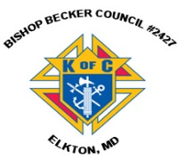**Knights of Columbus**

***Bishop Becker Council 2427***

**443-616-5370** or [**www.kofc2427.org**](http://www.kofc2427.org)

**Meetings:** 2nd & 4th Tuesdays of the month at 7:00 pm at the Parish Center

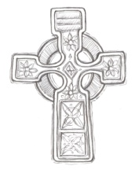**LAOH (The Ladies Ancient Order of Hibernians)**

The Ladies Ancient Order of Hibernians, Inc. Cecil County Division 1, an Irish Catholic Action group has meetings on = the first Wednesdays of the month at 1:00pm in the ICC Parish Center. Meetings run September through May. We are always looking for new members! If you are an Irish Catholic woman and want to serve your community, and learn more about your Irish heritage come join us! Contact Janice White, President at 410-378-3493

**Gardeners wanted!!**

If you would like to lend a hand (attached to a shovel,) working in the Immaculate Conception Church Prayer garden, we would gladly accept your help!! No experience necessary!! Call Gardener Val for more information at 443-907-5822.

**Video tours of historic churches available!** The Diocese of Wilmington has released a new video tour of the original St. Mary Star of the Sea Church, now called the Tubman Chapel. The video is the 5th in a series featuring historic churches of the Diocese and is available free to the public on the Diocese of Wilmington’s YouTube channel: [www.youtube.com/DioceseofWilm](http://www.youtube.com/DioceseofWilm).

Other churches include St. Francis Xavier Shrine (Old Bohemia), Old St. Joseph’s Mission Church, St. Peter the Apostle, and the Cathedral of St. Peter. The diocese also produced a short video on the life of Maryland native, the Rev. Paul Wattson, SA, (1863-1940) - also known as Father Paul of Graymoor - who may be the first person born in the Diocese, to be a canonized saint. All these videos are available on the YouTube site and on the diocesan 150th anniversary page, [www.cdow.org/150th](http://www.cdow.org/150th).

**Boy Scout Religious Awards**

Any scout who is interested in earning their Catholic religious award should contact the Diocese of Wilmington’s Catholic Committee on Scouting. Our committee can help get the process started and will supply the award, once earned. Each year the Bishop will present the awards to the scouts of our Diocese at our annual Scout Mass. For further information please contact either Bob Murray, Committee Chair at (302) 993-6290 or Deacon Tommy Watts, Boy Scout Chaplain (302) 218-1415.