|  |
| --- |
| ***From Father Jim***  **Third Sunday in Ordinary Time**  Dear Parishioners,  On behalf of our parish, I want to thank you for responding in faith to our parish Increased Offertory program. With each renewal of this effort, we strengthen our ties to each other as a parish and demonstrate to the wider community the depth of our faith commitment.  May the blessings of God’s spirit continue to nourish you in the days to come.  Sincerely in St. Francis de Sales,    Fr. Jim Yeakel, OSFS |

**Save the Date for our Parish Concert!**

Please join us for our Parish Concert **January 28, 2018 at 3:00pm** at Immaculate Conception Church. Grant Us Peace! This concert will be featuring the Parish Choir, Contemporary Ensemble, Children’s Choir, and instrumentalists. The program will be focused around our need for God’s peace in our world, and our prayer for peace through music. A free will offering will be taken and a reception will follow the concert

**~~~~~~~~~~~~~~~~~~~~~~~~~~~~~~~~~~~~~~~~**

**Cemetery Notice**: All Christmas decorations may remain on the graves at both cemeteries until the end of January. If you have any decorations that you wish to keep, you **must remove them by January 31, 2018.** Please remember that with the exception of flowers in memorial marker vases, no decorations of any type, (wind chimes, statues, fencing, flags, potted plants, etc.) are permitted on the graves during the mowing season – April 15 to October 30. Thank you for your cooperation.

**~~~~~~~~~~~~~~~~~~~~~~~~~~~~~~~~~~~~~~~~**

***Congratulations to those who were recently baptized:***

Meyer Adeline Begin

***We extend our condolences and prayers to the families of those who have recently died:***

Mrs. Joan Berwick

Mrs. Anita Shrewsbury

Mr. Thomas Wade

**~~~~~~~~~~~~~~~~~~~~~~~~~~~~~~~~~~~~~~~~**

**Ash Wednesday is February 14!**

Please bring in your last year's palms for us to turn into this year's ashes. Palms may be deposited in the baskets at the entrances to our churches.

**Our 11th annual ICS Waffles and Raffles is coming up on Sunday, January 28th** from 8:00am-12:00pm. “Follow The Yellow Brick Road” to our Wizard of OZ themed event and enjoy fun, friendship, food, and possible prizes! Don’t miss the silent auction and raffle! The cost is $7 for adults, $6 for seniors and children (4-12 yrs), and kids 3 and under are free! ICS Students will receive a Jeans Pass and Raffle ticket with the purchase of a meal ticket! All proceeds benefit ICS.

**~~~~~~~~~~~~~~~~~~~~~~~~~~~~~~~~~~~~~~~~**

2

**The New- and Not-so- Newlywed Game Night**

**SAVE THE DATE!** The Parish and Family Life Committee will be sponsoring an evening of fun, laughter, and good food on Saturday, February 10 beginning at 6:15. The evening will consist of a dinner and a game for new, and not-so-new-lyweds! Modeled after the TV show, couples will compare answers to some intriguing and comical questions. Here is a perfect way to celebrate Valentine’s Day! Tickets will be sold after Masses for the next two weekends. You may also purchase tickets at the parish office. Tickets are $45 per couple or $150 for a table reservation (4 couples). The ticket includes one complementary bar beverage, water, tea, coffee, a buffet dinner, dessert, and the game. Cash bar will be available that evening for wine and beer.

**~~~~~~~~~~~~~~~~~~~~~~~~~~~~~~~~~~~~~~~~**



**January 22, 2018**

8:30 AM Catharine Stevens (Living Intention)

**January 23, 2018 St. Marianne Cope and St. Vincent, Deacon & Martyr**

8:30 AM Mabel Davis

**January 24, 2018 St. Francis de Sales, Bishop and Dr. of the Church**

8:30 AM Sarah Smith

**January 25, 2018 The Conversion of St. Paul, Apostle**

8:30 AM Gail Toohey

**January 26, 2018 St. Timothy and St. Titus, Bishops**

8:30 AM Dolores Racobaldo

**January 27, 2018 St. Angela Merici**

8:30 AM Joseph Gindhart

5:00 PM Alexander Michael Szewczyk

**January 28, 2018 Fourth Sunday in Ordinary Time**

7:00 AM Jose Goveya

8:30 AM Emeterio Buni

9:00 AM SJ Phil Young

10:15 AM People of the Parish

12:00 PM Alice Becker

**Liturgy**

**Readings for next week: 4th Sunday in Ordinary Time**

**First Reading: Deuteronomy 18:15-20**

Moses explains to the people that a prophet will come from among them, and that they should listen to this prophet’s words, for God has told him of this prophet. God also tells Moses that anyone who pretends to speak in his words, or speaks in the name of other gods shall die.

**Second Reading: 1 Corinthians 7:32-35**

Paul tells the Corinthians how an unmarried man or woman is able to devote themselves fully to God without concern for the needs of a spouse. Paul explains that God wants to help them promote good and devote themselves more fully to God.

**Gospel: Mark 1:21-28**

As Jesus was teaching, a man with an unclean spirit came to the synagogue and asked if Jesus had come to destroy them. Jesus ordered the spirit out of the man, who shrieked violently as the spirit departed. The people were amazed at the authority he had over the spirit.

**~~~~~~~~~~~~~~~~~~~~~~~~~~~~~~~~~~~~~~~~**

**Attention young adults in the parish:** coming in 2018 there will be a ministry in the parish specifically for you! Stay tuned to the bulletin and parish website for upcoming events. Feel free to reach out to Madison Reese ([mem.reese1010@gmail.com](mailto:mem.reese1010@gmail.com)) if you would like more information or to get involved!

Join us, **today, Sunday, January 21, 2018.** Join fellow young adults from around the Diocese of Wilmington to celebrate Mass with Bishop Malooly at St. Mary of the Assumption in Hockessin, DE. Mass starts at 11:30am followed by lunch and fellowship with the Bishop.

**~~~~~~~~~~~~~~~~~~~~~~~~~~~~~~~~~~~~~~~~**

**Does your child need to be Baptized? The next Baptism Class is Monday, March 19th.** 7:00-8:30pm in the Parish Center. It’s never too early to prepare for the Baptism of your child. Parents are required and Godparents are encouraged to attend. Contact us to register and arrange the Baptism date at 410-398-1100.

**~~~~~~~~~~~~~~~~~~~~~~~~~~~~~~~~~~~~~~~~**

**Emergency Rotating Shelter for 2018.** Immaculate Conception/St. Jude will host the shelter this year from February 5th through 19th. There is a volunteer meeting scheduled on **January 25, at 7pm** in the Parish Center. Many volunteers are needed to help with this mission. Many thanks for all the help you have provided in past years. Look forward to meeting anyone interested in helping this year. For additional information or questions, please call Carol and Bill Dale, 410-287-9548 or email [dales7@comcast.net](mailto:dales7@comcast.net).



**Daily Readings: Third Sunday in Ordinary Time**

**Sunday**

Jon 3:1-5, 10; 1 Cor 7:29-31; Mk 1:14-20

**Monday**

*Lectionary for Ritual Masses, vol. IV “Mass for Peace & Justice”,nos. 887-891*

**Tuesday**

2 Sm 6:12b-15, 17-19; Mk 3:31-35

**Wednesday**

2 Sm 7:4-17; Mk 4:1-20

**Thursday**

Acts 22:3-16 or 9:1-22; Mk 16:15-18

**Friday**

2 Tm 1:1-8 or Ti 1:1-5; Mk 4:26-34

**Saturday**

2 Sm 12:1-7a, 10-17; Mk 4:35-41

**~~~~~~~~~~~~~~~~~~~~~~~~~~~~~~~~~~~~~~~~**

**Adoration for Vocations:** On the 1st Sunday of each month, exposition of the Blessed Sacrament occurs from 1pm-3pm in IC Chapel. Join us to pray for vocations to priesthood and religious life. The next opportunity is **February 4th**. Contact Dermott Mullan at 410-398-3368

**~~~~~~~~~~~~~~~~~~~~~~~~~~~~~~~~~~~~~~~~**

**Liturgical Ministers for Next Week: January 27-28**

***5:00pm***

**Altar Servers:** Thomas L, Henry W **EM’s** Mary Anne E, Madison L, Gina L **Lector:** Alison D **Ushers:** Eileen P, Bill B, Diana B Pat C

***7:00am***

**Altar Servers:** Sarah B, Jacob B **EM’s**: Sandra H, Alan S, Gerald M **Lector:** David D **Ushers:** Charles M, William C

***8:30am***

**Altar Servers:** Jeremy M, Grace S **EMs:** Don H, Frank S, Mary Ann H **Lector:** Kathleen W **Ushers:** Anthony D, Steve C, Wendel S, Anthony M

***9:00am (SJ)***

**Altar Servers:** Luke T, Matthew T **EM’s:** Narcy Z, Tom V, Bill C, Diane C, Dotty F **Lector:** Louis N **Ushers:** Kevin O, Bill D, Jule V

***10:15am***

**Altar Servers:** Tommy M, Benedict J **EM’s:** Rita M, Ben F, David L, Peter G, Cecilia G **Lector:** Paula G **Ushers:** Bob W Steve A

***12:00noon***

**Altar Servers:** Gabriel O, Cecilia G **EM’s:** Kathy C, Pat K, Charles C **Lector:** Roberto O **Ushers:** Teresa G

**Children’s Liturgy of the Word**

Children’s Liturgy is for children ages 5-8 ONLY. Children who are not in this category are asked to remain in church.

**The catechist for next Sunday, Jan 28th is:**

**Dana Bell**

**Faith Formation**

**Immaculate Conception School News**

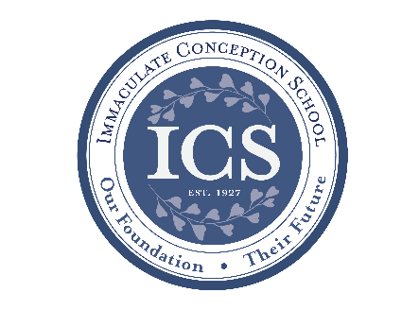

**This week marks the interim** **for the 2nd trimester,** which is the mid-point of our school year. Interim reports will go home at the end of the week so that parents and students can monitor academic progress.

**We are making the final plans for** **Catholic Schools Week** which will begin next weekend. Our kick-off for the week-long celebration of Catholic education begins with **Waffles & Raffles on Sunday, the 28th** from 8:00 - noon in the cafeteria. Our theme this year is the Wizard of Oz, so follow the yellow brick road to see what fun and good food you can find! Stop in after Mass next Sunday to enjoy a delicious breakfast and participate in the raffles and silent auction. We have a wonderful selection of items on which to bid! Other big events that week include an assembly by Justin Berk called “Faith in the Flakes”, our Open Houses on Tuesday, school Mass on Wednesday, our talent Show Thursday night, and our Blue/White Rally on Friday afternoon. Other activities will be our annual spelling bee, the geography bee, and the Challenge Cup game between the staff and 8th graders.

**If you are curious about our school,** now is a perfect time to explore. We are holding our winter Open House which will be in three phases on Jan. 30. The first phase is during the school day when parents and potential students can get a feel for what a typical ICS day is like. Then, in the evening, there will be two sessions; one for preschool families to focus on the benefits we provide for 3 and 4 year olds, and a second session which will be focused on students transferring in from other schools with an explanation of our new Tuition Transfer Grant program and the availability of tuition assistance. We still have “Walk-in Wednesday” when we will are prepared to have student ambassador tour guides as well as our advancement director available for any questions. You may also schedule a school tour at any time by calling Emily Murphy at 410-398-2636. If you are considering applying for tuition assistance, now is the perfect time to come visit ICS.

**Do you have a young child at home?** Are you looking for ideas to help you foster a love of reading for your child? Do you home school your child, and you want fresh ways to encourage reading? We may have an answer for you. Our next Story Time session will be this Tuesday, Jan. 23 at 9:00. If you have questions about the program or are interested in helping, please contact Emily Murphy at the school (410-398-2636).

**~~~~~~~~~~~~~~~~~~~~~~~~~~~~~~~~~~~**

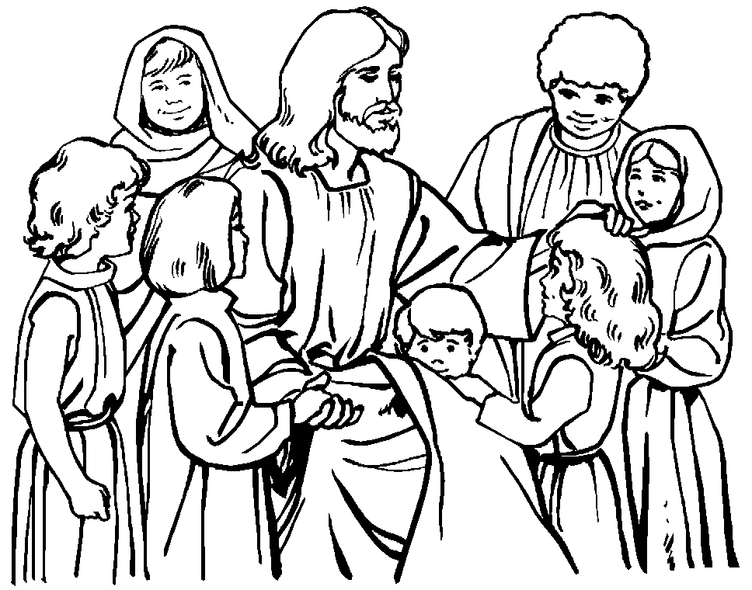**Faith Formation**

**Religious Education & Sacraments**

**Religion Classes for Grades K-8:**

**Sunday Program:** Classes for Gr. K-8 will be held today, Jan. 21st at 8:30am

**Wednesday Program:** Classes for Gr. 1-8 will be held this Wednesday, Jan.24th at 6:15pm.

**FIRST COMMUNION PROGRAM:**

Parents of children who are eligible to enroll in this year’s First Communion Program should have received an invitation. MARK YOUR CALENDAR for **The Parent Orientation Meeting that will be held Next Monday, January** **29th at 6:30pm in Church**. At least one parent must be in attendance at this meeting and bring with them the form noting the celebration date chosen for First Communion. Call the parish religion office with questions or concerns.

**~~~~~~~~~~~~~~~~~~~~~~~~~~~~~~~~~~~**

#### Youth Ministry & Confirmation

**CONFIRMATION PROGRAM:**

Regular Schedule- Sun. Class 4pm, Wed. Class 6:15pm; next whole group candidates’ gathering is **Sunday, February 4, 4-5:30** at St. Jude’s. Each candidate is to turn in their choice of Confirmation saint at this gathering. This form is in your packet you received at our first meeting.

**YOUTH GROUP: 6-8pm, bring a friend! Open topic/discussion night! Pizza night!**

**YOUTH MINISTRY WISH LIST:** Mac n’ cheese kits, popcorn, bottled water, cocoa.

**Are you being called to serve the Parish Youth?** If interested in serving our parish youth even once a month, contact Cheryl Nickle in the religion office. We’re forming a Core Team of adults to help 7th-12th grade youth groups. Thanks to those who have volunteered so far. We will be calling on you soon.

**YOUNG ADULTS**

Thank you to Maddie Reese for spearheading the creation of our Young Adult’s Group. Check Flocknote for news!

**~~~~~~~~~~~~~~~~~~~~~~~~~~~~~~~~~~~**

**Adult Education**

**Interested in a study group?** Many opportunities are available. Call the Parish Office at 410-392-3551.

**Adult Enrichment Program: Footprints of God:**

Sessions will be held this week on Mon., Jan. 22nd at 6:30pm and Tues., Jan. 23rd at 9:15am The Topic will be: Paul: Contending for the Faith. Next week will be the last session in this series!

**\*\*Beginning Feb. 19th & 20th there will be a program entitled “Symbolon: The Catholic Faith Explained.”**

Whether you are looking to grow in your faith or just learning about the Catholic Church, Symbolon will take you through a journey into the timeless beauty and truths of the Catholic faith and reveal God’s incredible love for us. All who want to learn more about their faith are welcome. It will be conducted for 10 weeks. The cost is $25.00 to cover the book. Registration forms are available in the vestibule of Church and Parish Center

**Social Concerns**

**Outreach:**

**Please consider donating non-perishable foods to the Outreach! Thank you for your** help, prayers, & donations to this essential ministry!!

**We are currently in need of:** peanut butter, jelly, canned fruit, Jello, instant pudding, spaghetti, spaghetti sauce, canned pasta, and dish detergent

**Parish and Family Life**

**Parish Coffee**: Join us for Parish Coffee **February 4th** after the 9 AM Mass at St. Jude’s.

**Join us for Parish Coffee February 11th after 10:15 mass at IC!** Hope to see you there

**Parish Events / Information**

**COMMUNITY KITCHEN:** Our next Community Kitchen will be **Friday, January 26th** at the Elkton Presbyterian Church at noon. We make and serve sandwiches, homemade soup, fruit, and dessert to anyone needing a good, hearty meal. If you would like to help by providing ready-made sandwiches, and/or can help serve or clean up after, we would love to have you join us! We generally meet at the Church dining room around 11:00, and are finished by 1:30. Please contact Joyce Speakman at 610-597-3135, or Kathy Chamberlin at 410-398-7299 for more information, or if you can help us in any capacity. We also would be glad to receive monetary donations. If donating by check, please make it out to Immaculate Conception Church, and write Community Kitchen in the memo section. We have a wonderful group of faithful volunteers and would welcome anyone who can spare a couple of hours in this very worthwhile and enjoyable effort.

**~~~~~~~~~~~~~~~~~~~~~~~~~~~~~~~~~~~~~**

**During this season of giving, Immaculate Conception School asks for your contribution**, to keep the mission of the school going strong. Any type of donation will be greatly appreciated and put to good use by marketing the school, increasing enrollment, strengthening programs and repairing the building. We need your help! Please deposit your donations in the church vestibule or make a stock transfer by contacting Peggy O’Donnell at 410-398-1100. **Emily Murphy, the Advancement Director** at Immaculate Conception School needs your help! If you would like to help the school in other ways, she would like to meet you! Please contact her any time at 410-398-2636 or [emurphy@icschoolweb.org\](mailto:emurphy@icschoolweb.org\)





**Offertory Week of: January 14 Fiscal Budget**

Immaculate Conception $9,257.00 $8,940.75

St. Jude’s $1,730.00 $1,771.25

Online $2,695.00 $2,690.50

Christmas Offertory: $23,676.45 $19,000.00

Total: $37,358.45 $32,402.50

**2017-2018 Fiscal YTD Offertory short fall** ($5,098.46)

**Consider switching to Electronic Giving**. It's easy, convenient, & consistent. Visit iccparish.webconnect.com, click “GO TO ONLINE GIVING” and sign up. It's that easy

**Amazon Smile:** Shop with a smile at [smile.amazon.com](http://smile.amazon.com), select Immaculate Conception, Elkton, MD as the charity of your choice and Amazon will donate 10% of your purchase to Immaculate Conception!



**Sunday, January 21**

8:20 AM Confessions - SJ

8:30 AM Religious Ed

10:30 AM Baptisms - SJ

4:00 PM Confirmation Class - PC

6:00 PM HS Gathering - PC

Monday, January 22

9:00 AM Novena – CH

6:30 PM Adult Ed Program - PC

8:00 PM AA Mtg - Caf

Tuesday, January 23

9:00 AM Holy Hour – CH

9:15 AM Adult Ed Program - PC

9:15 AM Book Discussion - PC

2:30 PM ICS Talent Show Reh - gym

6:00 PM Basketball - gym

6:30 PM Handbell Rehearsal - IC

7:00 PM Knights of Columbus Mtg - PC

7:30 PM Contemporary Rehearsal - IC

Wednesday, January 24

9:00 AM Rosary Crusade/SJ Novena - CH

9:30 AM Cantor Reh - IC

1:00 PM Leisure Club - PC

3:45 PM Children’s Choir Reh - IC

6:00 PM Basketball - gym

6:15 PM Religious Ed/Confirmation Class

Thursday, January 25

9:00 AM Rosary Crusade - CH

4:00 PM Godspell Rehearsal - gym

6:30 PM Boy Scout Mtg - PC

6:30 PM Cub Scouts - Caf

6:30 PM ICS 8th Grade Science Fair - gym

6:30 PM Cantor Rehearsal - IC

7:00 PM Parish Choir Reh - IC

7:00 PM Rotating Shelter Mtg - PC

Friday, January 26

9:00 AM Rosary Crusade - CH

9:30 AM Altar Server Training - IC

7:00 PM NA - Caf

**Saturday, January 27**

9:00 AM Rosary Crusade - CH

9:00 AM Waffles & Raffles Set-up

10:00 AM Dress Rehearsal for Concert - IC

4:15 PM Confessions - IC

7:00 PM NA - gym

**Community Events / Information**

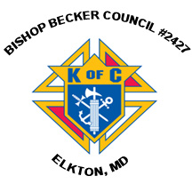**Knights of Columbus**

**Bishop Becker Council 2427**

**443-616-5370 or** [**www.kofc2427.org**](http://www.kofc2427.org)

**Meetings:** 2nd & 4th Tuesdays of the month at the Parish Center

**~~~~~~~~~~~~~~~~~~~~~~~~~~~~~~~~~~~~~**

**Faith & Family Night at the University of Delaware** is just around the corner! On **Feb. 16** at 7:00 pm our Women’s Basketball team will be taking on James Madison University. Tickets are just $4 with the promo code below! If you would like to bring a group out for a night of fun and faith, please contact Brandon Crist at [bcrist@udel.edu](mailto:bcrist@udel.edu) or 302-831-4493 or reserve your seats at [www.bluehens.com/promocode](http://www.bluehens.com/promocode) and enter **promo code: FAITH17.**

**~~~~~~~~~~~~~~~~~~~~~~~~~~~~~~~~~~~~~**

**Mount Aviat’s Annual Cream Puff Day** – **February 9** Delicious, homemade cream puffs —a specialty of the Oblate Sisters — are available for pre-order only until February 2nd. Pricing is $2.75 each or $33/dozen. Pick up is Friday, February 9th at the MAA gym between the hours of 8 a.m.-3 p.m. MAA is located at 399 Childs Road, Childs, MD 21916. Delivery is available for large orders in Elkton and Newark. Order forms are available on the MAA website at [www.MountAviat.org](http://www.MountAviat.org).

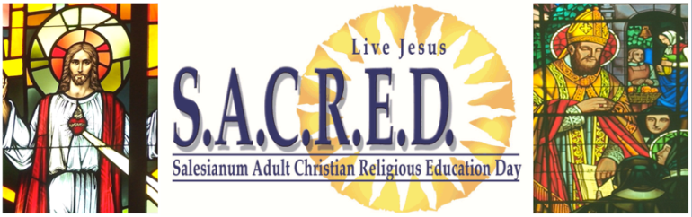

***S.A.C.R.E.D. - Salesianum Adult Christian Religious Education Day:*** This year S.A.C.R.E.D. will be hosted by Salesianum in Wilmington, Delaware on Saturday, **February 24th** from 8am-3pm. Celebrate our Catholic Faith with a day of spiritual renewal. The price includes coffee, light breakfast, a hot lunch and all day beverages with over 15 courses in adult religious education. Reconciliation is offered at 8am, noon, and 3pm. Cost is $45, or $40 if paid by Tuesday, January, 31st online. <http://sacred.salesianum.org>. Don’t miss out on a fun filled and informative way to celebrate our Catholic Faith and to enter the season of Lent as Salesianum offers SACRED for the 18th time. We expect over 200 people, don’t miss your chance!

**~~~~~~~~~~~~~~~~~~~~~~~~~~~~~~~~~~~~~**

**Villa Maria House of Studies (IHM Motherhouse), Immaculata, PA.** Young women (18-35) are invited to join us for this retreat which focuses on the IHM Charism and the importance of listening to God's call and discovering the many ways that God speaks to us. Time will be included Friday, **January 26** (6 PM) to Sunday, **January 28** (1 PM) for personal and communal prayer as well as the opportunity to interact with the sisters in Formation. ([Contact: ihmvoc@aol.com](mailto:Contact:%20ihmvoc@aol.com) or [610-889-1553](tel:610-889-1553))