***From Father Jim***

**“Brothers and sisters: Every priest stands daily at his ministry, offering frequently those same sacrifices that can never take away sins. But this one offered one sacrifice for sins, and took His seat forever at the right hand of God. Where there is forgiveness of these, there is no longer offering for sin.”**

Jesus is our high priest. When we come to mass our priest leads us in prayer, but he acts only in the person of Christ. It is Jesus who offers the sacrifice of Calvary. Sometimes we know the priest quite well. At times a visitor or missionary celebrates the Eucharist for us. How special it is that we have someone to, in the words of St. Peter, ‘to lead us to God.’

Angel 03May we reflect for a moment on the person of the priest. Pray for him, offer him your friendship and support, express your gratitude for his role in leading, teaching, preaching and living the gospel. Encourage others to follow Christ on the service of the community. Remember your priests who have died, asking the Lord to reward them for their ministry. Although a priest is often at our side at moments of sickness and death, it is often said that the priest dies alone. Pray for priests.

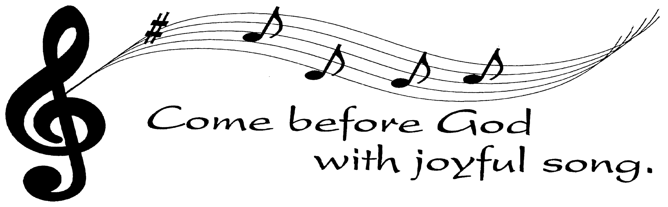**Advent/Christmas Concert!**

**Join us Sunday, December 9th** at 3:00pm at Immaculate Conception Church for a flute, harp, and keyboard concert to celebrate the Advent and Christmas seasons. We look forward to seeing you there!

**Thank you, Thank you, Thank you!**

**Thank you to all of those who volunteered or participated** in our 44th Annual Christmas Bazaar!! The bazaar was a huge success and a ton of fun! Thank you so much for all of your help putting this important parish fundraiser together!! We could not have done it without you!!



**November 19, 2018**

8:30 am All Souls

**November 20, 2018**

8:30 am All Souls

**November 21, 2018**

8:30 am All Souls

**November 22, 2018 The Presentation of the Blessed Virgin Mary**

8:30 am All Souls

**November 23, 2018 Saint Cecilia, Virgin and Martyr**

8:30 am All Souls

**November 24, 2018 Saint Clement I, Pope and Martyr**

8:30 am All Souls

5:00 pm Tony Sniadowski

**November 25, 2018 *Our Lord Jesus Christ, King of the Universe***

7:00 am Patsy Rush

8:30 am Rolando Najera

9:00 am SJ George Benvegno Sr.

10:15 am All Souls

12:00 pm Anthony Mallia



**The Angel Trees are up!!**

The Angel Trees are up and full of pink and blue angels! As you take your angel from the tree, please record the name and number of the angel along with your name and telephone number. Someone from the angel tree committee will be able to help you. The angel you select is either pink for a girl or blue for a boy. Each child has two angels on the tree - one for toys and one for clothing. This ensures that all the little ones will receive something they *need* as well as something they *want!* If you pick a clothing request, no need to purchase a toy, too. He or she will get one! **Please return wrapped presents to the church by December 2nd with the angel securely attached!**

***Congratulations to those who were recently baptized:***

*Wyatt Alexander Wheel*

***We extend our condolences and prayers to the families of those who have recently died:***

*Mrs. Barbara J. Olson*

***Congratulations to the couples recently married in the parish:***

*Robert Lawson and Page Welch*

*Benjamin Contreras & Adriana Guerrero*

**Readings for next week:**

**33rd Sunday in Ordinary Time**

**First Reading: Daniel 7:13-14**

Daniel describes the one who will appear on the clouds of heaven and receive glory. People of every language will serve this one, and his leadership and community will be his forever.

**Second Reading: Revelation 1:5-8**

Jesus is so powerful; he is the ruler of kings. He loved us enough to free us from sin, and so he will be glorified forever. He will appear again and be seen by all the people of the earth. God calls himself the first and last, "the One who is and who was and who is to come," reminding all people that God will remain with us always.

**Gospel: John 18:33b-37**

Pilate asks Jesus if he is a king. Jesus explains that his kingdom is not of this world. Pilate asks again if Jesus is a king. He replies, "I came into the world to testify to the truth. Anyone committed to the truth hears my voice.”

**Adoration for Vocations**

On the 1st Sunday of each month, exposition of the Blessed Sacrament occurs from 1pm-3pm in IC Chapel. Join us to pray for vocations to priesthood and religious life. The next opportunity is **December 2nd.** Contact Dermott Mullan at 410-398-3368.

**The Pastoral Council kicked off the 2018-2019** year with a retreat in August and has been having regular meetings every month. The Parish Pastoral Council is a consultative body to the Pastor. It is the coordinating and unifying structure of the Parish Community. Its function is to develop a deep, personal and communal commitment to and maximal participation in the total life of the parish by its members. Within the next few weeks you will notice pictures of the current Pastoral Council members posted on bulletin boards in both churches. Please feel free to discuss with us any thoughts, ideas, or concerns you may have regarding our parish. God be praised!

**Ecumenical Thanksgiving Festival!**

The Greater Elkton Ministerial Association (GEMA) invites you to take part in the annual Thanksgiving Service TODAY, **November 18th** at 4:00pm at Elkton United Methodist Church. It will feature a choir festival including some of our parish choir members as well as choirs from many other churches around Elkton! This wonderful event is a great way to give thanks to God for all his blessings! Hope to see you there!



**Does your child need to be Baptized?**

The next Baptism Class is **January 7th**, 7:00-8:30 pm in the Parish Center. It’s never too early to prepare for the Baptism of your child. Parents are required and Godparents are encouraged to attend. Contact the Parish Office to register at 410-398-1100.

**Daily Readings:**

***Thirty-Third Sunday in Ordinary Time***

**Sunday**..........................Dn 12:1-3; Heb 10:11-14, 18; Mk 13:24-32

**Monday**.................................................Rv 1:1-4,2:1-5; Lk 18:35-43

**Tuesday**.................................................Rv 3:1-6, 14-22; Lk 19:1-10

**Wednesday.**..................................................Rv 4:1-11; Lk 19:11-28

**Thursday.***.................................*Lk 19:11-28; Rv 5:1-10; Lk 19:41-44

**Friday .**........................................................Rv 10:8-11; Lk 19:45-48

**Saturday**.....................................................Rv 11:4-12; Lk 20:27-40

**Liturgical Ministers for Next Week: *November 24th and 25th***

***5:00 pm***

**Altar Servers:** Grace B, Donovan O •**EM’s:** Mary Anne S, John N, Cheryl N • **Lector:** Mary Ann E • **Ushers:** Eileen P, Pat C, Bill B

***7:00 am***

**Altar Servers:** Ryan M, Sean M •**EM’s:** Frank S, Sandra H, Gerald M

• **Lector:** James S • **Ushers:** Charles M, William C

***8:30 am***

**Altar Servers:** Jeremy M • **EMs:** Don H, Peter G, Cecilia G

•**Lector:** Mary K •**Ushers:** Anthony D Wendel S Anthony M, Steve C

***9:00 am (SJ)***

**Altar Servers:** Mitchell H, Alex L • **EM’s:** Chris H, Larry B, Narcy Z, Dotty F, Les F• **Lector:** Louis N •**Ushers:** Kevin O, Bill D, Jule V, Jake S

***10:15 am***

**Altar Servers:** Elizabeth R, Mason H • **EM’s:** Gwen D, James D, Rita M, Ben F, Helen B• **Lector:** Nora W •**Ushers:** Bob W, Steve A

***12:00 noon***

**Altar Servers:** Benedict J • **EMs:** Kathy C, Corazon S, David L

• **Lector:** Frank E • **Ushers:** Teresa G, Charles C

**Children’s Liturgy of the Word**

Children’s Liturgy is for children ages 5-8 ONLY. Children   
who are not in this category are asked to remain in church.

**There is NO Children’s Liturgy next week, Nov. 25th. Happy Thanksgiving!**

**Inspirational Quote of the Week:**

“In meditation we find the strength to bring Christ to birth in ourselves and in others.” -- Saint Charles Borromeo

**Immaculate Conception**

**School News**

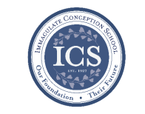**Walk-In Wednesdays** areevery Wednesday from 9:00am–11am. Spread the news! Tours are offered to those who wish to see the school in action!

The next **Story Time** is on Wednesday, **December 5th** at 10am in the PreK Room. Visit our Facebook page (<https://www.facebook.com/icschoolmd>) and mark “Going” if you plan on attending. Space is limited, but all are welcome!

**STEM Middle School Panel** The Middle school had the opportunity to talk to a few STEM professionals last Friday. These professionals came to the school cafeteria and fielded questions about their jobs, their education, how they employ their science skills, and how they ended up in their respective positions. This program helped the students envision how the lessons they are learning today could pave the way toward future careers in the sciences!

**5th Grade Service Project:** During November, the 5th-grade class had their annual service project. They collected donations for the Cecil County Animal Shelter and winter coats for the clients of our Outreach.

**Coming up…**

**Mon Nov 19:** 11:00am, the 5th grade will deliver their winter-coat collection to Dottie at Outreach. Please join us for this very meaningful event!

**Tues Nov 20:** 10:00am, Kindergarten and 1st grade classes will lead a Thanksgiving Prayer Service in the school gym. Please join us as they don their pilgrim bonnets. This is always an adorable occasion!

**Tues Nov 29**: Immaculate Conception School’s Board of Specified Jurisdiction will have its second meeting at 6pm.

**ICS Basketball Registration:**

We are still looking for 5th and 6th grade girls for the JV Basketball team!! All other teams are FULL!! Thank you to everyone for their support of CYM Athletics! Athlete registration is available on our school website, [www.icschoolweb.org](http://www.icschoolweb.org) under the community tab. Please contact Michelle Riddle at [icshawkssports@gmail.com](mailto:icshawkssports@gmail.com) for more information or with any questions.

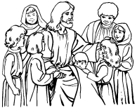**Faith Formation**

**Religious Education & Sacraments**

**Religion Classes:**  There will be **no classes on Wednesday, November 21st and Sunday, November, 25th** Happy Thanksgiving!

All classes are reminded to **bring in stocking items for the troops.** We will be collecting items until Wednesday, November 28th.

**First Reconciliation** – Tour of the Reconciliation Room on Sunday, December 18th at 9:30 am.

**Outreach Donations**: Thank you to all who filled a grocery bag for this important ministry.

**Youth Ministry & Confirmation**

#### whats-your-story

**Thank you to members of the Confirmation class** **and Youth Group** who participated in our parish Christmas Bazaar. You made a difference!!

**CONFIRMATION**

Next class is **Sunday, November 18th** at 8:30am & 6:30pm in the Parish Center. **No class on Wednesday**, November 21st.

**YOUTH GROUP:**

There will be a meeting on Sunday, November 18th at 6:00 pm in the Youth Room.

**YOUTH MINISTRY WISH LIST:** Bottled water and sodas

**YOUNG ADULTS**

Contact Maddie at [memreese1010@gmail.com](mailto:memreese1010@gmail.com) for updates.

**ADULT EDUCATION**

**Interested in a study group?** Many opportunities are available. Call the Office at 410-392-3551.

**Symbolon –The Catholic Faith Explained–Part 2**

The next class is Monday Evening – Nov. 19th and will repeat on Tuesday Morning–Nov. 20th.

**RESOURCES FOR THE SEASON:**

-Go to the Parish Website at [iccparish.weconnect.com](http://www.iccparish.weconnect.com) and look under ‘Resources’ to find Prayer, Scripture, etc. .

**SOCIAL CONCERNS**

**Outreach**

Please consider donating non-perishable foods to the Outreach! Thank you so much for your help, generosity, prayers, & donations to this essential ministry!!

 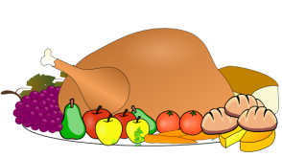

**We are collecting Thanksgiving food! Please consider donating Thanksgiving fixin’s including turkeys, green beans, corn, etc. Thank you!**

**PARISH & FAMILY LIFE**

**Parish Coffee**

Join us for Parish Coffee **December 2nd** after 9:00 am Mass at St. Jude’s.

Join us for Parish Coffee **December 9th** after 10:15am Mass at ICC!

**PARISH EVENTS/INFORMATION**



*Thank you so much for your continued*

*generosity and support to your parish!*

**Weekly Church Collections: Week of Nov. 11th**

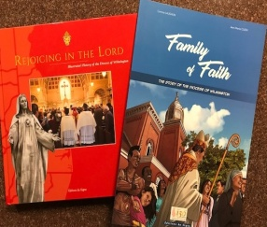 ICC $9,817.00

St. Jude--------------------- $1,376.00

Online $3,059.00

Total Offertory $14,252.00

***We offer electronic giving!***

**How does Online giving benefit you?**

1. It’s easy, convenient, and safe
2. Allows you to give any amount, any time.
3. Allows you to track your giving

**How does Online giving benefit the parish?**

1. Creates consistency of giving to help with financial planning
2. Increases the efficiency of processing giving

**How to sign up?**

1. Visit iccparish.weconnect.com
2. Click “Go to Online Giving”
3. Sign up! It’s that easy!

**PARISH EVENTS/INFORMATION**

**Deck the halls!! Fresh Christmas Wreaths** **for sale!!** Only $20! These gorgeous 22” balsam wreathes are decorated with pine cones and beautiful hand-made bows!! They are great for the home, office, gravestone, or as a gift! Purchase them after all masses on December 1st/2nd and December 8th/9th at both churches or you can call the Parish Office at 410-398-1100 to pre-order yours!

**St. Jude’s 50th Anniversary planning:**

Anyone interested in helping to plan for St. Jude's 50th Anniversary (first mass was in June 1969, dedicated on October 26, 1969) is asked to please share any memories and ways to communicate our history as we look forward to the future. We will need photos and memorabilia to put into a video presentation, technically skilled people to create this, ways to invite back many who have moved away, ways to involve our local community in this anniversary mass and celebration, etc. Please contact Cheryl Nickle at 410-392-3551 or [youthministry@iccparish.org](mailto:youthministry@iccparish.org) with ideas or for more information.

**limited supply!! Makes for the perfect Christmas Gift!!**

We have **a limited supply** of two history books, “Rejoicing in the Lord,” and “Family of Faith” published by the Diocese to commemorate the 150th anniversary of the Catholic Diocese of Wilmington. “Rejoicing in the Lord” is a hard-cover, full-color coffee table book that features histories and never-before-seen photographs of all Catholic churches in Delaware and Maryland’s Eastern Shore, plus biographies of all nine Wilmington bishops, with important ministries and events highlights. “Family of Faith” is a 35-page, color diocesan history done in the comic book or graphic novel style.

**“Rejoicing in the Lord” is available for $30 each, and “Family of Faith” is sold for $12.** To purchase one or both books, please contact or visit the parish office Make sure to **purchase yours today!!**



**Sunday, November 18 Christmas Bazaar!**

8:20 AM - Confessions - SJ

8:30 AM - Religious Ed

8:30 AM - Confirmation Class - PC

9:30 AM - Tour of Reconciliation Room - IC

10:30 AM - Baptism - SJ

11:00 AM - Baptism - CH

6:00 PM - HS Gathering - PC

Monday, November 19

9:00 AM - Novena - CH

6:30 PM - Adult Ed Symbolon - PC

6:30 PM - Cub Scout Committee Mtg - PC

8:00 PM - AA Mtg - Caf

Tuesday, November 20 - ICS ½ Day, No Aftercare!

9:00 AM - Holy Hour – CH

9:15 AM - Adult Ed Symbolon - PC

9:15 AM - Adult Ed book club - PC

5:30 PM - Pre JV Basketball - gym

6:30 PM - Varsity Boys Basketball - gym

7:00 PM - Boy Scout Patrol Leader Mtg - PC

7:30 PM - Contemp Rehearsal - IC

Wednesday, November 21 - ICS No School!

9:00 AM - Rosary Crusade/SJ Novena-CH

9:30 AM - Cantor Rehearsal - IC

6:30 PM - JV Boys Basketball - gym

Thursday, November 22 - ICS and Parish Office Closed!

9:00 AM - Rosary Crusade - CH

6:30 PM - Cantor Rehearsal - IC

7:00 PM - Parish Choir Rehearsal - IC

Friday, November 23 - ICS and Parish Office Closed!

9:00 AM - Rosary Crusade - CH

7:00 PM - NA – Caf

**Saturday, November 24**

9:00 AM - Rosary Crusade - CH

4:15 PM - Confessions - IC

7:00 PM - NA – Caf

**COMMUNITY EVENTS/INFORMATION**

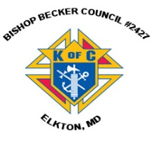**Knights of Columbus**

***Bishop Becker Council 2427***

**443-616-5370** or [**www.kofc2427.org**](http://www.kofc2427.org)

**Meetings:** 2nd & 4th Tuesdays of the month at 7:00 pm at the Parish Center

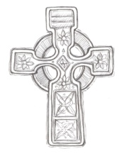**LAOH (The Ladies Ancient Order of Hibernians)**

The Ladies Ancient Order of Hibernians, Inc. Cecil County Division 1, an Irish Catholic Action group has meetings on = the first Wednesdays of the month at 1:00pm in the ICC Parish Center. Meetings run September through May. We are always looking for new members! If you are an Irish Catholic woman and want to serve your community, and learn more about your Irish heritage come join us! Contact Janice White, President at 410-378-3493

**Boy Scout Religious Awards**

Any scout who is interested in earning their Catholic religious award should contact the Diocese of Wilmington’s Catholic Committee on Scouting. Our committee can help get the process started and will supply the award, once earned. Each year the Bishop will present the awards to the scouts of our Diocese at our annual Scout Mass. For further information please contact either Bob Murray, Committee Chair at (302) 993-6290 or Deacon Tommy Watts, Boy Scout Chaplain (302) 218-1415.

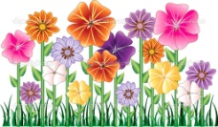**Gardeners wanted!!**

If you would like to lend a hand (attached to a shovel,) working in the Immaculate Conception Church Prayer garden, we would gladly accept your help!! No experience necessary!! Call Gardener Val for more information at 443-907-5822.

**Video tours of historic churches available!**

The Diocese of Wilmington has released a new video tour of the original St. Mary Star of the Sea Church, now called the Tubman Chapel. The video is the 5th in a series featuring historic churches of the Diocese and is available free to the public on the Diocesan YouTube channel: [www.youtube.com/DioceseofWilm](http://www.youtube.com/DioceseofWilm).

Other churches include St. Francis Xavier Shrine (Old Bohemia), Old St. Joseph’s Mission Church, St. Peter the Apostle, and the Cathedral of St. Peter. The diocese also produced a short video on the life of Maryland native, the Rev. Paul Wattson, SA, (1863-1940) - also known as Father Paul of Graymoor - who may be the first person born in the Diocese, to be a canonized saint. All these videos are available on the YouTube site and on the diocesan 150th anniversary page, [www.cdow.org/150th](http://www.cdow.org/150th).