***From Father Jim***

**“Since we have a great high priest who has passed through the heavens, Jesus, the Son of God, let us hold fast to our confession. For we do not have a high priest who is unable to sympathize with our weaknesses, for he has similarly been tested in every way, yet without sin. So let us confidently approach the throne of grace to receive mercy and to find grace for timely help.”**

When the Father sent the Son as our redeemer, Jesus assumed every part of our humanity, except sin. For this reason He knows and understands us, with our strengths and weaknesses, our cares and concerns. Because of His identity with us, I am able to seek Him out in my every need.

He knows my deep desire to live as a faithful disciple. He knows that when I fail, He is awaiting me with open arms. Because of His closeness to me, I go to Him without fear, as He gives me the gift of His mercy and grace.

***Congratulations to those who were recently baptized:***

*Enzo Alexander DeJesus*

*Esme Sue DeJesus*

*Brady Christopher Park*

***We extend our condolences and prayers to the families of those who have recently died:***

*Mrs Kathryn Burgess*

**Mark your calendars!**

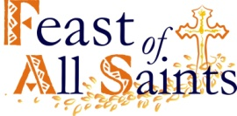The Feast of All Saints is November 1st, and is a Holy Day of Obligation. Our Mass schedule for the feast day will be:

**Wednesday, October 31st:** 7:00pm at St. Jude

**Thursday, November 1st:** 8:30am, 10:00am, 7:00pm at Immaculate Conception

**The All Souls** Evening of Remembrance Mass will be held on **Friday, November 2nd** at 7:00pm at Immaculate Conception



**October 22, 2018 St. John Paul II, Pope**

8:30 am Bernadette Sniadoswki (Living Intention)

**October 23, 2018 St. John of Capistrano, Priest**

8:30 am Lynda Macaluso--Williams

**October 24, 2018 St. Anthony Mary Claret, Bishop**

8:30 am Brandon and Brianna Howe

**October 25, 2018**

8:30 am Jacob Pratt

**October 26, 2018**

8:30 am People of the Parish

**October 27, 2018**

8:30 am Patricia Hitchcock

5:00 pm Arthur R. Jones

**October 28, 2018 *30th Sunday in Ordinary Time***

7:00 am Patrick Noren Hurley

8:30 am George Grumbach Sr.

9:00 am SJ Albert Vaccarini

10:15 am People of the Parish

12:00 pm Anthony Mallia



**limited supply!! Makes for the perfect Christmas Gift!!T**

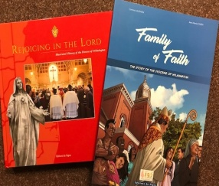We have **a limited supply** of two history books, “Rejoicing in the Lord,” and “Family of Faith” published by the Diocese to commemorate the 150th anniversary of the Catholic Diocese of Wilmington. “Rejoicing in the Lord” is a hard-cover, full-color coffee table book that features histories and never-before-seen photographs of all Catholic churches in Delaware and Maryland’s Eastern Shore, plus biographies of all nine Wilmington bishops, with important ministries and events highlights. “Family of Faith” is a 35-page, color diocesan history done in the comic book or graphic novel style.

**“Rejoicing in the Lord” is available for $30 each, and “Family of Faith” is sold for $12.** To purchase one or both books, please contact or visit the parish office Make sure to **purchase yours today!!**

**Readings for next week:**

**29th Sunday in Ordinary Time**

**First Reading: Jeremiah 31:7-9**

Jeremiah speaks of God reuniting the people of Israel after their exile. He states that although they departed in tears, God will lead them back and protect them, because he is father to Israel.

**Second Reading: Hebrews 5:1-6**

Each high priest is taken from among people and offers sacrifices for their sins. High priests do not choose to take on this honor, but are chosen by God. Even Christ did not choose this office, but was chosen by God to be a priest forever.

**Gospel: Mark 10:46-52**

A blind beggar approached Jesus and pleaded that Jesus heal him. Jesus called the man over and said, “Your faith has healed you.” The man immediately received his sight and proceeded to follow Jesus up the road.

**THE COMMEMORATION OF THE FAITHFUL DEPARTED [ALL SOULS’ DAY]**

**On Friday, November 2nd** at ICC at 7:00 PM, we commemorate all of our faithful departed family and friends. We observe this day because we believe that the souls which are not perfectly cleansed from venial sins or who have not fully atoned for their past transgressions are waiting in Purgatory. We can help them into Heaven by our prayers, charitable works, and the sacrifice of the Mass. I invite all to attend this solemn day of commemoration.

**Thus, we not only remember our love ones**; we also help them gain Heaven. If we assist them into Heaven, their gratitude will be eternal and they, in turn, will assist us to gain the Beatific Vision. This is truly an exchange of loving gifts to each other.

**On this day there will be remembrance candles** for those who have died since last November 2, 2017. Their names have been written in our Book of Remembrance, which will be placed in the Sanctuary of both churches for the entire month of November.

**We hope that all who have died** have obtained eternal happiness in Heaven. But for those who are in Purgatory preparing to enter Heaven, we must assist them. As a parish community and family, we need each other’s prayers and support.

**In conclusion, here is a prayer** that may be recited for our departed loved ones: "Eternal rest grant unto them, O Lord, and let perpetual light shine upon them. May the souls of the faithful departed, through the mercy of God, rest in peace. Amen."

-- Deacon Mike

**Come join us TODAY** from 1:00-3:00pm in the Immaculate Conception Chapel for a presentation titled, “The Community Jesus Left Behind” led by **Fr. Michael Connolly, OSFS**. He will also be returning to continue this presentation next weekend, **October 28th from 1:00-3:00pm** in the Immaculate Conception Chapel. Hope to see you there!

**The Pastoral Council kicked off the 2018-2019** year with a retreat in late August and have been having our regular meetings every month. The Parish Pastoral Council is a consultative body to the Pastor. It is the coordinating and unifying structure of the Parish Community. Its function is to develop a deep, personal and communal commitment to and maximal participation in the total life of the parish by its members. Within the next few weeks you will notice pictures of the current Pastoral Council members posted on bulletin boards in both churches. Please feel free to discuss with us any thoughts, ideas, or concerns you may have regarding our parish. May God be Praised!

**Daily Readings:**

***Twenty-Ninth Sunday in Ordinary Time***

**Sunday**..........Is 53:10-11; Heb 44:14-16; Mk 10:35-45 or 10:42-45

**Monday**......................................................Eph 2:1-10; Lk 12:13-21

**Tuesday.**...................................................Eph 2:12-22; Lk 12:35-38

**Wednesday**.................................................Eph 3:2-12; Lk 12:39-48

**Thursday***...................................................*Eph 3:14-21; Lk 12:49-53

**Friday ..**.........................................................Eph 4:1-6; Lk 12:54-59

**Saturday** ........................................................Eph 4:7-16; Lk 13:1-9

**Liturgical Ministers for Next Week: *October 27th and 28th***

***5:00 pm***

**Altar Servers:** Nathan S, Grace B •**EM’s:** Diana B, Mary Anne S

• **Lector:** Mary Ann E • **Ushers:** Eileen P, Bill B, Pat C

***7:00 am***

**Altar Servers: *Unfilled\*** •**EM’s:** Frank S, Sandra H • **Lector:** Bill K

• **Ushers:** Charles M, William C

***8:30 am***

**Altar Servers:** Jeremy M • **EMs:** Don H, Cecilia G, Peter G

•**Lector:** Louis N • **Ushers:** Anthony D, Wendel S, Anthony M, Steve C

***9:00 am (SJ)***

**Altar Servers:** Mitchell H, Alex L • **EM’s:** Chris H, Diane C, Pat D, Carol V, Bill C • **Lector:** Michele C •**Ushers:** Kevin O, Jule V, Bill D, Jake S

***10:15 am***

**Altar Servers:** Aila S, Hendric S • **EM’s:** Rita M, Gwen D, James D, Richard B, Elizabeth B • **Lector:** Ben F • **Ushers:** Bob W, Steve A

***12:00 noon***

**Altar Servers:** Valerie O, Gabriel O • **EMs:** Kathy C, Cynthia J, Grace B • **Lector:** Brigid W • **Ushers:** Teresa G, Charles C

**Children’s Liturgy of the Word**

Children’s Liturgy is for children ages 5-8 ONLY. Children   
who are not in this category are asked to remain in church.

**The Catechist for next week: October 28th is:**

Justine Quirk

**Immaculate Conception**

**School News**

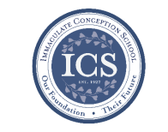**During the month of October** Kindergarten & PreK students are asked to bring in items for the **Food Pantry**.

Immaculate Conception School continues **Walk-In Wednesdays** every Wednesday from 9 am -

11am. Spread the news! Tours are offered to those who wish to see the school in action.

We had a beautiful **Respect Life Prayer Service** on Thursday, October 18th at Immaculate Conception Church.

**7th grade Special Persons Lunch** was on Thursday. We enjoyed seeing the students’ friends and families.

**Challenge Island** STEAM program continues after school.

**Friday, Oct 19 was Pink Day!** Student Council had a **Bake Sale** at lunch to raise money for the Union Hospital Breast Cancer Center and students and staff were invited to help raise awareness about breast cancer by wearing pink!

The next **Story Time** is on Wednesday, **November 3rd at 10:00 am** in the PreK-3 Room. Please go to our Facebook page: https://www.facebook.com/icschoolmd and mark “Going” if you plan on attending. Space is limited, but all are welcome!

**Faith Formation**

**Religious Education & Sacraments**

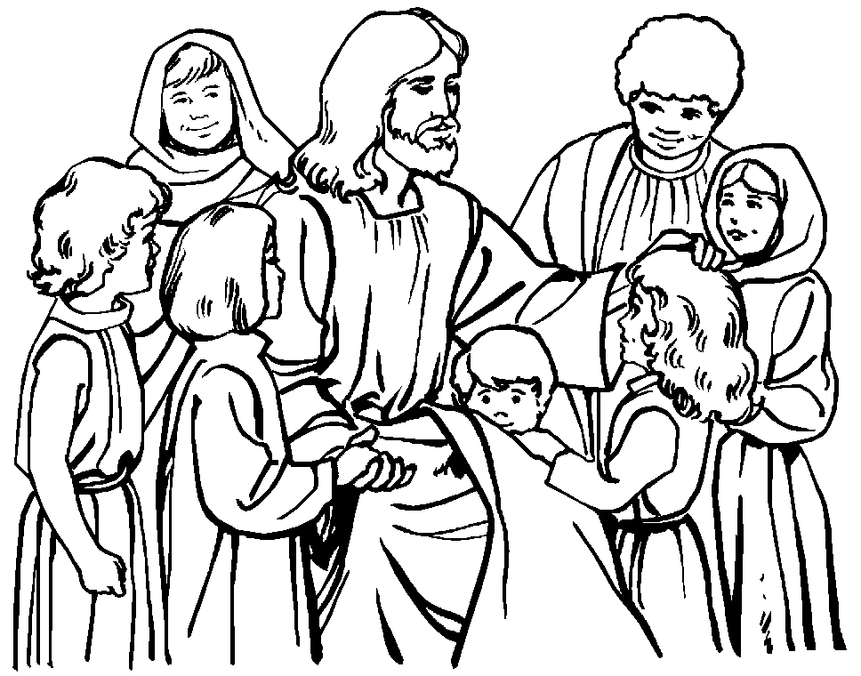

**Religion Classes** have started if you have not registered please contact the office asap.

**Bible Class 4th grade** - parent and child session will be held on **Wednesday, Oct. 24th** and **Sunday, Oct. 28th** during religion class. All parents of 4th grade students are welcome to attend.

**First Reconciliation** – Parent/Child meeting is on Sunday, Oct. 28th at 4:00pm in the church.

**Outreach Donations**: Your child will bring home a grocery paper bag to fill for Outreach for the Holiday season on Wednesday, October 24th and Sunday, October 28. Please fill and return to the church or parish center by Friday, November 9th.

**Halloween** – Reminder there are no religion classes on Wednesday, October 31st.

**Youth Ministry & Confirmation**

#### whats-your-story

**CONFIRMATION**

Classes start on Sunday, October 21st at 8:30 am or 6:30 pm, or Wednesday, October 23rd at 6:15 pm.

**YOUTH GROUP:**

There will be a meeting on Sunday, 21st at 6:00 pm.

**YOUTH MINISTRY WISH LIST:**

Bottled water and sodas

**YOUNG ADULTS**

Contact Maddie at [mem.reese1010@gmail.com](mailto:mem.reese1010@gmail.com) for updates.

**ADULT EDUCATION**

**Interested in a study group?** Many opportunities are available. Call the Parish Office at 410-392-3551.

**Symbolon –The Catholic Faith Explained–Part 2**

The next class is Monday Evening – October 22nd and will repeat on Tuesday Morning – October 23rd

**St. Jude’s 50th Anniversary planning meeting:**

Anyone interested in planning for St. Jude's 50th Anniversary (first mass was in June 1969, dedicated on October 26, 1969) is invited to attend a meeting at St. Jude’s on Tuesday, October 30th at 7:00pm. Please come with memories to share and ideas to communicate our history as we look forward to the future. We will need photos and memorabilia to put into a video presentation, technically skilled people to create this, ways to invite back many who have moved away, ways to involve our local community in this anniversary mass and celebration, etc. Please contact Cheryl Nickle at 410-392-3551 or [youthministry@iccparish.org](mailto:youthministry@iccparish.org) with ideas or for more information.

**SOCIAL CONCERNS**

**Outreach**

Please consider donating non-perishable foods to the Outreach! Thank you so much for your help, generosity, prayers, & donations to this essential ministry!!



**Outreach is** **in need** of all types of canned fruits and vegetables, spaghetti, & spaghetti sauce! Thank you!!

**PARISH & FAMILY LIFE**

**Parish Coffee**

Join us for Parish Coffee**,** **November 4th** after 9:00 am Mass at St. Jude’s.

**There will not** be any Parish Coffee during October at ICC due to scheduling conflicts.

**PARISH EVENTS/INFORMATION**





*Thank you so much for your continued*

*generosity and support to your parish!*

**Weekly Church Collections: Week of Oct. 14th**

ICC $9,895.00

St. Jude--------------------- $1,335.00

Online $4,550.00

Total Offertory $15,779.00

***We offer electronic giving!***

**How does Online giving benefit you?**

1. It’s easy, convenient, and safe
2. Allows you to give any amount, any time.
3. Allows you to track your giving

**How does Online giving benefit the parish?**

1. Creates consistency of giving to help with financial planning
2. Increases the efficiency of processing giving

**How to sign up?**

1. Visit iccparish.weconnect.com
2. Click “Go to Online Giving”
3. Sign up! It’s that easy!

**PARISH EVENTS/INFORMATION**

**Christmas Bazaar Needs:**

**The Christmas Bazaar is just 3 weeks away!!** Prizes being raffled at the bazaar include a Thousand Dollars in Cash, Philadelphia Eagles Game Tickets, a handmade hope chest, and many wonderful Theme Baskets. Raffle tickets will be on sale after all masses next weekend. We are also in need of people to help at the parish booths at the Christmas bazaar. **The Christmas Bazaar, scheduled for November 10th & 11th!** Donations of books and CD's for the Book Nook can be dropped off at the Parish Center during business hours. No VHS tapes, please! Our Sign-Up Genius is online and ready for you to sign up to help. **Go to: bit.ly/ICC-SJ-ChristmasBazaar.** Then find the time and location you'd like to volunteer, click the red "Sign Up" block to check that time, and click "Submit and Sign Up" at the bottom of the page. We have started placing yard signs in the community to advertise the Bazaar. If you would like to plant a sign in your yard, please call the Parish Center to make sure one is available and pick it up there. Thank you for helping with the Bazaar. If you have any questions you can contact Lisa Kaminski at 410-392-9558 or Jackie Gedz at 410-392-0396. Please leave a message.

**Fresh Christmas Wreaths!!** Don’t buy your Christmas wreaths anywhere else! Fresh pine wreaths will be sold after all Masses at Immaculate Conception and St. Jude’s on the weekends of December 2 & December 9. All proceeds benefit the Parish. Pre-orders will be taken ONLY at the Christmas Bazaar with pick up on Dec 2nd. Samples will be on display at the Christmas Bazaar. These lovely 24” double sided pine wreaths are adorned with pinecones and a variety of beautiful hand-made bows and cost just $20. They will make a wonderful addition to your home for the holidays or a thoughtful gift for a friend.

**COMMUNITY KITCHEN:** Our next Community Kitchen will be held on **October 26th** at the Elkton Presbyterian Church at noon. We will be serving the ever popular Fried Chicken luncheon for our guests. We are asking for donations of large cans of green beans, ready-to-serve dinner rolls, applesauce, pans of scalloped potatoes, & desserts.

**If you are able to help** with any of these items or want to join us for this enjoyable service opportunity, please call Joyce Speakman at 610-597-3135, or Kathy Chamberlin at 410-398-7299 for more information. Of course, cash donations are always welcome and are always directly used for buying food. If donating by check, please make it out to Immaculate Conception Church, and write “Community Kitchen” in the memo section. **Thank you for all you have done** to make our Community Kitchen so outstanding!

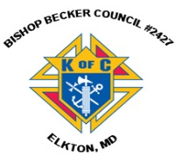

**Sunday, October 21**

8:20 AM - Confessions - SJ

8:30 AM - Religious Education

10:30 AM - Baptisms - SJ

6:00 PM - HS Gathering - PC

6:30 PM - Confirmation Class - PC

Monday, October 22

9:00 AM - Novena - CH

6:00 PM - Volleyball - gym

6:30 PM - Adult Ed Symbolon - PC

7:00 PM - Troop Committee Mtg - PC

8:00 PM - AA Mtg - Caf

Tuesday, October 23

9:00 AM - Holy Hour – CH

9:15 AM - Adult Ed Symbolon - PC

9:15 AM - Adult Ed book club - PC

6:00 PM - Volleyball - gym

7:00 PM - Knights of Columbus Mtg - PC

7:30 PM - Contemp Rehearsal - IC

Wednesday, October 24

9:00 AM - Rosary Crusade/SJ Novena-CH

9:30 AM - Cantor Rehearsal - IC

1:00 PM - Leisure Club - PC

6:15 PM - Religious Ed Classes

Thursday, October 25

9:00 AM - Rosary Crusade - CH

6:00 PM - Volleyball - gym

6:30 PM - Boy Scout Meeting - PC

6:30 PM - Cub Scout Meeting - caf

6:30 PM - Cantor Rehearsal - IC

7:00 PM - Parish Choir Rehearsal - IC

Friday, October 26

9:00 AM - Rosary Crusade - CH

7:00 PM - NA – Caf

**Saturday, October 27**

9:00 AM - Rosary Crusade - CH

4:15 PM - Confessions - IC

7:00 PM - NA – Caf

**COMMUNITY EVENTS/INFORMATION**

**Knights of Columbus**

***Bishop Becker Council 2427***

**443-616-5370** or [**www.kofc2427.org**](http://www.kofc2427.org)

**Meetings:** 2nd & 4th Tuesdays of the month at 7:00 pm at the Parish Center

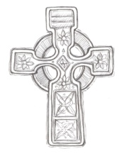**LAOH (The Ladies Ancient Order of Hibernians)**

The Ladies Ancient Order of Hibernians, Inc. Cecil County Division 1, an Irish Catholic Action group has meetings on = the first Wednesdays of the month at 1:00pm in the ICC Parish Center. Meetings run September through May. We are always looking for new members! If you are an Irish Catholic woman and want to serve your community, and learn more about your Irish heritage come join us! Contact Janice White, President at 410-378-3493

**Cathedral of St. Peter Organ Recital**

**Sunday, October 21st** at 3:00 p.m., the Cathedral of St. Peter will celebrate the 100th Anniversary of the 1918 Austin Opus 807 pipe organ with a special organ recital. The recital will feature six organists and other instrumentalists to mark the occasion with many classical organ works and congregational hymns. A special arrangement of the hymn, “All Creatures of Our God and King” has been composed by Dr. David Herman for the recital. The organ was built in 1918 and has been renovated by Michael Davidson, the Director of Liturgical Music over 23 years. The recital is free and open to the public.

**Crouch Funeral Home’s 10TH Annual Stockings for Soldiers:** Crouch Funeral Home will be **sending stockings to our military & veterans at military bases, National Guard bases, VA Hospitals, and reserve posts across America. They will be collecting items such as:** candy, hand sanitizer, baby wipes, toothpaste/toothbrushes, moisturizer, first-aid supplies, shampoo/conditioner, eye drops, protein bars, batteries, lip balm, crossword puzzles, hot chocolate, etc. They also collect cell phones on a year-round basis. **Place items and Christmas Cards in Stocking**. Close the stocking securely so the items inside do not fall out. **Filled stockings must be returned no later than Monday, December 3rd to ensure they reach our troops and veterans in time for Christmas! Please return to Crouch Funeral Home:** 127 South Main Street, North East, MD. Contact them at 410-287-6166 or [crouchfh@gmail.com](mailto:crouchfh@gmail.com) for more information.

**Inspirational Quote of the Week:**

“Let nothing disturb you. Let nothing frighten you. All things are passing. God alone does not change. Patience achieves everything. Whoever has God lacks nothing. God alone suffices.” -- Saint Teresa of Avila