***From Father Jim***

**I am not a big fan of “high wire acts.” Even as a kid, when I went to the circus, I could not enjoy them.** I have the greatest admiration for the performer. It takes incredible skill and precision to make the crossing from one side of the ‘big top’ to the other. However, I could not hold the tension inside of me and keep focused. I was in awe of the feat, but had to look away. It was more tension than I could stand!

Today’s Gospel story of “a woman caught in adultery” kicks up the same reaction. The tension between misery and mercy is found right at the center of genuine Gospel living. It is a story of incredible skill and precision. Jesus holds within Himself the tension between good and evil; light and darkness; between joy and despair. Jesus is not up in the air for this “high wire act,” but right here on the ground with the woman, the elders, his disciples, and the lookers and passersby. What a work of mercy!

This story has way more at work in it than often considered. Our focus goes to the woman and her grave sins. Yet, she is far from the only sinner in the story. Jesus has in his view everyone who has gathered. His eyes are on her, but also the crowd who brought her, and all of the members on the ground with them. His eyes are on not only the woman’s sin, but also those of the crowd who brought her, who were literally using her to get at Him. This confrontation had all the makings of an unbelievably hostile and violent event. Talk about a risk taker!

It is awesome that no one walked away from this event with condemnation. She, we know, walked away with mercy and forgiveness. The rest just walked away. They left possibly even worse than they arrived. They left with their unclaimed misery and now even more frustration! How different an ending could be for anyone, everyone, who can recognize their need for forgiveness and healing. How different a beginning for anyone who can recognize that Yes, God’s mercy, forgiveness, and healing is right here on the ground and in our midst. Some “high wire acts” are worth taking!

**“Dare to Walk with Jesus” - presentation by parishioner/author, Michele Chynoweth**

We can all say that we want to walk with Jesus, but often we let our egos, fears, and resentments get in the way. We need to take action to cast them aside to be free to step outside of our comfort zones and really make the journey. Award-winning author and speaker, Michele Chynoweth will share with us her personal story of how she overcame her fears and failures to walk in faith. Join us Sunday, **April 7, 1:15** in the Parish Center for an intimate, interactive workshop.

**Adoration for Vocations**

On the 1st Sunday of the month, exposition of the Blessed Sacrament occurs from 1pm-3pm in IC Chapel. Join us to pray for vocations. The next opportunity is **April 7th.** Contact Dermott Mullan at 410-398-3368.



**April 8, 2019**

8:30 am Gary and Betty Lilly

**April 9, 2019**

8:30am Ritchie Staats

**April 10, 2019**

8:30 am Stephen Sol

**April 11, 2019**

8:30 am Gary and Betty Lilly

**April 12, 2019**

8:30 am Gemma Davis

**April 13, 2019**

8:30 am Gary and Betty Lilly

5:00 pm Teri Lynn Schall

**April 14, 2019 Palm Sunday of the Passion of the Lord**

7:00 am Gemma Davis

8:30 am Mimo Calvarese

9:00 am SJ Paul Biedrzycki

10:15 am Genevieve Coiner (Living Intention)

12:00 pm Charles, Susanna, and Jordan Cole

**2019 Annual Catholic Appeal –*“*As I have done for you, you should also do*”***

Turn away from sin and be faithful to the Gospel. During this time of Lent we make every effort to distance ourselves from sin and more aggressively live out the Gospel in our daily lives.

As recipients of God’s love and compassion, we make our way through life expressing our gratitude for Christ’s enduring presence and forgiveness. As Disciples of Christ, we demonstrate our gratitude through acts of love, compassion, and kindness to others. One way we do this, is through our support of the Annual Catholic Appeal.

The theme of the 2019 Annual Catholic Appeal is, *“As I have done for you, you should also do.”* Those words recall the act of service Jesus performed for His Discipleds on the night before He died. He took the role of the servant and washed their feet, and then asked them to follow His example by doing the same for others. Jesus wanted the Disciples to understand the importance of humble service and that to glorify God means to respond to the needs of others.

You can learn more about the 37 ministries supported by the Annual Catholic Appeal by picking up a copy of the campaign information handout located **by the entrances of the church** or by visiting the diocesan website at [www.cdow.org/annualcatholicappeal](http://www.cdow.org/annualcatholicappeal).

**Readings for next week:**

**Palm Sunday of the Passion of the Lord**

**First Reading: Isaiah 50:4-7**

Isaiah describes an individual who had been taught by God to reach out to others. He also describes this individual's willingness to be beaten and spit upon, secure that with God's help, he will not be disgraced.

**Second Reading: Philippians 2:6-11**

Paul discusses how Jesus did not declare equality with God, but took on human form. He humbled himself enough to accept dying on the cross. God in turn exalted him and wants us to respect Jesus' name and worship him.

**Gospel: Luke 22:14—23:56**

Luke gives a detailed account of Jesus' last supper with the apostles, where Jesus tells them he will soon suffer in fulfillment of God's will. Jesus prayed that he might be spared if it suited God's will. After Judas betrayed Jesus, he was arrested. Although Pilate did not think Jesus was guilty, he gave in to the people, and sentenced Jesus to death on a cross. Jesus was crucified and his body laid in a tomb.

**Daily Readings:**

***5th Sunday of Lent***

**Sunday**................................Is 43:16-21; Phil 3:8-14; Jn 8:-1-11

**Monday**....................................Dn 13:1-9, 15-17, 19-30, 33-62

or 13:41c-62; Jn 8:12-20

**Tuesday**..................................................Nm 21:4-9; Jn 8:21-30

**Wednesday**..........................Dn 3:14-20, 91-92, 95; Jn 8:31-42

**Thursday.***................................................*Gn 17:3-9; Jn 8:51-59

**Friday**................................................Jer 20:10-13; Jn 10:31-42

**Saturday.**............................................Ez 37:21-28; Jn 11:45-56

**Holy Week Schedule:**

* **Palm Sunday, April 14**
  + Regular Sunday Mass Schedule
* **Holy Thursday, April 18**
  + 8:30AM Morning Prayer - IC Chapel
  + 7:00PM Evening Mass of the Lord’s Supper - SJ

Adoration of the Blessed Sacrament follows until 9:30pm.

* **Good Friday, April 19**
  + 8:30AM Morning Prayer - IC Chapel
  + 7:00PM Celebration of the Passion of the Lord - SJ
* **Holy Saturday, April 20**
  + 8:30AM Morning Prayer - IC Chapel
  + 11:00AM Blessing of Food - IC Chapel
  + 12:00PM Ecumenical Service of the Passion - Elkton Presbyterian Church
  + 8:00PM Easter Vigil - ICC
* **Easter Sunday, April 21**
  + ICC - 7:00am, 8:30am, 10:15am, 12:00pm
  + Saint Jude Church - 9:00am

**Parish Cemetery Regulations Seasonal Reminder**:

Mowing Season is from April 1st - Nov 30th. No decorations of any type are permitted on graves during mowing season. This includes solar lights, shepherd hooks, figures, etc. Thank you for your cooperation!

**Focus for Lent 2019**

**By “Walking with Jesus”,** we are gradually surrounding ourselves with footprints of Corporal Works of Mercy and the Beatitudes. Many parish groups have filled in footprints that are on the windows. Trace your foot, add names of loved ones, and give it to an usher before Mass. We will make copies so it is in both churches. Bring in a stone representing your efforts to walk with Jesus. Help pave the path to the altar. Lastly, read the parishioner articles highlighted each week. Check out our parish website or the bulletin boards to read them in their entirety.

**Pro Life Movement -** Bette Green

When the Supreme Court handed down the Roe v. Wade decision in 1963, I knew that killing babies before birth was now legal. My son was one year old and I had seen all the pictures of the baby’s development in uterus. I felt that there had to be a remedy for this law. As years went by, things got worse. I decided to interview the local health department. The head nurse told me that they only referred for abortions. I was shocked. I knew of a group from Canada called “Birthright”. They promoted helping young families have their babies. Mimi Szepp and I went to our Parish Council asking for space to set up an office for “Birthright”. We were given a room at St. Jude’s (the now storage room across from the bathroom). A telephone answering system was set up and scheduled times were arranged for women to be present to answer the phone. We got pregnancy tests and Mimi organized a “baby shower” to collect baby items to give out to the women. (Today our local LAOH, Ladies Ancient Order of Hibernians Cecil County Division 1, holds a baby shower each May carrying on this early tradition). Baby items began to flow in from the parish responding to bulletin requests. Then we were offered a house at 273 West Main Street in Elkton. To read the rest of Bette’s article please go to our parish website or check our church bulletin boards.

**PALM SUNDAY, APRIL 14TH:**

Next weekend, April 13/14, we will celebrate Palm Sunday of the Passion of the Lord, which marks the beginning of Holy Week. On this feast day, we commemorate Christ's entrance into Jerusalem to accomplish the Paschal Mystery of His death and resurrection. At the 9:00am Mass at St Jude and the 12:00pm Mass at IC, we will commemorate this great event with a procession. At the beginning of Mass, the Gospel passage about Christ's entry into Jerusalem will be read, palm branches will be blessed and carried, and we will process into the church singing "Hosanna! Blessed is He who comes in the name of the Lord." Please make sure to allow extra time to pick up a palm branch and participate in this wonderful ritual! At all other Masses next weekend, we will follow the Solemn Entrance for Palm Sunday, which includes the reading of the Gospel and the blessing of palms, but omits the procession.

**Children’s Liturgy of the Word**

Children’s Liturgy is for children ages 5-8 ONLY. Children

who are not in this category are asked to stay in church.

**The catechist for Next week, April 14th is:**

Grace Amoretti

**Immaculate Conception**

**School News**

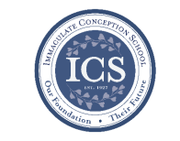

**Walk-In Wednesdays:**

Walk -In Wednesdays areevery Wednesday from 9:00am–11am. Tours are offered to those who wish to see the school in action!

**Have you come to Story Time yet??** Join us Wednesdays at 10:00am to listen to Gwen Davis ready classic stories. Mrs. Davis provides activities to compliment the story. It is a morning full of crafts, music, and sometimes even snacks! **The next Story Time** is Wednesday, **April 10th** at 10:00am in the PreK Room. Visit [www.facebook.com/icschoolmd](http://www.facebook.com/icschoolmd) and mark “Going” if you plan on attending. Space is limited, but all are welcome!

**In the spirit of Giving:** Grades 1 & 2 are doing a great job with Outreach donations!

**Last Week...**

**Congratulations, Kadyn!** Kadyn won the Zaner-Bloser Handwriting Competition for all of Maryland! She beat out 280k participants!! Now it’s off to Nationals! Good luck, Kadyn!

**We inducted our National Junior Honor Society Members!** We are very proud of the NJHS students and all of their many accomplishments!

**ICS did very well in the Catholic Math League!** Our 6th - 8th graders competed against hundreds of students and several of them placed! ICS finished 3rd overall out of 11 schools! Congratulations!

**Our 6th - 8th graders also competed in Science and Math Olympiad** at St. Mark’s High School. 20 students competed and walked away with 23 medals!!

**Coming Up...**

**On Fridays** during lunch, students will be selling Philly Pretzel Factory Pretzels. The sales benefit the theater program at ICS!

**Tuesdays during lunch**, student council will be selling ice cream to benefit Haiti.

**Faith Formation**

**Religious Education & Sacraments**

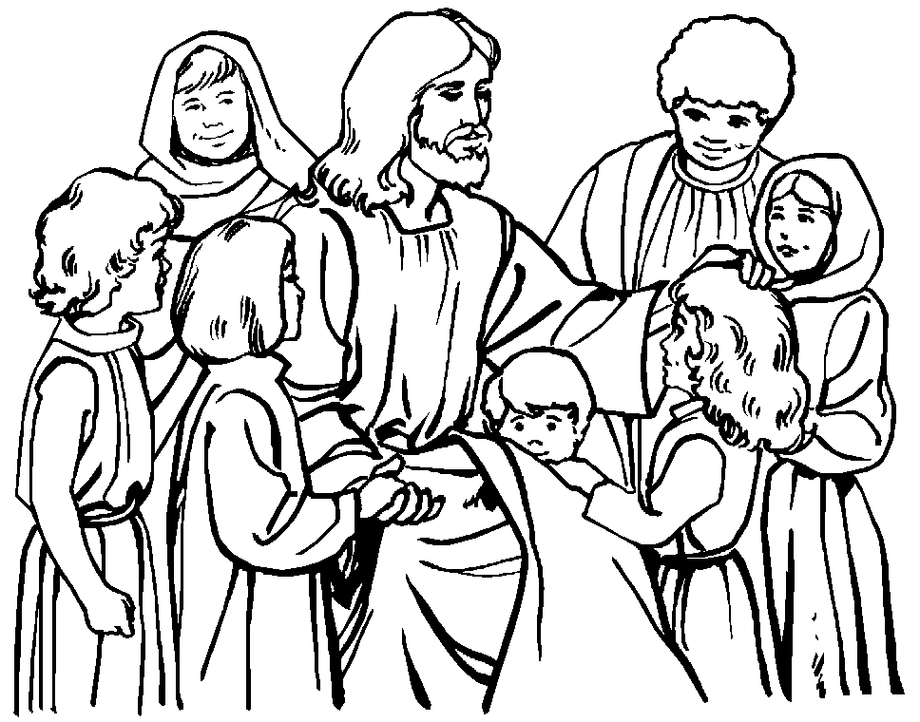**Religion Classes:** We have approximately 38 families who have not re-registered for classes next year. We need your registration to order books and supplies for next year.

**First Communion:** There is a Communion Rehearsal at St. Jude’s on Thursday, April 25th at 6:30 pm for children celebrating Communion at St. Jude’s on Sunday, April 28th at 9:00 am.

**Outreach Donations**: Please remember items for Outreach

**Thank you Sister Grace!!** We are saddened to announce that because of complications in health and recovery, Sister Grace has decided that she will be unable to return to us next year. We are beyond thankful for her years of dedication and service to our Religious Ed program and its students.

**Some have been asking for Sr. Grace’s address:**

Sr. Grace Andrew Jeffery, OSF

Assisi House

600 Red Hill Road

Aston, Pa. 19014

**Youth Ministry & Confirmation**

#### whats-your-story

**CONFIRMATION**

Next class is today, Sunday, April 7th.

Whole group meeting is Saturday, April 13th at 10:00 am for the Seder Meal in the ICS Cafeteria.

**\*** Service Activities/Projects form is now past due.

**\*** Letter to Pastor is now past due.

**YOUTH GROUP**

Youth Group will meet tonight from 6:00 pm to 8:00 pm in the Parish Center. Youth Group will not meet on Palm Sunday, April 14th or Easter Sunday, April 21st.

**YOUTH MINISTRY WISH LIST:** Sodas and paper plates

**ADULT EDUCATION**

**Interested in a study group?** Many opportunities are available. Call the Parish Office at 410-392-3551.

**Follow Me – Meeting Jesus in The Gospel of John**

Will meet on Monday, April 8th at 6:30pm and repeats on Tuesday, April 9th at 9:15am in the parish center. All are welcome.

**SOCIAL CONCERNS**

**Outreach**

Please consider donating to the Outreach! Thank you so much for your help, generosity, prayers, & donations to this essential ministry!!

**Food items needed:** Baked Beans, cereal, soup, and crackers.

**Non-Food items needed:** toothbrushes, deodorant, soap, razors, and paper towels.

**No clothing please!!** As much as we appreciate the gesture, we simply do not have the space to store them. Thank you!

**PARISH & FAMILY LIFE**

**Parish Coffee**

Join us for Parish Coffee,TODAY, **April 7th** after 9:00 am Mass at St. Jude’s.

Join us for Parish Coffee, **April 14th** after 10:15am Mass at ICC!

**PARISH EVENTS/INFORMATION**



**Weekly Church Collections: Week of March 24th**

ICC $9,114

St. Jude $1,462

Online $3,236

Total Offertory $13,811

**Keep up with regular offerings by giving electronically!!**

Just as you rely upon receiving income on a regular basis, we rely on your regular contributions. We greatly appreciate the efforts of our parishioners to make consistent donations throughout the year! To assist you, the church provides a convenient electronic giving option for setting up regular contributions. Simply visit our website and click the Online Giving Button!

**How does Online giving benefit you?**

1. It’s easy, convenient, and safe
2. Allows you to give any amount, any time.
3. Allows you to track your giving

**How does Online giving benefit the parish?**

1. Creates consistency of giving
2. Increases efficiency of processing giving

**How to sign up?**

1. Visit iccparish.weconnect.com
2. Click “Go to Online Giving”
3. Sign up! It’s that easy!

**PARISH EVENTS/INFORMATION**

**5th Annual ICAA Wine and Beer Tasting!**

Save the Date!! Join us Saturday, June 8th from 6:00pm-8:00pm. State Line Liquors will host our wine and beer tasting event. Please come out and support the Immaculate Conception Athletic Association! They will have finger foods, appetizers, and a multitude of wines and beers. Make sure to also participate in the 50/50 drawing! Tickets are $25 per person and can be purchased from Angela Maxwell, Michelle Riddle, or at the Parish Center. Tickets will also be sold at the door. Make sure to join us!

**“How is ‘The Community Left Behind’ Our Catholic Church?” - presentation by Fr. Michael Connolly, OSFS**

How did a handful of followers of Jesus convert an unwilling Roman Empire? The New Testament tells us that some days after Jesus’ crucifixion and resurrection, 11 disciples and a few women and men came to believe that Jesus had risen from the dead. Before three centuries had passed, these 20-or-so lower-class, illiterate Jews from rural Galilee had become a church of some 30,000,000. How did that happen and what does that mean for us? The infant community (28 AD - 110 AD) grew despite persecutions and dissentions. Our 21st century Catholic Church is connected to these primitive roots. **Join us Saturday, April 13, 3:00pm and Sunday, April 14, 1:15pm in Immaculate Conception Chapel** as we explore how our modern Catholic Church is connected to that early Christian community.

**SAVE THE DATE! Our 9th Annual Golf Classic** is going to be held on Monday, **June 10th, 2019 at the Deerfield Country Club!!** Join us for a fun-filled day of golf, great food, and some amazing auction items and golf prizes! **Spaces are limited!!** You can participate by: golfing, sponsoring, contributing auction Items, Volunteering, or joining us for dinner! **Register online** at www.iccparish.org by scrolling through the banner photos. Contact the Parish Office at 410-398-1100 for more information.

**COMMUNITY KITCHEN**

**Our next Community Kitchen** will be held Friday, April 26 at the Elkton Presbyterian Church. We are asking for donations of sandwiches (any kind), fruit, and desserts to be delivered to the Presbyterian Church by 11:00am, or the Parish Center by 10:00am the day of the luncheon. We also need volunteers to help prepare, serve, and clean up afterward. Plan to arrive around 11:00 and be finished around 1:30.

If you would like to join us on this day, please call Joyce Speakman at 610-597-3135, or Kathy Chamberlin at 410-398-7299. Cash donations are always appreciated, and if giving by check, please make it out to Immaculate Conception Church, and write Community Kitchen in the Memo section. Thank you for your generosity.



**Sunday, April 7**

8:20 AM - Confessions - SJ

8:30 AM - Religious Ed

8:30 AM - Third Scrutiny - CH

1:15 PM - Michele Chynoweth Presentation -PC

1:30 PM Adoration for Vocations - CH

6:00 PM - HS Gathering - PC

6:30 PM - Confirmation Class - PC

Monday, April 8

9:30 AM - Novena - CH

6:30 PM - Adult Ed Program: John - PC

8:00 PM - AA Mtg - Caf

Tuesday, April 9

9:00 AM - Holy Hour - CH

9:15 AM - Adult Ed Program: John - PC

2:45 PM - Intramural BBall - gym

4:00 PM - “Honk” Rehearsal - gym

6:30 PM - Knights of Columbus Mtg - PC

7:30 PM - Contemporary Rehearsal - IC

Wednesday, April 10

9:00 AM - Rosary Crusade/SJ Novena-CH

9:30 AM - Cantor Reh - IC

1:00 PM - Leisure Club - PC

4:00 PM - “Honk Rehearsal” - gym

7:00 PM - Parish Reconciliation - IC

Thursday, April 11

9:00 AM - Rosary Crusade - CH

10:00 AM - Adult Ed Committee - PC

11:00 AM - 1st Grade Special Person Lunch

4:00 PM - “Honk” Rehearsal - gym

6:30 PM - Boy Scouts - PC

6:30 PM - Cub Scouts - PC

6:30 PM - Cantor Rehearsal - IC

7:00 PM - Parish Choir Rehearsal - IC

7:00 PM - RCIA - PC

Friday, April 12

9:00 AM - Rosary Crusade - CH

7:00 PM - NA Mtg - Caf

7:00 PM - Stations of the Cross - IC

**Saturday, April 13**

8:30 AM RCIA Retreat - IC

9:00 AM - Rosary Crusade - CH

12:00 PM - Confirmation Whole Group - caf

3:00 PM - Fr. Michael Connolly presentation-CH

4:15 PM - Confessions - IC

7:00 PM - NA Mtg - Caf

**community EVENTS/INFORMATION**

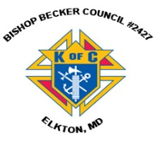

**Knights of Columbus**

***Bishop Becker Council 2427***

**443-616-5370** or [**www.kofc2427.org**](http://www.kofc2427.org)

**Meetings:** 2nd & 4th Tuesdays of the month at 7:00 pm at the Parish Center

**LAOH (The Ladies Ancient Order of Hibernians)**

The Ladies Ancient Order of Hibernians, Inc. Cecil County Division 1, an Irish Catholic Action group has meetings on the first Wednesdays of the month at 1:00pm in the ICC Parish Center. Meetings run September through May. We are always looking for new members! If you are an Irish Catholic woman and want to serve your community, and learn more about your Irish heritage come join us! Contact Janice White, President at 410-378-3493

**ADULT FAITH FORMATION:**

Holy Family Weekend getaway to Washington, DC will be held on Saturday-Sunday, May 18-19. Join us as we travel by coach bus to the Museum of the Bible and Franciscan Monastery. Trip cost includes overnight accommodations at hotel, all meals, snacks, attraction tickets, fees, taxes, and transportation. Cost based on overnight room occupancy per person at $300 single, $250 double, $225 Triple, and $200 Quadruple. Register online at [www.holyfamilynewark.org/adultformation.php](http://www.holyfamilynewark.org/adultformation.php) or contact the RE Office at [rgarland@holyfamilynewark.org](mailto:rgarland@holyfamilynewark.org) or [ljablonski@holyfamilynewark.org](mailto:ljablonski@holyfamilynewark.org). or 302.368.8976 during business hours.

**Designer Hand Bag Bingo!**

Support Singerly Fire Company by joining them on **Friday, April 26th** at 6:00pm for Designer Handbag Bingo! Refreshments and a cash bar will be available. Tickets are $25 in advance/$30 at the door. If you purchase by April 20th you will be entered in an *additional* drawing! They are also having a “31 Days of Handbags” Lottery! Tickets will be available on April 1st for $5. They will have a winner every day for the month of July! Purchase your ticket and watch the MD Pick 3 nightly number every day for the month of July. If the number on the ticket is drawn, you win! For tickets or more information, please contact Holly at 443-309-4820 or Nancy at 410-398-2486 or 410-441-0846.

**Earth Day/Pollution Prevention Outreach Event:**

Join the town of Elkton Department of Public Works on **Saturday, April 13th from 9:00am - 1:00pm** for our Earth Day/Pollution Prevention Outreach Event, in addition to educational awareness and children’s activities. DPW will accept used, unwanted house paint for proper disposal. DPW is located at 209 Blueball Ave - next to Purnell’s Body Shop. For more information, contact DPW at 410-392-6636.