***From Father Jim***

**“Brothers and sisters: If then you were raised with Christ, seek what is above, where Christ is seated at the right hand of God. Think of what is above, not of what is on earth. For you have died, and your life is hidden with Christ in God. When Christ your life appears, then you too will appear with him in glory.”**

The day of victory and triumph, bringing great joy and peace. We have visited the empty tomb, and ask with the anxious apostles, ‘where is He?’. ‘We were hoping…’ As Easter people our hopes are not dashed, but we hear reports of the Risen Christ in the upper room, on the road to Emmaus, in the garden and at the shores of the sea. He is not hidden.

We as believers look for the Lord too. Look within, as He lives and lives in us. Today may we recognize His presence through the life of grace. May we acknowledge in His presence in others. May we bring that presence to those who are slow to believe. May we adore that presence in the Eucharist.

Don’t let His life remain hidden, but through living your faith reveal that presence to others.

**Second Sunday of Easter of the Divine Mercy**

**Next Sunday, April 28th** is “Divine Mercy Sunday.” We invite you to celebrate Divine Mercy in any of the following ways:

1. Exposition of the Blessed Sacrament will occur after 12:00 Mass.

2. Those gathered will pray the Chaplet of Divine Mercy at 2:00 PM concluding with Benediction.

3. The requirements for the indulgence associated with this devotional can be satisfied by participating in any of the parish Masses next Sunday or participating in Reconciliation at ICC Saturday from 4:10pm - 4:50pm or SJ Sunday from 8:20am - 8:50am.

**OUTREACH:** "Thanks" those Parishioners who send in their Redner's Grocery Receipts. We need the 'Full Receipt’ to include the part that shows “Today's 1% Save A Tape Total.” Each receipt is counted using the sum found in this section. Without this information we cannot use the receipt. Outreach earns 1% of your purchase total. This money provides help to people in need. Please sign up to participate in the Redner's 1% Save A Tape program if you are not already a member.



**April 22, 2019**

8:30 am Joseph Coiner (Living Intention)

**April 23, 2019**

8:30am Danny Quiamco

**April 24, 2019**

8:30 am Alma Jose

**April 25, 2019**

8:30 am Vincenzo Esposito

7:00 pm SJ Gemma Zagni Davis

**April 26, 2019**

8:30 am Mary Louise Williams

**April 27, 2019**

8:30 am Patricia Monterosso (Living Intention)

5:00pm Victor Gottemoller

**April 21, 2019 Sunday of Divine Mercy**

7:00 am Aurora Barbaro

8:30 am Walter Narkiewicz

9:00 am SJ People of the Parish

10:15 am Shannon Hensley

12:00 pm Kathleen Glenn



**Holy Week Schedule:**

* **Holy Thursday, April 18**
  + 8:30AM Morning Prayer - IC Chapel
  + 7:00PM Evening Mass of the Lord’s Supper - SJ

Adoration of the Blessed Sacrament follows until 9:30pm.

* **Good Friday, April 19**
  + 8:30AM Morning Prayer - IC Chapel
  + 7:00PM Celebration of the Passion of the Lord - SJ
* **Holy Saturday, April 20**
  + 8:30AM Morning Prayer - IC Chapel
  + 11:00AM Blessing of Food - IC Chapel
  + 12:00PM Ecumenical Service of the Passion - Elkton Presbyterian Church
  + 8:00PM Easter Vigil - ICC
* **Easter Sunday, April 21**
  + Regular Sunday Mass Schedule

**Readings for next week:**

**Sunday of Divine Mercy**

**First Reading: Acts 5:12-16**

The people held the apostles in great esteem and brought sick people to them to be healed. Although some were afraid to be known, the number of Jesus' followers continued to grow steadily.

**Second Reading: Revelation 1:9-11a, 12-13, 17-19**

John depicts a vision of lamp-stands of gold and one like the Son of Man in a robe with a sash of gold. This apparition told John he had nothing to fear and then described himself as one who was dead but now lived again. He then instructed John to record any other visions he might have.

**Gospel: John 20:19-31**

Jesus appeared to the disciples and breathed on them saying, "Receive the Holy Spirit." He gives them the power to forgive people's sins or hold them accountable. Thomas, who was not present, refused to believe Jesus had appeared until he came to them once more. Jesus told Thomas to believe and added, "Blessed are those who have not seen and have believed."

**Daily Readings:**

***Easter Sunday of the Resurrection of the Lord***

**Sunday** ............Acts 10:34a, 37-43; Col 3:1-4 or 1 Cor 5:6b-8;

Jn 20:1-9 or Lk 24:1-12 or, at an afternoon Mass, Lk 24:13-35

**Monday**......................................Acts 2:14, 22-33; Mt 28:8-15

**Tuesday**.............................................Acts 2:36-41; Jn 20:11-18

**Wednesday**.........................................Acts 3:1-10; Lk 24:13-35

**Thursday***...........................................*Acts 3:11-26; Lk 24:35-48

**Friday**....................................................Acts 4:1-12; Jn 21:1-14

**Saturday**............................................Acts 4:13-21; Mk 16:9-15

**CONGRATULATIONS!**

It is with great joy that we welcome four new members to our Catholic community at Immaculate Conception / St. Jude Parish!

Those who are receiving the sacraments of Baptism, Eucharist, and Confirmation:

Mariana Brown

Barbara Lewis

Those receiving the sacraments of Eucharist and Confirmation:

Isaiah Brickus-Barlow

Christopher Outlaw

Congratulations to you all! We are proud of your dedication on your journey toward the Easter Vigil and full reception into the Catholic Church through the grace of the sacraments of initiation.



**Does your child need to be Baptized?**

The next Baptism Class is **May 13th**, 7:00-8:30pm in the Parish Center. It’s never too early to prepare for the Baptism of your child. Parents are required to attend. Contact the Parish at 410-398-1100 to register.

**Adoration for Vocations**

On the 1st Sunday of the month, exposition of the Blessed Sacrament occurs from 1pm-3pm in IC Chapel. Join us to pray for vocations. The next opportunity is **May 5th.** Contact Dermott Mullan at 410-398-3368.

**Adult Confirmation Class:** Do you want to be confirmed and have not been. If you have been baptized and received Communion then this class is for you. Please contact the Religion Office at 410-392-3551 to register for this all important class on Thursday, May 16th.

**Liturgical Ministers Next Week: *April 27th and 28th***

***5:00 pm***

**Altar Servers:** Mason H, Grace B •**EM’s:** Mary Anne S, Mary C **Lector:** Alison D • **Ushers:** Eileen P, Pat C, Bill B

***7:00 am***

**Altar Servers:** Jacob B, Sarah B • **EM’s:** Frank S, Sandra H, Gerald M •**Lector:** Christopher W •**Ushers:** Charles M, William C

***8:30 am***

**Altar Servers:** Elizabeth R, Sean M • **EMs:** Cecilia G, Peter G, Don H •**Lector:** Louis N •**Ushers:** Anthony D, Wendel S, Anthony M, Steve C

***9:00 am (SJ)***

**Altar Servers:** Luke T, Matthew T • **EM’s:** Diane C, Peggy O, Pat D, Les F, Dotty F• **Lector:** Hank C • **Ushers:** Jule V, Bill D, Kevin O

***10:15 am***

**Altar Servers:** Justin M, David M • **EM’s:** Rita M, Gwen D Helen B, • **Lector:** Ben F •**Ushers:** Bob W, Steve A, James D

***12:00 noon***

**Altar Servers:** Gabriel O, Valerie O • **EMs:** Cynthia J, Grace B • **Lector:** Frank E • **Ushers:** Teresa G, Charles C

**Children’s Liturgy of the Word**

Children’s Liturgy is for children ages 5-8 ONLY.

Children who are not in this category are asked to

remain in church.

**The catechist for next Sunday, April 28th is:**

**Kathy Chamberlin**

**Inspirational Quote of the Week:** “Ingratitude is the soul's enemy; it empties it of merit, scatters its virtues, and deprives it of graces.” -- Saint Bernard of Clairvaux

**Immaculate Conception**

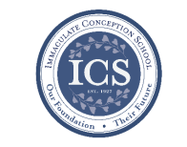**School News**

**Walk-In Wednesdays:**

Walk -In Wednesdays areevery Wednesday from 9:00am–11am. Tours are offered to those who wish to see the school in action!

**Have you come to Story Time yet??** Join us Wednesdays at 10:00am to listen to Gwen Davis ready classic stories. Mrs. Davis provides activities to compliment the story. It is a morning full of crafts, music, and even snacks! **The last chance** to go to **Story Time** this year is Wednesday, **May 8th** at 10:00am in the PreK Room!! Visit [www.facebook.com/icschoolmd](http://www.facebook.com/icschoolmd) and mark “Going” if you plan on attending. Space is limited, but all are welcome!

**In the spirit of Giving:** Grades 1 & 2 are doing a great job with Outreach donations! Grades 3 and 4 will take over donations in May.

**EASTER BREAK:** ICS will be closed for Easter Break from Friday, April 19th - Monday, April 29th. We hope the students and teachers alike have a relaxing and enjoyable time during this welcome break!

**Last Week...**

**Our students will had a Seder meal** as well as Stations of the Cross on Thursday, April 18th.

**Challenge Island has begun!!** Once upon a time there was a page-turning island that transformed favorite children's books into action-packed STEAM adventures. Challenge Island's Fantastic Fiction Island is a literary adventure of epic proportions!

**Coming Up...**

**On Fridays** during lunch, students will be selling Philly Pretzel Factory Pretzels. The sales benefit the theater program at ICS!

**Tuesdays during lunch**, student council will be selling ice cream to benefit Haiti.

**Faith Formation**

**Religious Education & Sacraments**

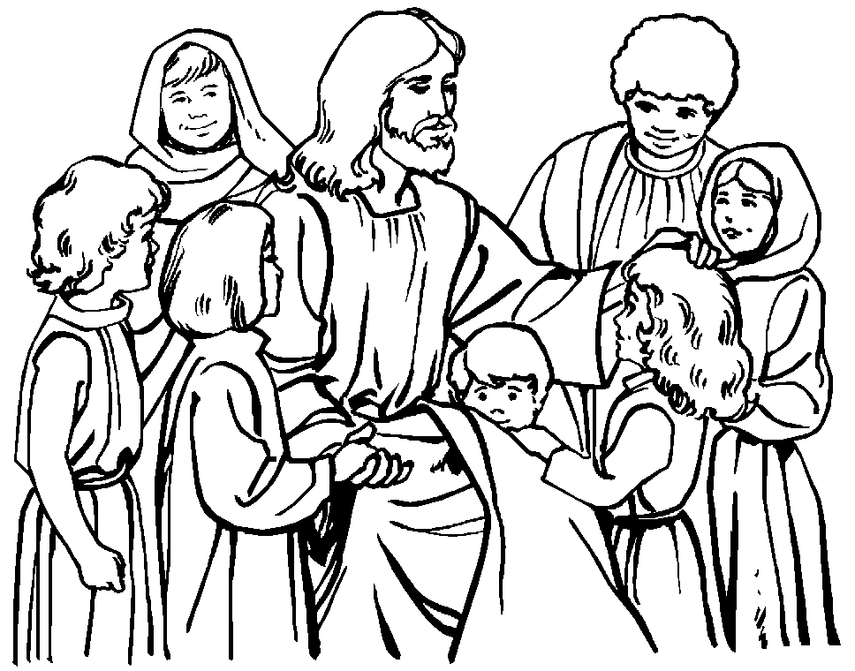**Religion Classes:** We have approximately 30 families who have not re-registered for classes next year. We need your registration to order books and supplies for next year.

**First Communion:** There is a Communion Rehearsal at St. Jude’s on Thursday, April 25th at 6:30 pm for children celebrating Communion at St. Jude’s on Sunday, April 28th at 9:00 am.

**Outreach Donations**: Please remember items for Outreach

**Vacation Bible School:** Join us for Vacation Bible School from Sunday, June 23 - Thursday, June 27 from 6:00 pm to 8:30 pm in the school. Preschool 4 and 5 year old Elementary: K - Gr 5. Registrations are at the parish center and online.

**Some have been asking for Sr. Grace’s address:**

Sr. Grace Andrew Jeffery, OSF

Assisi House

600 Red Hill Road

Aston, PA 19014

**Youth Ministry & Confirmation**

#### whats-your-story

**CONFIRMATION**

*Mandatory Retreat is on Saturday, April 27th from 8am - 12 Noon in the Gym.

*Rehearsal is Monday, April 29th at 7 pm at ICC

*Confirmation is Wednesday, May 1st at 7 pm at ICC. Candidates and Sponsors need to be in the Gym at 5:30 pm for a meeting with the Bishop.

*Service Activities/Projects form is now past due.

**YOUTH GROUP**

Youth Group will not meet tonight, or Easter Sunday, April 21st.

**YOUTH MINISTRY WISH LIST:** Sodas and paper plates

**ADULT EDUCATION**

**Interested in a study group?** Many different opportunities are available. Call the Parish Office at 410-392-3551.

**Follow Me – Meeting Jesus in The Gospel of John**

Will meet again on, April 29th at 6:30pm and repeats on Tuesday, April 30th at 9:15 am in the parish center. All are welcome.

**SOCIAL CONCERNS**

**Outreach**

Please consider donating to the Outreach! Thank you so much for your help, generosity, prayers, & donations to this essential ministry!!

**Food items needed:** Baked Beans, cereal, soup, and crackers.

**Non-Food items:** toothbrushes, deodorant, soap, paper towels, and diapers size 5 or 6.

**No clothing please!!** As much as we appreciate the gesture, we simply do not have the space to store them. Thank you!

**PARISH & FAMILY LIFE**

**Parish Coffee**

Join us for Parish Coffee, **May 5th** after 9:00 am Mass at St. Jude’s.

Join us for Parish Coffee, **May 12th** after 10:15am Mass at ICC!

**PARISH EVENTS/INFORMATION**



**Weekly Church Collections: Week of April 14th**

ICC $11,621

St. Jude $2,682

Online $2,270

Total Offertory $16,574

**Keep up with regular offerings by giving electronically!!**

Just as you rely upon receiving income on a regular basis, we rely on your regular contributions. We greatly appreciate the efforts of our parishioners to make consistent donations throughout the year! To assist you, the church provides a convenient electronic giving option for setting up regular contributions. Simply visit our website and click the Online Giving Button!

**How does Online giving benefit you?**

1. It’s easy, convenient, and safe
2. Allows you to give any amount, any time.
3. Allows you to track your giving

**How does Online giving benefit the parish?**

1. Creates consistency of giving
2. Increases efficiency of processing giving

**How to sign up?**

1. Visit iccparish.weconnect.com
2. Click “Go to Online Giving”
3. Sign up! It’s that easy!

**PARISH EVENTS/INFORMATION**

**5th Annual ICAA Wine and Beer Tasting!**

Save the Date!! Join us Saturday, June 8th from 6:00pm-8:00pm. State Line Liquors will host our wine and beer tasting event. Please come out and support the Immaculate Conception Athletic Association! They will have finger foods, appetizers, and a multitude of wines and beers. Make sure to also participate in the 50/50 drawing! Tickets are $25 per person and can be purchased from Angela Maxwell, Michelle Riddle, or at the Parish Center. Tickets will also be sold at the door. Make sure to join us!

**Food, Flights, and Fundraising!!**

**Join us at Elk River Brewing Company on May 4th from 6-8pm**! We will be having a fundraiser to support Immaculate Conception’s Spring Musical production of “Honk! Jr.” Tickets are $25 per person and include a beer flight or glass of wine, food samplings from Simply Savory and live music by Jimmie and Kat Davis! Tickets are available at the door, the parish center, or you can email [michelleriddle50@gmail.com](mailto:michelleriddle50@gmail.com). Hope to see you there!! *This is an Adults-only event. No one under 21 will be permitted.

**SAVE THE DATE! Our 9th Annual Golf Classic** is going to be held on Monday, **June 10th, 2019 at the Deerfield Country Club!!** Join us for a fun-filled day of golf, great food, and some amazing auction items and golf prizes! **Spaces are limited!!** You can participate by: golfing, sponsoring, contributing auction Items, Volunteering, or joining us for dinner! **Register online** at www.iccparish.org by scrolling through the banner photos. Contact the Parish Office at 410-398-1100 for more information.

**COMMUNITY KITCHEN**

**Our next Community Kitchen** will be held Friday, April 26 at the Elkton Presbyterian Church. We are asking for donations of sandwiches (any kind), fruit, and desserts to be delivered to the Presbyterian Church by 11:00am, or the Parish Center by 10:00am the day of the luncheon. We also need volunteers to help prepare, serve, and clean up afterward. Plan to arrive around 11:00 and be finished around 1:30.

If you would like to join us on this day, please call Joyce Speakman at 610-597-3135, or Kathy Chamberlin at 410-398-7299. Cash donations are always appreciated, and if giving by check, please make it out to Immaculate Conception Church, and write Community Kitchen in the Memo section. Thank you for your generosity.



**Sunday, April 21**

7,8:30,10:15, 12 - Masses - ICC

9:00 AM - Mass - SJ

Monday, April 22

9:30 AM - Novena - CH

7:00 PM - Boy Scout Patrol Mtg - PC

8:00 PM - AA Mtg - Caf

Tuesday, April 23

9:00 AM - Holy Hour - CH

6:30 PM - VBS Volunteer Mtg -PC

7:00 PM - Knights of Columbus - PC

7:30 PM - Contemporary Rehearsal - IC

Wednesday, April 24

9:00 AM - Rosary Crusade/SJ Novena-CH

9:30 AM - Cantor Reh - IC

10:00 AM - LAOH Officer Mtg - PC

1:00 PM - Leisure Club - Mtg - PC

4:00 PM - “Honk Rehearsal” - gym

Thursday, April 25 ICS No School!

9:00 AM - Rosary Crusade - CH

6:30 PM - Boy Scouts - PC

6:30 PM - First Communion Rehearsal - SJ

6:30 PM - Cantor Rehearsal - IC

7:00 PM - Parish Choir Rehearsal - IC

Friday, April 26 ICS No School!

9:00 AM - Rosary Crusade - CH

7:00 PM - NA Mtg - Caf

**Saturday, April 27**

8:00 AM - Confirmation Retreat - ICS

9:00 AM - Rosary Crusade - CH

4:15 PM - Confessions - IC

7:00 PM - NA Mtg - Caf



**community EVENTS/INFORMATION**

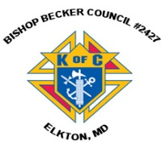

**Knights of Columbus**

***Bishop Becker Council 2427***

**443-616-5370** or [**www.kofc2427.org**](http://www.kofc2427.org)

**Meetings:** 2nd & 4th Tuesdays of the month at 7:00 pm at the Parish Center

**LAOH (The Ladies Ancient Order of Hibernians)**

The Ladies Ancient Order of Hibernians, Inc. Cecil County Division 1, an Irish Catholic Action group has meetings on the first Wednesdays of the month at 1:00pm in the ICC Parish Center. Meetings run September through May. We are always looking for new members! If you are an Irish Catholic woman and want to serve your community, and learn more about your Irish heritage come join us! Contact Janice White, President at 410-378-3493

**ADULT FAITH FORMATION:**

Holy Family Weekend getaway to Washington, DC will be held on Saturday-Sunday, May 18-19. Join us as we travel by coach bus to the Museum of the Bible and Franciscan Monastery. Trip cost includes overnight accommodations at hotel, all meals, snacks, attraction tickets, fees, taxes, and transportation. Cost based on overnight room occupancy per person at $300 single, $250 double, $225 Triple, and $200 Quadruple. Register online at [www.holyfamilynewark.org/adultformation.php](http://www.holyfamilynewark.org/adultformation.php) or contact the RE Office at [rgarland@holyfamilynewark.org](mailto:rgarland@holyfamilynewark.org) or [ljablonski@holyfamilynewark.org](mailto:ljablonski@holyfamilynewark.org). or 302.368.8976.

***Worldwide Marriage Encounter – MARRIED COUPLES***:

A Worldwide Marriage Encounter Weekend is like Springtime! It is a weekend of fresh air, the rebirth of romance and new beginnings. If you’d like to make your marriage even more special than it already is – our next Marriage Encounter Weekend is November 1-3 in Rehoboth Beach, DE. For more information visit our website at [www.wwme-delmar.org](http://www.wwme-demar.org) or to register for the weekend, please call Tony and Linda Massino at 302-220-9833.

***Save the Dates! – Dancing Date Night!***

Do you want deeper intimacy with your spouse/Fiancé and with God AND learn the basics of four classic ballroom dances? Join us Saturday Nights 6:30 pm-9:00 pm

May 4: Fox Trot; May 18: Waltz; June 1: Swing; June 22: Rumba

An evening of Marriage Enrichment Bring a dish to share; learn about hot topics such as communication, understanding your spouse’s needs, building intimacy, and fostering forgiveness. End each night in your partner’s arms with a dance lesson taught by former professional dancers. DESTINATION: St. Mary of the Assumption 7200 Lancaster Pike, Hockessin, DE. To register or for more info: Sue O’Hanlon [sohanlon@sjbde.org](mailto:sohanlon@sjbde.org) 302-423-4356