***From Father Jim***

**Mark your calendars! Advent Services:**

**Reconciliation Services:**

**Immaculate Conception:**

Saturdays, 4:10-4:50pm December 7, 14, 21, & 28

**St. Jude:**

Sundays, 8:20-8:50am December 1, 8, 15, 22, & 29

**Additional Reconciliation Services: Open to all!**

10:00am Tues, December 10th - ICC School Service

7:00pm Mon, December 16th - IC Parish / Rel Ed. service

**Advent Liturgies/ Services:**

**Harp, Flute, Keyboard Concert**

Sunday, December 8th: 5:00pm - ICC

**Feast of Immaculate Conception**

Monday, December 9th: 8:30 - ICC School Service

Monday, December 9th: 7:00pm - ICC

**Holy Hour / Taizé Service**

Wednesday, December 11th: 5:30pm - ICC

**Christmas Masses:**

**Immaculate Conception Church**

**Christmas Eve, Tuesday, December 24**

**4:00pm Mass with Christmas Pageant**

Pageant begins at 3:40pm with Children’s Choir

**7:00pm Mass**

Carol prelude begins at 6:30pm with Contemporary Ensemble

**12:00 Midnight Mass**

Carol prelude begins at 11:30pm with the Parish Choir & Instrumentalists

**Christmas Day, Wednesday, December 25**

**10:15am Mass**

Hand bells during Mass

**St. Jude Mission Church**

**Christmas Eve, Tuesday, December 24**

**4:00pm Mass with Christmas Pageant**

Pageant begins at 3:40pm

**10:00pm Mass**

Carol prelude begins at 9:40pm

**Christmas Day, Wednesday, December 25**

**9:00am Mass**

**New Years Eve/New Years Day**

Tuesday, December 31st 7:00pm Vigil - SJ

Wednesday, January 1st 9:00am, 10:15am Mass - IC



**December 2, 2019**

8:30 am Maria Hoeffliger (Living Intention)

**December 3, 2019 St. Francis Xavier, Priest**

8:30 am Gloria González Acevedo

**December 4, 2019 St. John Damascene, Priest and Dr.**

8:30 am Sister Anne May McFeeley

**December 5, 2019**

9:00 am Walter Narkiewicz

**December 6, 2019 St. Nicholas, Bishop**

8:30 am Gloria González Acevedo

**December 7, 2019 St. Ambrose, Bishop and Dr.**

8:30 am Timothy Oliver Larkin

5:00 pm Francis and Alda Guns

**December 8, 2019 Second Sunday of Advent**

7:00 am People of the Parish

8:30 am Laura and Earl Koch

9:00 am SJ Warren and Winifred Holmes

10:15 am Vincent McMahon Sr.

12:00 pm Conception Ramos (Living Intention)

***Congratulations to those who were recently baptized:***

*Gabriella Avery Gibson*

*Maeson James Hensel*



**Harp, Flute, and Keyboard Christmas Concert**

Join us on Sunday, **December 8th** at 5pm at Immaculate Conception for our second annual harp, flute, and keyboard Christmas Concert, featuring Lynn Broderick, Denise Lano, and Dana Brehany! A light reception will follow. Hope to see you there!

**angel tree gifts:**

**All Angel Tree gifts to be returned TODAY!!**

All Angel Trees gifts must be returned to either St. Jude’s or Immaculate Conception Church by TODAY, December 1st! Please make sure that the gifts wrapped and the pink or blue angel is **securely** attached to the package(s). If you have multiple boxes, please tie them together! Thank you for being an Angel to someone in need this Christmas!!!

**Thank you ACME!** The next time you visit the Elkton ACME, please thank the store, the staff, and their great customers for their support of The Parish Outreach! This holiday season, ACME is helping local families by donating 20 turkey dinners to help community families in need this Thanksgiving!

**Readings for next week:**

***Second Sunday of Advent***

**First Reading: Isaiah 11:1-10**

In this beautiful passage, a messianic prophecy, Isaiah exults in the coming of the Lord, who will bring justice and peace for all.

**Second Reading: Romans 15:4-9**

Paul reveals to us the necessity of living in peace and harmony. His words “Accept one another, then, as Christ accepted you, for the Glory of God” are as needed today as they were in Paul’s own time.

**Gospel: Matthew 3:1-12**

John the Baptizer prepares the way for Jesus. Clothed in a garment of camel’s hair, he baptizes the people in the Jordan River, but warns the Pharisees in ringing tones that they must give evidence that they mean to reform.

**Daily Readings:**

***Our Lord Jesus Christ, King of the Universe***

**Sunday** ........................... Is 2:1-5; Rom 13:11-14; Mt 24:37-44

**Monday** ...................................................... Is 4:2-6; Mt 8:5-11

**Tuesday .**.............................................. Is 11:1-10; Lk 10:21-24

**Wednesday** ...................................... Is 25:6-10a; Mt 15:29-37

**Thursday** ........................................... Is 26:1-6; Mt 7:21, 24-27

**Friday** ................................................. Is 29:17-24; Mt 9:27-31

**Saturday** .................. Is 30:19-21, 23-26; Mt 9:35-10:1, 5a, 6-8

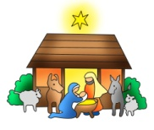

**2019 Christmas Eve Pageants**

**We are** **planning our annual** Christmas Eve Nativity Pageants at St. Jude & Immaculate Conception Churches! Children grades K-3 can participate. Sign up early, space is limited!! The pageants will be performed before the 4pm Masses at Immaculate Conception and St. Jude’s Church on Christmas Eve. If interested, please contact the following with your child’s name, gender, and age no later than December 13th.

**Contact information:**

**St. Jude’s -** Dottie Dhamer at [sassydot1@comcast.net](mailto:sassydot1@comcast.net) (preferred) or 443-350-7186. (Practice is Sunday, December 22nd after 9:00am Mass)

**ICC** - Kim Burnham at [ksburnham@comcast.net](mailto:ksburnham@comcast.net) (Practice is Saturday, Dec 21st at the 11:00am)

**Adoration for Vocations**

On the 1st Sunday of the month, exposition of the Blessed Sacrament occurs from 1pm-3pm in IC Chapel. Join us to pray for vocations. The next opportunity is TODAY, **December 1st** Contact Dermott Mullan at 410-398-3368.

**Liturgical Ministers Next Week: *Dec. 7th & 8th***

***5:00 pm*** Alex F, Andrew F •**EM’s:** Mary Anne S, Cheryl N

• **Lector:** Edward R • **Ushers:** Eileen P, William B Pat C

***7:00 am***

•**Altar Servers**: **\*UNFILLED\*** •**EMs:** Peter D, Ginnie D, Alan S • **Lector:** James S • **Ushers:** Charles M

***8:30 am***

**Altar Servers:** Elizabeth R, Alex L • **EMs:** Peter G, Cecilia G, Frank S • **Lector:** Pat K • **Ushers:** Anthony D, Wendel S, Anthony M, Stephen C

***9:00 am (SJ)***

**Altar Servers:** David M, Adam M • **EM’s:** Helen B, Pat D, Diane C, Chris H, Peggy O • **Lector:** Dwight T • **Ushers:** Kevin O, Jule V, William D, Jake S

***10:15 am***

**Altar Servers:** Justin M, Hayden S • **EM’s:** Barbara R, Richard L • **Lector:** Tina B • **Ushers:** Bob W, Steve A

**12:00 *noon***

**Altar Servers:** Catherine G, Cecilia G •**EMs:** Kathy C, Mary L, Charles C • **Lector:** Mary K • **Ushers:** Teresa G



**Does your child need to be Baptized?**

The next Baptism Class is **January 13th**, 7:00-8:30 pm in the Parish Center. It’s never too early to prepare for the Baptism of your child. Parents are required and Godparents are encouraged to attend. Contact the Parish Office to register at 410-398-1100.

**Advent Holy Hour**

We will have an opportunity for adoration on Wednesday, December 11 from 5:30 to 6:30pm at Immaculate Conception. This time of prayer will feature Taizé music, readings, and silence, ending with Benediction of the Blessed Sacrament. Come spend some time with Our Lord as we prepare to celebrate His birth!

**Children’s Liturgy of the Word**

CLW is for children 5-8 years old. Children under 5 are welcome if they are accompanied by a parent (not a sibling!)

CLW is in desperate need of adult help for. If interested, please contact Gwen Davis at 410-392-8078

**The Catechist for next Sunday, December 8th is:**

**Lynn O’Brien**

**St. Jude’s Word Search Puzzle Winners**

1.) Anna C. 2.) Mitch H. 3.) Anna M. 4.) Barb B. 5.) Mike B.

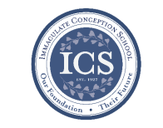**Immaculate Conception**

**School News**

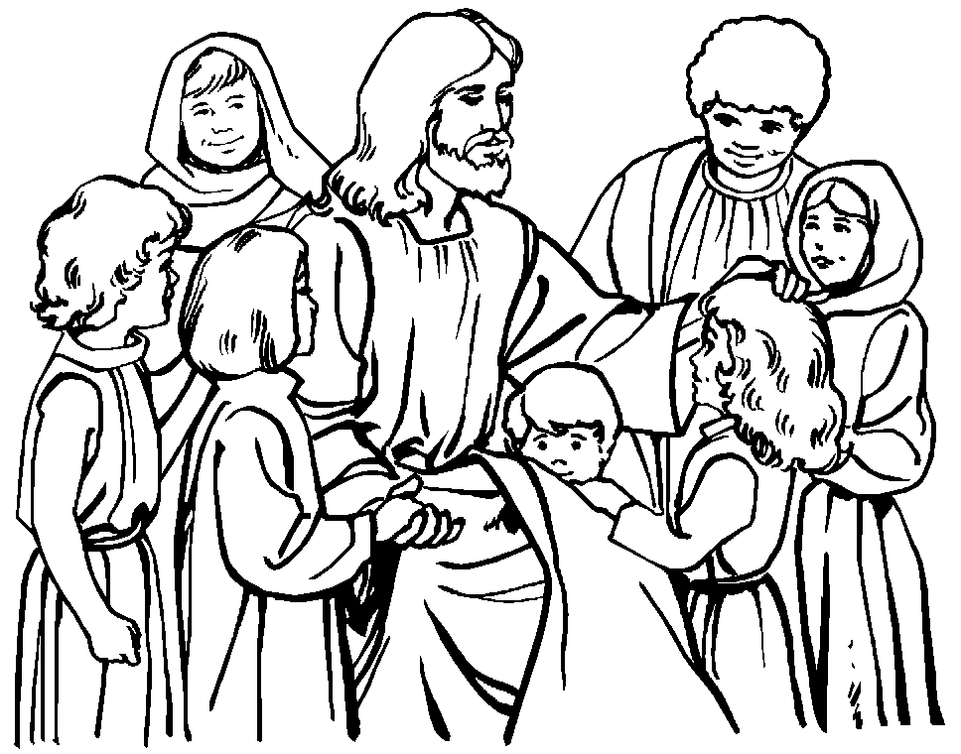**Have you seen our test scores?!**

ICS test scores are ranked in the 90th percentile compared to test scores from other schools across the Diocese! This is in part because of how passionate we are about our students’ education, small class sizes, and incredible staff!

“ICS offers a solid, traditional academic program which prepares students for success in high school and beyond. Teachers prepare meaningful academic lessons and students are very engaged and inquisitive throughout the school day. Assessment results indicate very strong achievement; on both the Renaissance STAR Math and Reading assessments, ICS students perform among the highest in the diocese.” - Diocese of Wilmington Office for Catholic Schools.

**Last Week...**

**5th Grade service project: Coat Drive!**

During November, the 5th-grade class had their annual service project. They collected donations for the Parish Outreach. Last week they delivered their winter coats to Dottie. It was a very meaningful event! Dottie was so grateful!

**Coming up…**

**NJHS Service:**

The ICS National Junior Honor Society will be going to volunteer at the Community Kitchen on **Friday, December 6th.** This is always such a meaningful event for the students as they give back to the community!

**Report Cards:**

The first trimester is quickly coming to an end! Our hardworking students will be getting their report cards from the first trimester on **Monday, December 9th**. We know they worked their hardest!

**Christmas Concert**

Grades Pre-K - 5th will get to show off their musical talents at the annual Christmas Concert on **December 12th**! Each grade will sing Christmas songs, and our beginner and advanced bands will show off all that they have learned from Ms. D’Amico!

**Special Person’s Lunch:**

Our 5th graders will have their family, friends, and loved ones join them for lunch on **December 19th** at 11:00am in the school cafeteria. The students love having their visitors stop by! Enjoy!!

**Faith Formation**

**Religious Education & Sacraments**

**Religion Classes:** There will be no class today, Sunday, December 1st for the Thanksgiving Holiday.

**First Reconciliation:** Next meeting will be Sunday, December 8th at 2:00pm at ICC.

**Outreach:** December donations: Christmas food items!

**Youth Ministry & Confirmation**

#### whats-your-story

**CONFIRMATION**

#### Next class is Sunday, December 8th and Wednesday, December 11th.

**YOUTH GROUP – Grades 9 thru 12**

**Meetings are 6 – 8 pm in the parish center**

No meeting today, December 1st.

Next meeting Sunday, December 8th

**YOUTH MINISTRY WISH LIST:**

* We are asking for sodas (cans please!)

**JUNIOR YOUTH GROUP – Grades 6 thru 8**

Join us to grow in faith through fun and fellowship!

No meeting today, December 1st.

Next meeting Sunday, December 8th

**ADULT EDUCATION**

**Interested in a study group?** Many opportunities are available. Call the Religion Office at 410-392-3551.

**Adult Education classes**

The Sacred That Surrounds Us – will start on Monday, January 6th and Thursday, January 9th.

**Book Study**

Will start Tuesday, January 7th at 9:15 am in the parish center.

**SOCIAL CONCERNS**

**Outreach**

**Please consider donating** to the Outreach! Thank you so much to all those who have donated!! Thank you for your help, generosity, prayers, & donations to this essential ministry!!



**Holiday items:** We are collecting holiday food for Christmas!! **Please consider donating holiday food items to the parish outreach!**

**Food items:** We are in need of chicken noodle and tomato soups, pasta, and pasta sauce

**Non-Food Items:** Toothpaste, toothbrushes, and shampoo

**PARISH EVENTS/INFORMATION**



**Weekly Church Collections: Week of Nov. 17th**

ICC $8,489

St. Jude $2,003

Online $3,615

Total Offertory $14,107

**Keep up with regular offerings by giving electronically!!**

Just as you rely upon receiving income on a regular basis, we rely on your regular contributions. We greatly appreciate the efforts of our parishioners to make consistent donations throughout the year! To assist you, the church provides a convenient electronic giving option for setting up regular contributions! Simply visit our website and click the Online Giving Button!

**How does Online giving benefit you?**

1. It’s easy, convenient, and safe
2. Allows you to give any amount, any time.
3. Allows you to track your giving

**How does Online giving benefit the parish?**

1. Creates consistency of giving
2. Increases efficiency of processing giving

**How to sign up?**

1. Visit www.iccparish.org
2. Click “Go to Online Giving”
3. Sign up! It’s that easy!

**PARISH & FAMILY LIFE**

**Parish Coffee**

Please join us at St. Jude’s for Parish Coffee **Dec 1st** following the 9:00 Mass.

**Join us** for Parish Coffee, **Dec. 8th** after 8:30am and 10:15am Masses at ICC!

**PARISH EVENTS/INFORMATION**

**Basketball registration!**

Basketball is in need of two heads for Pre-JV and two heads for JV to make these teams a go! Please contact [Icshawkssports@gmail.com](mailto:Icshawkssports@gmail.com) if you are interested!

**Registration is OPEN!**

3rd & 4th grade boys and girls (co-ed) -- Pre-JV. Practices Tues/Thurs 5:30 to 6:30

5th & 6th grade boys - JV.

Practices Tues/Thurs 6:30 - 8 p.m.

7th & 8th grade boys - Varsity.

Practices Wed/Friday 6:30 - 8 p.m.

We are eligible for girls JV and Varsity teams too!  If we have any interested players or questions please

contact [icshawkssports@gmail.com](mailto:icshawkssports@gmail.com)



**The Immaculate Conception Rolling Lottery is back! A $20 chance can win you up to $1,500**! These make a great Christmas Gift!! We will be selling tickets after Masses on Nov 30 - Dec 1, and again on Dec 7-8. We will also be selling them in the Religious Ed office during Classes on Sundays/Wednesdays and at the Parish Center during business hours. Tickets will be sold through December. The rolling lottery will follow The Maryland Lottery Pick 3 for winners in January. The MSL draws twice a day, so ticket holders have 60 chances to win. The stakes go up $25 after each draw if nobody wins that draw. Proceeds benefit ICC Parish and Religious Education. This is not affiliated with the MSL.

**Emergency Rotating Shelter:**

ICC/St Jude will be participating in the 2020 Emergency Rotating Shelter. We are scheduled for the week of Jan 13-19 at Truth and Life Center, 1924 West Pulaski Highway, Elkton. Many volunteers are needed to help in this important mission of housing and feeding our homeless. There are many ways to help: preparing parts of a meal, hosting an evening, staying overnight, or just stopping in and visiting. For more information please contact Carol and Bill Dale, 410-287-9548, or email [dales7@comcast.net](mailto:dales7@comcast.net).

## KofC Logo

**Sunday, December 1**

8:20 AM - Confessions - SJ

10:00 AM - Coffee Sunday - SJ

1:30 PM - Adoration for Vocations - IC

6:00 PM - HS Gathering - PC

Monday, December 2

9:30 AM - Novena - CH

5:30 PM - Boys Varsity Basketball - gym

8:00 PM - AA Mtg -caf

Tuesday, December 3

9:00 AM - Holy Hour - CH

5:30 PM - Pre JV Basketball - gym

6:00 PM - Liturgy Committee Mtg - PC

6:30 PM - JV Basketball - gym

6:30 PM - Handbell Rehearsal - IC

7:30 PM - Contemporary Rehearsal - IC

Wednesday, December 4

9:00 AM - Rosary Crusade / Novena-CH

9:30 AM - Cantor Reh - IC

4:00 PM - Children’s Choir - PC

6:15 PM - Religious Ed - ICS

6:30 PM - JV Boys basketball - gym

7:00 PM - Varsity Basketball - gym

Thursday, December 5

9:00 AM - Rosary Crusade - CH

5:30 PM - Pre JV Basketball - gym

6:30 PM - Girls Varsity Basketball - gym

6:30 PM - Boy Scouts - PC

6:30 PM - Cub Scouts - PC

6:30 PM - Cantor Reh - IC

7:00 PM - Parish Choir - IC

7:00 PM - RCIA - PC

Friday, December 6

9:00 AM - Rosary Crusade - CH

6:30 PM - Varsity Basketball - gym

7:00 PM - NA Mtg - Caf

**Saturday, December 7**

7:00 AM - Scouts - caf

9:00 AM - Rosary Crusade - CH

4:15 PM - Confessions - IC

7:00 PM - NA Mtg - Caf

**community EVENTS/INFORMATION**

**Knights of Columbus**

***Bishop Becker Council 2427***

**Meetings:** 2nd & 4th Tuesdays of the month at 6:30 pm at the Parish Center

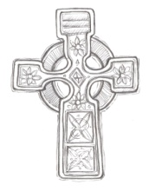**LAOH (The Ladies Ancient Order of Hibernians)**

The Ladies Ancient Order of Hibernians, Inc. Cecil County Division 1, an Irish Catholic Action group has meetings on the first Wednesdays of the month at 1:00pm in the Parish Center. Meetings run September through May. We are always looking for new members! If you are an Irish Catholic woman and want to serve your community, and learn more about your Irish heritage come join us! Please contact the historian, Betty Green at 410-392-5287



**Have you started your Holiday shopping yet??**

Did you know that when you shop for the holidays at [smile.amazon.com/ch/52-6015220](https://smile.amazon.com/gp/f.html?C=JY11A2HZ6P5O&K=15GG5P8RFW6OS&M=urn:rtn:msg:20191029140523f1195f2dfe184a69b3de15dd32f0p0na&R=37U11G4BVSQZ8&T=C&U=http%3A%2F%2Fsmile.amazon.com%2Fch%2F52-6015220&H=JQMAB6AKUPPIGGRGSADMKNBYZ9YA), AmazonSmile donates to Immaculate Conception Church? Shop at Amazonsmile.com this holiday season and you can help raise funds for our parish!

**MASS FOR THE FEAST OF SAINT FRANCIS XAVIER**

Fr. Chris Hanley will celebrate Mass in honor of the Feast of Saint Francis Xavier on Tuesday, December 3 at 6:30 pm at St. Francis Xavier Church (Old Bohemia) in Warwick, MD. The rectory museum will be open for individual examination one hour before the start of Mass. The church is available for tours, group retreats and Catholic weddings. A video about the property can be viewed on YouTube at <https://www.youtube.com/watch?v=BFGlCsNM6gk>. For additional information, contact Kathy at 302.378.7293 or send email <OldBohemiaHS@gmail.com>. The GPS location is 1690 Bohemia Church Road, Warwick, MD 21912.

**Warm up for winter!**

Catholic Charities needs your help to warm up for winter! As temperatures decline, Catholic Charities is preparing to *warm up for winter* for its most vulnerable neighbors by collecting new and gently used blankets, bedding, coats, hats, and gloves at each of its office locations now through the end of January 2020. Locations will accept donations between the hours of 9 am - 4:30pm. Visit <http://www.ccwilm.org/> for more information.

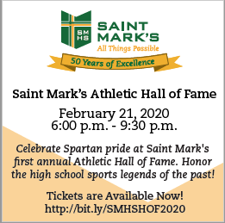

**Saint Mark’s High School**

***Athletic Hall of Fame***

Saint Mark’s invites you to celebrate Spartan pride at Saint Mark’s 1st Annual Athletic Hall of Fame on **Friday, February 21, 2020 from 6:00 - 9:30 pm.**

Honor the high school sports legends of the past! **Tickets are Available Now! Visit** [**http://bit.ly/SMHSHOF2020**](http://bit.ly/SMHSHOF2020)