***From Father Jim***

***Mark your calendars!***

***Advent Services:***

**Reconciliation Services:**

**Immaculate Conception:**

Saturdays, 4:10-4:50pm December 28

**St. Jude:**

Sundays, 8:20-8:50am December 22, & 29

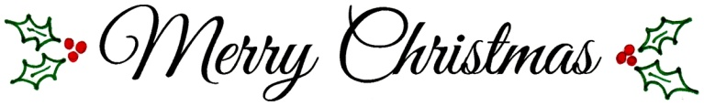

**Christmas Masses:**

**Immaculate Conception Church**

**Christmas Eve, Tuesday, December 24**

**4:00pm Mass with Christmas Pageant**

Pageant begins at 3:40pm with Children’s Choir

**7:00pm Mass**

Carol prelude begins at 6:30pm with Contemporary Ensemble

**12:00 Midnight Mass**

Carol prelude begins at 11:30pm with the Parish Choir & Instrumentalists

**Christmas Day, Wednesday, December 25**

**10:15am Mass**

Hand bells during Mass

**St. Jude Mission Church**

**Christmas Eve, Tuesday, December 24**

**4:00pm Mass with Christmas Pageant**

Pageant begins at 3:40pm

**10:00pm Mass**

Carol prelude begins at 9:40pm

**Christmas Day, Wednesday, December 25**

**9:00am Mass**

**New Years Eve/New Years Day**

Tuesday, December 31st 7:00pm Vigil - SJ

Wednesday, January 1st 9:00am, 10:15am Mass - IC

**The Parish office will be closed Tuesday, December 24th, Wednesday, December 25th, and Thursday, December 26th. Merry Christmas!!**



**December 23, 2019**

8:30 am Madelin Martinee

**December 24, 2019**

8:30 am Anna Marie Dodson-Collins

4:00 pm IC Deacon Joseph Kosman

4:00 pm SJ Rep. Duffy

7:00 pm IC Sarah Smith

10:00 pm SJ Ed Banas

12:00 am IC Tony Sniadoski

**December 25, 2019 The Nativity of the Lord**

9:00 am SJ George Armstrong

10:15 am IC Joseph McGlinn

**December 26, 2019 St. Stephen the First, Martyr**

8:30 am Madeline Martinee

**December 27, 2019 St. John, Apostle and Evangelist**

8:30 am Mary Kirkwood (Living Intention)

**December 28, 2019 The Holy Innocents, Martyrs**

8:30 am John Ferrick

5:00 pm Bessie Dvorak

**December 29, 2019 The Holy Family of Jesus, Mary, and Joseph**

7:00 am Kevin Rzucidlo

8:30 am Anne and Edward Weber

9:00 am SJ Carolyn Delores Smith

10:15 am Ginger Duffy

12:00 pm People of the Parish

***We extend a warm welcome to our new Parishioners:***

*Mr. Ikechukwu Okeke*

*Ms. Robin Templeton*

**Cemetery Notice:** All decorations will be removed from the graves at both cemeteries the First week in February. If you have any decorations that you wish to keep, you must remove them **by January 31**. Please remember that with the exception of flowers in memorial marker vases, no decorations of any type, (wind chimes, statues, fencing, flags, potted plants, etc.) are permitted on the graves during the mowing season – April 15 to October 30. Thank you for your cooperation.

**Decorating for Christmas**

We will decorate St. Jude’s for Christmas TODAY, December 22, after the 9 AM Mass. We will decorate Immaculate Conception on Sunday, December 22, after the noon Mass. Many helpers are needed! Thank you!

**Readings for next week:**

***HOLY FAMILY OF JESUS, MARY AND JOSEPH***

**First Reading: Sirach 3:2-6, 12-14**

This passage from Sirach details the duties children owe to father and mother. Their life-long devotion will not be forgotten and “will take lasting root.”

**Second Reading: Colossians 3:12-21**

Paul urges Christians particularly in the setting of the family, to “clothe” themselves with kindness, patience, humility, and mercy; to forgive; and, above all, to love!

**Gospel: Matthew 2:13-15, 19-23**

An angel of the Lord, appearing in a dream to Joseph, urges him to flee with Jesus and Mary to Egypt to escape the murderous schemes of Herod. Later, in another dream, an angel tells Joseph to go with Jesus and Mary to a town called Nazareth in the region of Galilee, thus fulfilling the Scriptures: “He shall be called a Nazarean.”

**Daily Readings:**

***Fourth Sunday of Advent***

**Sunday** ............................... Is 7:10-14; Rom 1:1-7; Mt 1:18-24

**Monday** ...................................... Mal 3:1-4, 23-24; Lk 1:57-66

**Tuesday** ....... Morning: 2 Sm 7:1-5, 8b-12, 14a, 16; Lk 1:67-79

**Wednesday**.....Vigil: Is 62:1-5; Acts 13:16-17, 22-25; Mt 1:1-25

or 1:18-25 Night: Is 9:1-6; Ti 2:11-14; Lk 2:1-14

Dawn: Is 62:11-12; Ti 3:4-7; Lk 2:15-20

Day: Is 52:7-10; Heb 1:1-6; Jn 1:1-18 or 1:1-5, 9-14

**Thursday** ............................ Acts 6:8-10, 7:54-59; Mt 10:17-22

**Friday** ................................................. 1 Jn 1:1-4; Jn 20:1a, 2-8

**Saturday** ............................................ 1 Jn 1:5-2:2; Mt 2:13-18

**Epiphany Concert**

**Join us on Sunday, January 5th at 3pm** at Immaculate Conception for a concert featuring Daniel and Elizabeth Stevens. Enjoy the sounds of the piano and oboe as we close out the Christmas season. We look forward to seeing you there!

**“Socks Galore!”**

We will be collecting men’s women’s and children’s socks from December 29th - January 12th at Immaculate Conception and St. Jude’s churches! Please consider donating warm socks for those in need in the community! We will have tubs available in both churches during the weekends of December 29th, January 5th, and January 12th. Thank you for participating in this great cause!

**Year-End Donations:**

In the course of year-end tax planning, you may find yourself considering extra donations. As you contemplate year-end gifts, please keep Immaculate Conception/St. Jude Parish in mind. We welcome your donations through the giving page on the church website at iccparish.org. or in the Parish office. Your generosity will be a great help to the parish and may benefit you as you prepare your taxes!

**Liturgical Ministers Next Week: *Dec. 28th & 29th***

***5:00 pm*** Andrew F, Grace B •**EM’s:** Mary Anne S • **Lector:** Mary Ann E • **Ushers:** Eileen P, Pat C, Bob E

***7:00 am***

•**Altar Servers**:Benedict J •**EMs:** Gerald M, Sandra H, Frank S • **Lector:** Edward R • **Ushers:** Charles M

***8:30 am***

**Altar Servers:** Henry W, Damian W • **EMs:** Don H, Peter G, Cecilia G • **Lector:** Rachel W • **Ushers:** Anthony D, Anthony M, Wendel S

***9:00 am (SJ)***

**Altar Servers:** David M, Adam M • **EM’s:** Diane C, Pat D, Les F, Dotty F, Narcy Z • **Lector:** Chris W • **Ushers:** Kevin O, Jule V, William D

***10:15 am***

**Altar Servers:** Catherine G, Carolena G • **EM’s:** Rita M, Barbara R • **Lector:** Benjamin F • **Ushers:** Bob W, Steve A

**12:00 *noon***

**Altar Servers:** **\*UNFILLED\*** •**EMs:** Mary L, Grace B • **Lector:** Mary C • **Ushers:** Teresa G, Charles C



**Does your child need to be Baptized?**

The next Baptism Class is **January 13th**, 7:00-8:30 pm in the Parish Center. It’s never too early to prepare for the Baptism of your child. Parents are required and Godparents are encouraged to attend. Contact the Parish Office to register at 410-398-1100.

**Children’s Liturgy of the Word**

CLW is for children 5-8 years old. Children under 5 are welcome if they are accompanied by a parent (not a sibling!)

**Children’s Liturgy**: We are looking for someone to take over coordinating Children’s Liturgy! If interested, please contact Vickie Eichler at 410-392-3551

**The Catechist for next Sunday, December 29th is:**

**Kathy Chamberlin**

**Adoration for Vocations**

On the 1st Sunday of the month, exposition of the Blessed Sacrament occurs from 1pm-3pm in IC Chapel. Join us to pray for vocations. The next opportunity is **January 5th** Contact Dermott Mullan at 410-398-3368.

**2019 Giving Statements**

This January, as per IRS requirements, we will mail out acknowledgement letters to those who donated at least $250 in total donations in 2019. Acknowledgement letters for smaller total donation amounts will only be sent out to those who request an acknowledgement letter. If you would like to request a letter or if you have questions, please contact Kathleen Davis at [office@iccparish.org](mailto:office@iccparish.org). Thank you for your generosity supporting Immaculate Conception /St. Jude Parish.

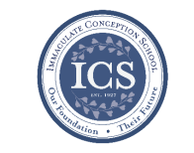**Immaculate Conception**

**School News**

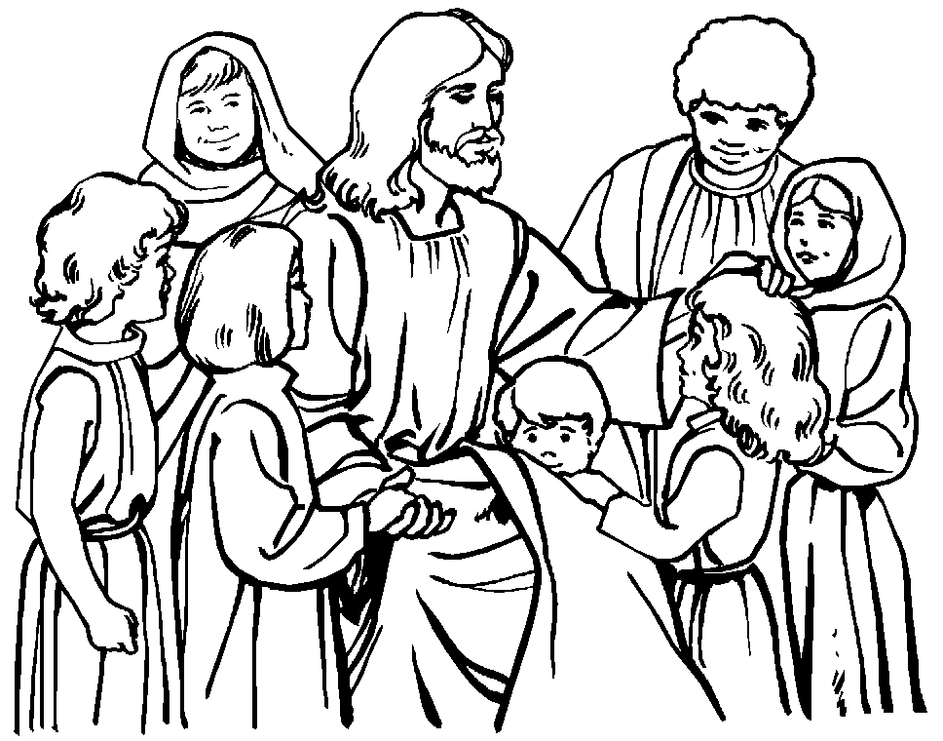

**Have you seen our test scores?!**

ICS test scores are ranked in the 90th percentile compared to test scores from other schools across the Diocese! This is in part because of how passionate we are about our students’ education, small class sizes, and incredible staff!

“ICS offers a solid, traditional academic program which prepares students for success in high school and beyond. Teachers prepare meaningful academic lessons and students are very engaged and inquisitive throughout the school day. Assessment results indicate very strong achievement; on both the Renaissance STAR Math and Reading assessments, ICS students perform among the highest in the diocese.” - Diocese of Wilmington Office for Catholic Schools.

**Last Week...**

**Christmas Holiday:**

ICS is full of fun events before the start of Christmas break! They had an Ugly Sweater Contest on **December 18th** and had winners for the most creative, ugliest, and most festive! The 8th graders dressed up and performed a Nativity visit for each of the classes on **December 19th**. The whole school gathered together on **December 20th** to watch the movie “The Polar Express” while enjoying a PJ dress-down day with hot chocolate and cookies! The Christmas Holiday began on **December 20th!** School will resume on Thursday, **January 2nd.** Merry Christmas and Happy New Year!!

**Coming up…**

**Advent is in full swing**, at ICS! Students have been hard at work and having a lot of fun making preparations for the birth of Jesus! The school is decorated for Advent and Christmas, as we all eagerly await the birth of Jesus!

**First Friday Mass**

When students return, we will have our 1st Friday Mass on January 3rd at 8:30am. Come join us!

**Catholic School’s Week/Waffles & Raffles**

Catholic School’s Week begins **January 26th** and we kick it off with our Waffles & Raffles and our school-wide open house! Be sure to stop by!!

**Faith Formation**

**Religious Education & Sacraments**

**Religion Classes:** No Religion Classes for the Christmas Holiday.

Classes will resume on Sunday, Jan. 5th and Wednesday, Jan. 8th.

**First Reconciliation:** Congratulations to all who made their First Reconciliation!!

**Outreach:** January donations: Soup, Rice & Instant Potatoes.

***Rolling Lottery*** – is the only Religious Education fundraiser this year. We are asking for all families to participate in some way (buy a ticket, help sell tickets after Masses.)

**Children’s Liturgy**: We are looking for someone to take over coordinating Children’s Liturgy for the 10:15 Masses.

**Youth Ministry & Confirmation**

#### whats-your-story

**CONFIRMATION**

#### Classes resume on Sunday, January 5th and Wednesday, January 8th.

#### Past due are Sponsor Eligibility Forms and Patron Saint Forms.

#### Sponsor Meeting Sunday, January 12th, at 4:00pm in ICC. Sponsor and Candidate should attend.

**YOUTH GROUP – Grades 9 thru 12**

**Meetings are 6 – 8 pm in the parish center**

Next meeting - **Sunday, January 5th**. We will be doing Stations of the Crib.

Save the date: **January 19th** we will be helping with the Rotating Shelter!

**YOUTH MINISTRY WISH LIST:**

* We are asking for sodas (cans please!)

**JUNIOR YOUTH GROUP – Grades 6 thru 8**

Join us to grow in faith through fun and fellowship!

Next meeting, Sunday, January 5th – 4 to 6pm.

**ADULT EDUCATION**

**Interested in a study group?** Many opportunities are available. Call the Religion Office at 410-392-3551.

***Adult Education classes*** –

The Sacred That Surrounds Us – will start on Monday, January 6th and Thursday, January 9th.

**Book Study:** Resumes on Tuesday, January 7th at 9:15 am in the parish center.

**SOCIAL CONCERNS**

**Outreach**

**Please consider donating** to the Outreach! Thank you so much to all those who have donated!! Thank you for your help, generosity, prayers, & donations to this essential ministry!!

**Non-Food Items:** Toothpaste, toothbrushes, and shampoo

**PARISH EVENTS/INFORMATION**



**Weekly Church Collections: Week of Dec. 8th**

ICC $7,208

St. Jude $1,822

Online $1,953

Total Offertory $10,983

**Keep up with regular offerings by giving electronically!!**

Just as you rely upon receiving income on a regular basis, we rely on your regular contributions. We greatly appreciate the efforts of our parishioners to make consistent donations throughout the year! To assist you, the church provides a convenient electronic giving option for setting up regular contributions! Simply visit our website and click the Online Giving Button!

**How does Online giving benefit you?**

1. It’s easy, convenient, and safe
2. Allows you to give any amount, any time.
3. Allows you to track your giving

**How does Online giving benefit the parish?**

1. Creates consistency of giving
2. Increases efficiency of processing giving

**How to sign up?**

1. Visit www.iccparish.org
2. Click “Go to Online Giving”
3. Sign up! It’s that easy!

**PARISH & FAMILY LIFE**

**Parish Coffee**

Please join us at St. Jude’s for Parish Coffee **Jan 5th** following the 9:00 Mass.

**Join us** for Parish Coffee, **Jan 12th** after 8:30am and 10:15am Masses at ICC!

**PARISH EVENTS/INFORMATION**

**Spirit of Love:**

**Sacred Music Concert and Dinner**

Join us on **Saturday, February 15th** at 6:30pm at Immaculate Conception Church for a concert featuring the Parish Choir, Contemporary Ensemble, Children’s Choir, and Handbells. Dinner will follow in the ICS cafeteria. Tickets for this event are $10 per person. Please contact our Director of Music Ministry, Dana Brehany at [ICSJmusic@gmail.com](mailto:ICSJmusic@gmail.com) for more information or to register. This is sure to be a beautiful event!

**COMMUNITY KITCHEN:** Our next Community Kitchen will be held on Friday, January 24th at the Elkton Presbyterian Church [at noon](x-apple-data-detectors://6). We are asking for donations of sandwiches (any kind), fruit, and dessert to be delivered to the Presbyterian Church by [11:00am](x-apple-data-detectors://7) or the ICC Parish Center by [10:00am](x-apple-data-detectors://8). We also need volunteers to help prepare, serve, and clean up afterward. Plan to arrive [around 11:00](x-apple-data-detectors://9) and be finished clean up [around 1:30](x-apple-data-detectors://10). (Not to mention enjoying a stupendous lunch!) If you would like to join our merry band of helpers on this day, please call Joyce Speakman [610-597-3135](tel:610-597-3135), or Kathy Chamberlin 410-[398-7299](tel:398-7299). Cash donations are always appreciated, and if giving by check, please make it out to Immaculate Conception Church and write Community Kitchen in the Memo section. Thank you so much for your continued generosity.



**The Immaculate Conception Rolling Lottery is back! A $20 chance can win you up to $1,500**! We will be selling tickets after Masses this weekend! We will also be selling them in the Religious Ed office during Classes on Sundays/Wednesdays and at the Parish Center during business hours. Tickets will be sold through December. The rolling lottery will follow The Maryland Lottery Pick 3 for winners in January. The MSL draws twice a day, so ticket holders have 60 chances to win. The stakes go up $25 after each draw if nobody wins that draw. Proceeds benefit ICC Parish and Religious Education. This is not affiliated with the MSL.

**Emergency Rotating Shelter:**

ICC/St Jude will be participating in the 2020 Emergency Rotating Shelter. We are scheduled for the week of Jan 13-19 at Truth and Life Center, 1924 West Pulaski Highway, Elkton. Many volunteers are needed to help in this important mission of housing and feeding our homeless. There are many ways to help: preparing parts of a meal, hosting an evening, staying overnight, or just stopping in and visiting. For more information please contact Carol and Bill Dale, 410-287-9548, or email [dales7@comcast.net](mailto:dales7@comcast.net).

## KofC Logo

**Sunday, December 22**

8:20 AM - Confessions - SJ

8:30 AM - RCIA - IC

10:00 AM - Christmas Pageant

Rehearsal - SJ

1:30 PM - Baptisms - IC

Monday, December 23 ICS no School

9:30 AM - Novena - CH

6:30 PM - Boys Varsity Basketball - gym

8:00 PM - AA Mtg -caf

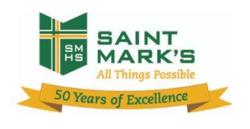

Tuesday, December 24 ICS & Parish closed

8:30 AM - Mass - IC

4:00 PM - Mass - IC

4:00 PM - Mass - SJ

7:00 PM - Mass - IC

8:00 PM - AA Mtg - Caf

10:00 PM - Mass - SJ

Midnight - Mass - IC

Wednesday, December 25 ICS & Parish closed

9:00 AM - Mass - SJ

10:15 AM - Mass - IC

Thursday, December 26 ICS & Parish closed

9:00 AM - Rosary Crusade - CH

5:30 PM - Pre JV Basketball - gym

6:30 PM - Cantor Reh - IC

7:00 PM - Parish Choir - IC

Friday, December 27 ICS no school

9:00 AM - Rosary Crusade - CH

7:00 PM - NA Mtg - Caf

**Saturday, December 28**

9:00 AM - Rosary Crusade - CH

4:15 PM - Confessions - IC

7:00 PM - NA Mtg - Caf

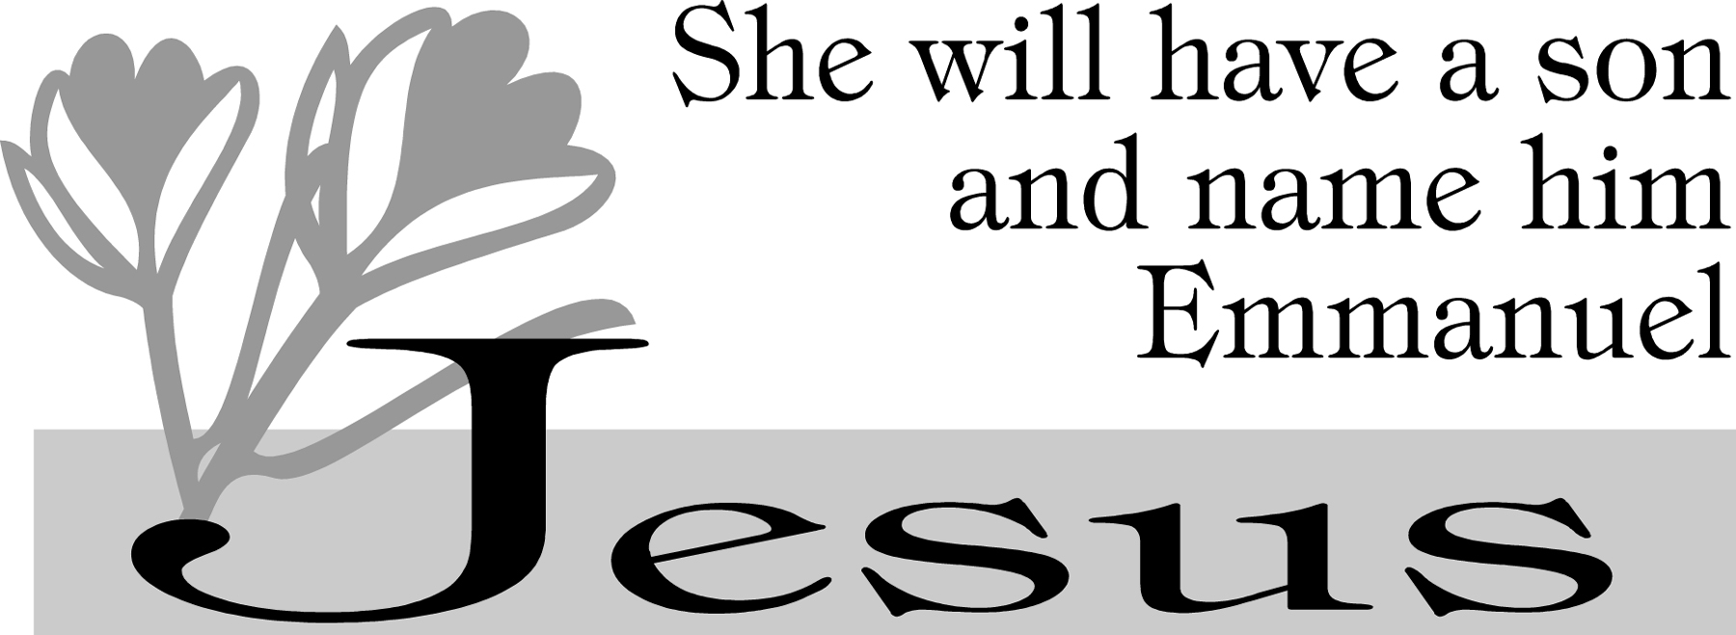

**community EVENTS/INFORMATION**

**Knights of Columbus**

***Bishop Becker Council 2427***

**Meetings:** 2nd & 4th Tuesdays of the month at 6:30 pm at the Parish Center

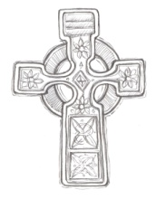

**LAOH (The Ladies Ancient Order of Hibernians)**

The Ladies Ancient Order of Hibernians, Inc. Cecil County Division 1, an Irish Catholic Action group has meetings on the first Wednesdays of the month at 1:00pm in the Parish Center. Meetings run September through May. We are always looking for new members! If you are an Irish Catholic woman and want to serve your community, and learn more about your Irish heritage come join us! Please contact the historian, Betty Green at 410-392-5287

**Saint Mark’s 50th Anniversary Alumni Performance Musicale Extraordinaire!**

**Join us as alumni perform** songs from the first 50 years of St. Mark’s musicals! This spectacular event will be taking place on **Saturday, May 30, 2020 at 7:00pm** at the St. Mark’s Theatre. The theme for the selection of songs is ‘LOVE’ one Another.’ The director will be Jeff Santoro ’87 and it is sure to be outstanding! Admission is free; a free-will offering after the show will benefit the Fine and Performing Arts Department at SMH. Vocalists and pianists are needed for large and small choral groups. You do not have to be a soloist. All music and lyrics will be available in advance of the show.

* Vocalists and Pianists should contact Pauline Citro DeAscanis at [pdeascanis@gmail.com](mailto:pdeascanis@gmail.com).
* Instrumentalists should contact Joe Dawson ’73 at [jdawson@psre.com](mailto:jdawson@psre.com).
* Other volunteers should contact Anne Harrison Smith ’74 at [asmith0756@comcast.net](mailto:asmith0756@comcast.net).
* Alumni: please update your contact information (include the year of graduation) at [advancementalumni@stmarkshs.net](mailto:advancementalumni@stmarkshs.net).

**Father Morrisey Nullity of Marriage meeting:**

**Father Francis Morrisey, OMI** was chosen by our Holy Father, Pope Francis, to work on the revision of canon law section on the nullity of marriage and the process. With the permission of Bishop Malooly, Father Morrisey will be giving a one study day on the implementation of the revised canons of the Code of Canon Law. This meeting will take place at the Early Learning Center at Holy Cross Church in Dover, DE on **January 11, 2020** at 9:00am. If you would like to participate, please contact the parish office at 410-398-1100



**Do you still have some Holiday shopping to do??**

Did you know that when you shop for the holidays at [smile.amazon.com/ch/52-6015220](https://smile.amazon.com/gp/f.html?C=JY11A2HZ6P5O&K=15GG5P8RFW6OS&M=urn:rtn:msg:20191029140523f1195f2dfe184a69b3de15dd32f0p0na&R=37U11G4BVSQZ8&T=C&U=http%3A%2F%2Fsmile.amazon.com%2Fch%2F52-6015220&H=JQMAB6AKUPPIGGRGSADMKNBYZ9YA), AmazonSmile donates to Immaculate Conception Church? Shop at Amazonsmile.com this holiday season and you can help raise funds for our parish!