***From Father Jim***

**Mark your calendars! Advent Services:**

**Reconciliation Services:**

**Immaculate Conception:**

Saturdays, 4:10-4:50pm December 14, 21, & 28

**St. Jude:**

Sundays, 8:20-8:50am December 8, 15, 22, & 29

**Additional Reconciliation Services: Open to all!**

10:00am Tues, December 10th - ICC School Service

7:00pm Mon, December 16th - IC Parish / Rel Ed. service

**Advent Liturgies/ Services:**

**Harp, Flute, Keyboard Concert**

TODAY, Sunday, December 8th: 5:00pm - ICC

**Feast of Immaculate Conception**

Monday, December 9th: 8:30 - ICC School Service

Monday, December 9th: 7:00pm - ICC

**Holy Hour / Taizé Service**

Wednesday, December 11th: 5:30pm - ICC

**Christmas Masses:**

**Immaculate Conception Church**

**Christmas Eve, Tuesday, December 24**

**4:00pm Mass with Christmas Pageant**

Pageant begins at 3:40pm with Children’s Choir

**7:00pm Mass**

Carol prelude begins at 6:30pm with Contemporary Ensemble

**12:00 Midnight Mass**

Carol prelude begins at 11:30pm with the Parish Choir & Instrumentalists

**Christmas Day, Wednesday, December 25**

**10:15am Mass**

Hand bells during Mass

**St. Jude Mission Church**

**Christmas Eve, Tuesday, December 24**

**4:00pm Mass with Christmas Pageant**

Pageant begins at 3:40pm

**10:00pm Mass**

Carol prelude begins at 9:40pm

**Christmas Day, Wednesday, December 25**

**9:00am Mass**

**New Years Eve/New Years Day**

Tuesday, December 31st 7:00pm Vigil - SJ

Wednesday, January 1st 9:00am, 10:15am Mass - IC



**December 9, 2019**

8:30 am Anette Bohn

7:00 pm Matthew and Genevieve Lynch

**December 10, 2019**

8:30 am Melisha Spahr and family (Living Intention)

**December 11, 2019 St. Damasus I Pope**

8:30 am Penny Happel and family (Living Intention)

**December 12, 2019 Our Lady of Guadalupe**

8:30 am Robin Schaible

**December 13, 2019 St. Lucy, Martyr**

8:30 am Daniel Sanchez (Living Intention)

**December 14, 2019 St. John of the Cross, Priest & Doctor**

8:30 am Maryrose Truman

5:00 pm Helen Johnston

**December 15, 2019 Third Sunday of Advent**

7:00 am Edward Fischer Jr.

8:30 am Marianne and Lyle Utt

9:00 am SJ Robert Dudley and Family

10:15 am People of the Parish

12:00 pm Robert VanLuvanee

***Congratulations to those who were recently baptized:***

*James Harrison Broderick*



**TODAY! Harp, Flute, and Keyboard Christmas Concert**

Join us TODAY, **December 8th** at 5pm at Immaculate Conception for our second annual harp, flute, and keyboard Christmas Concert, featuring Lynn Broderick, Denise Lano, and Dana Brehany! A light reception will follow. Hope to see you there!

**Thank you Kirkwood Pest Control and ACME!** The next time you visit the Kirkwood Pest Control or Elkton ACME, please thank the store, and their incredible staff for their support of The Parish Outreach! This holiday season, Kirkwood Pest and ACME helped local families by donating turkey dinners to help families in need this Thanksgiving and Christmas!

**Decorating for Christmas**

We will decorate St. Jude’s for Christmas on Sunday, December 22, after the 9 AM Mass. We will decorate Immaculate Conception on Sunday, December 22, after the noon Mass. Many helpers are needed! Thank you!

**Readings for next week:**

***Third Sunday of Advent***

**First Reading: Isaiah 35:1-6a, 10**

Isaiah tells us that when Christ comes, the weak will be made strong, the deaf will hear, the blind will see, and, above all, “sorrow and mourning will flee.”

**Second Reading: James 5:7-10**

As the farmer waits patiently through winter and spring for the “yield of the soil” so, too, must we wait patiently for the coming of the Messiah.

**Gospel: Matthew 11:2-11**

While in prison, John sends a messenger to Jesus to ask, “Are you He who is to come or do we look for another?” Jesus replies by citing the miracles he has performed for the blind, the deaf, and the crippled. He concludes by identifying John as the messenger He has sent to prepare the way.

**Daily Readings:**

***Second Sunday of Advent***

**Sunday** ............................... Is 11:1-10; Rom 15:4-9; Mt 3:1-12

**Monday** ............... Gn 3:9-15, 20; Eph 1:3-6, 11-12; Lk 1:26-38

**Tuesday .**............................................. Is 40:1-11; Mt 18:12-14

**Wednesday** ...................................... Is 40:25-31; Mt 11:28-30

**Thursday** Zec 2:14-17 or Rv 11:19a, 12:1-6a, 10ab; Lk 1:26-38 or Lk 1:39-47, or any readings from the Lectionary for Mass (vol. IV), the Common of the Blessed Virgin Mary, nos. 707-712

**Friday** ............................................... Is 48:17-19; Mt 11:16-19

**Saturday** ............................... Sir 48:1-4, 9-11; Mt 17:9a, 10-13

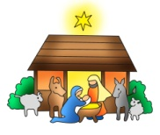

**2019 Christmas Eve Pageants**

**We are** **planning our annual** Christmas Eve Nativity Pageants at St. Jude & Immaculate Conception Churches! Children grades K-3 can participate. Sign up early, space is limited!! The pageants will be performed before the 4pm Masses at Immaculate Conception and St. Jude’s Church on Christmas Eve. If interested, please contact the following with your child’s name, gender, and age no later than **December 13th.**

**Contact information:**

**St. Jude’s -** Dottie Dhamer at [sassydot1@comcast.net](mailto:sassydot1@comcast.net) (preferred) or 443-350-7186. (Practice is Sunday, December 22nd after 9:00am Mass)

**ICC** - Kim Burnham at [ksburnham@comcast.net](mailto:ksburnham@comcast.net) (Practice is Saturday, Dec 21st at the 11:00am)

**Adoration for Vocations**

On the 1st Sunday of the month, exposition of the Blessed Sacrament occurs from 1pm-3pm in IC Chapel. Join us to pray for vocations. The next opportunity is **January 5th** Contact Dermott Mullan at 410-398-3368.

**angel tree gifts:**

THANK YOU to everyone who donated Angel Tree toys, clothing, or turkeys!! Your generous donations will help many members of our community this Christmas! Thank you for being an Angel to someone in need!!!

**Liturgical Ministers Next Week: *Dec. 14th & 15th***

***5:00 pm*** Mason H, Grace B •**EM’s:** Mary Anne E • **Lector:** Alison D • **Ushers:** Eileen P, William B Pat C, Bob E

***7:00 am***

•**Altar Servers**:Benedict J •**EMs:** Sandra H, Gerald M, Frank S • **Lector:** William K • **Ushers:** Charles M

***8:30 am***

**Altar Servers:** Jeremy M • **EMs:** Don H, Peter G, Cecilia G • **Lector:** Francis C • **Ushers:** Anthony D, Wendel S, Anthony M, Stephen C

***9:00 am (SJ)***

**Altar Servers:** Robert H, Joseph H • **EM’s:** Mary Anne S, Dorothy D, Narcy Z, Dorothy F, Les F • **Lector:** Michele C

• **Ushers:** Kevin O, Jule V, William D

***10:15 am***

**Altar Servers:** Donovan O, Justin M • **EM’s:** Barbara R, Richard L • **Lector:** Paula G • **Ushers:** Bob W, Steve A

**12:00 *noon***

**Altar Servers:** Damian W, Henry W •**EMs:**Mary L, Grace B, Kathy C • **Lector:** Brigid W • **Ushers:** Teresa G, Charles C



**Does your child need to be Baptized?**

The next Baptism Class is **January 13th**, 7:00-8:30 pm in the Parish Center. It’s never too early to prepare for the Baptism of your child. Parents are required and Godparents are encouraged to attend. Contact the Parish Office to register at 410-398-1100.

**Advent Holy Hour**

We will have an opportunity for adoration on **Wednesday, December 11** from 5:30 to 6:30pm at Immaculate Conception. This time of prayer will feature Taizé music, readings, and silence, ending with Benediction of the Blessed Sacrament. Come spend some time with Our Lord as we prepare to celebrate His birth!

**Children’s Liturgy of the Word**

CLW is for children 5-8 years old. Children under 5 are welcome if they are accompanied by a parent (not a sibling!)

**Children’s Liturgy**: We are looking for someone to take over coordinating Children’s Liturgy! If interested, please contact Vickie Eichler at 410-392-3551

**The Catechist for next Sunday, December 15th is:**

**Lindsay Partridge**

**ART IN ST. JUDE’S PRAYER ALCOVE:**

Please stop at the Prayer Alcove to spend a few moments in meditation before the icons created by parishioner Leona Papagno. Thank you, Leona!

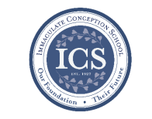**Immaculate Conception**

**School News**

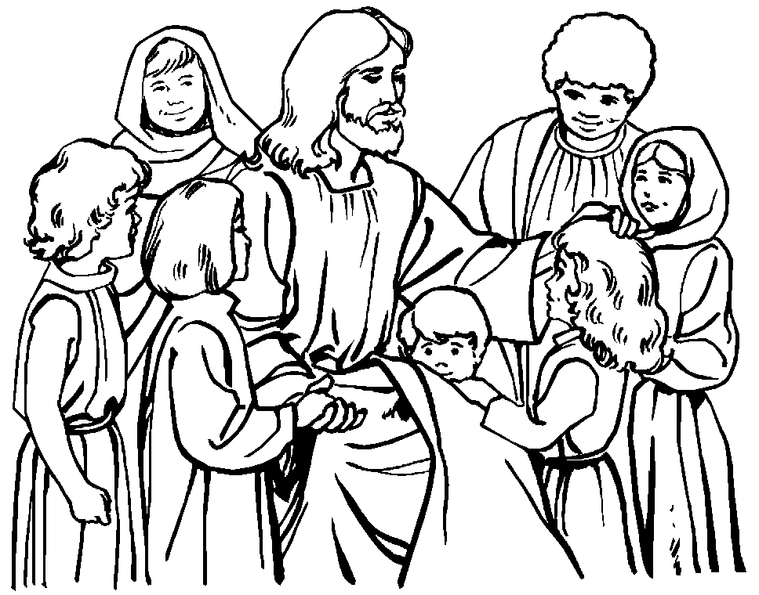**Have you seen our test scores?!**

ICS test scores are ranked in the 90th percentile compared to test scores from other schools across the Diocese! This is in part because of how passionate we are about our students’ education, small class sizes, and incredible staff!

“ICS offers a solid, traditional academic program which prepares students for success in high school and beyond. Teachers prepare meaningful academic lessons and students are very engaged and inquisitive throughout the school day. Assessment results indicate very strong achievement; on both the Renaissance STAR Math and Reading assessments, ICS students perform among the highest in the diocese.” - Diocese of Wilmington Office for Catholic Schools.

**Last Week...**

**NJHS Service:**

The ICS National Junior Honor Society will be going to volunteer at the Community Kitchen on **Friday, December 6th.** This is always such a meaningful event for the students as they give back to the community!

**Coming up…**

**Report Cards:**

The first trimester is quickly coming to an end! Our hardworking students will be getting their report cards from the first trimester on **Monday, December 9th**. We know they worked their hardest!

**Christmas Concert**

Grades Pre-K - 5th will get to show off their musical talents at the annual Christmas Concert on **December 12th**! Each grade will sing Christmas songs, and our beginner and advanced bands will show off all that they have learned from Ms. D’Amico!

**Special Person’s Lunch:**

Our 5th graders will have their family, friends, and loved ones join them for lunch on **December 19th** at 11:00am in the school cafeteria. The students love having their visitors stop by! Enjoy!!

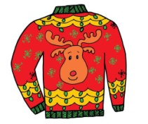**Christmas Holiday:**

The last day of school before the Christmas Holiday begins is December 20th!! School will resume on Thursday, January 2nd. Merry Christmas and Happy New Year!!

**Faith Formation**

**Religious Education & Sacraments**

**Religion Classes:** Classes will resume today, December 8th and Wednesday, December 11th

**First Reconciliation:** Meeting will be today, Sunday, December 8th at 2:00pm at ICC.

**Outreach:** December donations: Christmas food items!

***Rolling Lottery*** – is the only Religious Education fundraiser this year. We are asking for all families to participate in some way (buy a ticket, help sell tickets after Masses.)

**Youth Ministry & Confirmation**

#### whats-your-story

**CONFIRMATION**

#### Next class is today, Sunday, December 8th and Wednesday, December 11th.

**YOUTH GROUP – Grades 9 thru 12**

**Meetings are 6 – 8 pm in the parish center**

Next meeting tonight, Sunday, December 8th

**YOUTH MINISTRY WISH LIST:**

* We are asking for sodas (cans please!)

**JUNIOR YOUTH GROUP – Grades 6 thru 8**

Join us to grow in faith through fun and fellowship!

Next meeting today, Sunday, December 8th

**ADULT EDUCATION**

**Interested in a study group?** Many opportunities are available. Call the Religion Office at 410-392-3551.

***Adult Education classes*** –

The Sacred That Surrounds Us – will start on Monday, January 6th and Thursday, January 9th.

**Book Study**

Resumes on Tuesday, January 7th at 9:15 am in the parish center.

**SOCIAL CONCERNS**

**Outreach**

**Please consider donating** to the Outreach! Thank you so much to all those who have donated!! Thank you for your help, generosity, prayers, & donations to this essential ministry!!

**Holiday items:** We are collecting holiday food for Christmas!! **Please consider donating holiday food items to the parish outreach!**

**Food items:** We are in need of chicken noodle and tomato soups, pasta, and pasta sauce

**Non-Food Items:** Toothpaste, toothbrushes, and shampoo

**PARISH EVENTS/INFORMATION**



**Weekly Church Collections: Week of Dec. 1st**

ICC $8,958

St. Jude $1,817

Online $5,150

Total Offertory $15,925

**Keep up with regular offerings by giving electronically!!**

Just as you rely upon receiving income on a regular basis, we rely on your regular contributions. We greatly appreciate the efforts of our parishioners to make consistent donations throughout the year! To assist you, the church provides a convenient electronic giving option for setting up regular contributions! Simply visit our website and click the Online Giving Button!

**How does Online giving benefit you?**

1. It’s easy, convenient, and safe
2. Allows you to give any amount, any time.
3. Allows you to track your giving

**How does Online giving benefit the parish?**

1. Creates consistency of giving
2. Increases efficiency of processing giving

**How to sign up?**

1. Visit www.iccparish.org
2. Click “Go to Online Giving”
3. Sign up! It’s that easy!

**PARISH & FAMILY LIFE**

**Parish Coffee**

Please join us at St. Jude’s for Parish Coffee **Jan 5th** following the 9:00 Mass.

**Join us** for Parish Coffee TODAY, **Dec. 8th** after 8:30am and 10:15am Masses at ICC!

**PARISH EVENTS/INFORMATION**

**Basketball registration!**

Basketball is in need of two heads for Pre-JV and two heads for JV to make these teams a go! Please contact [Icshawkssports@gmail.com](mailto:Icshawkssports@gmail.com) if you are interested!

**Registration is OPEN!**

3rd & 4th grade boys and girls (co-ed) -- Pre-JV. Practices Tues/Thurs 5:30 to 6:30

5th & 6th grade boys - JV.

Practices Tues/Thurs 6:30 - 8 p.m.

7th & 8th grade boys - Varsity.

Practices Wed/Friday 6:30 - 8 p.m.

We are eligible for girls JV and Varsity teams too!  If we have any interested players or questions please

contact [icshawkssports@gmail.com](mailto:icshawkssports@gmail.com)



**The Immaculate Conception Rolling Lottery is back! A $20 chance can win you up to $1,500**! These make a great Christmas Gift!! We will be selling tickets after Masses on Nov 30 - Dec 1, and again on Dec 7-8. We will also be selling them in the Religious Ed office during Classes on Sundays/Wednesdays and at the Parish Center during business hours. Tickets will be sold through December. The rolling lottery will follow The Maryland Lottery Pick 3 for winners in January. The MSL draws twice a day, so ticket holders have 60 chances to win. The stakes go up $25 after each draw if nobody wins that draw. Proceeds benefit ICC Parish and Religious Education. This is not affiliated with the MSL.

**Emergency Rotating Shelter:**

ICC/St Jude will be participating in the 2020 Emergency Rotating Shelter. We are scheduled for the week of Jan 13-19 at Truth and Life Center, 1924 West Pulaski Highway, Elkton. Many volunteers are needed to help in this important mission of housing and feeding our homeless. There are many ways to help: preparing parts of a meal, hosting an evening, staying overnight, or just stopping in and visiting. For more information please contact Carol and Bill Dale, 410-287-9548, or email [dales7@comcast.net](mailto:dales7@comcast.net).

## KofC Logo

**Sunday, December 8**

8:20 AM - Confessions - SJ

11:00 AM - Coffee Sunday - IC

1:30 PM - Baptisms - IC

2:00 PM - 1st Reconciliation practice - IC

5:00 PM - Flute, Harp, Keyboard Concert-IC

6:00 PM - HS Gathering - PC

Monday, December 9

9:30 AM - Novena - CH

6:30 PM - Boys Varsity Basketball - gym

7:00 PM - Immaculate Conception Mass- IC

8:00 PM - AA Mtg -caf

Tuesday, December 10

9:00 AM - Holy Hour - CH

10:00 AM - ICS Reconciliation - IC

5:30 PM - Pre JV Basketball - gym

6:30 PM - Knights of Columbus Mtg - PC

6:30 PM - Girls JV Basketball - gym

6:30 PM - Handbell Rehearsal - IC

7:30 PM - Contemporary Rehearsal - IC

Wednesday, December 11

9:00 AM - Rosary Crusade / Novena-CH

9:30 AM - Cantor Reh - IC

1:00 PM - Leisure Club - PC

4:00 PM - Children’s Choir - PC

5:30 PM - Advent Holy Hour - IC

6:00 PM - Confirmation Class - PC

6:15 PM - Religious Ed - ICS

6:30 PM - JV Boys basketball - gym

8:00 PM - Varsity Basketball - gym

Thursday, December 12

9:00 AM - Rosary Crusade - CH

6:00 PM - ICS Christmas Concert - gym

6:30 PM - Boy Scouts - PC

6:30 PM - Cub Scouts - PC

6:30 PM - Cantor Reh - IC

7:00 PM - Parish Choir - IC

7:00 PM - RCIA - PC

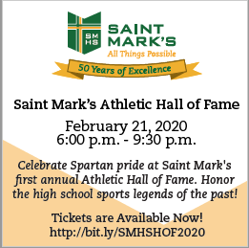

Friday, December 13 ICS ½ day

9:00 AM - Rosary Crusade - CH

7:00 PM - NA Mtg - Caf

**Saturday, December 14**

9:00 AM - Rosary Crusade - CH

4:15 PM - Confessions - IC

7:00 PM - NA Mtg - Caf

**community EVENTS/INFORMATION**

**Knights of Columbus**

***Bishop Becker Council 2427***

**Meetings:** 2nd & 4th Tuesdays of the month at 6:30 pm at the Parish Center

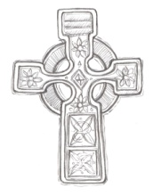**LAOH (The Ladies Ancient Order of Hibernians)**

The Ladies Ancient Order of Hibernians, Inc. Cecil County Division 1, an Irish Catholic Action group has meetings on the first Wednesdays of the month at 1:00pm in the Parish Center. Meetings run September through May. We are always looking for new members! If you are an Irish Catholic woman and want to serve your community, and learn more about your Irish heritage come join us! Please contact the historian, Betty Green at 410-392-5287



**Have you started your Holiday shopping yet??**

Did you know that when you shop for the holidays at [smile.amazon.com/ch/52-6015220](https://smile.amazon.com/gp/f.html?C=JY11A2HZ6P5O&K=15GG5P8RFW6OS&M=urn:rtn:msg:20191029140523f1195f2dfe184a69b3de15dd32f0p0na&R=37U11G4BVSQZ8&T=C&U=http%3A%2F%2Fsmile.amazon.com%2Fch%2F52-6015220&H=JQMAB6AKUPPIGGRGSADMKNBYZ9YA), AmazonSmile donates to Immaculate Conception Church? Shop at Amazonsmile.com this holiday season and you can help raise funds for our parish!

**WORLDWIDE MARRIAGE ENCOUNTER**

**Want to give a gift that keeps on giving?**  A gift filled with Romance and Excitement?  Enrich your relationship by attending a Worldwide Marriage Encounter Weekend on **March 6-8, 2020** in Rehoboth Beach, DE.  For more information visit our website at [www.wwme-delmar.org](http://www.wwme-delmar.org) or to register for the weekend, please call Tony and Linda Massino at 302-220-9833.

**Warm up for winter!**

Catholic Charities needs your help to warm up for winter! As temperatures decline, Catholic Charities is preparing to *warm up for winter* for its most vulnerable neighbors by collecting new and gently used blankets, bedding, coats, hats, and gloves at each of its office locations now through the end of January 2020. Locations will accept donations between the hours of 9 am - 4:30pm. Visit <http://www.ccwilm.org/> for more information.

**Saint Mark’s High School**

***Athletic Hall of Fame***

Saint Mark’s invites you to celebrate Spartan pride at Saint Mark’s 1st Annual Athletic Hall of Fame on **Friday, February 21, 2020 from 6:00 - 9:30 pm.**

Honor the high school sports legends of the past! **Tickets are Available Now! Visit** [**http://bit.ly/SMHSHOF2020**](http://bit.ly/SMHSHOF2020)