***From Father Jim***

**“At that time the Lord appointed 72 others whom he sent ahead of him in pairs to every town and place he intended to visit. He said to them ‘the harvest is abundant, but the laborers are few; so ask the master of the harvest to send out laborers into his harvest. Go on your way; behold, I am sending you like lambs among wolves.”**

Imagine being one of those sent. Who is your companion, as you go to bring the message of Jesus to someone else? Is your partner the talkative type? To whom will you go, either knocking on a door, stopping by a hospital, saying hello to someone on the street? Isn’t it interesting to wrestle with the answers?

Well, you are one of the lucky ones, not among the seventy-two, but among all the baptized to work in bringing in the harvest. If someone doesn’t do his or her part, the harvest fails, dies, or simply rots. It is out there and the Lord needs people to follow His call as priests and deacons, as religious and committed lay workers, as missionary disciples. The good thing is, we do not do it alone but the Lord accompanies you.

There is work to be done He is asking you to do it. Talk to someone about it today and fulfill your potential.

***Congratulations to those who were recently married in the parish:***

*Mr. and Mrs. Chris and Katie Webb*

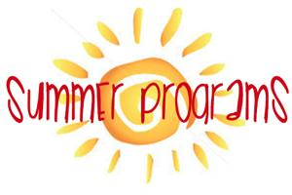**St. Jude’s 50th Anniversary**

**Photos of past St. Jude’s celebrations** will continue to be posted throughout the Church. Please contribute by placing pictures in the baskets marked for photos or turn them into the box in the Parish Center. We would love photos of special occasions or group photos!

**Our 9th Annual Golf Classic** is rescheduled for **July 15th** **at the Deerfield Country Club!!** Join us for a fun-filled day of golf, great food, and some amazing auction items and prizes! **Spaces for golfers are full**, but you can still participate by contributing auction Items, volunteering, or joining us for dinner! **Register online** at www.iccparish.org by scrolling through the banner photos. Contact the Parish Office at 410-398-1100 for more information.



**July 8, 2019**

8:30 am Ruth Viars

**July 9, 2019 St. Augustine Zhao Rong & companions**

8:30 am Patrick Hanyok

**July 10, 2019**

8:30 am Rosita Rodriguez

**July 11, 2019 St. Benedict, Abbot**

8:30 am Rosita Rodriguez

**July 12, 2019**

8:30 am Rosita Rodriguez

**July 13, 2019 St. Henry**

8:30 am Sr. Ursula Tisdall

5:00 pm Francis and Alda Guns

**July 14, 2019 Fourteenth Sunday in Ordinary Time**

7:00 am People of the Parish

8:30 am Edward and Patricia McCarthy

9:00 am SJ Irene Gottemoller

10:15 am Shannon Hensley

12:00 pm Sally George

**COMING UP:- ICS SUMMER PROGRAMS!!**

**Don’t Miss out!!** Immaculate Conception School is excited to offer three programs throughout the summer!

* **Our STEAM Spectacular camps are coming up!!** The first session starts **NEXT WEEK,** July 15th! There is a 2nd session during the week of August 5th. You won’t want to miss these awesome, science-filled adventures!
* **Avoid summer ‘brain-drain’** and sign up for one of our **tutoring programs!**
* **We are continuing Story-Time** for children aged 2-5. Gwen Davis reads classic children’s stories, provides themed activities, music, and snacks! Story-Time is FREE!!

**Contact Emily Murphy at** 410-398-2636 or [Emurphy@icschoolweb.org](mailto:Emurphy@icschoolweb.org) for more information or to register for any of these programs!

**Readings for next week:**

***Fifteenth Sunday in Ordinary Time***

**First Reading: Deuteronomy 30:10-14**

Moses petitions the people to follow the commandments God has set before them. He reminds them that the laws are not in the sky or far away at sea, but are accessible to them and meant to be followed if they wish to prosper.

**Second Reading: Colossians 1:15-20**

Paul discusses the divine nature of Jesus, and explains that Jesus was created before anything else. Everything else was "created through him, and for him."

**Gospel: Luke 10:25-37**

While discussing everlasting life, a lawyer mentions loving one's neighbor as oneself. The lawyer then asks Jesus, "Who is my neighbor?" Jesus tells him about a man beaten by robbers, who was ignored by both a priest and a Levite before a Samaritan stopped and offered him aid. Jesus asks the lawyer who was neighbor to the injured man. The lawyer says "the one who treated him with compassion." Jesus encourages him to go and do the same.

**Daily Readings:**

***Fourteenth Sunday in Ordinary Time***

**Sunday** ....................................... Is 66:10-14c; Gal 6:14-18;

Lk 10:1-12, 17-20 or 10:1-9

**Monday .**.................................... Gn 28:10-22a; Mt 9:18-26

**Tuesday** ....................................... Gn 32:23-33; Mt 9:32-38

**Wednesday** ......... Gn 41:55-57, 42:5-7a, 17-24a; Mt 10:1-7

**Thursday** ............ Gn 44:18-21, 23b-29, 45:1-5; Mt 10:7-15

**Friday** .................................. Gn 46:1-7, 28-30; Mt 10:16-23

**Saturday** .................. Gn 49:29-32, 50:15-26a; Mt 10:24-33

**The Cenacle of Divine Mercy** at Immaculate Conception will hold its next meeting next **Saturday, July 13th** from 10AM-12PM in the parish youth room. The meeting is open to all adult females in the parish. Join us for refreshments and hear the message of divine mercy. For more information contact Heather Ulmen at [hu_ntrprtr@outlook.com](mailto:hu_ntrprtr@outlook.com) .

**Adoration for Vocations**

On the 1st Sunday of the month, exposition of the Blessed Sacrament occurs from 1pm-3pm in IC Chapel. Join us to pray for vocations. The next opportunity is, TODAY, **July 7th.** Contact Dermott Mullan at 410-398-3368.

**Children’s Liturgy of the Word**

CLW is for children ages 5-8 only. Children who are

not in this category are asked to remain in church.

**There is NO CLW during the summer months!**

**Liturgical Ministers Next Week: *July 13 and 14***

***5:00 pm***

**Altar Servers:** AJ S, Nathan S •**EM’s:** Carol K, Mary Ann E, Mary Ann S •**Lector:** Paula G • **Ushers:** Pat C, Bob E, Eileen P, Bill B

***7:00 am***

**Altar Servers**: Benedict J • **EM’s:** Gerald M, Peter D, Ginnie D • **Lector:** Christopher W • **Ushers:** Charles M

***8:30 am***

**Altar Servers:** Cecilia G, Carolena G • **EMs:** Cecilia G, Peter G • **Lector:** John G • **Ushers:** Anthony D, Wendel S, Anthony M, Steve C

***9:00 am (SJ)***

**Altar Servers:** Robert H, Joseph H • **EM’s:** Chris H, Larry B, Patricia D, Narcy Z, Dorothy D • **Lector:** Monica V

• **Ushers:** Jule V, Bill D, Kevin O, Jake S

***10:15 am***

**Altar Servers:** Donovan O, Jeremy M • **EM’s:** Richard B, Betty B, Richard L • **Lector:** Tina B •**Ushers:** Bob W, Steve A

**12:00 *noon***

**Altar Servers:** Valerie O, Gabriel O • **EMs:** Cynthia J, Pat K, Charles C • **Lector:** Roberto O • **Ushers:** Teresa G

**St. Jude 50th Anniversary:**

**Letter from Fr. Anthony Giamello**

*As you know* Our Parish is celebrating the 50th Anniversary of St. Jude Church in 2019! Celebrate and Remember!

As part of our Celebration, we have invited priests who have served our parish to join us during the Anniversary Season. Fr. Anthony Giamello sent the following letter:

Dear ICC/SJ Parish,

Congratulations on the 50th Anniversary of St. Jude’s Mission Church. During my 8 months as Administrator, I always looked forward to traveling to North East to celebrate Sunday Mass there. It is a warm, welcoming, and vibrant community. Please be assured of my continued prayers for you and the community. Thank you for inviting me to one of your Masses, please forgive me if I’m not able to attend one of these Masses. As pastor of two churches myself, it is difficult to find coverage as I’m sure you know quite well. Once again, congratulations!

Sincerely, Rev. Anthony Giamello

#### 

**Does your child need to be Baptized?**

The next Baptism Class is **August 19th**, 7:00-8:30pm in the Parish Center. It’s never too early to prepare for the Baptism of your child. Parents are required to attend. Contact the Parish at 410-398-1100 to register.

**Immaculate Conception**

**School News**

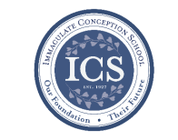

Our halls are quiet now that the students and staff are off for summer vacation! Looking back, it has been an amazing year! **Our students excelled in so many ways this year!** Or staff has proven their excellence and dedication again through the countless hours of planning and preparation to bring their lessons to life!

**Please keep our students and staff in your prayers** that they enjoy a wonderful and well-deserved summer break. They will return in the fall, ready to start another exciting year!

**Story time continues at ICS!**

Bring your little ones, ages 2-5 to ICS this summer! Gwen Davis will be reading classic children’s stories and providing themed activities, music, crafts, and snacks! **Story time is FREE!!** Your children will love it! The next story time is **this Wednesday, June 26th at 10:00am.** Please call 410-398-2636 to reserve your spot!

**If you are interested in learning more about ICS or would like to enroll your child,** please contact our Advancement Director, Emily Murphy at [emurphy@icschoolweb.org](mailto:emurphy@icschoolweb.org). Now is the time to consider the benefits of the strong, faith-based, challenging academic program that ICS provides.

**You may contact office personnel** including the secretary, principal, and advancement director any time during the summer. Phone and email messages will be checked regularly. Other school personnel are not required to monitor emails throughout the summer.

**office hours**

* **June:** 8:00am - 1:00pm Monday - Friday.
* **July & August**: 9:00a-1:00p Mon - Thurs.

**Contact Info:**

* Secretary [jwilson@icschoolweb.org](mailto:jwilson@icschoolweb.org).
* Principal - [bschilling@icschoolweb.org](mailto:bschilling@icschoolweb.org)
* Advancement Director:-

[emurphy@icshoolweb.org](mailto:emurphy@icshoolweb.org)

**Faith Formation**

**Religious Education & Sacraments**

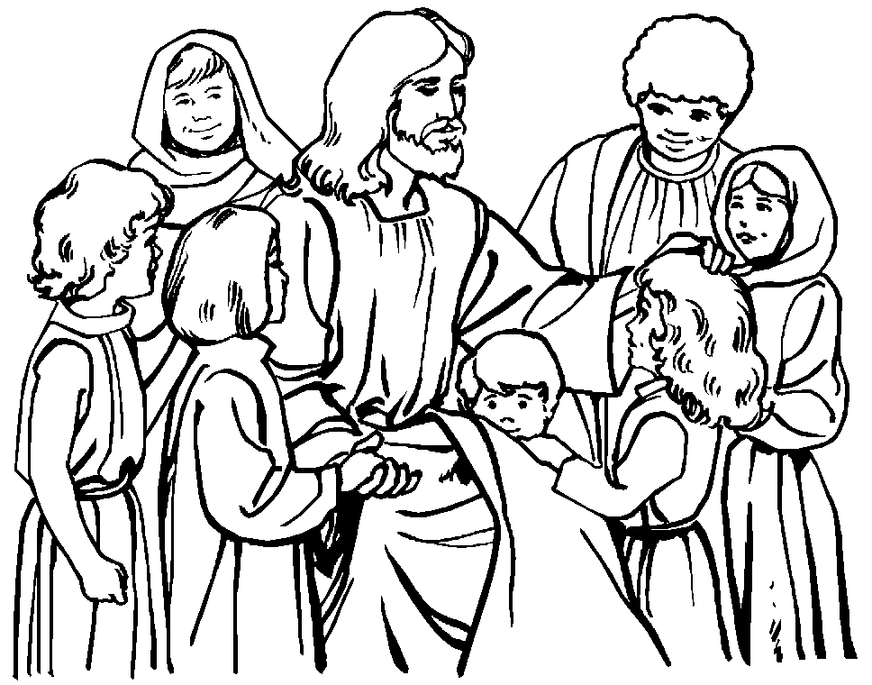

**Religion Classes:** Classes are filling up quickly, please register as soon as possible.

**We need Catechists and Assistants!** Would you like to share your Faith with the children of our parish? If so, please contact the Religious Ed office!

***We need of Catechists & Assistants in the following Classes:***

***Sunday***

Kindergarten: Catechist and Assistant

Gr 1: - Catechist Gr 2: - Assistant

Gr 3: - Catechist & Assistant Gr 4: - Catechist & Assistant

Gr 7: - Assistant Gr 8: - Assistant

***Wednesday***

Gr 1: - Assistant Gr 7: - Assistant

**Outreach Donations:** Please remember Outreach over the summer.

**Vacation Bible School:** Starts tonight Sunday, June 23rd at 6:00 pm. Thank you to everyone who is volunteering their time to make this happen for our children.

**This morning you are invited to Coffee and Donuts** in the school gym, where you can get a look at the awesome decorations and pick up your t-shirts and supplies.

**Youth Ministry & Confirmation**

#### whats-your-story

**CONFIRMATION**

We are accepting registrations for Confirmation in the spring of 2020. Contact the Religious Education office to register

**YOUTH GROUP - Summer Calendar**

**Meetings are from 6-8pm in the Parish Center**

**July 7th** – Meeting **July 14th** – No Meeting

**July 21st** – Meeting **July 28th** – No Meeting

**YOUTH MINISTRY WISH LIST:** Sodas (cans please!)

**YOUNG ADULT MINISTRY:**

If you feel called to this ministry please contact the Cheryl at 410-392-3551 or [youthministry@iccparish.org](mailto:youthministry@iccparish.org).

**ADULT EDUCATION**

**Interested in a study group?** Call the office at 410-392-3551.

**All Adult Education classes are over for the summer.**

**Adult Education classes** – We are looking for someone to help teach classes next year. If you are interested please contact Vickie at 410-392-3551 or [re@iccparish.org](mailto:re@iccparish.org).

**SOCIAL CONCERNS**

**Outreach**

Please consider donating to the Outreach! Thank you so much for your help, generosity, prayers, & donations to this essential ministry!!

**Food items:** baked beans and tuna

**Non-Food items:** shampoo, toothpaste, soap, laundry detergent, and deodorant.

**No clothing please!!** As much as we appreciate the gesture, we simply do not have the space to store them. Thank you!

**PARISH EVENTS/INFORMATION**



**Weekly Church Collections: Week of June 23rd**

ICC $7,294

St. Jude $1,951

Online $5,498

Total Offertory $14,743

**Keep up with regular offerings by giving electronically!!**

Just as you rely upon receiving income on a regular basis, we rely on your regular contributions. We greatly appreciate the efforts of our parishioners to make consistent donations throughout the year! To assist you, the church provides a convenient electronic giving option for setting up regular contributions! Simply visit our website and click the Online Giving Button!

**How does Online giving benefit you?**

1. It’s easy, convenient, and safe
2. Allows you to give any amount, any time.
3. Allows you to track your giving

**How does Online giving benefit the parish?**

1. Creates consistency of giving
2. Increases efficiency of processing giving

**How to sign up?**

1. Visit www.iccparish.org
2. Click “Go to Online Giving”
3. Sign up! It’s that easy!

**PARISH & FAMILY LIFE**

**Parish Coffee**

There will not be Parish Coffee in June at St. Jude’s. Please join us for Parish Coffee on **July 7th** following the 9:00 Mass.

Join us for Parish Coffee, **July 14th** after the 8:30 and 10:15am Mass at ICC!

**PARISH EVENTS/INFORMATION**



**We are looking for 4th - 8th boys AND girls** to join ICS JV and varsity soccer teams, or 4th – 8th Girls to join the JV & Varsity Volleyball teams. The CYM registration link will be up mid-June. If your child is interested, PLEASEsend an email to [icshawkssports@gmail.com](mailto:icshawkssports@gmail.com). Please include name, grade and contact information.

**Community Kitchen:** Our next Community Kitchen will be on **July 26th** at the Elkton Presbyterian Church. We are serving Sloppy Joes, pasta salad, watermelon, and wonderful desserts. We are asking for donations of hamburger rolls, pasta salad, or watermelon. We also need volunteers to help with prep and serving the meal. Our volunteers arrive at 11:00 and we are finished by 1:30. Money donations are also welcome, and if donating by check, just make it out to Immaculate Conception Church and write Community Kitchen on the Memo line. Thanks so much for your continued generosity. Please call Kathy Chamberlin at 410-398-7299, or Joyce Speakman at 610-597-3135 if you can help out with this luncheon.

**Longest Married Couple Project Winners:**

**Congratulations to parishioners, Bill and Amee McCarthy** who were nominated in the Worldwide Marriage Encounter’s “Longest Married Couple Project.” Bill and Amee, who have been married for 77 years, were selected as the “Longest Married Couple in the State of Maryland for 2019.” We are in awe of the love and commitment you have shown. You are a sign for all of us of the power of love shown in God’s precious gift of marriage. We can only imagine how many hearts and lives have been guided and blessed by your relationship throughout the years! What a glorious gift you have been given to journey through these many years as husband and wife! May God continue to bless you and your marriage! “So faith, hope, and love remain; and the greatest of these is love.” (1 Cor 13:13)

**SAVE YOUR REDNER’S RECEIPTS FOR OUTREACH!!** Thank you to those Parishioners who send in their Redner's Grocery Receipts! We need the 'Full Receipt’ to include the part that shows “Today's 1% Save A Tape Total.” Each receipt is counted using the sum found in this section. Without this information we cannot use the receipt. Outreach earns 1% of your purchase total. This money provides help to people in need. Please sign up to participate in the Redner's 1% Save A Tape program if you are not already a member.



**Sunday, July 7**

8:20 AM - Confessions - SJ

1:30 PM - Adoration for Vocations -CH

6:00 PM - HS Gathering - PC

Monday, July 8

9:30 AM - Novena - CH

7:00 PM - Boy Scout Patrol Ldr Mtg - PC

8:00 PM - AA Mtg

Tuesday, July 9

9:00 AM - Holy Hour - CH

6:30 PM - Knights of Columbus Mtg - PC

7:30 PM - Contemporary Rehearsal - IC

Wednesday, July 10

9:00 AM - Rosary Crusade / Novena-CH

9:30 AM - Cantor Rehearsal - IC

1:00 PM - Leisure Club - PC

Thursday, July 11

9:00 AM - Rosary Crusade - CH

6:30 PM - Cantor Rehearsal - IC

6:30 PM - Boy Scout Mtg - PC

7:00 PM - Parish Choir Rehearsal - IC

Friday, July 12

9:00 AM - Rosary Crusade - CH

7:00 PM - NA Mtg - Caf

**Saturday, July 13**

9:00 AM - Rosary Crusade - CH

10:00 AM - NA Group - Grounds

1:00 PM - Cenacle of Divine Mercy - PC

4:15 PM - Confessions - IC

7:00 PM - NA Mtg - Caf



**community EVENTS/INFORMATION**

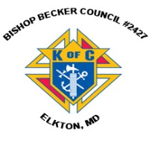**Knights of Columbus**

***Bishop Becker Council 2427***

**443-616-5370** or [**www.kofc2427.org**](http://www.kofc2427.org)

**Meetings:** 2nd & 4th Tuesdays of the month at 7:00 pm at the Parish Center

**LAOH (The Ladies Ancient Order of Hibernians)**

The Ladies Ancient Order of Hibernians, Inc. Cecil County Division 1, an Irish Catholic Action group has meetings on the first Wednesdays of the month at 1:00pm in the ICC Parish Center. Meetings run September through May. We are always looking for new members! If you are an Irish Catholic woman and want to serve your community, and learn more about your Irish heritage come join us! Contact Janice White, President at 410-378-3493

**Immaculate Conception is an affiliate Partner of The Franklin Institute!**

As a parishioner, you get 20% off discount pricing for admission and exhibits! Go to [www.fi.edu/affiliates](http://www.fi.edu/affiliates) and enter organization code: ICCPMGRP. **Check out some of the exhibits they are running:**

* This summer, our museum is being taken over by super heroes! The exhibit [*Marvel: Universe of Super Heroes*](https://www.fi.edu/exhibit/marvel-universe-super-heroes) opened on April 13th to record setting pre-sales, and is open until September 2nd.

**Listen to Catholic Forum every Saturday morning at 11:00** on Relevant Radio 640. Next Saturday, June 29th, tune in to meet the new pastor of St. John the Baptist/Holy Angels Parish in Newark, DE, Father Stanislao Esposito as he reflects on his nine years as pastor of St. Mary Star of the Sea/Holy Savior Parish in Ocean City, MD. After it airs, listen online anytime at [www.cdow.org/CatholicForum](http://www.cdow.org/CatholicForum), or search “Catholic Forum” on Apple, Spotify, or iHeartRadio podcasts. For photos, information regarding upcoming guests, links and more, “Like” Catholic Forum on Facebook at [www.facebook.com/catholicforum](http://www.facebook.com/catholicforum).

**Annual St. Joseph Parish Carnival -Middletown**

Join us July 16 - July 20 for exciting rides, games and nightly entertainment under the big top! Special children's game area! MegaPass-ride all week is only $45! July 16th and 17th are Family Nights: $25/night/per person/ all rides! NEW THIS YEAR--Huge Gift Basket Auction all week in the Parish Hall!! Delicious meals in our air- conditioned Hall beginning at 5:30 pm Tuesday-Thursday. Outdoor dining, rides and games begin at 6:00 p.m. nightly. FREE admission and parking! More information, call the Parish Office at 302-378-5800 or [www.stjosephmiddletown.com](http://www.stjosephmiddletown.com).

**Annual Catholic Appeal**

THANK YOU to everyone who made a pledge to the diocesan Annual Catholic Appeal! Giving to the Appeal greatly helps our Parish! We are so close to meeting our parish goal! We are only $5,815 away in pledges! If you have not yet participated, please consider doing so today! Thank you for your generosity and support! To learn more, visit [www.cdow.org](http://www.cdow.org). Click “Giving” then “Annual Catholic Appeal.”