***From Father Jim***

**“I have much more to tell you but you cannot bear it now. But when he comes, the Spirit of truth, he will guide you to all truth. He will not speak on his own, but he will speak what he hears, and will declare to you the things that are coming… Everything that the Father has is mine; for this reason I have told you that he will take from what is mine and declare it to you.”**

The great celebration of the Trinity calls us to learn, listen and live in the presence of the creating Father, the redeeming Son, moved by the Spirit. We reflect upon a mystery we cannot fully explain or understand, but worship a loving God who is One, but Three Persons. We profess our faith in this mystery every time we pause and bless ourselves. We speak our faith every Sunday when we recite the creed.

Throughout history countless attempts have been made to help us understand a mystery beyond our comprehension, yet the scriptures reveal the presence of our Triune God. What can I do about it? Two common examples might help. As you look at your watch (not a digital one) did you ever wonder how it works? As you put your key to unlock a door, did you ever try to understand the mystery how it works?

Today we reflect upon the God who loves us, knows us, supports us, and we struggle to say ‘thank you’ Father, Son and Holy Spirit.

**Our 9th Annual Golf Classic** was postponed until July 15th **at the Deerfield Country Club!!** Join us for a fun-filled day of golf, great food, and some amazing auction items and golf prizes! **Spaces are limited!!** You can participate by, sponsoring, contributing auction Items, volunteering, or joining us for dinner! **Register online** at www.iccparish.org by scrolling through the banner photos. Contact the Parish Office at 410-398-1100 for more information.

**Corpus Christi Procession, June 23rd**

On the Feast of Corpus Christi, the Body and Blood of Christ, we will have a Eucharistic procession after the 12:00 Mass on June 23. Our Lord in the Eucharist will be carried to the church office, field, school, and back to the church, along with prayers and hymns. Please plan to join us for this beautiful tradition.

***Congratulations to those who were recently baptized:***

*Jaxon Alan Basl*

*Thomas Mays Boettcher*

*Eleanor Beatrice Danos*

*Caroline Rose Payne*

***Congratulations to the couples who were recently married in the parish:***

*Mr. and Mrs. Ryan and Jessica Adams*

*Mr. and Mrs. Michael and Charlotte Biggs*

***We extend a warm welcome to our new Parishioners:***

*Mr. and Mrs. David and Leisa Boyer*

***We extend our condolences and prayers to the families of those who have recently died:***

*Mr. Paul Barker*

*Mr. Daniel Graham*



**June 17, 2019**

8:30 am Fathers of the Parish

**June 18, 2019**

8:30 am Fathers of the Parish

**June 19, 2019 St. Romuald, Abbot**

8:30 am Fathers of the Parish

**June 20, 2019**

8:30 am Fathers of the Parish

**June 21, 2019 St. Aloysius Gonzaga, Religious**

8:30 am Fathers of the Parish

**June 22, 2019 Sts. Paulinus of Nola, John Fisher and Thomas Moure, Bishops and Martyrs**

8:30 am Fathers of the Parish

5:00 pm Daniel L. McMenamin Jr.

**June 23, 2019 The Most Holy Body and Blood of Christ (Corpus Christi)**

7:00 am Itico Tanaka

8:30 am Miko and Tillie Blendy

9:00 am SJ John Gottemoller

10:15 am People of the Parish

12:00 pm John Hanyok

**Readings for next week:**

***The Most Holy Body and Blood of Christ (Corpus Christi)***

**First Reading: Genesis 14:18-20**

Melchizedek, a priest of God, prayed that Abram would be blessed by God. He also praised God for delivering Abram's foes into his hands.

**Second Reading: 1 Corinthians 11:23-26**

Paul describes Jesus' actions during the last supper. Jesus broke bread and said it was his body given for us, asking that we do the same in remembrance of him. He then passed the cup and called it his blood. Jesus then asked us to break bread in this manner to remember his death until he returns.

**Gospel: Luke 9:11b-17**

Jesus spoke to a large crowd when his disciples asked that he dismiss the people to give them a chance to find food and lodging. Jesus asked the disciples to give the crowd something to eat, but they had only five loaves of bread and two fish. Jesus then blessed and distributed the food, which fed about 5,000 people. Twelve baskets were then collected from what was left over.

**Daily Readings:**

***The Most Holy Trinity***

**Sunday** ................... Prv 8:22-31; Rom 5:1-5; Jn 16:12-15

**Monday .**.................................. 2 Cor 6:1-10; Mt 5:38-42

**Tuesday** .................................... 2 Cor 8:1-9; Mt 5:43-48

**Wednesday** ...................... 2 Cor 9:6-11; Mt 6:1-6, 16-18

**Thursday** .................................. 2 Cor 11:1-11; Mt 6:7-15

**Friday** ............................. 2 Cor 11:18, 21-30; Mt 6:19-23

**Saturday** ................................ 2 Cor 12:1-10; Mt 6:24-34

**The Cenacle of Divine Mercy** at Immaculate Conception will hold its next meeting on Saturday, July 13th from 10AM-12PM in the parish youth room. The meeting is open to all adult females in the parish. Join us for refreshments and hear the message of divine mercy. For more information contact Heather Ulmen at [hu_ntrprtr@outlook.com](mailto:hu_ntrprtr@outlook.com) .

**Adoration for Vocations**

On the 1st Sunday of the month, exposition of the Blessed Sacrament occurs from 1pm-3pm in IC Chapel. Join us to pray for vocations. The next opportunity is, **July 7th.** Contact Dermott Mullan at 410-398-3368.

**Children’s Liturgy of the Word**

CLW is for children ages 5-8 only. Children who are

not in this category are asked to remain in church.

**There is NO CLW during the summer months!**

**Liturgical Ministers Next Week: *June 22 and 23***

***5:00 pm***

**Altar Servers:** Mason H, Grace B •**EM’s:** Jule M, Carol K

• **Lector:** Tina B • **Ushers:** Pat C, Bob E, Eileen P

***7:00 am***

**Altar Servers**: Jacob B, Sarah B • **EM’s:** Frank S, Sandra H, Alan S • **Lector:** Christopher W • **Ushers:** Charles M

***8:30 am***

**Altar Servers:** Alex L, Sean M • **EMs:** Peter G, Cecilia G, Don H • **Lector:** John G • **Ushers:** Anthony D, Wendel S, Anthony M, Steve C

***9:00 am (SJ)***

**Altar Servers:** Mitchell H, Robert H • **EM’s:** Cheryl N, Pat D, John N, Dotty F, Les F • **Lector:** Marcia B • **Ushers:** Jule V, Bill D, Kevin O

***10:15 am***

**Altar Servers:** Hayden S, Hendric S • **EM’s:** Helen B, Richard B, Elizabeth B • **Lector:** Nora W •**Ushers:** Bob W, Steve A

***12:00 noon***

**Altar Servers:** Alex F, Andrew F • **EMs:** Pat K, Grace B, Corazon S • **Lector:** Frank E • **Ushers:** Teresa G, Charles C

**St. Jude Memories By: Bill and Bette Green**

Bette and I, and our three young daughters, Susan, Leigh, and Pam, moved to Elk Neck in the summer of 1970. We found that we were in Immaculate Conception Parish, with the main church on Bridge St. in Elkton, and a newly-constructed St. Jude Mission Church in North East. We began attending the 9:00 Mass at St. Jude. Fr. James Eckrich was pastor and Fr. Michael Gallagher was the associate. Within a few months, I was asked by Bud Shivery to be a lector. There were only a couple of a dozen year-round families attending St. Jude at that time, although attendance swelled during the summer months with boaters, campers, and scouts. You could always tell when the scouts arrived from the smell of the campfire. Like Jule Vaccarini and Kevin O’Donnell today, we had Fred Foster and Ernie Wood, dedicated men, who week in, and week out, would open the church for Mass and serve as ushers. The baton was later passed to Eddie Purnell and Paul Ward. There was no choir in the early days. Connie La Monica led the music, often A cappella. Her daughter, Jo Ward, later started a choir. We were blessed to have priests of the Oblates of St. Francis de Sales nearby. Fr. Joseph Dunn, Fr. Joseph Stafford, and Fr. Tony Larry were regular celebrants of Mass at St. Jude.

(To be continued next week.)

**Immaculate Conception**

**School News**

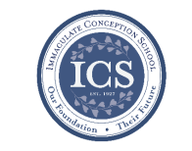

**Dear ICS Families:**

As we have reached the conclusion of the 2018-2019 school year, it is imperative that I express my thanks and gratitude for allowing me to be a part of your children’s lives.

**I am delighted to highlight** some of the activities, events, and workshops that have taken place at our wonderful school over the past year: Curtis Blues, Maryland Agriculture Science Lab, Challenge Island, Girls in STEM, Story Time, 7th Grade Mock Trial, Middle School History field trip, Trunk-or-Treat, Vocations field grip, American Legion school program, Christmas Bazaar, animal shelter drive, coat drive, monthly food drive, Toys for Tots, Christmas concert, Science and Math Olympiad, VFW Essay Contest, Spelling Bee, Geography Bee, 8th Grade Community Kitchen volunteering, Pi-Day, Renaissance Program, Talent Show, Waffles and Raffles, Spanish, Stuck for a Buck, Science Fair, Franklin Institute, Walnut Street Theater, Historic Old New Castle trip, NJHS Induction, 8th Grade retreat, Special Persons’ Lunch, Book Fair, 1st Friday Masses, Plumpton Park Zoo, Hershey Park, Spring Concert, School-wide bowling trip, 3rd grade Living Museum, Honk Jr., 8th Grade Washington DC Trip, and Field Day. In addition, we had a comprehensive state-of-the-art security camera system installed. Students also enjoyed special lunches almost every week from Luisa’s Chick-Fil-A, Roma’s and PSO.

**The ICS staff works endlessly** to ensure that your sons and daughters are receiving a world-class education embedded in the principles of our Catholic faith. Without a superior staff and the never-ending support of the PSO, and volunteers, this would not be possible. Together, we are all giving our children the gifts they need to truly make the world a better place.

Thank you, and have a wonderful summer!

Sincerely, Mr. William Schilling, Principal

**You may contact office personnel** including the secretary, principal, and advancement director any time during the summer. Phone and email messages will be checked regularly. Other school personnel are not required to monitor emails throughout the summer.

**office hours**

* **June:** 8:00am - 3:00pm Monday - Friday.
* **July & August**: 9:00a-1:00p Mon - Thurs.

**Contact Info:**

* Secretary [jwilson@icschoolweb.org](mailto:jwilson@icschoolweb.org).
* Principal - [bschilling@icschoolweb.org](mailto:bschilling@icschoolweb.org)
* Advancement Director:- [emurphy@icshoolweb.org](mailto:emurphy@icshoolweb.org)

**Faith Formation**

**Religious Education & Sacraments**

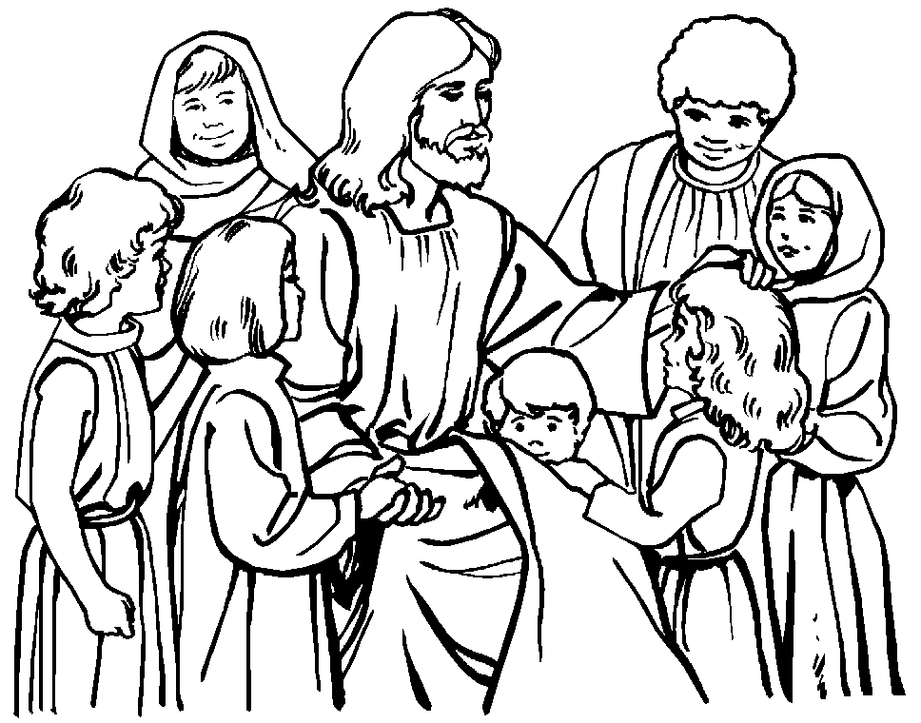

**Religion Classes:** We have approximately 27 families who have not re-registered for classes next year. We need your registration to order books and supplies for next year.

**Outreach Donations**: Please remember Outreach items!

**Vacation Bible School:** Registrations are being accepted for Vacation Bible School. Children will have lots of fun as we “ROAR” the week of Sun, June 23 - Thurs, June 27 from 6:00 to 8:30 pm. VBS is for students in Pre-K through incoming 6th graders. Registrations are at the parish center and online.

**VBS Wish list**: quart & gallon zip lock bags, rolls of brown craft paper, duct and packing tape, green poster board, large cardboard boxes.

**Youth Ministry & Confirmation**

#### whats-your-story

**CONFIRMATION**

We are presently accepting registrations for Confirmation in the spring of 2020. If you need to register please contact the Religious Education office.

**YOUTH GROUP - Summer Calendar**

June 16th – No Meeting – Father’s Day

June 23rd – No Meeting – Vacation Bible School

June 30th – Meeting

July 7th – Meeting

July 14th – No Meeting

July 21st – Meeting

July 28th – No Meeting

**YOUTH MINISTRY WISH LIST:** Sodas (cans please!)

**ADULT EDUCATION**

**Interested in a study group?** Call the Office at 410-392-3551.

**All Adult Education classes are over for the summer.**

***Adult Education classes*** – We are looking for someone to help Pat teach the classes next year. If you are interested please contact Vickie in the Religion Office at 410-392-3551 or [re@iccparish.org](mailto:re@iccparish.org)

**SOCIAL CONCERNS**

**Outreach**

Please consider donating to the Outreach! Thank you so much for your help, generosity, prayers, & donations to this essential ministry!!

**Food items:** cereal

**Non-Food items:** shampoo, toothpaste, toothbrushes, laundry deodorant, liquid dish soap, and diapers

**No clothing please!!** As much as we appreciate the gesture, we simply do not have the space to store them. Thank you!

**PARISH EVENTS/INFORMATION**



**Weekly Church Collections: Week of June 9th**

ICC $8,358

St. Jude $2,181

Online $3,911

Total Offertory $14,450

**Keep up with regular offerings by giving electronically!!**

Just as you rely upon receiving income on a regular basis, we rely on your regular contributions. We greatly appreciate the efforts of our parishioners to make consistent donations throughout the year! To assist you, the church provides a convenient electronic giving option for setting up regular contributions! Simply visit our website and click the Online Giving Button!

**How does Online giving benefit you?**

1. It’s easy, convenient, and safe
2. Allows you to give any amount, any time.
3. Allows you to track your giving

**How does Online giving benefit the parish?**

1. Creates consistency of giving
2. Increases efficiency of processing giving

**How to sign up?**

1. Visit www.iccparish.org
2. Click “Go to Online Giving”
3. Sign up! It’s that easy!

**PARISH & FAMILY LIFE**

**Parish Coffee**

There will not be Parish Coffee in June at St. Jude’s. Please join us for Parish Coffee on **July 7th** following the 9:00 Mass.

Join us for Parish Coffee, **July 14th** after the 8:30 and 10:15am Mass at ICC!

**PARISH EVENTS/INFORMATION**

**We are looking for 4th - 8th boys AND girls** to join ICS JV and varsity soccer teams, or 4th – 8th Girls to join the JV & Varsity Volleyball teams. The CYM registration link will be up mid-June. If your child is interested, PLEASEsend an email to [icshawkssports@gmail.com](mailto:icshawkssports@gmail.com). Please include name, grade and contact information.

#### 

**Does your child need to be Baptized?**

The next Baptism Class is **August 19th**, 7:00-8:30pm in the Parish Center. It’s never too early to prepare for the Baptism of your child. Parents are required to attend. Contact the Parish at 410-398-1100 to register.

**Annual Catholic Appeal**

“*Disciples of Christ, Witnesses of Faith”*

THANK YOU to everyone who made a pledge to the diocesan Annual Catholic Appeal! Giving to the Appeal greatly helps our Parish! We are so close to meeting our parish goal! We are only $5,815 away in pledges! If you have not yet participated, please consider doing so today! Thank you for your generosity and support! To learn more, visit [www.cdow.org](http://www.cdow.org). Click “Giving” then “Annual Catholic Appeal.”

**St. Jude’s 50th Anniversary**

**Photos of past St. Jude’s celebrations** will continue to be posted throughout the Church. Please contribute by placing pictures in the baskets marked for photos or turn them into the box in the Parish Center. We would love photos of special occasions or group photos!



**Sunday, June 16**

8:20 AM - Confessions - SJ

10:30 AM - Baptisms - SJ

12:00 PM - VBS set-up - gym/ICS

6:00 PM - HS Gathering - PC

Monday, June 17

9:30 AM - Novena - CH

12:00 PM - VBS set-up - gym/ICS

8:00 PM - AA Mtg - Caf

Tuesday, June 18

9:00 AM - Holy Hour - CH

12:00 PM - VBS set-up - gym/ICS

6:00 PM - Christmas Bazaar Mtg - PC

7:30 PM - Contemporary Rehearsal - IC

Wednesday, June 19

9:00 AM - Rosary Crusade / Novena-CH

12:00 PM - VBS set-up - gym/ICS

Thursday, June 20

9:00 AM - Rosary Crusade - CH

12:00 PM - VBS set-up - gym/ICS

6:30 PM - Cantor Rehearsal - IC

6:30 PM - Boy Scout Mtg - PC

7:00 PM - Parish Choir Rehearsal - IC

Friday, June 21

9:00 AM - Rosary Crusade - CH

12:00 PM - VBS set-up - gym/ICS

7:00 PM - NA Mtg - Caf

**Saturday, June 22**

9:00 AM - Rosary Crusade - CH

12:00 PM - VBS set-up - gym/ICS

4:15 PM - Confessions - IC

7:00 PM - NA Mtg - Caf



**community EVENTS/INFORMATION**

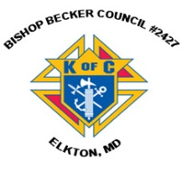**Knights of Columbus**

***Bishop Becker Council 2427***

**443-616-5370** or [**www.kofc2427.org**](http://www.kofc2427.org)

**Meetings:** 2nd & 4th Tuesdays of the month at 7:00 pm at the Parish Center

**LAOH (The Ladies Ancient Order of Hibernians)**

The Ladies Ancient Order of Hibernians, Inc. Cecil County Division 1, an Irish Catholic Action group has meetings on the first Wednesdays of the month at 1:00pm in the ICC Parish Center. Meetings run September through May. We are always looking for new members! If you are an Irish Catholic woman and want to serve your community, and learn more about your Irish heritage come join us! Contact Janice White, President at 410-378-3493

**Immaculate Conception is an affiliate Partner of The Franklin Institute**

As a parishioner, you get 20% off discount pricing for admission and exhibits! Go to [www.fi.edu/affiliates](http://www.fi.edu/affiliates) and enter organization code: ICCPMGRP. **Check out some of the exhibits they are running:**

* This summer, our museum is being taken over by super heroes! The exhibit [*Marvel: Universe of Super Heroes*](https://www.fi.edu/exhibit/marvel-universe-super-heroes) opened on April 13th to record setting pre-sales, and is open until September 2nd.

**Listen to Catholic Forum every Saturday morning at 11:00** on Relevant Radio 640. Tune in Saturday, June 22nd, to hear about Religious Freedom Week with guest, Hillary Byrnes, Director of Religious Liberty at the USCCB. Listen online at [www.cdow.org/CatholicForum](http://www.cdow.org/CatholicForum) or search “Catholic Forum” on Apple, Spotify, or iHeartRadio podcasts. For photos, information regarding upcoming guests, links and more, “Like” Catholic Forum on Facebook at [www.facebook.com/catholicforum](http://www.facebook.com/catholicforum).

**Prayer Service:**

On Monday, August 19th, from 12 noon-1pm, the same date and time of the 4th Apparition of Fatima, a public Prayer Vigil will be held for our Bishop, ourselves, and Holy Mother Church. Following the Prayer Vigil, Bishop Malooly will Consecrate our Diocese to Mary's Immaculate Heart. This special event will take place near Our Lady of Peace Statue outside of Holy Spirit parish in New Castle. Everyone, please come.

**Religious Freedom Week 2019: Strength in Hope** takes place from June 22 - 29. The Week begins with the Feast of Sts. John Fisher and Thomas More, ends with the Solemnity of Sts. Peter and Paul, and includes the Feast of the Nativity of St. John the Baptist. During Religious Freedom Week, Catholics are encouraged to pray and act each day for religious freedom. The Pray-Reflect-Act series aims to help Catholics build solidarity with those who are persecuted and find strength to carry out their missions **Thank you for your support for Religious Freedom Week** and for your united voices in the defense of religious freedom! Learn more at **www.usccb.org/ReligiousFreedomWeek**



**June 17, 2019**

8:30 am Fathers of the Parish

**June 18, 2019**

8:30 am Fathers of the Parish

**June 19, 2019 St. Romuald, Abbot**

8:30 am Fathers of the Parish

**June 20, 2019**

8:30 am Fathers of the Parish

**June 21, 2019 St. Aloysius Gonzaga, Religious**

8:30 am Fathers of the Parish

**June 22, 2019**

8:30 am Fathers of the Parish

5:00 pm Daniel L. McMenamin Jr.

**June 23, 2019 The Most Holy Body and Blood of Christ (Corpus Christi)**

7:00 am Itico Tanaka

8:30 am Miko and Tillie Blendy

9:00 am SJ John Gottemoller

10:15 am People of the Parish

12:00 pm John Hanyok



**June 17, 2019**

8:30 am Fathers of the Parish

**June 18, 2019**

8:30 am Fathers of the Parish

**June 19, 2019 St. Romuald, Abbot**

8:30 am Fathers of the Parish

**June 20, 2019**

8:30 am Fathers of the Parish

**June 21, 2019 St. Aloysius Gonzaga, Religious**

8:30 am Fathers of the Parish

**June 22, 2019**

8:30 am Fathers of the Parish

5:00 pm Daniel L. McMenamin Jr.

**June 23, 2019 The Most Holy Body and Blood of Christ (Corpus Christi)**

7:00 am Itico Tanaka

8:30 am Miko and Tillie Blendy

9:00 am SJ John Gottemoller

10:15 am People of the Parish

12:00 pm John Hanyok



**June 17, 2019**

8:30 am Fathers of the Parish

**June 18, 2019**

8:30 am Fathers of the Parish

**June 19, 2019 St. Romuald, Abbot**

8:30 am Fathers of the Parish

**June 20, 2019**

8:30 am Fathers of the Parish

**June 21, 2019 St. Aloysius Gonzaga, Religious**

8:30 am Fathers of the Parish

**June 22, 2019**

8:30 am Fathers of the Parish

5:00 pm Daniel L. McMenamin Jr.

**June 23, 2019 The Most Holy Body and Blood of Christ (Corpus Christi)**

7:00 am Itico Tanaka

8:30 am Miko and Tillie Blendy

9:00 am SJ John Gottemoller

10:15 am People of the Parish

12:00 pm John Hanyok



**June 17, 2019**

8:30 am Fathers of the Parish

**June 18, 2019**

8:30 am Fathers of the Parish

**June 19, 2019 St. Romuald, Abbot**

8:30 am Fathers of the Parish

**June 20, 2019**

8:30 am Fathers of the Parish

**June 21, 2019 St. Aloysius Gonzaga, Religious**

8:30 am Fathers of the Parish

**June 22, 2019**

8:30 am Fathers of the Parish

5:00 pm Daniel L. McMenamin Jr.

**June 23, 2019 The Most Holy Body and Blood of Christ (Corpus Christi)**

7:00 am Itico Tanaka

8:30 am Miko and Tillie Blendy

9:00 am SJ John Gottemoller

10:15 am People of the Parish

12:00 pm John Hanyok