***From Father Jim***

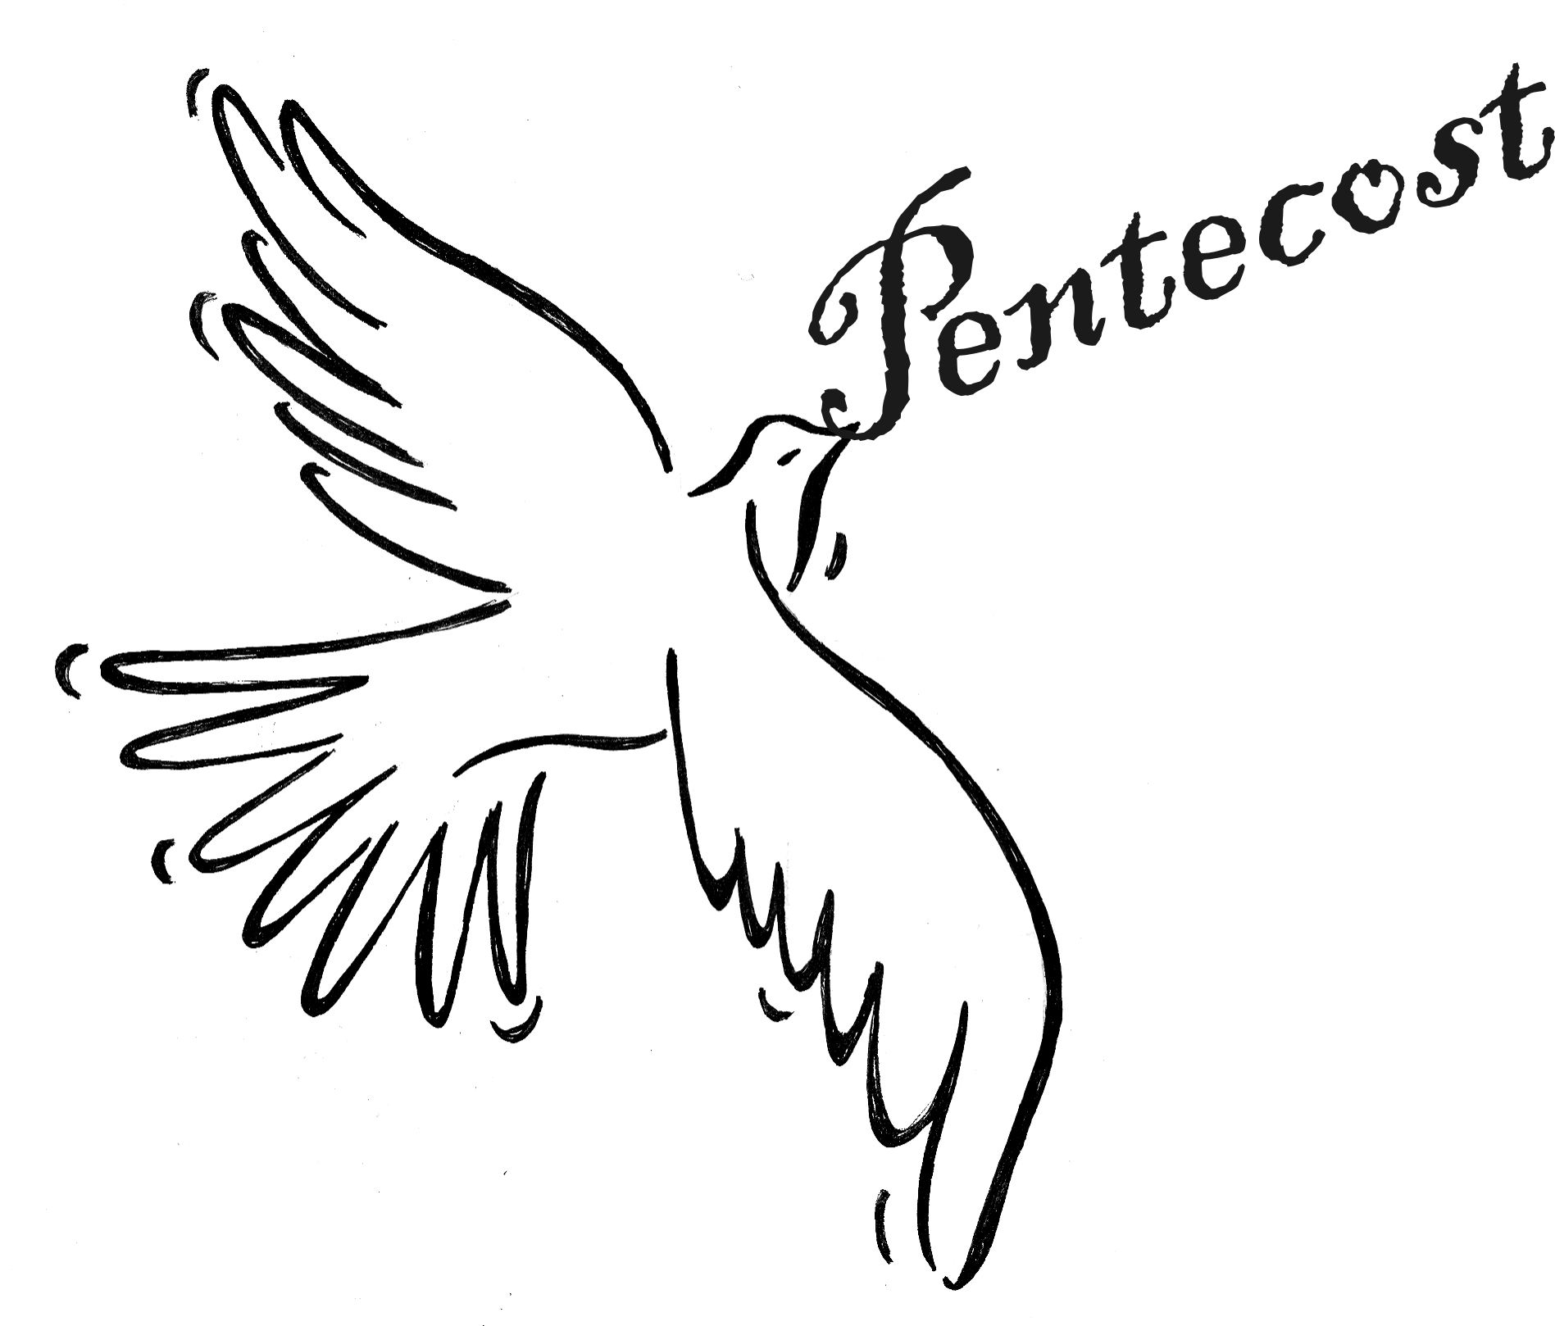

**“In the same way, the Spirit too comes to the aid of our weakness; for we do not know how to pray as we ought, but the Spirit himself intercedes with inexpressible groaning. And the one who searches hearts knows what is the intention of the Spirit because he intercedes for the holy ones according to God’s will.”**

The promised Spirit has come and gives life to the church. Pentecost was not just an event or experience, but the beginning of a movement that continues this very moment. The visible of wind, fire, and noise may have subsided but the event becomes our experience.

The movement which began in the upper room spread to the streets of Jerusalem, and moves us today. Our church, enlivened and motivated by the same Spirit summons us to go out and transform a world seemingly distant from the gospel and its values. The Spirit, living in us, yearns to touch the lives of others. Because of the Holy Spirit we too have been changed, let the Spirit move you, or as Paul says, ‘don’t stifle the Spirit.’ We are accountable.

**Our 9th Annual Golf Classic** is TOMORROW!! It is going to be held on Monday, **June 10th, 2019 at the Deerfield Country Club!!** Join us for a fun-filled day of golf, great food, and some amazing auction items and golf prizes! **Spaces are limited!!** You can participate by golfing, sponsoring, contributing auction Items, Volunteering, or joining us for dinner! **Register online** at www.iccparish.org by scrolling through the banner photos. Contact the Parish Office at 410-398-1100 for more information.

**Corpus Christi Procession, June 23rd**

On the Feast of Corpus Christi, the Body and Blood of Christ, we will have a Eucharistic procession after the 12:00 Mass on June 23. Our Lord in the Eucharist will be carried to the church office, field, school, and back to the church, along with prayers and hymns. Please plan to join us for this beautiful tradition.

**St. Jude’s 50th Anniversary**

Last Sunday, June 2, the community of parishioners at St. Jude’s Church kicked off the 50th Anniversary celebration of our church in North East. Prior to the beginning of Mass, individual members of the congregation placed flowers at the altar, commemorating all who have shared in our 50 years of worship. Fr. Jim, wearing brand new vestments, which were generously donated by the Knights of Columbus, celebrated Mass for the Ascension of the Lord. Our Parish Contemporary Choir provided wonderful music, including selections of hymns which had been previously used for the 10th, 20th, and 25th anniversary celebrations. “Dressing the altar,” a traditional practice at St. Jude’s, was resurrected, as Patty Banas and Carol Vaccarini brought up the altar cloth and placed it on the altar. After a joyful celebration of the Mass, those who attended enjoyed brunch, fellowship, and perfect weather!



**June 10, 2019**

8:30 am Brad Kam (Living Intention)

**June 11, 2019 St. Barnabas, Apostle**

8:30 am Patrick Hoefler

**June 12, 2019**

8:30 am Ray Galasco

9:30 am ICS Closing Ceremony

**June 13, 2019 St. Anthony of Padua**

8:30 am Alicia Schweizer

**June 14, 2019**

8:30 am Catherine Travers

**June 15, 2019**

8:30 am Sarah Hagelin

5:00 pm Gemma Davis

**June 16, 2019 The Most Holy Trinity**

7:00 am Fathers of the Parish

8:30 am Laura and Earl Koch

9:00 am SJ Jake Williams

10:15 am Ray Burkle

12:00 pm People of the Parish

**St. Jude’s 50th Anniversary**

**Photos of past St. Jude’s celebrations** will continue to be posted throughout the Church. Please contribute by placing pictures in the baskets marked for photos or turn them into the box in the Parish Center. We would love photos of special occasions or group photos!

**Readings for next week:**

***Pentecost Sunday***

**First Reading: Proverbs 8:22-31**

God created Wisdom before he created the earth or the skies. This spirit stood beside God every day until the earth was complete, then "found delight in the people of the earth." This indicates that the spirit of wisdom was later personified by Jesus.

**Second Reading: Romans 5:1-5**

Paul says that we are now at peace with God through our faith in Jesus. We also hope to see the glory of God. This hope will not leave us disappointed because of the love God has shown in sending us the Holy Spirit.

**Gospel: John 16:12-15**

Jesus tells the disciples that when he leaves them, a Spirit will help guide them to the truth. This Spirit will announce what he hears from Jesus, rather than speaking on his own. Everything God has also belongs to Jesus, which is why those things announced by the Spirit will actually come from Jesus.

**Daily Readings:**

***The Ascension of the Lord***

**Sunday** ..... Vigil: Gn 11:1-9 or Ex 19:3-8a, 16-20b Jl 3:15; Rom 8:22-27; Jn 7:37-39 Day: Acts 2:1-11; 1 Cor 12:3b 7, 12-13 Jn 2-:19-23 or Jn 14:15-16, 23b-26

**Monday** ................................................ 2 Cor 1:1-7; Mt 5:1-12

**Tuesday** ............................ Acts 11:21b-26, 13:1-3; Mt 5:13-16

**Wednesday** ...................................... 2 Cor 3:4-11; Mt 5:17-19

**Thursday** ................................ 2 Cor 3:15-4:1, 3-6; Mt 5:20-26

**Friday** ................................................ 2 Cor 4:7-15; Mt 5:27-32

**Saturday** ......................................... 2 Cor 5:14-21; Mt 5:33-37

**The Cenacle of Divine Mercy** at Immaculate Conception will hold its next meeting on Saturday, July 13th 8 from 10AM-12PM in the parish youth room. The meeting is open to all adult females in the parish. Join us for refreshments and hear the message of divine mercy. For more information contact Heather Ulmen at [hu_ntrprtr@outlook.com](mailto:hu_ntrprtr@outlook.com) .

**Adoration for Vocations**

On the 1st Sunday of the month, exposition of the Blessed Sacrament occurs from 1pm-3pm in IC Chapel. Join us to pray for vocations. The next opportunity is, **July 7th.** Contact Dermott Mullan at 410-398-3368.

**Children’s Liturgy of the Word**

CLW is for children ages 5-8 only. Children who are not

in this category are asked to remain in church.

**There is NO CLW during the summer months!**

**Liturgical Ministers Next Week: *June 15 and 16***

***5:00 pm***

**Altar Servers:** Mason H, Grace B •**EM’s:** Mary Anne E, Carol K

• **Lector:** Edward R • **Ushers:** Pat C, Bill B, Bob E, Eileen P

***7:00 am***

**Altar Servers**: Jacob B, Sarah B • **EM’s:** Gerald M, Peter D, Ginnie D • **Lector:** James S • **Ushers:** Charles M

***8:30 am***

**Altar Servers:** Jeremy M, Elizabeth R • **EMs:** Mary Ann H, Don H • **Lector:** Mary L • **Ushers:** Anthony D, Wendel S, Anthony M, Steve C

***9:00 am (SJ)***

**Altar Servers:** Joseph H, Robert H • **EM’s:** Chris H, Tom V, Diane C, Carol V, Narcy Z • **Lector:** Hank C • **Ushers:** Jule V, Bill D, Kevin O, Jake S

***10:15 am***

**Altar Servers:** Ariane S, Aila S• **EM’s:** Helen B, Cecilia G, Peter G • **Lector:** Paula G •**Ushers:** Bob W, Steve A

***12:00 noon***

**Altar Servers:** David M, Adam M • **EMs:** Charles C, Corazon S

• **Lector:** David T • **Ushers:** Teresa G

**Parish council elections**

We will be holding the Pastoral Council Election. One member will be elected for Immaculate Conception.

**Let’s meet the Candidates!!**

**BRIAN ULMEN -** I am Brian Ulmen and I am seeking to further serve the Church as a member of the ICC Parish Council. Born and raised in Northern New York on the shores of the Chaumont River, I joined the Army after high school and retired in 2009 as Signals Intelligence Warrant Officer after 21 years of service. I am currently an Army contractor (Test Engineer) at Aberdeen Proving Grounds. My wife, Heather, and I have 4 children and 2 grandchildren. We chose Elkton as our after-Army home because of its central location to family and the presence of Immaculate Conception Church and school. I am committed to the growth of our Catholic youth into young men and women of character having over 15 years’ experience with youth outdoor programs (Boy Scouts, American Heritage Girls, TrailLifeUSA). I am a 4th Degree Knight of Columbus, a Past Grand Knight for Bishop Salpoint Council #4584 (Sierra Vista, AZ) and serve as the Financial Secretary for ICC’s Bishop Becker Council #2427. My wife and I host the monthly Doughnut Social at ICC and are active in supporting the various Parish ministries.

**Michelle Riddle**- I have been a parishioner and resident of Elkton for 24 years after moving here from Albany, New York. My husband, William, and I have two sons, 14 and 12. Our oldest is an ICS Alumni who now attends St. Mark’s High School, and our youngest will be in 8th grade at ICS. My husband and I are both active, involved parents at ICS and with the Immaculate Conception Athletic Association. I have been very active in the ICS Theater Program, as well as the music program. I have been active in many community events throughout Cecil County. I would like to be a part of Parish Council so that I can help to make our parish stronger.

**Immaculate Conception**

**School News**

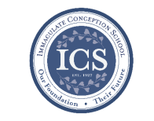

**It’s incredible to realize** that this is the last weekend before students and staff head off for summer vacation! Looking back, it has been an amazing year! **Our students excelled** in so many competitions across all areas – math, writing, penmanship, science, art, music, athletics, and more. **Our staff has proven their dedication** again through the countless hours of planning and preparation to bring their lessons to life.

**We will have our closing school Mass** on Wed, June 12 at 9:00. Following Mass, we will have our presentation of awards, distribute report cards, and then it will be off for weeks of family, fun, and rest! After three days of professional development, our teachers will head out for the same. **Please keep our students and staff in your prayers** that they enjoy a wonderful summer and return in the fall, ready for another exciting year!

**The office** will be open from 8:00 - 3:00 Monday - Friday in the month of June. July & August hours are 9:00-1:00pm Mon - Thurs.

**If you are interested in learning more about ICS** **or would like to enroll your child**, please contact our Advancement Director, Emily Murphy at [emurphy@icschoolweb.org](mailto:emurphy@icschoolweb.org). Now is the time to consider the benefits of a strong faith-based, challenging academic program that ICS provides.

**You may contact office personnel** including the secretary, principal, and advancement director any time during the summer. Phone and email messages will be checked regularly. Other school personnel such as teachers, the counselor, and the nurse are not required to monitor emails throughout the summer.

**Contact Info:**

* Secretary [jwilson@icschoolweb.org](mailto:jwilson@icschoolweb.org).
* Principal - [bschilling@icschoolweb.org](mailto:bschilling@icschoolweb.org)
* Advancement Director: [emurphy@icshoolweb.org](mailto:emurphy@icshoolweb.org)

**Faith Formation**

**Religious Education & Sacraments**

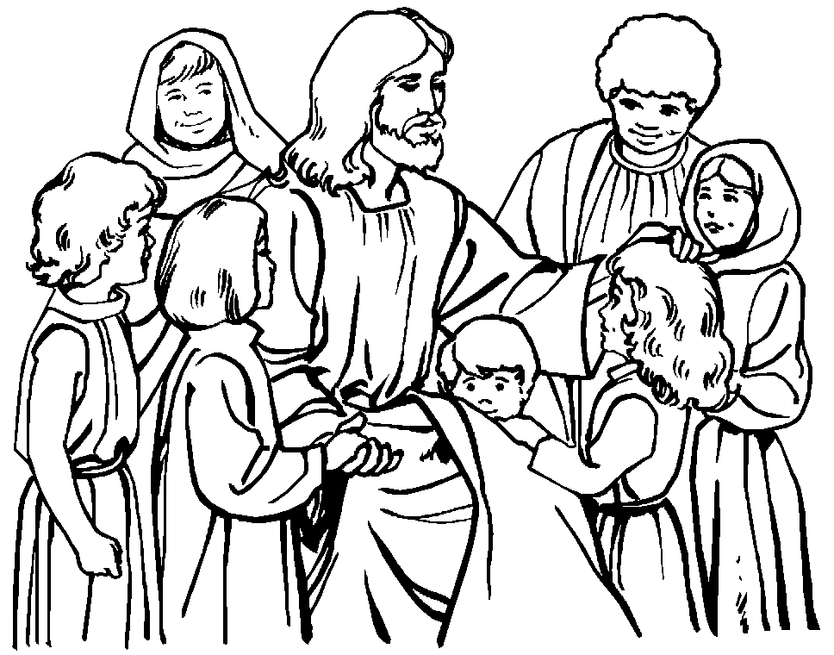**Religion Classes:** We have approximately 27 families who have not re-registered for classes next year. We need your registration to order books and supplies for next year.

**Outreach Donations**: Please remember Outreach items!

**Vacation Bible School:** Registrations are being accepted for Vacation Bible School. Children will have lots of fun as we “ROAR” the week of Sun, June 23 - Thurs, June 27 from 6:00 to 8:30 pm. VBS is for students in Pre-K through incoming 6th graders. Registrations are at the parish center and online.

**VBS Wish list**: quart & gallon zip lock bags, rolls of brown craft paper, duct and packing tape, green poster board, large cardboard boxes.

**Youth Ministry & Confirmation**

#### whats-your-story

**CONFIRMATION**

We are presently accepting registrations for Confirmation in the spring of 2020. If you need to register please contact the Religious Education office.

**YOUTH GROUP - Summer Calendar**

June 9th – Meeting

June 16th – No Meeting – Father’s Day

June 23rd – No Meeting – Vacation Bible School

June 30th – Meeting

July 7th – Meeting

July 14th – No Meeting

July 21st – Meeting

July 28th – No Meeting

**YOUTH MINISTRY WISH LIST:** Pop corn

**ADULT EDUCATION**

**Interested in a study group?** Call the Office at 410-392-3551.

**All Adult Education classes are over for the summer.**

***Adult Education classes*** – We are looking for someone to help Pat teach the classes next year. If you are interested please contact Vickie in the Religion Office at 410-392-3551 or [re@iccparish.org](mailto:re@iccparish.org)

**SOCIAL CONCERNS**

**Outreach**

Please consider donating to the Outreach! Thank you so much for your help, generosity, prayers, & donations to this essential ministry!!

**Food items:** cereal

**Non-Food items:** shampoo, toothpaste, toothbrushes, laundry deodorant, liquid dish soap, and diapers

**No clothing please!!** As much as we appreciate the gesture, we simply do not have the space to store them. Thank you!

**PARISH & FAMILY LIFE**

**Parish Coffee**

There will not be Parish Coffee in June at St. Jude’s. Please join us for Parish Coffee on **July 7th** following the 9:00 Mass.

Join us for Parish Coffee,TODAY, **June 9th** after the 8:30 and 10:15am Mass at ICC!

**PARISH EVENTS/INFORMATION**



**Weekly Church Collections: Week of June 2nd**

ICC $9,161

St. Jude $2,376

Online $3,938

Total Offertory $15,475

**Keep up with regular offerings by giving electronically!!**

Just as you rely upon receiving income on a regular basis, we rely on your regular contributions. We greatly appreciate the efforts of our parishioners to make consistent donations throughout the year! To assist you, the church provides a convenient electronic giving option for setting up regular contributions! Simply visit our website and click the Online Giving Button!

**How does Online giving benefit you?**

1. It’s easy, convenient, and safe
2. Allows you to give any amount, any time.
3. Allows you to track your giving

**How does Online giving benefit the parish?**

1. Creates consistency of giving
2. Increases efficiency of processing giving

**How to sign up?**

1. Visit www.iccparish.org
2. Click “Go to Online Giving”
3. Sign up! It’s that easy!

**PARISH EVENTS/INFORMATION**

**We are looking for 4th - 8th boys AND girls** to join ICS JV and varsity soccer teams, or 4th – 8th Girls to join the JV & Varsity Volleyball teams. The CYM registration link will be up mid-June. If your child is interested, PLEASEsend an email to [icshawkssports@gmail.com](mailto:icshawkssports@gmail.com). Please include name, grade and contact information.

**St. Jude Memories** By: Patty Banas

Walking into St. Jude's the first time 31 years ago, there was a different feel from our previous parish in Alexandria VA. It was a small town. It was friendly. It was HOT. But from that very first time, it was a feeling of welcome. My husband, son, and I were welcomed with open arms and friendly conversations. The first to welcome us were Narcy and Rita Zionkowski. In the coming weeks, months, and years we were welcomed by many others at St. Jude’s, not just into the church, but in some cases into their lives as family. That's what St. Jude seems to be, *family*. New parishioners coming now are welcomed, as we all once were, with smiles, handshakes, and friendly greetings. Over the years we've seen parish priests come and go. We all have had our favorites, but we miss them all when they leave, and reflect on how they've been a part of our Masses and our lives. Who could forget the parish priest who had us all hold hands - stretching across the aisles so we could all be connected? Or the priest who loved to douse certain people with holy water during the Easter season. Singing River of Glory and sounding like a congregation twice our size. Listening to homilies that made us laugh, think, cry and remember who we worship. St. Jude's and the whole community have celebrated with my family, for First Communions of both our boys. They have watched my oldest son grow up as he served as an Altar server, retiring when he dwarfed the priests. They listened to my youngest son play trumpet during special masses. They celebrated with us as my son received his Eagle Scout award at St. Jude's. They prayed for my husband and our family as he struggled with many health problems, and consoled us when he lost his battle. They've adopted us into their own families, checking on us, and making sure we are okay. Yes, St. Jude's is a welcoming church. But the people are more than just a congregation, they are family.

#### 

**Does your child need to be Baptized?**

The next Baptism Class is **August 19th**, 7:00-8:30pm in the Parish Center. It’s never too early to prepare for the Baptism of your child. Parents are required to attend. Contact the Parish at 410-398-1100 to register.

**Annual Catholic Appeal**

“*Disciples of Christ, Witnesses of Faith”*

THANK YOU to everyone who made a pledge to the diocesan Annual Catholic Appeal! Giving to the Appeal greatly helps our Parish! We are so close to meeting our parish goal! We are only $5,815 away in pledges! If you have not yet participated, please consider doing so today! Thank you for your generosity and support! To learn more, visit [www.cdow.org](http://www.cdow.org). Click “Giving” then “Annual Catholic Appeal.”



**Sunday, June 9**

8:20 AM - Confessions - SJ

1:30 PM - Baptisms - IC

6:00 PM - HS Gathering - PC

Monday, June 10

9:30 AM - Novena - CH

8:00 PM - AA Mtg - Caf

Tuesday, June 11

9:00 AM - Holy Hour - CH

6:30 PM - Knights of Columbus - PC

7:30 PM - Contemporary Rehearsal - IC

Wednesday, June 12 - ICS Last Day!

9:00 AM - Rosary Crusade / Novena-CH

9:00 AM - Closing School Mass - IC

1:00 PM - Leisure Club - PC

6:00 PM - ICS Board Mtg - ICS

Thursday, June 13

9:00 AM - Rosary Crusade - CH

6:30 PM - Cantor Rehearsal - IC

7:00 PM - Parish Choir Rehearsal - IC

Friday, June 14

9:00 AM - Rosary Crusade - CH

7:00 PM - NA Mtg - Caf

**Saturday, June 15**

9:00 AM - Rosary Crusade - CH

4:15 PM - Confessions - IC

7:00 PM - NA Mtg - Caf



**community EVENTS/INFORMATION**

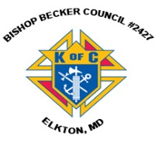**Knights of Columbus**

***Bishop Becker Council 2427***

**443-616-5370** or [**www.kofc2427.org**](http://www.kofc2427.org)

**Meetings:** 2nd & 4th Tuesdays of the month at 7:00 pm at the Parish Center

**LAOH (The Ladies Ancient Order of Hibernians)**

The Ladies Ancient Order of Hibernians, Inc. Cecil County Division 1, an Irish Catholic Action group has meetings on the first Wednesdays of the month at 1:00pm in the ICC Parish Center. Meetings run September through May. We are always looking for new members! If you are an Irish Catholic woman and want to serve your community, and learn more about your Irish heritage come join us! Contact Janice White, President at 410-378-3493

**Immaculate Conception is an affiliate Partner of The Franklin Institute**

As a parishioner, you get 20% off discount pricing for admission and exhibits! Go to [www.fi.edu/affiliates](http://www.fi.edu/affiliates) and enter organization code: ICCPMGRP. **Check out some of the summer exhibits they are running:**

* This summer, our museum is being taken over by super heroes! The exhibit [*Marvel: Universe of Super Heroes*](https://www.fi.edu/exhibit/marvel-universe-super-heroes) opened on April 13th to record setting pre-sales, and is open until September 2nd.
* [Night Skies](https://www.fi.edu/event/2019-06-11/night-skies-joel-n-bloom-observatory-0), June 11th & June 13th at 7:00 PM Build your own experience from any combination of planetarium shows, a live science talk on astronomy or space science, hands-on astronomy activities, and continuous telescopic observing all evening. (Weather permitting.)
* [Science After Hours: Pride](https://www.fi.edu/event/2019-06-25/science-after-hours-pride), June 25th at 7:00 PM An evening dedicated to celebrating the rich diversity among the science and arts community, join us for a special celebration during the June edition of Science After Hours.

**Listen to Catholic Forum every Saturday morning at 11:00** on Relevant Radio 640. Tune in Saturday, June 22nd, to hear about Religious Freedom Week with guest, Hillary Byrnes, Director of Religious Liberty at the USCCB. Listen online at [www.cdow.org/CatholicForum](http://www.cdow.org/CatholicForum) or search “Catholic Forum” on Apple, Spotify, or iHeartRadio podcasts. For photos, information regarding upcoming guests, links and more, “Like” Catholic Forum on Facebook at [www.facebook.com/catholicforum](http://www.facebook.com/catholicforum).

**Religious Freedom Week 2019: Strength in Hope** takes place from June 22 - 29. The Week begins with the Feast of Sts. John Fisher and Thomas More, ends with the Solemnity of Sts. Peter and Paul, and includes the Feast of the Nativity of St. John the Baptist. During Religious Freedom Week, Catholics are encouraged to pray and act each day for religious freedom. The Pray-Reflect-Act series aims to help Catholics build solidarity with those who are persecuted and find strength to carry out their missions **Thank you for your support for Religious Freedom Week** and for your united voices in the defense of religious freedom! Learn more at **www.usccb.org/ReligiousFreedomWeek**