***From Father Jim***

**“Both Paul and Barnabas spoke out and said, ‘It was necessary that the word of God be spoken to you first, but since you reject it and condemn yourselves as unworthy of eternal life, we now turn to the Gentiles. The Gentiles were delighted when they heard this and glorified the word of the Lord. All who were destined for eternal life came to believe, and the word of the Lord continued to spread through the whole region.”**

Pretend that you are in the audience as Paul spoke, so convincingly. Place yourself in the shoes first of the Israelite and see how well you accept or reject what you hear. You were urged to remain faithful to the grace of God. Now change your shoes and see you too are destined for eternal life and believe.

The magic of Paul and Barnabas is God’s grace and we all today, gifted with eternal life and the Holy Spirit, are to live and bring that life to others. We hear and listen and become witnesses as well. One of the encouraging words of Pope Francis is that we speak out ‘boldly’ of the Christ we know.



**ICS SPRING MUSICAL, “HONK! JR.”**

There is one last chance to see The ICS production of “Honk! Jr!!” The final performance is **May 12th at 2:00pm** in the ICS gym. Admission is FREE! Make sure to come out to see our very talented performers in this funny and heartwarming musical tale of “The Ugly Duckling!”

**SAVE THE DATE! Our 9th Annual Golf Classic** is going to be held on Monday, **June 10th, 2019 at the Deerfield Country Club!!** Join us for a fun-filled day of golf, great food, and some amazing auction items and golf prizes! **Spaces are limited!!** You can participate by: golfing, sponsoring, contributing auction Items, Volunteering, or joining us for dinner! **Register online** at www.iccparish.org by scrolling through the banner photos. Contact the Parish Office at 410-398-1100 for more information.



**May 13, 2019 Our Lady of Fatima**

8:30 am Mothers of the Parish

**May 14, 2019 St. Matthias, Apostle**

8:30am Mothers of the Parish

**May 15, 2019 St. Isidore**

8:30 am Mothers of the Parish

**May 16, 2019**

8:30 am Mothers of the Parish

**May 17, 2019**

8:30 am Mothers of the Parish

**May 18, 2019 St. John I, Pope and Martyr**

8:30 am Mothers of the Parish

5:00pm Shirley and Kenneth Bareham

**May 19, 2019 5th Sunday of Easter**

7:00 am Joseph and Lena Rettaglia

8:30 am Ann T. Saunders

9:00 am SJ Paul Roberts Jr.

10:15 am Vince McMahon Jr. (Living Intention)

12:00 pm People of the Parish

**We are looking for 4th - 8th boys AND girls** to join ICS JV and varsity soccer teams, or 4th – 8th Girls to join the JV & Varsity Volleyball teams. The CYM registration link will be up mid-June. If your child is interested in playing PLEASEsend an email to [icshawkssports@gmail.com](mailto:icshawkssports@gmail.com)

Please include name, grade and contact information and we will contact you when registration is open. This helps to ascertain if we have full player rosters.

**Viola recital**

**Join us on Friday, May 17th at 7:00pm** at Immaculate Conception for a recital presented by the University of Delaware's Viola Department. They are graciously presenting this performance as a fundraiser to help ICSJ repair and upgrade our sound system! Please come and enjoy this beautiful music.

***We extend a warm welcome to new Parishioners:***

*Mr. and Mrs. DeFelice*

*Mr. Travis Newsome, Mrs. Renee Frasse and Family*

***We extend our condolences and prayers to the families of those who have recently died:***

*Mrs. Marion Dowdell*

*Mr. Arnold Jasinski*

**Readings for next week:**

***Fourth Sunday of Easter***

**First Reading: Acts 14:21-27**

Paul and Barnabas traveled to many towns and found many disciples willing to help them preach. They warned their disciples of the trials they would face. Paul and Barnabas then returned to Antioch, where their journey had begun, and told the congregation there of the progress they had made.

**Second Reading: Revelation 21:1-5a**

John had a vision of a new earth, and a new Jerusalem coming down from heaven. Then a voice described Jerusalem as a place where God would live among his people and comfort them. The former world had vanished, and pain, death and suffering had left the world as well.

**Gospel: John 13:31-33a, 34-35**

After Judas left the last supper, Jesus warned the other disciples that he would not be with them much longer. Jesus gave them a new commandment to love one another as he had loved them. He stated that their love for each other would distinguish them as his disciples.

**Daily Readings:**

***Fourth Sunday of Easter***

**Sunday**..Acts 13:14, 443-52; Rv 7:9, 14b-17; Jn 10:27-30

**Monday.**.....................................Acts 11:1-18; Jn 10:1-10

**Tuesday.**..........................Acts 1:15-17, 20-26; Jn 15:9-17

**Wednesday** ......................Acts 12:24-13:5a; Jn 12:44-50

**Thursday** ...............................Acts 13:13-25; Jn 13:16-20

**Friday .**.......................................Acts 13:26-33; Jn 14:1-6

**Saturday** ..................................Acts 13:44-52; Jn 14:7-14

**Knights of Columbus Open Meeting**

The Bishop Becker Council of the Knights of Columbus would like to invite all interested men to an open meeting. This will be held on Wednesday, May 15 at 6:30pm at the Parish Center, which is directly across the street from Immaculate Conception Church. Refreshments, pizza, wings, etc. will be served. This is an opportunity to meet many members of the Knighthood. You will be able to ask questions about the Knights and how to become one. A short history of the Knights and the work we perform for the parish community will also be presented. If you were thinking about joining the Knights of Columbus, or just want to learn more, this is the perfect opportunity! Please RSVP to [Wkonowitz@gmail.com](mailto:Wkonowitz@gmail.com). “In Service to One, In Service to All!”



**Does your child need to be Baptized?**

The next Baptism Class is **May 13th**, 7:00-8:30pm in the Parish Center. It’s never too early to prepare for the Baptism of your child. Parents are required to attend. Contact the Parish at 410-398-1100 to register.

**Adoration for Vocations**

On the 1st Sunday of the month, exposition of the Blessed Sacrament occurs from 1pm-3pm in IC Chapel. Join us to pray for vocations. The next opportunity is **May 5th.** Contact Dermott Mullan at 410-398-3368.

**Liturgical Ministers Next Week: *May 18 and 19***

***5:00 pm***

**Altar Servers:** Mason H, David M •**EM’s:** Julie M, Diana B, Carol K **Lector:** Paula G • **Ushers:** Eileen P, Pat C, Bill B

***7:00 am***

**Altar Servers:** Jacob B, Sarah B • **EM’s:** Alan S, Gerald M, Sandra H •**Lector:** Edward R •**Ushers:** Charles M, William C

***8:30 am***

**Altar Servers:** Jeremy M, Sean M • **EMs:** Don H, Mary Ann H, Mary Ann E •**Lector:** Rachel W •**Ushers:** Anthony D, Wendel S, Anthony M, Steve C

***9:00 am (SJ)***

**Altar Servers:** Matthew T, Luke T • **EM’s:** Dotty F, Lester F, Peggy O, Diane C, Carol V • **Lector:** Dwight T • **Ushers:** Jule V, Bill D, Kevin O

***10:15 am***

**Altar Servers:** Hendric S, Ariane S • **EM’s:** Elizabeth B, Gwen D, Richard B • **Lector:** Tina B •**Ushers:** Bob W, Steve A, James D

***12:00 noon***

**Altar Servers:** Alex F, Andrew F • **EMs:** Corazon S, Kathy C, Charles C • **Lector:** Roberto O • **Ushers:** Teresa G, David T

**Children’s Liturgy of the Word**

Children’s Liturgy is for children ages 5-8 ONLY.

Children who are not in this category are asked to

remain in church.

**The Catechist for next week, May 19th is:**

Kimberly Burnham

**Inspirational Quote of the Week:** “A tree is known by its fruit; a person by her deeds. A good deed is never lost; one who sows courtesy reaps friendship, and one who plants kindness gathers love.” -- Saint Basil

**Adult Confirmation Class:** Do you want to be confirmed and have not been. If you have been baptized and received Communion then this class is for you. Please contact the Religion Office at 410-392-3551 to register for this all important class on Thursday, **May 16th.**

**Immaculate Conception**

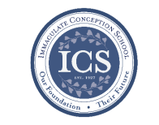**School News**

**Walk-In Wednesdays:**

Walk -In Wednesdays areevery Wednesday from 9:00am–11am. Tours are offered to those who wish to see the school in action!

**In the spirit of Giving:** Grades 3 & 4 are doing a great job with Outreach donations! They had a “Peanut Butter Rally” this week to collect as much Peanut butter as possible for Outreach!

**Coming Up...**



**SPRING MUSICAL, “HONK! JR.”**

There is one last chance to see The ICS production of “Honk! Jr!” The final performance is TODAY, **May 12th at 2:00pm** in the ICS gym. Admission is FREE! Come on see our performers in this heartwarming tale! We are so proud of our incredibly talented students! They have worked so hard and have done a fabulous job!

**On Fridays** during lunch, students will be selling Philly Pretzel Factory Pretzels. The sales benefit the theater program at ICS!

**Tuesdays during lunch**, student council will be selling ice cream to benefit Haiti.

**K-2 Field Trip!** Monday, May 13th some of our students will visit the Plumpton Park Zoo! We know they will have an educational and enjoyable time!

**Kindergarten Special Person’s Lunch** will be celebrated on **Thurs, May 16th** at 11.

**Our students bowl us over!** The School-wide bowling trip is Thursday, May 23rd!

**Faith Formation**

**Religious Education & Sacraments**

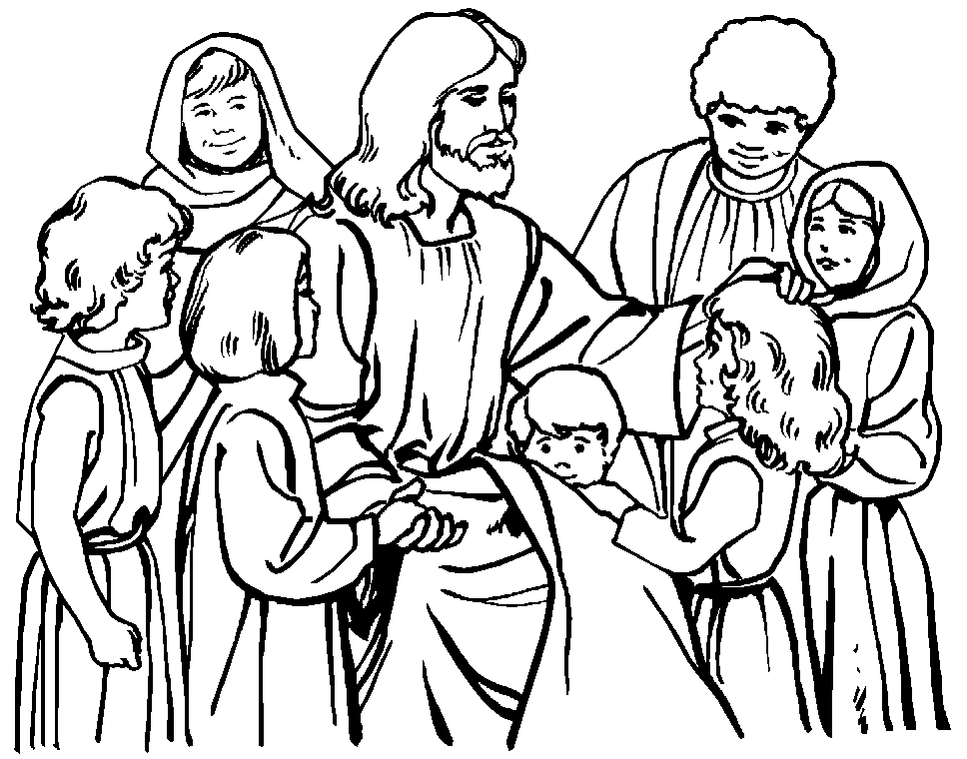**Religion Classes:** We have approximately 29 families who have not re-registered for classes next year. We need your registration to order books and supplies for next year.

**First Communion:** Congratulations to all of our students who made their First Holy Communion last week!!

**Outreach Donations**: Please remember items for Outreach

**Vacation Bible School:** Registrations are being accepted for Vacation Bible School. Children will have lots of fun as we “ROAR” thru the week of Sun, June 23 - Thurs, June 27 from 6:00 to 8:30 pm. VBS is for students in Pre-K through incoming 5th graders. Registrations are at the parish center and online.

**VBS Wish list**: quart & gallon zip lock bags, rolls of brown craft paper, duct/packing tape, green poster board, cardboard boxes.

**Some have been asking for Sr. Grace’s address:**

Sr. Grace Andrew Jeffery, OSF

Assisi House

600 Red Hill Road

Aston, PA 19014

**Youth Ministry & Confirmation**

#### whats-your-story

**CONFIRMATION**

Congratulations to all who were confirmed by Bishop Malooly. There are pictures available on the parish website. Simply click “photos” at the top of the page, and then “Confirmation.”

**YOUTH GROUP**

There will be no meeting on Sunday, May 12th Mother’s Day. The next meeting will be Sunday, May 19th.

**YOUTH MINISTRY WISH LIST:** Sodas and paper plates

**ADULT EDUCATION**

**Interested in a study group?** Call the Office at 410-392-3551.

**Follow Me – Meeting Jesus in The Gospel of John**

Will meet on Monday, May 13th at 6:30pm and repeats on Tues, May 14th at 9:15am in the parish center. All are welcome!

**RESOURCES FOR THE SEASON:**

-Go to the Parish Website at [www.iccparish.org](http://www.iccparish.org) and look under “Resources” to find Resources for Prayer, Scripture, etc.

**SOCIAL CONCERNS**

**Outreach**

Please consider donating to the Outreach! Thank you so much for your help, generosity, prayers, & donations to this essential ministry!!

**Food items:** cereal, rice, jello, tea and coffee

**Non-Food items:** toothpaste, toothbrushes, deodorant, paper towels, liquid dish soap and mr clean, and diapers size 5 or 6.

**No clothing please!!** As much as we appreciate the gesture, we simply do not have the space to store them. Thank you!

**PARISH & FAMILY LIFE**

**Parish Coffee**

Join us for Parish Coffee, **June 2nd** after 9:00 am Mass at St. Jude’s.

Join us for Parish Coffee, **May 12th** after 10:15am Mass at ICC!

**PARISH EVENTS/INFORMATION**



**Weekly Church Collections: Week of May 5th**

ICC $9,062

St. Jude $2,034

Online $4,658

Total Offertory $15,754

**Keep up with regular offerings by giving electronically!!**

Just as you rely upon receiving income on a regular basis, we rely on your regular contributions. We greatly appreciate the efforts of our parishioners to make consistent donations throughout the year! To assist you, the church provides a convenient electronic giving option for setting up regular contributions! Simply visit our website and click the Online Giving Button!

**How does Online giving benefit you?**

1. It’s easy, convenient, and safe
2. Allows you to give any amount, any time.
3. Allows you to track your giving

**How does Online giving benefit the parish?**

1. Creates consistency of giving
2. Increases efficiency of processing giving

**How to sign up?**

1. Visit www.iccparish.org
2. Click “Go to Online Giving”
3. Sign up! It’s that easy!

**PARISH EVENTS/INFORMATION**

**5th Annual ICAA Wine and Beer Tasting!**

Save the Date!! Join us Saturday, June 8th from 6:00pm-8:00pm. State Line Liquors will host our wine and beer tasting event. Please come out and support the Immaculate Conception Athletic Association! They will have finger foods, appetizers, and a multitude of wines and beers. Make sure to also participate in the 50/50 drawing! Tickets are $25 per person and can be purchased from Angela Maxwell, Michelle Riddle, or at the Parish Center. Tickets will also be sold at the door. Make sure to join us!

**OUTREACH:** "Thanks" those Parishioners who send in their Redner's Grocery Receipts. We need the 'Full Receipt’ to include the part that shows “Today's 1% Save A Tape Total.” Each receipt is counted using the sum found in this section. Without this information we cannot use the receipt. Outreach earns 1% of your purchase total. This money provides help to people in need. Please sign up to participate in the Redner's 1% Save A Tape program if you are not already a member.

**VOLLEYBALL TRY OUTS!**

Try-Out Date:**May 29, 2019**

Location: **Bo Manor High School (Middle School Gym)**

Time: **JV and Varsity 6:00pm – 8:00pm** (Incoming 4- 8 graders)

All athletes must go to the online ICAA registration site at <http://iccparish.weconnect.com/Athletic-Association>

Once you complete the registration process, continue to pay your registration fee online (if the system is set up at the time of registration). In addition the membership fee, there will be a $50 uniform deposit fee due prior to receiving a uniform. No uniforms will be distributed without the deposit fee. The fee will be returned to you at the end of the season if 1) the entire uniform is returned AND 2) the uniform is in the same condition as player received it.

In mid-June, all parents must go onto the CYM website (incoming Grades 4-8) and register at [www.cdow.or/cymathletics.html](http://www.cdow.or/cymathletics.html). The CYM website is not available until mid-June for fall registrations. Please make sure you register through ICAA website ASAP so you can be contacted when the CYM website is available. A signed copy of the registration form must be turned into the coaches before the first practice in August. **Please contact the CYM office for eligibility and questions at 302-658-3800.**

For questions, please contact: Angela Maxwell- ICAA Volleyball Coordinator at [icsmaxwell@yahoo.com](mailto:icsmaxwell@yahoo.com) or 302-563-0994.



**Sunday, May 12**

8:20 - Confessions - SJ

2:00 PM - Honk performance - gym

1:30 PM - Baptisms - IC

2:00 PM - 1st Communion - IC

6:00 PM - HS Gathering - PC

Monday, May 13

9:30 AM - Novena - CH

6:30 PM - Adult Ed Program - PC

7:00 PM - Baptism Class - PC

8:00 PM - AA Mtg - Caf

Tuesday, May 14

9:00 AM - Holy Hour - CH

9:15 AM - Adult Ed Program - PC

6:30 PM - Knights of Columbus - PC

7:30 PM - Contemporary Rehearsal - IC

Wednesday, May 15

9:00 AM - Rosary Crusade/SJ Novena-CH

9:30 AM - Cantor Reh - IC

5:00 PM - Parish Council Mtg - PC

6:30 PM-Knights of Columbus open mtg-PC

Thursday, May 16

9:00 AM - Rosary Crusade - CH

11:00 AM - Kindergarten Special Person Lunch - Caf

6:30 PM - Boy Scouts - PC

6:30 PM - Cub Scouts - caf

6:30 PM - Cantor Rehearsal - IC

7:00 PM - Parish Choir Rehearsal - IC

Friday, May 17

9:00 AM - Rosary Crusade - CH

5:00 PM - UD Viola Recital - IC

7:00 PM - NA Mtg - Caf

**Saturday, May 18**

9:00 AM - Rosary Crusade - CH

4:15 PM - Confessions - IC

7:00 PM - NA Mtg - Caf



**community EVENTS/INFORMATION**

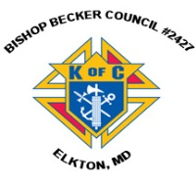

**Knights of Columbus**

***Bishop Becker Council 2427***

**443-616-5370** or [**www.kofc2427.org**](http://www.kofc2427.org)

**Meetings:** 2nd & 4th Tuesdays of the month at 7:00 pm at the Parish Center

**LAOH (The Ladies Ancient Order of Hibernians)**

The Ladies Ancient Order of Hibernians, Inc. Cecil County Division 1, an Irish Catholic Action group has meetings on the first Wednesdays of the month at 1:00pm in the ICC Parish Center. Meetings run September through May. We are always looking for new members! If you are an Irish Catholic woman and want to serve your community, and learn more about your Irish heritage come join us! Contact Janice White, President at 410-378-3493

**OLD BOHEMIA HISTORICAL SOCIETY FUNDRAISER:**

A Flapjack Fundraiser will be held on **Saturday, June 1** at Applebee’s, 320 Dove Run Centre Blvd, Middletown, from 8:00am - 10:00am. The unlimited breakfast buffet includes pancakes, scrambled eggs, sausage, orange juice and coffee. Tickets are $10 for adults and $7 for children age 12 and under. A gift basket raffle will also be held during the event. Proceeds from the fundraiser will benefit The Old Bohemia Historical Society whose mission is to restore and maintain St. Francis Xavier Shrine (Old Bohemia) in Warwick, MD. The breakfast is made possible through the generosity of Applebee’s. To purchase tickets, please contact Kathy at 302.530.9206 or [OldBohemiaHS@gmail.com](mailto:OldBohemiaHS@gmail.com). A limited number of tickets will be available at the door.

**Diocesan Mass For Vocations:**

You are invited to join Bishop Malooly in prayer and support of those discerning a call to the Priesthood, Consecrated Life and Permanent Diaconate at the Diocesan Mass for Vocations, Saturday, June 15 at 11:00am at the Cathedral of Saint Peter, 500 N. West Street, in Wilmington. Visit at [www.cdow.org/vocations](http://www.cdow.org/vocations).

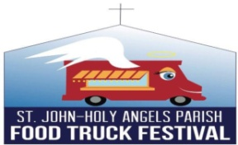

**St. John-Holy Angel Food Truck Festival:**

June 1, 11:30am-5pm: **Food Truck Festival**, Holy Angels Church, 82 Possum Park Road, Newark. Featuring Polish Connection, Outlandish, La Mixteca Poblana, The Wandering Chef, Deerhead Hot Dogs, Gotta Lotta Gelata, Viva Bowls, Harvest Ridge Winery, Liquid Alchemy and Valhalla Brewery. Gluten free and vegan food options. Other vendors include Terrarium Therapy, Origami Owl, Usborne Books, Lularoe, Hempworx, and many more! Games, face painting, moon bounce. Rain or shine. Indoor arrangements for inclement weather. For more information contact Amy Press at 302-731-2219 or [apress@holyangels.net](mailto:apress@holyangels.net).