***From Father Jim***

**“You know how you must imitate us…we wanted to present ourselves as a model for you so that you might imitate us. In fact, when we were with you, we instructed you that if anyone was unwilling to work, neither should that one eat.”**

‘Imitation is the greatest form of flattery’ but often it can lead others astray. The lack of truthfulness in government, deceit in business, use of performance-enhancing drugs in sports become the norm, not the exception. ‘Everyone is doing it’ is the response, but does not make it right.

Paul’s exhortation and example called and challenged his hearers not to be so easily persuaded to laziness, a capital sin, but to labor intensely for the Lord. What he lived and taught was to remedy what he saw as contrary to a Christian life.

His words are directed to us as a model, an example to follow. Jesus is our leader, Paul our teacher, and we eagerly accept the challenge to be a model for others. Can we say that? ‘Do as I say or do as I do.’

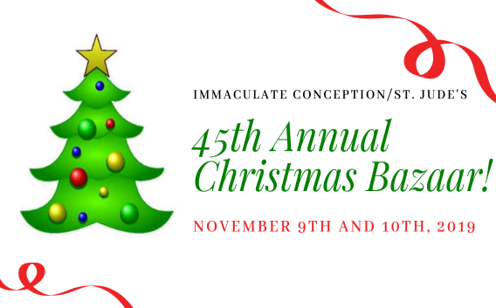

**CHRISTMAS BAZAAR:**

**THANK YOU!!** Our 45th annual Christmas Bazaar was a huge success, and it’s all thanks to the hard work and dedication of our many volunteers!! A special thank you to our committee chairs, **Lisa Kaminski, Jackie Getz, and Terry Gustafson, and all the committee members and volunteers!** Thank you to everyone who attended, participated in, or volunteered at the Bazaar!! Thank you for making this such a fun and successful event!!

***Congratulations to those who were recently baptized:***

*Natalie Blake Button*

*Owen James Quirk*

*Jordan Christopher Weaver*



**Harp, Flute, and Keyboard Christmas Concert**

Join us on Sunday, **December 8th** at 5pm at Immaculate Conception for our second annual harp, flute, and keyboard Christmas Concert, featuring Lynn Broderick, Denise Lano, and Dana Brehany! A light reception will follow. Hope to see you there!



**November 18, 2019 The Dedication of the Basilicas of Saints Peter and Paul, Apostles**

8:30 am All Souls of the Parish

**November 19, 2019**

8:30 am All Souls of the Parish

**November 20, 2019**

8:30 am All Souls of the Parish

**November 21, 2019 The Presentation of the Blessed Virgin Mary**

8:30 am All Souls of the Parish

**November 22, 2019 St. Cecilia, Martyr**

8:30 am All Souls of the Parish

**November 23, 2019 St. Clement I, Pope and Martyr**

8:30 am All Souls of the Parish

5:00 pm Francis and Alda Guns

**November 24, 2019 Our Lord Jesus Christ, King of the**

**Universe**

7:00 am All Souls of the Parish

8:30 am John and Laura McCarthy

9:00 am SJ Joan Harrison

10:15 am People of the Parish

12:00 pm Grace Pursley (Living Intention)

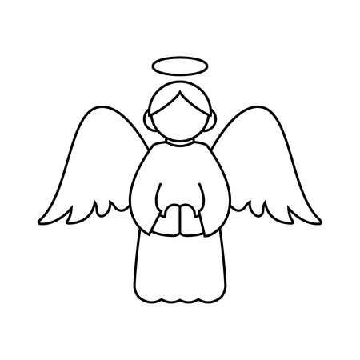

**Angel Trees!**

Thank you to everyone who has taken an Angel off of our Angel trees that went up last weekend!! We still have some angels left! If you are interested in taking an angel, please contact Jim and Gwen Davis at 410-392-8078. Please remember that all Angel Tree gifts must be returned to either St. Jude’s or Immaculate Conception by Sunday, December 1st. Please be sure the gifts are wrapped and that the pink or blue angel is **securely** attached to the package(s). If you have multiple boxes, please tie them together!! Thank you SO much for being an angel to someone in need this Christmas!!

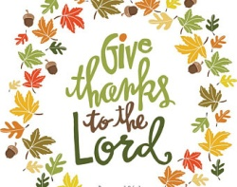**Thanksgiving Choir Festival**

As part of the Greater Elkton Ministerial Alliance, IC/SJ Parish invites you to the Annual Thanksgiving Choir Festival! Join us to praise God in thanksgiving on Sunday, **November 17th** at 4:00pm at Five Rivers Church, 290 Whitehall Rd. Elkton, MD. Hope to see you there!

**Readings for next week:**

***OUR LORD JESUS CHRIST, KING OF THE UNIVERSE***

**First Reading: 2 Samuel 5:1-3**

Samuel describes how all the tribes of Israel went to David in Hebron and said they were his bone and his flesh and it was he who led them back to Israel. The Lord told David he would be a shepherd to His people. David made an agreement with the elders and was anointed king.

**Second Reading: Colossians 1:12-20**

Paul explains to the Colossians that God has made them fit to share in the inheritance of the holy ones in light and that through the Son we have redemption and forgiveness of sin. He describes Jesus as the image of the invisible God, the head of the church and in Him all things hold together.

**Gospel: Luke 23:35-43**

Jesus is mocked by the crowd as he hung on the cross. Above him was an inscription that read “This is the king of the Jews.” One of the men being crucified with Jesus tells Him to save them and Himself, while the other asks that he be remembered when Jesus is in his kingdom. Jesus said in reply, “Amen I say to you, today you will be with me in Paradise.”

**Daily Readings:**

***Thirty-third Sunday in Ordinary Time***

**Sunday** ........... Mal 3:19-20a; 2 Thes 3:7-12; Lk 21:5-19

**Monday** ........ 1 Mc 1:10-15, 41-43, 54-57, 62-63; Lk 18:35-43 or, for the Memorial of the Dedication - Acts 28:11-16, 30-31; Mt 14:22-33

**Tuesday .**........................................... 2 Mc 6:18-31; Lk 19:1-10

**Wednesday** ................................ 2 Mc 7:1, 20-31; Lk 19:11-28

**Thursday** ........................................ 1 Mc 2:15-29; Lk 19:41-44

**Friday** .................................. 1 Mc 4:36-37, 52-59; Lk 19:45-48

**Saturday** ........................................... 1 Mc 6:1-13; Lk 20:27-40



**The new RCIA “Unplanned” Movie Screening**

The Cecil Pregnancy Center and Bishop Becker Council of the Knights of Columbus cordially invite you to a free screening of the film, "Unplanned". It is a scathing examination of the abortion industry. It also shows the efforts of people of faith to defend life at its most vulnerable. The film will be presented at 7 PM, Saturday, November 23 in the Immaculate Conception School gym. The film is rated R, due to some graphic scenes. No children will be admitted. Mature teens accompanied by a parent will be admitted.

**Liturgical Ministers Next Week: *November 23rd & 24th***

***5:00 pm*** Grace B, Mason H •**EM’s:** Mary Anne S, Carol K

• **Lector:** Tina B • **Ushers:** Eileen P, Bob E, Pat C

***7:00 am***

•**Altar Servers**: **\*UNFILLED\*** •**EMs:** Alan S, Frank S

• **Lector:** James S • **Ushers:** Charles M

***8:30 am***

**Altar Servers:** Elizabeth R, Alex L • **EMs:** Peter G, Cecilia G • **Lector:** Mary Ann E • **Ushers:** Anthony D, Stephen C, Anthony M

***9:00 am (SJ)***

**Altar Servers:** Matthew T, Luke T • **EM’s:** Peggy O, Les F, Dotty F, Narcy Z, Dorothy D • **Lector:** Monica V • **Ushers:** Kevin O, Jule V, William D

***10:15 am***

**Altar Servers:** Hayden S, Hendric S • **EM’s:** Elizabeth B, Richard B, Richard L • **Lector:** Rachel W • **Ushers:** Bob W, Steve A

**12:00 *noon***

**Altar Servers:** Gabriel O, Valerie O •**EMs:** Cynthia J, Mary C, Corazon • **Lector:** David T • **Ushers:** Teresa G, Charles C

**Advent Holy Hour**

We will have an opportunity for adoration on Wednesday, December 11 from 5:30 to 6:30pm at Immaculate Conception. This time of prayer will feature Taizé music, readings, and silence, ending with Benediction of the Blessed Sacrament. Come spend some time with Our Lord as we prepare to celebrate His birth!

**Adoration for Vocations**

On the 1st Sunday of the month, exposition of the Blessed Sacrament occurs from 1pm-3pm in IC Chapel. Join us to pray for vocations. The next opportunity is **December 1st** Contact Dermott Mullan at 410-398-3368.

**Children’s Liturgy of the Word**

CLW is for children 5-8 years old. Children under 5 are welcome if they are accompanied by a parent (not a sibling!)

CLW is in desperate need of adult help for. If interested, please contact Gwen Davis at 410-392-8078

**The Catechist for next Sunday, November 24th is:**

**Francis Capparuccini**

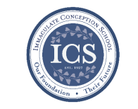**Immaculate Conception**

**School News**

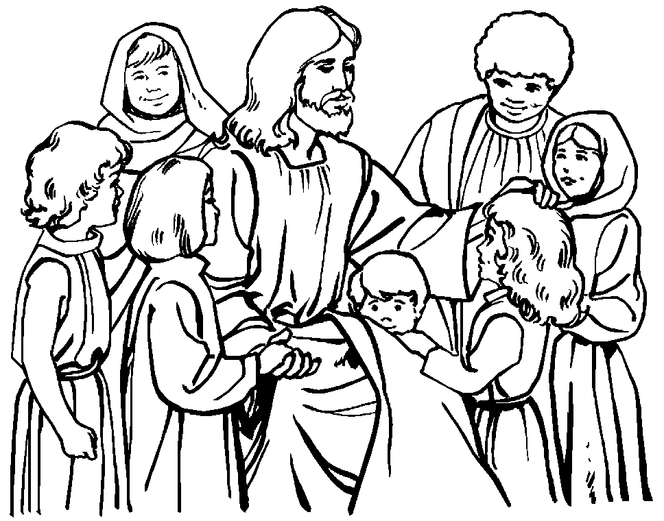**Have you seen our test scores?!**

ICS test scores are ranked in the 90th percentile compared to test scores from other schools across the Diocese! This is in part because of how passionate we are about our students’ education, small class sizes, and incredible staff!

“ICS offers a solid, traditional academic program which prepares students for success in high school and beyond. Teachers prepare meaningful academic lessons and students are very engaged and inquisitive throughout the school day. Assessment results indicate very strong achievement; on both the Renaissance STAR Math and Reading assessments, ICS students perform among the highest in the diocese.” - Diocese of Wilmington Office for Catholic Schools.

**COMING UP...**

**5th Grade service project: Coat Drive!**

It is COLD outside--the kind of cold that would be hard to endure without a warm coat! PLEASE, take a look through your closets and bring in any winter outerwear that is no longer worn. ICS students will be delivering these items to Outreach on November, 20th so bring your donations to ICS by **Tuesday, Nov. 19th!** Thank you for your help with this annual 5th grade service project! It benefits those in our community who are less fortunate. Dottie is always so grateful! There is a dire need for winter wear for adults and children alike.

**Ball in the house Assembly**

Our students will enjoy an awesome performance by “Ball In the House” tomorrow! Ball In the House is an R&B/Soul/Pop a cappella group from Boston, MA whose high-energy shows have audiences singing, dancing, and beat-boxing along!

**Story time continues at ICS!**

Bring your children, ages 2-5 to ICS! Gwen Davis reads classic children’s stories and provides themed activities, music, crafts, and snacks! **Story time is FREE!!** Your children will love it! The next Story Time is **November 20th at 10:00am.** Call 410-398-2636 to register.

**Thanksgiving Break!**

ICS will be having a Thanksgiving Prayer service on **Thursday, November 26th**, then they will begin their well -deserved Thanksgiving Break with a half day!!

**Faith Formation**

**Religious Education & Sacraments**

**Religion Classes:** For the Sake of God’s Children first session will be TODAY, Sunday, November 17th. All home-school students need to attend one of these sessions, as well!

**There will be no classes on Wednesday, November 27th and Sunday, December 1st for the Thanksgiving Holiday.**

**First Reconciliation:** Parent/Child meeting will be TODAY, Sunday, November 17th at 2:00pm at ICC.

**Outreach:** November donations: Thanksgiving food items! We ask anyone who has not returned their bag to please do so ASAP! Thank you for supporting Outreach!

**Youth Ministry & Confirmation**

#### whats-your-story

**YOUTH MINISTRY:** Thank you to all members of the Confirmation class, Jr. Youth Group and Youth Group for their participation in the Christmas Bazaar!

**CONFIRMATION**

The next class is TODAY, November 17th and Wednesday, November 20th. See you there!

**YOUTH GROUP – Grades 9 thru 12**

**Meetings are 6 – 8 pm in the parish center**

Next Meeting is TODAY, November 17th

Christmas gathering will be Sunday, December 15th

**YOUTH MINISTRY WISH LIST:**

* We are asking for sodas (cans please!)

**JUNIOR YOUTH GROUP – Grades 6 thru 8**

Join us to grow in faith through fun and fellowship!

Next Meeting is TODAY, November 17th

**ADULT EDUCATION**

**Interested in a study group?** Many opportunities are available. Call the Religion Office at 410-392-3551.

**Adult Education classes**

Catholicism Class, Monday, Nov. 18th at 6:30pm & repeats on Thursday, Nov. 21st at 9:15 am in the parish center.

**Book Study**

Tuesday, Nov. 19th at 9:15 am in the parish center.

**SOCIAL CONCERNS**

**Outreach**

**Please consider donating** to the Outreach! Thank you so much to all those who have donated!! Thank you for your help, generosity, prayers, & donations to this essential ministry!!

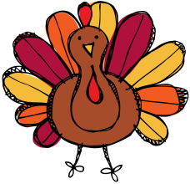

**Holiday items:** We are collecting holiday food for Thanksgiving! **Please remember that we need Holiday food donation bags back by November 20th!!**

**Food items:** We are in need of chicken noodle and tomato soups, pasta, and pasta sauce

**Non-Food Items:** Toothpaste, toothbrushes, and shampoo

**PARISH EVENTS/INFORMATION**



**Weekly Church Collections: Week of Nov. 10th**

ICC $8,657

St. Jude $1,743

Online $4,634

Total Offertory $15,034

**Keep up with regular offerings by giving electronically!!**

Just as you rely upon receiving income on a regular basis, we rely on your regular contributions. We greatly appreciate the efforts of our parishioners to make consistent donations throughout the year! To assist you, the church provides a convenient electronic giving option for setting up regular contributions! Simply visit our website and click the Online Giving Button!

**How does Online giving benefit you?**

1. It’s easy, convenient, and safe
2. Allows you to give any amount, any time.
3. Allows you to track your giving

**How does Online giving benefit the parish?**

1. Creates consistency of giving
2. Increases efficiency of processing giving

**How to sign up?**

1. Visit www.iccparish.org
2. Click “Go to Online Giving”
3. Sign up! It’s that easy!

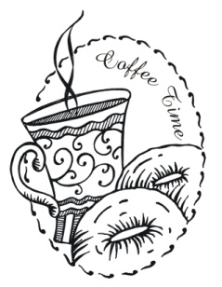**PARISH & FAMILY LIFE**

**Parish Coffee**

Please join us at St. Jude’s for Parish Coffee **Dec 1st** following the 9:00 Mass.

**Join us** for Parish Coffee, TODAY, **Nov. 17th** after 8:30am and 10:15am Masses at ICC!

**PARISH EVENTS/INFORMATION**

**Basketball registration!**

Basketball is in need of two heads for Pre-JV and two heads for JV to make these teams a go! Please contact [Icshawkssports@gmail.com](mailto:Icshawkssports@gmail.com) if you are interested!

**Registration is OPEN!**

3rd & 4th grade boys and girls (co-ed) -- Pre-JV. Practices Tues/Thurs 5:30 to 6:30

5th & 6th grade boys - JV.

Practices Tues/Thurs 6:30 - 8 p.m.

7th & 8th grade boys - Varsity.

Practices Wed/Friday 6:30 - 8 p.m.

We are eligible for girls JV and Varsity teams too!  If we have any interested players or questions please

contact [icshawkssports@gmail.com](mailto:icshawkssports@gmail.com)



**The Immaculate Conception Rolling Lottery is back! A $20 chance can win you up to $1,500**! These make a great Christmas Gift!! We will be selling tickets after Masses on Nov 30 - Dec 1, and again on Dec 7-8. We will also be selling them in the Religious Ed office during Classes on Sundays/Wednesdays and at the Parish Center during business hours. Tickets will be sold through December. The rolling lottery will follow The Maryland Lottery Pick 3 for winners in January. The MSL draws twice a day, so ticket holders have 60 chances to win. The stakes go up $25 after each draw if nobody wins that draw. Proceeds benefit ICC Parish and Religious Education. This is not affiliated with the MSL.

**Thanksgiving Mass Give Thanks by Sharing**

Thanksgiving Day is only 11 days from now. We will gather as a parish family to celebrate the Eucharist, from the Greek *eukaristia*, to give thanks. Every Mass is a thanksgiving to God for the gifts we have received, including our faith and Jesus Christ, present to us, in us and through us. At the beginning of each Eucharistic Prayer we exchange: “Let us give thanks to the Lord, our God.” “It is right and just.” On Thanksgiving we invite you to bring food or money for our Outreach Ministry. We will ask everyone at Mass to come forward during the Offertory Procession and place your food items on the floor and steps in front of the Altar or your money in a basket that will be there to receive monetary gifts. Let us give thanks by joining in the source and summit of our faith, the Eucharist and sharing with others signs of God’s blessings.

## KofC Logo

**Sunday, November 17**

8:20 AM - Confessions - SJ

10:30 AM - Baptisms - SJ

11:00 AM - Coffee Sunday - gym

1:30 PM - Baptism - IC

2:00 PM - 1st Reconciliation Mtg - IC

6:00 PM - HS Gathering - PC

Monday, November 18

9:30 AM - Novena - CH

5:30 PM - Volleyball - gym

6:30 PM - Catholicism

8:00 PM - AA Mtg -caf

Tuesday, November 19

9:00 AM - Holy Hour - CH

9:00 AM - Adult Ed Book Study - PC

5:30 PM - Pre JV Basketball - gym

6:30 PM - JV Basketball - gym

6:30 PM - Handbell Rehearsal - IC

7:30 PM - Contemporary Rehearsal - IC

Wednesday, November 20

9:00 AM - Rosary Crusade / Novena-CH

9:30 AM - Cantor Reh - IC

1:00 PM - LAOH - PC

4:00 PM - Children’s Choir - PC

5:00 PM - Parish Council - PC

6:00 PM - Confirmation Class - PC

6:15 PM - Religious Ed - ICS

7:00 PM - Varsity Basketball - gym

Thursday, November 21

9:00 AM - Rosary Crusade - CH

9:15 AM - Catholicism - PC

5:30 PM - Pre JV Basketball - gym

6:30 PM - JV Basketball - gym

6:30 PM - Boy Scout Mtg - PC

6:30 PM - cub scout mtg - caf

6:30 PM - Cantor Rehearsal - IC

7:00 PM - Parish Choir Rehearsal - IC

7:00 PM - RCIA - PC

Friday, November 22

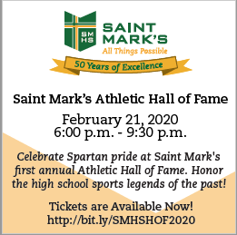9:00 AM - Rosary Crusade - CH

6:30 PM - Varsity Basketball - gym

7:00 PM - NA Mtg - Caf

**Saturday, November 16**

9:00 AM - Rosary Crusade - CH

4:15 PM - Confessions - IC

7:00 PM - NA Mtg - Caf

7:00 PM - “Unplanned” movie screening - gym

**community EVENTS/INFORMATION**

**Knights of Columbus**

***Bishop Becker Council 2427***

**Meetings:** 2nd & 4th Tuesdays of the month at 6:30 pm at the Parish Center

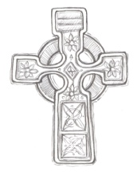**LAOH (The Ladies Ancient Order of Hibernians)**

The Ladies Ancient Order of Hibernians, Inc. Cecil County Division 1, an Irish Catholic Action group has meetings on the first Wednesdays of the month at 1:00pm in the Parish Center. Meetings run September through May. We are always looking for new members! If you are an Irish Catholic woman and want to serve your community, and learn more about your Irish heritage come join us! Please contact the historian, Betty Green at 410-392-5287



**Have you started your Holiday shopping yet??**

Did you know that when you shop for the holidays at [smile.amazon.com/ch/52-6015220](https://smile.amazon.com/gp/f.html?C=JY11A2HZ6P5O&K=15GG5P8RFW6OS&M=urn:rtn:msg:20191029140523f1195f2dfe184a69b3de15dd32f0p0na&R=37U11G4BVSQZ8&T=C&U=http%3A%2F%2Fsmile.amazon.com%2Fch%2F52-6015220&H=JQMAB6AKUPPIGGRGSADMKNBYZ9YA), AmazonSmile donates to Immaculate Conception Church? Shop at Amazonsmile.com this holiday season and you can help raise funds for our parish!

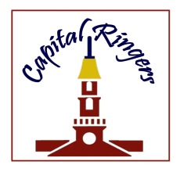**Capital Ringers Christmas Bells:**

You are invited to join Artistic Director Linda Simms and the Capital Ringers at their Christmas Bells concert on Sunday, November 24th at 4:00pm at St. Paul’s Lutheran Church. (701 South College Ave. Newark, DE) Tickets are $14 per person, and FREE to children 18 and under! To purchase tickets online, please visit brownpapertickets.com. For more information call 302-745-0359 or visit [www.capitalringers.org](http://www.capitalringers.org).

**Mount Aviat Academy’s 57th Annual Christmas Bazaar**

Don’t miss this fun holiday event for the whole family! Join us for MAA’s 57th Annual Christmas Bazaar on Saturday, November 23rd from 10:00 am - 4:00 pm. The Christmas Bazaar features: Pictures with Santa, 50/50 raffle tickets, a children’s bazaar run by 8th grade students, delicious food including cream puffs, as well as baked and homemade goods, silent auction, and much more! MAA is located at 399 Childs Road, Childs, MD.

**Saint Mark’s High School**

***Athletic Hall of Fame***

Saint Mark’s invites you to celebrate Spartan pride at Saint Mark’s 1st Annual Athletic Hall of Fame on **Friday, February 21, 2020 from 6:00 - 9:30 pm.**

Honor the high school sports legends of the past! **Tickets are Available Now! Visit** [**http://bit.ly/SMHSHOF2020**](http://bit.ly/SMHSHOF2020)