From Father Jim

“You have mercy on all, because you can do all things. You overlook people’s sins that they may repent. For you love all things that are and loathe nothing that you have made; for what you hated, you would not have fashioned. Therefore you rebuke offenders, warn them, and remind them of the sins they are committing, that they may abandon their wickedness and believe in you, O Lord. ‘Today salvation has come to this house.”

How wonderful that we believe in a merciful God, who looks past our sins, to gift us with mercy. That does not mean I am to overlook my fault but I have reason to repent. My goal is not to convince God that I deserve His mercy, but ask the Lord who sees me as I am to shower me with His love.

Zacchaeus wanted to see Jesus, but the Lord was looking for him. The word today speaks to me, reminding me to ask for forgiveness, to forgive others and believe in a loving merciful God. We hear warning alarms, sirens and smoke detectors. The word today reminds me of what I must abandon, change and seek. Jesus is looking for you.

CHRISTMAS BAZAAR:
The 45th annual Parish Christmas Bazaar is NEXT WEEKEND, Saturday, November 9th from 9am - 5pm and Sunday, November 10th from 8am - 2pm. We still need help in many of the parish-sponsored booth at the bazaar. Please go to https://bit.ly/ICC-SJ-ChristmasBazaar2019 to sign up. Donations of baked goods for the baked goods table can be dropped off at the school cafeteria on Friday, November 8th between 3pm and 7pm or Saturday morning after 8am. For more information about the Christmas Bazaar, please contact: Lisa Kaminski, 410-392-9558, kaminski-uch@comcast.net; Jackie Gedz, 410-392-0396, Jackie.gedz@verizon.net; or Terry Gustafson, 443-553-2324, teresa.gustafson@verizon.net.

We extend our condolences and prayers to the families of those who have recently died:
Mrs. Maryann Hucks
Mrs. Dorothy Maccari

Congratulations to those who were recently baptized:
Jilian Lynnlee Craine
Theodore James Sposato
November 4, 2019 St. Charles Borromeo, Bishop
8:30 am All Souls of the Parish
10:00 am ICS prayer service

November 5, 2019
8:30 am All Souls of the Parish

November 6, 2019
8:30 am All Souls of the Parish

November 7, 2019
8:30 am All Souls of the Parish

November 8, 2019
8:30 am All Souls of the Parish

November 9, 2019
8:30 am All Souls of the Parish
5:00 pm Martha Biedrzycki

November 10, 2019 31st Sunday in Ordinary Time
7:00 am All Souls of the Parish
8:30 am Edward and Patricia McCarthy
9:00 am SJ Kevin Haynes
10:15 am Cecilia Gnanes (Living Intention)
12:00 pm People of the Parish

Celebration for Sister Grace:
Join us today, November 3rd from 1 – 4pm in the ICS Gym all are invited to come and see Sr. Grace at this open house honoring her! We also would love to have your homemade desserts, snacks, potato or macaroni salads, or coleslaw to serve at the celebration for Sister Grace. Your goodies can be dropped off at the school gym on Sunday, November 3 anytime after the 8am Mass. Please contact Liz Orr at 410-920-8124 or lizorr@gmail.com or Gwen Davis at 410-392-8078 or gdavis@udel.edu and leave a message.

Students in 3rd grade and up:
Deacon Mike will be holding an altar server training meeting for anyone interested in learning how to be an altar server. Current servers who would like to brush up on their skills are also welcome! Anyone in third grade or up who has received their First Holy Communion may be an Altar Server. You may come on Saturday, November 9th at 10am at ICC, Wednesday, November 13th at 2:30pm at ICC. Hope to see you there!!
Readings for next week:
THIRTY-FIRST SUNDAY IN ORDINARY TIME
First Reading: 2 Maccabees 7:1-2, 9-14
A king tortured a Jewish family, and tried to make them violate the laws. They all refused to give in and violate the laws. All of the family members told the king they would rather die at his hands than surrender their hope of being resurrected by God.

Second Reading: 2 Thessalonians 2:16-3:5
Paul prays that the Thessalonians will be strengthened by God. He also asks them to pray that God's word will continue to spread, despite the persecution of Christians that was occurring at that time.

Gospel: Luke 20:27-38
Jesus encountered some Sadducees who did not believe in resurrection. Jesus refuted them by quoting Moses, who called the Lord the God of Abraham, Isaac and Jacob. Jesus then said. "God is not the God of the dead but of the living. All are alive for him."

Daily Readings:
Thirty-First Sunday in Ordinary Time
Sunday ................ Wis 11:22-12:2; 2 Thes 1:11-2:2; Lk 19:1-10

Monday ........................................ Rom 11:29-36; Lk 14:12-14
Tuesday ......................................... Rom 12:5-16b; Lk 14:15-24
Wednesday ..................................... Rom 13:8-10; Lk 14:25-33
Thursday ........................................... Rom 15:14-21; Lk 16:1-8
Friday ...... Ez 47:1-2, 8-9, 12; 1 Cor 3:9c-11, 16-17; Jn 2:13-22

The new RCIA program has begun. RCIA (Rite of Christian Initiation of Adults) is the process by which baptized Christians and those who are not baptized become members of the Catholic Church. It is also the process by which baptized Catholics receive the sacraments of Eucharist and Confirmation. If you feel God calling you to have a deeper relationship with Him, please call the Parish Office at 410-398-1100 to register with Pat Kosman. The RCIA process is a wonderful way to have a greater understanding of the Catholic faith and become closer to God in the process.

Sponsors are needed to walk with those who are going through the RCIA process. If you love your Catholic faith and want to share it with others, consider being a sponsor! It requires a small amount of effort, yet yields large rewards.

Adoration for Vocations
On the 1st Sunday of the month, exposition of the Blessed Sacrament occurs from 1pm-3pm in IC Chapel. Join us to pray for vocations. The next opportunity is TODAY November 3rd. Contact Dermott Mullan at 410-398-3368.
Liturgical Ministers Next Week: November 2nd & 3rd

5:00 pm Nathan S, AJ S •EM’s: Mary Ann S, *UNFILLED*
• Lector: David T • Ushers: Eileen P, William B, Pat C
7:00 am
•Altar Servers: Benedict J •EMs: Alan S, Sandra H, Frank S
• Lector: William K • Ushers: Charles M
8:30 am
Altar Servers:Henry W, Damian W •EMs: Don H, Mary Ann E •Lector:Rachel W •Ushers:Anthony D, Wendel S, Anthony M
9:00 am (SJ)
Altar Servers: Adam M, David M • EM’s: Cheryl N, John N, Peggy O, Carol V, Tom V • Lector: Hank C • Ushers: Kevin O, Jule V, Jake S, William D
10:15 am
Altar Servers: Hayden S, Hendric S • EM’s: Richard L, Helen B, Julie M • Lector: Francis C • Ushers: Bob W, Steve A
12:00 noon
Altar Servers: Carolena G, Claudia G •EMs: Charles C, Corazon S, Kathy C, • Lector: Tina B • Ushers: Teresa G

Angel Trees Go up November 9th and 10th!
The Angel trees will be up and full of pink and blue angels on Saturday, November 9th and 10th! As you take your angel from the tree, please record the name and number of the Angel along with your name and telephone number. Someone from the Angel Tree Committee will be able to help you if needed. The angel you select is either pink for a girl or blue for a boy. Each child has two angels on the tree - one for a toy and one for clothing. This insures that all the little ones receive needed clothing as well as a much wanted toy! If you pick an angel with a clothing request, no need to purchase a toy as well, he or she will get one! Please return the wrapped presents to the Church by Sunday, December 1st with the pink or blue angels securely attached!

St. Jude Aspirations:
Our gratitude goes out to all who made our 50th anniversary celebration truly a family affair. From the committee meetings to our to our participation in each Mass from June 2 through October 27, and culminating in our final Anniversary Mass last Sunday, we have shown what a precious thing we possess, a partnership in faith! Now we will continue to reflect that gift on our journey through year 51.

Children’s Liturgy of the Word
CLW is for children 5-8 years old. Children under 5 are welcome if they are accompanied by a parent (not a sibling!)

Also, CLW is in desperate need of adult help for. If interested, please contact Gwen Davis at 410-392-8078
The Catechist for next Sunday, November 10th is:
Justine Quirk

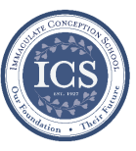
Immaculate Conception
School News

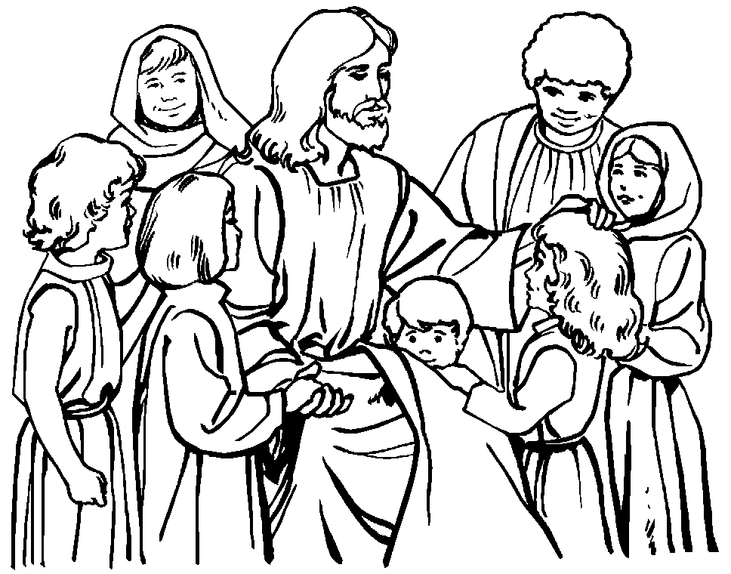
Have you seen our test scores?!
ICS academics are ranked in the 90th percentile compared to test scores from other schools across the Diocese! This is in part because of how passionate we are about our students’ education! This is also in part due to our small class sizes:
“Small classes have a positive impact on student engagement behaviors, which include the amount of effort put forth, initiative taken, and participation by a student. Not surprisingly, these characteristics have been shown to be important to classroom learning. Finn finds that students who were in small classes in STAR continued to have higher engagement ratings in subsequent grades.” -Diane Whitmore Schanzenbach, Northwestern University, February 2014, National Education Policy Center.

COMING UP...

Brrrr!! Bundle up!
ICS Students begin wearing their winter uniforms on Monday, November 4th. If you need any information about what the winter uniform requirements are, please visit the “parent resources” page at http://icschoolweb.org/our-community/parent-resources/ and click on the student handbook.

Special person’s lunch
Our 6th grade is hosting Special Person’s lunch for their loved ones on Thursday, November 14th at 11:00am.

Ball in the house Assembly
Our students will enjoy an awesome performance by “Ball In the House” on Monday, November 18th. Ball In the House is an R&B/Soul/Pop a cappella group from Boston, MA whose high-energy shows have audiences singing, dancing, and beatboxing along!

Story time continues at ICS!
Bring your little ones, ages 2-5 to ICS! Gwen Davis reads classic children’s stories and provides themed activities, music, crafts, and snacks! Story time is FREE!! Your children will love it! The next Story Time is this Wednesday, November 20th at 10:00am. Call 410-398-2636 to register.

We’re enrolling!
If you are interested in learning more about ICS or would like to enroll your child, please contact our Advancement Director, Emily Murphy at emurphy@icschoolweb.org. Now is the time to consider the benefits of the strong, faith-based, challenging academic program that ICS provides.
Faith Formation
Religious Education & Sacraments

Religion Classes: For the Sake of God’s Children first session will be today, Sunday, November 3rd. All home school students need to attend one of these sessions.

Outreach: for November donations requested are Thanksgiving foods. Children will bring home bags this week for the Outreach collection of food for the holidays.

Celebration for Sr. Grace – Please join us today Sunday, November 3rd from 1 – 4pm in the ICS Gym all are invited to come and see Sr. Grace at this open house honoring her.
If you would to volunteer to help please contact the Parish Volunteer Committee at 410-392-3551.

Youth Ministry & Confirmation

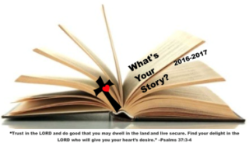
CONFIRMATION
Classes today - Sunday, November 3rd and on Wednesday, November 6th. Next whole group meeting is Saturday, November 16th at St. Jude’s.

YOUTH GROUP – Grades 9 thru 12
Meetings are 6 – 8 pm in the parish center
Thanks to everyone who participated in our 1st annual bonfire. All had a good time.
Meeting tonight, November 3rd.

YOUTH MINISTRY WISH LIST:
- Youth Group is looking for a replacement donation for refrigerator
- We also are asking for sodas (cans please!)

JUNIOR YOUTH GROUP – Grades 6 thru 8
Join us to grow in faith thru fun and fellowship!
Thank you to our members who attended the bonfire. Meeting today, Sunday, November 3rd from 4-6pm.

ADULT EDUCATION

Interested in a study group? Many opportunities are available. Call the Religion Office at 410-392-3551.

Adult Education classes
Catholicism Class, Monday, Nov. 4th at 6:30pm & repeats on Thursday, Nov. 7th at 9:15m in the parish center.

Book Study
Tuesday, Nov. 5th at 9:15 am in the parish center.

SOCIAL CONCERNS

Outreach

Please consider donating to the Outreach! Thank you so much to all those who have donated!! Thank you for your help, generosity, prayers, & donations to this essential ministry!!
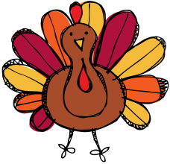
Food items: We are beginning to collect holiday food for Thanksgiving. Please consider donating food for the holidays.

PARISH EVENTS/INFORMATION

Weekly Church Collections: Week of Oct. 27th
ICC $7,168
St. Jude $1,661
Online $2,186
Total Offertory $11,015

Keep up with regular offerings by giving electronically!!

Just as you rely upon receiving income on a regular basis, we rely on your regular contributions. We greatly appreciate the efforts of our parishioners to make consistent donations throughout the year! To assist you, the church provides a convenient electronic giving option for setting up regular contributions! Simply visit our website and click the Online Giving Button!

How does Online giving benefit you?
- It’s easy, convenient, and safe
- Allows you to give any amount, any time.
- Allows you to track your giving

How does Online giving benefit the parish?
- Creates consistency of giving
- Increases efficiency of processing giving

How to sign up?
- Visit www.iccparish.org
- Click “Go to Online Giving”
- Sign up! It’s that easy!
PARISH & FAMILY LIFE

Parish Coffee
Please join us at St. Jude’s for Parish Coffee Nov 3rd following the 9:00 Mass.

Join us for Parish Coffee, November 17th after 8:30am and 10:15am Masses at ICC!

PARISH EVENTS/INFORMATION

Basketball registration!
Basketball is in need of two heads for Pre-JV and two heads for JV to make these teams a go! Please contact Icshawkssports@gmail.com if you are interested!

Registration is OPEN!
3rd & 4th grade boys and girls (co-ed) -- Pre-JV. Practices Tues/Thurs 5:30 to 6:30
5th & 6th grade boys - JV.
Practices Tues/Thurs 6:30 - 8 p.m.
7th & 8th grade boys - Varsity.
Practices Wed/Friday 6:30 - 8 p.m.

We are eligible for girls JV and Varsity teams too! If we have any interested players or questions please
contact icshawkssports@gmail.com

Community Kitchen
The Community Kitchen Annual Fried Chicken Dinner was a huge success! Thank you to all of our faithful volunteers who blessed us with cash donations to buy the delicious chicken from Redner's (with receipt going to Outreach); scalloped potatoes, string beans with ham, rolls and butter, apple sauce and a variety of lovely desserts. Thank you for your joy-filled prepping, serving and cleaning which allowed our guests to enjoy the meal with many compliments and kind words about our parish :) We look forward to our next service date on January 24th! We wish you a Happy Thanksgiving and a holy Advent & Christmas Season! Thank you, again, for bringing the gospel alive by this Ministry.

ICC hosts a meal at the Paris Foundation on the Second Thursday of each month. The next date is November 14th! We appreciate the support of our church family and are currently in need of monetary donations, as well as volunteers. We do this dinner 12 months a year. If you would be interested in doing this please contact Patricia Gibson at pag1974@yahoo.com. Thank you for your generosity and support!

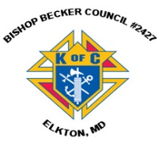
Sunday, November 3
8:20 AM - Confessions - SJ
8:30 AM - Religious Ed
10:00 AM - Coffee Sunday - SJ
1:00 PM - Sister Grace Celebration - gym
1:30 PM - Adoration for Vocations - CH
6:00 PM - HS Gathering - PC

Monday, November 4
9:30 AM - Novena - CH
10:00 AM - ICS Prayer service - IC
5:30 PM - Volleyball - gym
6:30 PM - CYO Soccer
6:30 PM - Catholicism
8:00 PM - AA Mtg -caf

Tuesday, November 5
9:00 AM - Holy Hour - CH
9:00 AM - Adult Ed Book Study - PC
5:30 PM - Pre JV Basketball - gym
6:00 PM - Liturgy Committee Mtg - PC
6:30 PM - JV Basketball - gym
7:30 PM - Contemporary Rehearsal - IC

Wednesday, November 6
9:00 AM - Rosary Crusade / Novena-CH
9:30 AM - Cantor Reh - IC
1:00 PM - LAOH Mtg - PC
4:00 PM - Children’s Choir - PC
6:00 PM - Confirmation Class - PC
6:15 PM - Religious Ed - ICS
6:30 PM - Varsity Basketball - gym
6:30 PM - CYO Soccer - grounds

Thursday, November 7
9:00 AM - Rosary Crusade - CH
9:15 AM - Catholicism - PC
3:00 PM - Parent/teacher conferences
5:30 PM - Pre JV Basketball - gym
6:30 PM - JV Basketball - gym
6:30 PM - Boy Scout Mtg - PC
6:30 PM - cub scout mtg - caf
6:30 PM - Cantor Rehearsal - IC
7:00 PM - Parish Choir Rehearsal - IC
7:00 PM - RCIA - PC

Friday, November 8 - ICS No school!
9:00 AM - Rosary Crusade - CH
6:30 PM - Varsity Basketball - gym
6:30 PM - CYO soccer - grounds
7:00 PM - NA Mtg - Caf

Saturday, November 9
9:00 AM - Rosary Crusade - CH
2:00 PM - Christmas Bazaar - ICS
4:15 PM - Confessions - IC
7:00 PM - NA Mtg - Caf
community EVENTS/INFORMATION

Knights of Columbus
Bishop Becker Council 2427
Meetings: 2nd & 4th Tuesdays of the month at 6:30 pm at the Parish Center

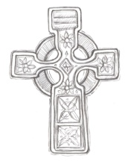
LAOH (The Ladies Ancient Order of Hibernians)
The Ladies Ancient Order of Hibernians, Inc. Cecil County Division 1, an Irish Catholic Action group has meetings on the first Wednesdays of the month at 1:00pm in the Parish Center. Meetings run September through May. We are always looking for new members! If you are an Irish Catholic woman and want to serve your community, and learn more about your Irish heritage come join us! Please contact the historian, Betty Green at 410-392-5287

Relevant Radio 640
Listen to Catholic Forum every Saturday morning at 11:00 on Relevant Radio 640. Next Saturday, November 9, 2019, tune in to meet Father Jerry Hogan, who has served for over 25 years, as national chaplain to circus performers and show people. After it airs, listen to Catholic Forum online anytime at www.cdow.org/CatholicForum, or search “Catholic Forum” on Apple, Spotify, or iHeartRadio podcasts. For photos, information regarding upcoming guests, links and more, “Like” Catholic Forum on Facebook at www.facebook.com/CatholicForum.

The Paris Foundation is having their annual banquet and auction fundraiser on November 7th at 6:00pm at Sandy Cove Ministries, 60 Sandy Cove Rd. North East, MD 21901 Join us for dinner, auctions, and some fabulous keynote speakers. Tickets are $30 per guest. There are sponsorships available for this fundraiser as well. For more information, please call 484-459-1288 or visit www.theparisfoundation.org.

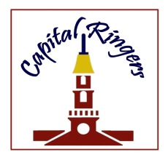
Capital Ringers Christmas Bells:
You are invited to join Artistic Director Linda Simms and the Capital Ringers at their Christmas Bells concert on Sunday, November 24th at 4:00pm at St. Paul’s Lutheran Church. (701 South College Ave. Newark, DE) Tickets are $14 per person, and FREE to children 18 and under! To purchase tickets online, please visit brownpapertickets.com. For more information call 302-745-0359 or visit www.capitalringers.org.

Mount Aviat Academy’s 57th Annual Christmas Bazaar
Don’t miss this fun holiday event for the whole family! Join us for MAA’s 57th Annual Christmas Bazaar on Saturday, November 23rd from 10:00 am - 4:00 pm. The Christmas Bazaar features: Pictures with Santa, 50/50 raffle tickets, a children’s bazaar run by 8th grade students, delicious food including cream puffs, as well as baked and homemade goods, silent auction, and much more! MAA is located at 399 Childs Road, Childs, MD.

