***From Father Jim***

**“Remember Jesus Christ, raised from the dead, is a descendant of David: such is my gospel, for which I am suffering, even to the point of chains, like a criminal. But the Word of God is not chained. Thus I bear with everything for the sake of those who are chosen, so that they too may obtain the salvation that is in Christ Jesus, together with eternal glory.”**

At every Eucharist, or in a quiet reflective moment, God speaks to us through the scriptures. We open our hearts to what the Lord has to say, and gently, softly, His word moves us to a deeper union with Him. For this to happen, it requires several steps. I begin by acknowledging that God is addressing me, at this moment, in this text. I simply ask ‘Lord what do you wish for me to take from this reading today?’ I wonder how the power of the word may direct my life.

Think for a moment. If each person in our parish community would ask these questions and seek the Lord’s response, our lives would be radically changed, our concern for those around me would grow and the unchained word would spread more effectively in my world. God speaks, I hear and listen, and others allow their response to blend with mine to obtain the salvation in Christ Jesus.

**Our Parish is celebrating the 50th Anniversary of St. Jude Church in 2019!**

As part of our Parish Celebration, we have invited priests who have served our parish to join us during the Anniversary Season. We are happy to announce that Fr. Stanislao Esposito, who served as Associate Pastor from 2007-2010, will celebrate the 9:00am Mass today, **October 13th**. Fr. Stanislao is warmly remembered for greeting us each week with, “Welcome Home.” Thank you for coming to celebrate with us!!

**Closing Celebration for the St. Jude’s 50th Anniversary!**

Join us for the 50th Anniversary Closing Celebration! We will commemorate the conclusion of the 50th Anniversary Celebration with brunch and fellowship on **Sunday, October 27th** at St. Jude’s following the 9:00am Mass. Bring a food item for the Parish Outreach!

**Fr. Michael Connelly, OSFS**: Join us **Sunday, October 20th** at 1pm at Immaculate Conception. Join Fr. Connelly as he explores the Letters of St. Paul to the Church.

**Columbus Day**

ICS and the Parish office will be CLOSED tomorrow, **October 14th** for Columbus Day!!



**October 14, 2019 Saint Callistus I, Pope and Martyr**

9:00 am Mary Lou Pronti

**October 15, 2019 St Teresa of Jesus, Dr of the Church**

8:30 am Deborah Nichols

**October 16, 2019 Saint Hedwig, Religious**

8:30 am Lenny DeAgani

10:00 am ICS Respect for life prayer service

**October 17, 2019 Saint Ignatius of Antioch, Bishop**

8:30 am Roberto Ortiz (Living Intention)

**October 18, 2019 Saint Luke, Evangelist**

8:30 am Luke Coiner

**October 19, 2019 Saints John de Brébeuf and Isaac Jogues, Priests and Martyrs**

8:30 am Ann Haley (Living Intention)

5:00 pm Mary Rudges

**October 20, 2019 29th Sunday in Ordinary Time**

7:00 am Louisa Caldwell

8:30 am Laura and Earl Koch

9:00 am SJ Vanessa Blankenship

10:15 am People of the Parish

12:00 pm Shirley Discher

***We extend a warm welcome to our new Parishioners:***

*Mr. Zachariah Foda and Dr. Clara Barr and family*

*Mr. and Mrs. Brian Landau*

*Mr. Leonardo Tadalan*

***We extend our condolences and prayers to the families of those who have recently died:***

*Mr. John Turnbull Jr.*

**All Saints/All Souls Mass Schedule**

**Thursday, October 31st**

8:30am Daily Mass - IC

5:00pm All Saints Vigil - IC

**Friday, Nov 1st**

8:30am All Saints/School Mass - IC

7:00pm All Saints Mass - SJ

**Saturday, Nov 2**

**\*\*NO 8:30am Mass!!**

10:00am All Souls Mass - IC

5:00pm Sunday Vigil Mass - IC

**Readings for next week:**

***TWENTY-NINTH SUNDAY IN ORDINARY TIME***

**First Reading: Exodus 17:8-13**

Amalek and his people attacked the Israelites, so Moses instructed Joshua to lead some of the Israelites into battle the next day. While Moses kept his hands raised in prayer, the Israelites were winning. But when he put his hands down, they would begin to lose. So two others helped him keep his hands raised, and Joshua and the Israelites won the battle.

**Second Reading: 2 Timothy 3:14-4:2**

Paul tells Timothy that the Scriptures are inspired by God and are an excellent tool in teaching others about God's expectations. Knowledge of the Scriptures, coupled with faith in Jesus, will lead people to salvation. Paul urges Timothy to continue preaching the gospel, even when it is a difficult task.

**Gospel: Luke 18:1-8**

Jesus speaks about a corrupt judge who lacked respect for either God or man. A widow repeatedly asked him to settle a case in her favor. He finally settled the case, only because he grew weary of listening to her requests. Jesus points out that if even this corrupt judge eventually listened, then God, who is just, will certainly answer the pleas of his people.

**Daily Readings:**

***Twenty-eighth Sunday in Ordinary Time***

**Sunday** ...................... 2 Kgs 5:14-17; 2 Tm 2:8-13; Lk 17:11-19

**Monday** .............................................. Rom 1:1-7; Lk 11:29-32

**Tuesday** ........................................... Rom 1:16-25; Lk 11:37-41

**Wednesday** ....................................... Rom 2:1-11; Lk 11:42-46

**Thursday** ......................................... Rom 3:21-30; Lk 11:47-54

**Friday** ............................................... 2 Tm 4:10-17b; Lk 10:1-9

**Saturday** ...................................... Rom 4:13, 16-18; Lk 12:8-12



**A new RCIA program has begun**. RCIA (Rite of Christian Initiation of Adults) is the process by which baptized Christians and those who are not baptized become members of the Catholic Church. It is also the process by which baptized Catholics receive the sacraments of Eucharist and Confirmation. If you feel God calling you to have a deeper relationship with Him, please call the Parish Office at 410-398-1100 to register with Pat Kosman. The RCIA process is a wonderful way to have a greater understanding of the Catholic faith and become closer to God in the process.

**Sponsors are needed to walk with those** who are going through the RCIA process. If you love your Catholic faith and want to share it with others, consider being a sponsor! It requires a small amount of effort, yet yields large rewards.

**Adoration for Vocations**

On the 1st Sunday of the month, exposition of the Blessed Sacrament occurs from 1pm-3pm in IC Chapel. Join us to pray for vocations. The next opportunity is **November 3rd.** Contact Dermott Mullan at 410-398-3368.

**Liturgical Ministers Next Week: *October 19th & 20th***

***5:00 pm*** AJ S, Nathan S •**EM’s:** Carol K, Mary C • **Lector:** Alison D • **Ushers:** Eileen P, Bob E, William B

***7:00 am***

•**Altar Servers**: **\*UNFILLED\***• **EM’s:** Gerald M, Frank S, Sandra H • **Lector:** James S • **Ushers:** Charles M

***8:30 am***

**Altar Servers:** Elizabeth R, Alex L • **EMs:** Don H, Peter G, Cecilia G • **Lector:** Francis C •**Ushers:** Anthony D, Stephen C, Wendel S

***9:00 am (SJ)***

**Altar Servers:** Mitchell H, Joseph H • **EM’s:** Chris H, Thomas V, Carol V, Dorothy D, Peggy O • **Lector:** Marcia B • **Ushers:** Jule V, Kevin O, William D

***10:15 am***

**Altar Servers:** David M, Adam M • **EM’s:** Gwen D, James D, Richard L • **Lector:** Tina B • **Ushers:** Bob W, Steve A

**12:00 *noon***

**Altar Servers:** Henry W, Damian W •**EMs:** Mary L, Corazon S, Charles C • **Lector:** Brigid W • **Ushers:** Teresa G



**St. Jude’s Memories**

This Sunday we are excited to “Welcome Home” Father Stanislao Esposito. We have our “Welcome Home” cross-shaped door hangings in place just in time for the returning priest who began each of his homilies with the phrase, “Welcome Home”. Someone must get a photo of Fr. Stanislao with one of the crosses in the background! In addition, the intention for this Mass is for Fr. Tony Larry whose birthday would be tomorrow, October 14. Members of Fr. Tony’s family, Margy (his sister) and Milt Bilecki are in attendance today. Also expected are their daughters, son, and their spouses: Margy and Michael Lacinski, Toni and Walt Knotts and Michael and Marisa Bilecki will be celebrating with us. They will ‘dress the altar’ by putting on the altar cloth and they will process up with the gifts. We hope they know we are so grateful for the love and service Fr. Tony provided us, especially the Christmas Eve Pageants and the Holy Week environment he created for us.

**Children’s Liturgy of the Word**

CLW is for children 5-8 years old. Children under 5 are welcome if they are accompanied by a parent (not a sibling!)

Also, CLW is in desperate need of adult help for. If interested, please contact Gwen Davis at 410-392-8078

**The Catechist for next Sunday, October 20th is:**

**Gwen Davis**

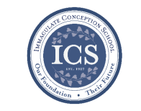**Immaculate Conception**

**School News**

**Have you seen our test scores?!**

ICS academics are ranked in the 90th percentile compared to test scores from other schools across the Diocese! This is in part because of how passionate we are about our students’ education! This is also in part due to our small class sizes:

“Small classes have a positive impact on student “engagement behaviors,” which include the amount of effort put forth, initiative taken, and participation by a student. Not surprisingly, these characteristics have been shown to be important to classroom learning. Finn finds that students who were in small classes in STAR continued to have higher engagement ratings in subsequent grades.” -Diane Whitmore Schanzenbach, Northwestern University, February 2014, National Education Policy Center.

**COMING UP...**

**Respect Life Prayer Service**

ICS will be having a Respect Life Prayer Service on **Wednesday, October 16th** at 10:00 am at Immaculate Conception Church. This is always a beautiful and meaningful service for the students.

**Story time continues at ICS!**

Bring your little ones, ages 2-5 to ICS! Gwen Davis reads classic children’s stories and provides themed activities, music, crafts, and snacks! **Story time is FREE!!** Your children will love it! The next Story Time is this Wednesday**, October 16th at 10:00am.** Call 410-398-2636 to register.

**Special person’s lunch**

Our 7th grade is hosting Special Person’s lunch for their loved ones on **Thursday,** **October 17th** at 11:00am.

**High school Information Night**

We are pleased to offer High School Information Night for the parents of current 7th and 8th grade students! This is a unique opportunity which allows parents and students to talk with the faculty and examine what to expect and information about the High Schools in the Diocese. High School Information Night is **Tuesday, October 29th at 6:00pm**.

**We’re enrolling!**

**If you are interested in learning more about ICS or would like to enroll your child,** please contact our Advancement Director, Emily Murphy at [emurphy@icschoolweb.org](mailto:emurphy@icschoolweb.org). Now is the time to consider the benefits of the strong, faith-based, challenging academic program that ICS provides.

**Faith Formation**

**Religious Education & Sacraments**

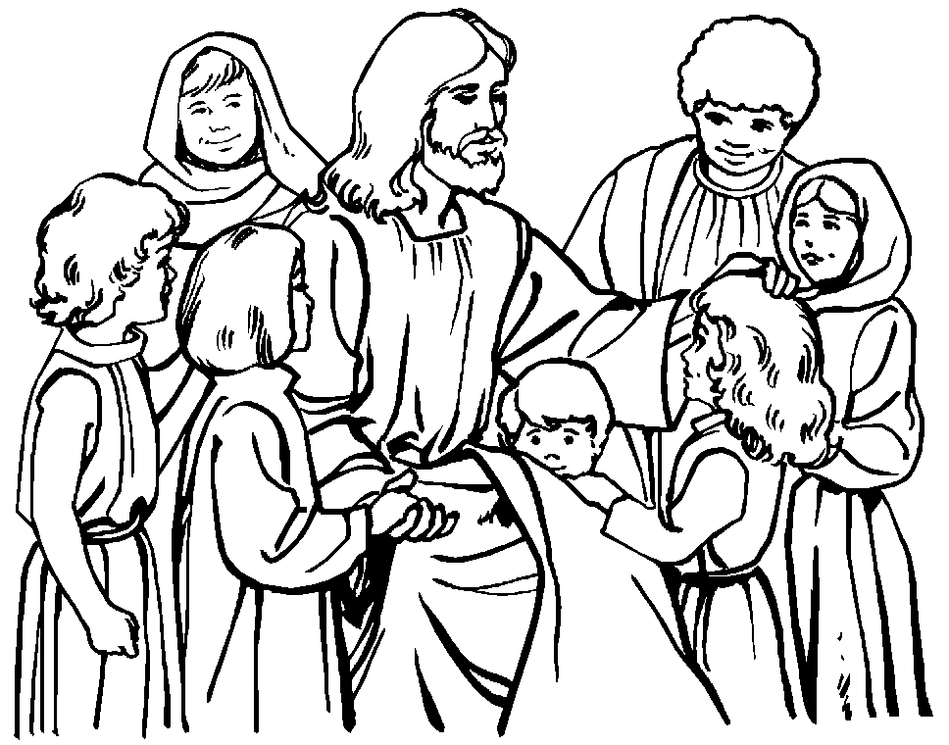

**Outreach:** for October is canned fruits and vegetables. Thank you for any donations

**Celebration for Sr. Grace** – Please save the date Sunday, November 3rd from 2 – 4pm in the ICS Gym all are invited to come and see Sr. Grace at this open house honoring her!

If you would to volunteer to help please contact the Parish Volunteer Committee at 410-392-3551.

**Youth Ministry & Confirmation**

#### whats-your-story

**CONFIRMATION**

Thanks to all who participated in the Stations of the Environment and Crop Walk.

Classes begin today Sunday and on Wednesday.

**YOUTH GROUP – Grades 9 thru 12**

**Meetings are 6 – 8 pm in the parish center**

Meeting - tonight October 13th. Bring a friend.

Save the date October 27th bonfire night.

**YOUTH MINISTRY WISH LIST:**

* Youth Group is looking for a replacement donation for refrigerator
* We also are asking for sodas (cans please!)

**JUNIOR YOUTH GROUP – Grades 6 thru 8**

Announcing Junior Youth Group!! Join us to grow in faith thru fun and fellowship!

Meets today, Oct. 20th at 4:00 pm in the parish center. Please bring a donation for outreach.

**ADULT EDUCATION**

**Interested in a study group?** Many opportunities are available. Call the Religion Office at 410-392-3551.

**Adult Education classes** –

Catholicism Class, Monday, Oct. 14th at 6:30pm & repeats Thursday, Oct. 17th at 9:15am in the parish center.

**Book Study**

Tuesday, Oct. 15th at 9:15 am in the parish center.

**SOCIAL CONCERNS**

**Outreach**

**Please consider donating** to the Outreach! Thank you so much to all those who have donated!! Thank you for your help, generosity, prayers, & donations to this essential ministry!!

**Food items:** baked beans, spaghetti, jelly, pancake mix, and syrup

**Non-Food items:** toilet paper and children’s coats

**PARISH EVENTS/INFORMATION**



**Weekly Church Collections: Week of Oct. 6th**

ICC $8,602

St. Jude $2,119

Online $3,862

Total Offertory $14,583

**Keep up with regular offerings by giving electronically!!**

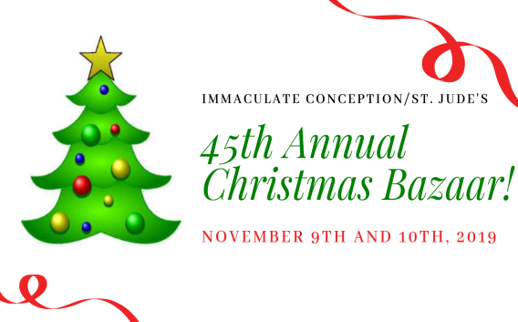Just as you rely upon receiving income on a regular basis, we rely on your regular contributions. We greatly appreciate the efforts of our parishioners to make consistent donations throughout the year! To assist you, the church provides a convenient electronic giving option for setting up regular contributions! Simply visit our website and click the Online Giving Button!

**How does Online giving benefit you?**

1. It’s easy, convenient, and safe
2. Allows you to give any amount, any time.
3. Allows you to track your giving

**How does Online giving benefit the parish?**

1. Creates consistency of giving
2. Increases efficiency of processing giving

**How to sign up?**

1. Visit www.iccparish.org
2. Click “Go to Online Giving”
3. Sign up! It’s that easy!

**PARISH & FAMILY LIFE**

**Parish Coffee**

Please join us at St. Jude’s for Parish Coffee **Nov 3rd** following the 9:00 Mass.

**Join us** for Parish Coffee, **October 13th** after 8:30am and 10:15am Masses at ICC!

**PARISH EVENTS/INFORMATION**

**Knights of Columbus Open House**

The Knights of Columbus will be hosting an Open House on October 22nd at the Parish Center at 7pm. We are looking for Catholic Men (18+) interested in following The Christ’s call to server one another. Join us at that time, or contact [Lnajera@davincigrp.com](mailto:Lnajera@davincigrp.com) for more details.

**COMMUNITY KITCHEN:**

Our next Community Kitchen will be held on **October 25th** at the Elkton Presbyterian Church at noon. We will again be serving the ever popular Fried Chicken luncheon for our guests! We are asking for donations of large size cans of green beans, ready to serve dinner rolls, applesauce, pans of scalloped potatoes, and desserts. We will begin around 11:00am for preparation, and then serve the meal at noon.

If you are able to help with any of these items or want to join us for this enjoyable community meal, please call Joyce Speakman at [610-597-3135](tel:610-597-3135), or Kathy Chamberlin at [410-398-7299](tel:410-398-7299). Of course, cash donations are always welcome and are always directly used for buying food. If donating by check, please make it out to Immaculate Conception Church, and just write “Community Kitchen” in the memo section. Thank you so much for all you have done to make our Community Kitchen so outstanding!

**CHRISTMAS BAZAAR:**

Mark your calendars for the annual Parish Christmas Bazaar to be held on **November 9th & 10th.** Our online Sign-Up Genius is now available so you can sign up to work at a parish-sponsored booth at the bazaar. Go to <https://bit.ly/ICC-SJ-ChristmasBazaar2019> to sign up. We accepting donations of used books and CD's for the Book Nook. Donations can be dropped off at the Parish Center during business hours. Anyone interested in joining the Christmas Bazaar planning committee is warmly invited to join us at our next meeting. For upcoming meeting dates or for other information about the Christmas Bazaar, please contact one of the following: Lisa Kaminski, 410-392-9558, [kaminski-uch@comcast.net](mailto:kaminski-uch@comcast.net); Jackie Gedz, 410-392-0396, [Jackie.gedz@verizon.net](mailto:Jackie.gedz@verizon.net); or Terry Gustafson, 443-553-2324, [teresa.gustafson@verizon.net](mailto:teresa.gustafson@verizon.net)

**The Cenacle of Divine Mercy** at Immaculate Conception will hold its next meeting **Saturday, November 2nd** from 10AM-12PM in the parish youth room. The meeting is open to all adult females in the parish. Join us for refreshments and hear the message of divine mercy. For more information contact Heather Ulmen at [hu_ntrprtr@outlook.com](mailto:hu_ntrprtr@outlook.com).

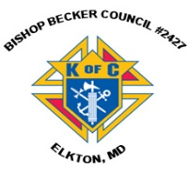

**Sunday, October 13**

8:20 AM - Confessions - SJ

8:30 AM - Religious Ed

11:00 AM - Coffee Sunday - gym

1:30 PM - Baptisms - IC

6:00 PM - HS Gathering - PC

Monday, October 14 - ICS & Parish Office closed

9:30 AM - Novena - CH

5:30 PM - Volleyball - gym

6:30 PM - CYO Soccer

6:30 PM - Catholicism

8:00 PM - AA Mtg -caf

Tuesday, October 15

9:00 AM - Holy Hour - CH

9:00 AM - Adult Ed Book Study - PC

4:45 PM - Finance Mtg - PC

6:30 PM - Handbell Rehearsal - IC

7:30 PM - Contemporary Rehearsal - IC

Wednesday, October 16

9:00 AM - Rosary Crusade / Novena-CH

9:30 AM - Cantor Reh - IC

10:00 AM - ICS prayer service - IC

4:00 PM - Children’s choir - PC

6:00 PM - Confirmation Class - PC

6:15 PM - Religious Ed - ICS

6:30 PM - CYO Soccer - grounds

Thursday, October 17

9:00 AM - Rosary Crusade - CH

9:15 AM - Catholicism - PC

11:00 AM - 7th Gr special person lunch - caf

6:30 PM - Boy Scout Mtg - PC

6:30 PM - cub scout mtg - caf

6:30 PM - Cantor Rehearsal - IC

7:00 PM - RCIA - PC

7:00 PM - Parish Choir Rehearsal - IC

Friday, October 18

9:00 AM - Rosary Crusade - CH

6:30 PM - CYO soccer - grounds

7:00 PM - NA Mtg - Caf

**Saturday, October** **19**

9:00 AM - Rosary Crusade - CH

4:15 PM - Confessions - IC

7:00 PM - NA Mtg - Caf

**community EVENTS/INFORMATION**

**Knights of Columbus**

***Bishop Becker Council 2427***

**Meetings:** 2nd & 4th Tuesdays of the month at 6:30 pm at the Parish Center

**LAOH (The Ladies Ancient Order of Hibernians)**

**Help the LAOH feed the hungry!**

The Cecil County Division 1, Ladies Ancient Order of Hibernians would like to thank this parish for helping us during our annual participation in Boscov’s “Friends Helping Friends” campaign! The funds are used to assist the Parish Outreach Program. **The LAOH is assisting local charities** by collecting your $5 donation at Boscov’s in Christiana on October 16 from 9am-6pm. Passes are also available in the Parish Office. In return, you will receive a Boscov’s 25% discount shopping pass to be used on **October 16th** for “Friends Helping Friends” Day shopping pass at all Boscov’s locations. In addition, you are eligible to register to win fabulous prizes, including shopping sprees and more! Thank you in advance for helping us help others.

**November 1 Holy Day Mass Online for the Homebound**

Is someone you love unable to join us at church for the November 1 Holy Day Mass in celebration of **All Saints Day**? Please invite anyone you know who cannot get out to church to experience the spiritual comfort of this joy-filled Catholic Mass. Online video will be available at www.HeartoftheNation.org all day!

**Crouch Funeral Home Life Planning Seminar**

Join us at a FREE Life Planning Seminar on **Wednesday, October 23rd** at 6:00pm at St. Mary Anne’s Episcopal Church in. We will have funeral directors, a Register of Wills, and Estate Planning Attorneys there to discuss everything necessary to ensure you and your families are taken care of in the event of one’s passing. Seating is limited! RSVP by October 21st at 410-287-6166 or [www.crouchfuneralhome.com](http://www.crouchfuneralhome.com). We hope to see you at this important and informative seminar!

**Capital Ringers Christmas Bells:**

You are invited to join Artistic Director Linda Simms and the Capital Ringers at their Christmas Bells concert on Sunday, November 24th at 4:00pm at St. Paul’s Lutheran Church. (701 South College Ave. Newark, DE) Tickets are $14 per person, and FREE to children 18 and under! To purchase tickets online, please visit brownpapertickets.com. For more information call 302-745-0359 or visit [www.capitalringers.org](http://www.capitalringers.org).

**DCMEP is sponsoring** a film screening and discussion of “Naila and the Uprising” on Tuesday, **November 5th** at 7:00pm at Silverside Church in Wilmington, DE. PBS/WNET featured it as part of the acclaimed "Women, War & Peace" series. This film tells the story that history overlooked - of a courageous, nonviolent women's movement at the head of a struggle for freedom." From the director, Julia Bacha: "The women in Naila and the Uprising are not only role models for the rising generation of Palestinians and Israelis struggling for justice, freedom, dignity, and equality. They also illuminate lessons and legacies for communities around the globe who are demanding more of their political leaders as they organize for the rights and well-being of all." Hope to see you there!