***From Father Jim***

**“Remain faithful to what you have learned, because you know from whom you have learned it, and from infancy you have known the sacred scriptures, which are capable of giving you wisdom for salvation through faith in Jesus. All scripture is inspired by God and is useful for teaching, for refutation, for correction and for training in righteousness, so that those who belong to Jesus may be competent, equipped for every good work.”**

When is the last time you opened your bible at home, or listened with great attention as the scriptures were proclaimed at mass? When did you reflect on God’s word, during the week after hearing it at liturgy, or heard a text which was familiar to you? When did you think it might be helpful to attend a bible study?

The words above which Paul wrote to Timothy are invitations to us, so we can grow in our faith. The teaching reminds us of growing after first communion, confirmation or our marriage. We continue to grow older, are we growing in holiness? Pope Francis’ exhortation offers us the beatitudes as the path for holiness. The bible in your living room has allergies. It is allergic to dust. Please open it and read it!

**/**

**THE COMMEMORATION OF ALL THE FAITHFUL DEPARTED [ALL SOULS’ DAY] By Deacon Mike:**

**Saturday, November 2nd at 10:00am,** at ICC, we commemorate all of our faithful departed family and friends. We observe this day because we believe that the souls which are not perfectly cleansed from sins or who have not fully atoned for their past transgressions are waiting in Purgatory. They are well aware that they are heaven bound. We can help them into Heaven by our prayers, charitable works, especially by the sacrifice of the Mass. I invite all to attend this solemn day of commemoration. On this day, there will be remembrance candles for those who have died since last November 2, 2018. Their names have been written in our Book of Remembrance, which will be placed in the Sanctuary of both churches for the entire month of November.

We hope that all who have died have obtained eternal happiness in Heaven. For those who are in Purgatory preparing to enter Heaven, we must assist them. As a parish family, we need each other’s prayers and support. At all Masses, the Universal Prayer always has an intention for those who have died, and the Church prays for the faithful departed throughout the year. However, All Souls’ Day is the solemn day of commemoration, when we remember, pray, and offer Mass for our faithful departed community.

Here is a prayer that may be recited for our departed loved ones: "Eternal rest grant unto them, O Lord, and let perpetual light shine upon them. May the souls of the faithful departed, through the mercy of God, rest in peace. Amen."



**October 21, 2019**

8:30 am Melinda Walters

**October 22, 2019 St. John Paul II, Pope**

8:30 am Bernadette Sniadowski (Living Intention)

**October 23, 2019 St. John of Capistrano, Priest**

8:30 am Bradley Bird

**October 24, 2019 St. Anthony Mary Claret, Bishop**

8:30 am Father Thien

**October 25, 2019**

8:30 am Anh Cuong

**October 26, 2019**

8:30 am John M. Schweizer III

5:00 pm Arthur R. Jones Jr.

**October 27, 2019 30th Sunday in Ordinary Time**

7:00 am Ho and Nguyen Families

8:30 am Marianne and Lyle Utt

9:00 am SJ James Joseph McPhillips

10:15 am Aldo Barbaro

12:00 pm People of the Parish

**Celebration for Sister Grace: YOUR HELP IS NEEDED!**

We would love to have your homemade desserts, savory snacks, potato or macaroni salads, or coleslaw to serve at the parish celebration for Sister Grace. Your goodies can be dropped off at the school auditorium on Sunday, November 3 anytime after the 8am Mass. Please email or call Liz Orr at 410-920-8124 or [lizorr@gmail.com](mailto:lizorr@gmail.com) or Gwen Davis at 410-392-8078 or [gdavis@udel.edu](mailto:gdavis@udel.edu) and leave a message. Also remember to come to the auditorium from 2-4 to celebrate Sister Grace!

**All Saints/All Souls Mass Schedule**

**Thursday, October 31st**

8:30am Daily Mass - IC

5:00pm All Saints Vigil - IC

**Friday, Nov 1st**

8:30am All Saints/School Mass - IC

7:00pm All Saints Mass - SJ

**Saturday, Nov 2**

**\*\*NO 8:30am Mass!!\*\***

10:00am All Souls Mass - IC

5:00pm Sunday Vigil Mass - IC

***Congratulations to those who were recently baptized:***

*Taylor June Pettitt*

*Blayke Ivy Pristash*

*Charlee Grace Pristash*

***We extend our condolences and prayers to the families of those who have recently died:***

*Mrs. Janice White*

**Readings for next week:**

***THIRTIETH SUNDAY IN ORDINARY TIME***

**First Reading: Sirach 35:12-14, 16-18**

God is just and does not show favoritism, but hears the prayers of everyone. Anyone who serves God, no matter how lowly his position here on earth, will be heard and answered.

**Second Reading: 2 Timothy 4:6-8, 16-18**

Paul writes to Timothy that he thinks his mission is near the end, and he is glad his faith is still strong. Paul hopes that all nations will hear the gospel. But, if he is executed as he anticipates, he is sure he will live forever in heaven.

**Gospel: Luke 18:9-14**

Jesus tells a parable about a Pharisee who went to the temple, and offered up a prayer of thanks because he was not a sinner like the tax collector who was also there to pray. The tax collector was far more humble, acknowledging his sins, and asking forgiveness for them. Jesus said the tax collector's prayer would be heard because, "Everyone who exalts himself will be humbled, while he who humbles himself will be exalted."

**Daily Readings:**

***Twenty-ninth Sunday in Ordinary Time***

**Sunday** ............................ Ex 17:8-13; 2 Tm 3:14-4:2; Lk 18:1-8

**Monday** .......................................... Rom 4:20-25; Lk 12:13-21

**Tuesday** ................ Rom 5:12, 15b, 17-19, 20b-21; Lk 12:35-38

**Wednesday** ..................................... Rom 6:12-18; Lk 12:39-48

**Thursday** ......................................... Rom 6:19-23; Lk 12:49-53

**Friday** ............................................ Rom 7:18-25a; Lk 12:54-59

**Saturday** ............................................... Rom 8:1-11; Lk 13:1-9

**A new RCIA program has begun**. RCIA (Rite of Christian Initiation of Adults) is the process by which baptized Christians and those who are not baptized become members of the Catholic Church. It is also the process by which baptized Catholics receive the sacraments of Eucharist and Confirmation. If you feel God calling you to have a deeper relationship with Him, please call the Parish Office at 410-398-1100 to register with Pat Kosman. The RCIA process is a wonderful way to have a greater understanding of the Catholic faith and become closer to God in the process.

**Sponsors are needed to walk with those** who are going through the RCIA process. If you love your Catholic faith and want to share it with others, consider being a sponsor! It requires a small amount of effort, yet yields large rewards.



**Fr. Michael Connelly, OSFS**: Join us **TODAY Sunday, October 20th** at 1:00 pm at Immaculate Conception. Join Fr. Connelly as he explores the Letters of St. Paul to the Church.

**Adoration for Vocations**

On the 1st Sunday of the month, exposition of the Blessed Sacrament occurs from 1pm-3pm in IC Chapel. Join us to pray for vocations. The next opportunity is **November 3rd.** Contact Dermott Mullan at 410-398-3368.

**Liturgical Ministers Next Week: *October 26th & 27th***

***5:00 pm*** Grace B, Mason H •**EM’s:** Julie M, **\*UNFILLED\***

• **Lector:** Mary Ann E • **Ushers:** Eileen P, Bob E, Pat C

***7:00 am***

•**Altar Servers**:**\*UNFILLED\***•**EMs:** Sandra H, Alan S, Gerald M • **Lector:** Edward R • **Ushers:** Charles M

***8:30 am***

**Altar Servers:** Jeremy M, Alex L • **EMs:** Peter G, Cecilia G • **Lector:** Nora W •**Ushers:** Anthony D, Stephen C, Anthony M

***9:00 am (SJ)***

**Altar Servers:** Luke T, Matthew T • **EM’s:** Pat D, Diane C, Lester F, Dorothy F, Narcy Z • **Lector:** Dwight T • **Ushers:** Kevin O, Narcy Z, William D

***10:15 am***

**Altar Servers:** Hayden S, Hendric S • **EM’s:** Rita M, Grace B, Barbara R • **Lector:** Ben F • **Ushers:** Bob W, Steve A

**12:00 *noon***

**Altar Servers:** Gabriel O, Valerie O •**EMs:** Cynthia J, Kathy C, Mary C • **Lector:** Pat K • **Ushers:** Teresa G, Charles C

**Celebration for the St. Jude’s 50th Anniversary!**

Join us for the 50th Anniversary Closing Celebration! We will commemorate the conclusion of the 50th Anniversary Celebration with brunch and fellowship NEXT WEEKEND, **Sunday, October 27th** at St. Jude’s following the 9:00am Mass. Bring a food item for the Parish Outreach!

**St. Jude’s Memories**

This Sunday we are excited to “Welcome Home” Father Stanislao Esposito. We have our “Welcome Home” cross-shaped door hangings in place just in time for the returning priest who began each of his homilies with the phrase, “Welcome Home”. Someone must get a photo of Fr. Stanislao with one of the crosses in the background! In addition, the intention for this Mass is for Fr. Tony Larry whose birthday would be tomorrow, October 14. Members of Fr. Tony’s family, Margy (his sister) and Milt Bilecki are in attendance today. Also expected are their daughters, son, and their spouses: Margy and Michael Lacinski, Toni and Walt Knotts and Michael and Marisa Bilecki will be celebrating with us. They will ‘dress the altar’ by putting on the altar cloth and they will process up with the gifts. We hope they know we are so grateful for the love and service Fr. Tony provided us, especially the Christmas Eve Pageants and the Holy Week environment he created for us.

**Children’s Liturgy of the Word**

CLW is for children 5-8 years old. Children under 5 are welcome if they are accompanied by a parent (not a sibling!)

Also, CLW is in desperate need of adult help for. If interested, please contact Gwen Davis at 410-392-8078

**The Catechist for next Sunday, October 27th is:**

**Grace Amoretti**

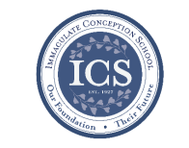**Immaculate Conception**

**School News**

**Have you seen our test scores?!**

ICS academics are ranked in the 90th percentile compared to test scores from other schools across the Diocese! This is in part because of how passionate we are about our students’ education! This is also in part due to our small class sizes:

“Small classes have a positive impact on student engagement behaviors, which include the amount of effort put forth, initiative taken, and participation by a student. Not surprisingly, these characteristics have been shown to be important to classroom learning. Finn finds that students who were in small classes in STAR continued to have higher engagement ratings in subsequent grades.” -Diane Whitmore Schanzenbach, Northwestern University, February 2014, National Education Policy Center.

**COMING UP...**

**Breast Cancer Awareness Month:**

October is Breast Cancer Awareness Month. NJHS will be sponsoring a pink dress down day on **Wednesday,** **October 23** with all of the proceeds benefitting Union Hospital Breast Health Center. The cost is $1.00 but we will gladly accept more.

**Brrrr!! Bundle up!**

ICS Students begin wearing their winter uniforms on **Monday, November 4th.** If you need any information about what the winter uniform requirements are, please visit the ICS “parent resources” site at <http://icschoolweb.org/our-community/parent-resources/> and click on the student handbook.

**Special person’s lunch**

Our 6th grade is hosting Special Person’s lunch for their loved ones on **Thursday,** **November 14th** at 11:00am.

**Story time continues at ICS!**

Bring your little ones, ages 2-5 to ICS! Gwen Davis reads classic children’s stories and provides themed activities, music, crafts, and snacks! **Story time is FREE!!** Your children will love it! The next Story Time is this Wednesday**, November 20th at 10:00am.** Call 410-398-2636 to register.

**We’re enrolling!**

**If you are interested in learning more about ICS or would like to enroll your child,** please contact our Advancement Director, Emily Murphy at [emurphy@icschoolweb.org](mailto:emurphy@icschoolweb.org). Now is the time to consider the benefits of the strong, faith-based, challenging academic program that ICS provides.

**Faith Formation**

**Religious Education & Sacraments**

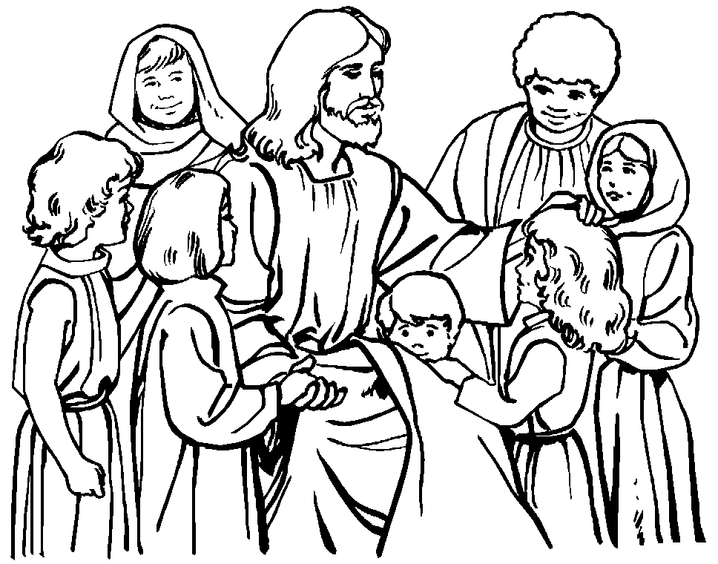

**Outreach:** for October is canned fruits and vegetables. Thank you for any donations

**Celebration for Sr. Grace** – Please save the date Sunday, **November 3rd** from 2 – 4pm in the ICS Gym all are invited to come and see Sr. Grace at this open house honoring her!

If you would to volunteer to help please contact the Parish Volunteer Committee at 410-392-3551.

**Youth Ministry & Confirmation**

#### whats-your-story

**CONFIRMATION**

Classes today Sunday, October 20th and on Wednesday, October 23rd.

**YOUTH GROUP – Grades 9 thru 12**

**Meetings are 6 – 8 pm in the parish center**

Meeting - tonight October 20th - bring a friend!

Save the date October 27th bonfire night.

**YOUTH MINISTRY WISH LIST:**

* Youth Group is looking for a replacement donation for refrigerator
* We also are asking for sodas (cans please!)

**JUNIOR YOUTH GROUP – Grades 6 thru 8**

Announcing Junior Youth Group!! Join us to grow in faith thru fun and fellowship!

Meets today, Oct. 20th at 4:00 pm in the parish center. Please bring a donation for outreach. All members are invited to the Bonfire on October 27th.

**ADULT EDUCATION**

**Interested in a study group?** Many opportunities are available. Call the Religion Office at 410-392-3551.

**Adult Education classes**

Catholicism Class, Monday, Oct. 21st at 6:30pm & repeats Thursday, Oct. 24th at 9:15am in the parish center.

**Book Study**

Tuesday, Oct. 22nd at 9:15 am in the parish center.

**SOCIAL CONCERNS**

**Outreach**

**Please consider donating** to the Outreach! Thank you so much to all those who have donated!! Thank you for your help, generosity, prayers, & donations to this essential ministry!!

**Food items:** baked beans, spaghetti, jelly, pancake mix, and syrup

**Non-Food items:** toilet paper and children’s coats

**PARISH EVENTS/INFORMATION**



**Weekly Church Collections: Week of Oct. 13th**

ICC $8,688

St. Jude $2,148

Online $3,531

Total Offertory $14,367

**Keep up with regular offerings by giving electronically!!**

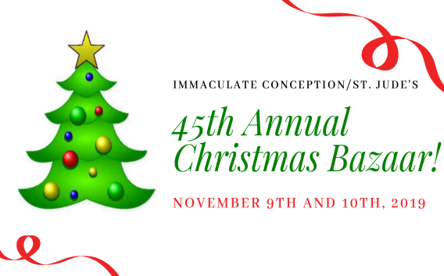Just as you rely upon receiving income on a regular basis, we rely on your regular contributions. We greatly appreciate the efforts of our parishioners to make consistent donations throughout the year! To assist you, the church provides a convenient electronic giving option for setting up regular contributions! Simply visit our website and click the Online Giving Button!

**How does Online giving benefit you?**

1. It’s easy, convenient, and safe
2. Allows you to give any amount, any time.
3. Allows you to track your giving

**How does Online giving benefit the parish?**

1. Creates consistency of giving
2. Increases efficiency of processing giving

**How to sign up?**

1. Visit www.iccparish.org
2. Click “Go to Online Giving”
3. Sign up! It’s that easy!

**PARISH & FAMILY LIFE**

**Parish Coffee**

Please join us at St. Jude’s for Parish Coffee **Nov 3rd** following the 9:00 Mass.

**Join us** for Parish Coffee, **November 17th** after 8:30am and 10:15am Masses at ICC!

**PARISH EVENTS/INFORMATION**

**Knights of Columbus Open House**

The Knights of Columbus will be hosting an Open House on **October 22nd** at the Parish Center at 7pm. We are looking for Catholic Men (18+) interested in following The Christ’s call to server one another. Join us at that time, or contact [Lnajera@davincigrp.com](mailto:Lnajera@davincigrp.com) for more details.

**COMMUNITY KITCHEN:**

Our next Community Kitchen will be held on **October 25th** at the Elkton Presbyterian Church at noon. We will again be serving the ever popular Fried Chicken luncheon for our guests! We are asking for donations of large size cans of green beans, ready to serve dinner rolls, applesauce, pans of scalloped potatoes, and desserts. We will begin around 11:00am for preparation, and then serve the meal at noon.

If you are able to help with any of these items or want to join us for this enjoyable community meal, please call Joyce Speakman at [610-597-3135](tel:610-597-3135), or Kathy Chamberlin at [410-398-7299](tel:410-398-7299). Of course, cash donations are always welcome and are always directly used for buying food. If donating by check, please make it out to Immaculate Conception Church, and just write “Community Kitchen” in the memo section. Thank you so much for all you have done to make our Community Kitchen so outstanding!

**CHRISTMAS BAZAAR:**

Mark your calendars for the annual Parish Christmas Bazaar to be held on **November 9th & 10th.** Our online Sign-Up Genius is now available so you can sign up to work at a parish-sponsored booth at the bazaar. Go to <https://bit.ly/ICC-SJ-ChristmasBazaar2019> to sign up. We are accepting donations of used books for the Book Nook. Donations can be dropped off at the Parish Center during business hours. Anyone interested in joining the Christmas Bazaar planning committee is warmly invited to join us at our next meeting. For upcoming meeting dates or other information, please contact one of the following: Lisa Kaminski, 410-392-9558, [kaminski-uch@comcast.net](mailto:kaminski-uch@comcast.net); Jackie Gedz, 410-392-0396, [Jackie.gedz@verizon.net](mailto:Jackie.gedz@verizon.net); or Terry Gustafson, 443-553-2324, [teresa.gustafson@verizon.net](mailto:teresa.gustafson@verizon.net)

**The Cenacle of Divine Mercy** at Immaculate Conception will hold its next meeting **Saturday, November 2nd** from 10AM-12PM in the parish youth room. The meeting is open to all adult females in the parish. Join us for refreshments and hear the message of divine mercy. For more information contact Heather Ulmen at [hu_ntrprtr@outlook.com](mailto:hu_ntrprtr@outlook.com).

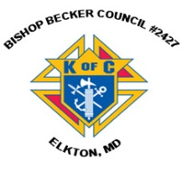

**Sunday, October 20**

8:20 AM - Confessions - SJ

8:30 AM - Religious Ed

10:30 AM - Baptisms - SJ

1:00 PM - Fr. Connelly presentation - CH

6:00 PM - HS Gathering - PC

Monday, October 21

9:30 AM - Novena - CH

5:30 PM - Volleyball - gym

6:30 PM - CYO Soccer

6:30 PM - Catholicism

7:00 PM - Baptism Class - PC

8:00 PM - AA Mtg -caf

Tuesday, October 22

9:00 AM - Holy Hour - CH

9:00 AM - Adult Ed Book Study - PC

6:00 PM - Christmas Bazaar Mtg - PC

6:30 PM - Knights of Columbus Mtg - PC

6:30 PM - Handbell Rehearsal - IC

7:30 PM - Contemporary Rehearsal - IC

Wednesday, October 23

9:00 AM - Rosary Crusade / Novena-CH

9:30 AM - Cantor Reh - IC

1:00 PM - Leisure Club - PC

4:00 PM - Children’s choir - PC

6:00 PM - Confirmation Class - PC

6:15 PM - Religious Ed - ICS

6:30 PM - CYO Soccer - grounds

Thursday, October 24

9:00 AM - Rosary Crusade - CH

9:15 AM - Catholicism - PC

6:30 PM - Boy Scout Mtg - PC

6:30 PM - Basketball - gym

6:30 PM - cub scout mtg - caf

6:30 PM - Cantor Rehearsal - IC

7:00 PM - RCIA - PC

7:00 PM - Parish Choir Rehearsal - IC

Friday, October 25

9:00 AM - Rosary Crusade - CH

6:30 PM - Basketball - gym

6:30 PM - CYO soccer - grounds

7:00 PM - NA Mtg - Caf

**Saturday, October** **26**

9:00 AM - Rosary Crusade - CH

4:15 PM - Confessions - IC

7:00 PM - NA Mtg - Caf

**community EVENTS/INFORMATION**

**Knights of Columbus**

***Bishop Becker Council 2427***

**Meetings:** 2nd & 4th Tuesdays of the month at 6:30 pm at the Parish Center

**LAOH (The Ladies Ancient Order of Hibernians)**

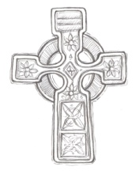The Ladies Ancient Order of Hibernians, Inc. Cecil County Division 1, an Irish Catholic Action group has meetings on = the first Wednesdays of the month at 1:00pm in the ICC Parish Center. Meetings run September through May. We are always looking for new members! If you are an Irish Catholic woman and want to serve your community, and learn more about your Irish heritage come join us! Contact Janice White, President at 410-378-3493

**November 1 Holy Day Mass Online for the Homebound**

Is someone you love unable to join us at church for the November 1 Holy Day Mass in celebration of **All Saints Day**? Please invite anyone you know who cannot get out to church to experience the spiritual comfort of this joy-filled Catholic Mass. Online video will be available at www.HeartoftheNation.org all day!

**Crouch Funeral Home Life Planning Seminar**

Join us at a FREE Life Planning Seminar on **Wednesday, October 23rd** at 6:00pm at St. Mary Anne’s Episcopal Church in. We will have funeral directors, a Register of Wills, and Estate Planning Attorneys there to discuss everything necessary to ensure you and your families are taken care of in the event of one’s passing. Seating is limited! RSVP by October 21st at 410-287-6166 or [www.crouchfuneralhome.com](http://www.crouchfuneralhome.com). We hope to see you at this important and informative seminar!

**Capital Ringers Christmas Bells:**

You are invited to join Artistic Director Linda Simms and the Capital Ringers at their Christmas Bells concert on Sunday, November 24th at 4:00pm at St. Paul’s Lutheran Church. (701 South College Ave. Newark, DE) Tickets are $14 per person, and FREE to children 18 and under! To purchase tickets online, please visit brownpapertickets.com. For more information call 302-745-0359 or visit [www.capitalringers.org](http://www.capitalringers.org).

**The Paris Foundation is having their annual banquet and auction fundraiser** on November 7th at 6:00pm at Sandy Cove Ministries, 60 Sandy Cove Rd. North East, MD 21901 Join us for dinner, auctions, and some fabulous keynote speakers. Tickets are $30 per guest. There are sponsorships available for this fundraiser as well. For more information, please call 484-459-1288 or visit [www.theparisfoundation.org](http://www.theparisfoundation.org).

**St. Dennis Church will be having their annual Christmas Bazaar** on November 2nd from 9:00am - 2:00pm. Join us Arts and crafts, silent auctions, vendors, raffles, and much more! New vendors are welcome: Call Jim at 717-575-1235.