***From Father Jim***

**“I came to you in weakness and fear and much trembling, and my message and my proclamation were not with persuasive words of wisdom, but with a demonstration of Spirit and power, so that your faith might rest not on human wisdom but on the power of God….You are the salt of the earth…you are the light of the world.’”**

We are so accustomed to read the letters of St. Paul, or travel with him on his journeys, to consider this itinerant preacher as one who had it all together. As we listen to him today, he placed his trust on the Lord, the Spirit and God’s good grace or power. Although he denies the use of persuasive speech, our Christian lives are molded and formed by his great teaching. As I listen to the homily at mass, may I ask that that same Sprit and power be on the lips and in the heart of the preacher, to assist me in my growth as a disciple.

May the image of salt and light, strengthen and guide me as the words and Spirit move my heart.

***We extend our condolences and prayers to the families of those who have recently died:***

*Mr. Charles Boulden*

*Mr. Joseph Ricciardelli*

*Mrs. Betty Storm*

****

**Ash Wednesday is February 26th!**

Please bring in your last year's palms for us to turn into this year's ashes. Palms may be deposited in the baskets at the entrances to our churches.

**Outreach Needs:**

Thank you so much for responding to the needs of Outreach! However, sometimes, we find that we are often overloaded with some items and lacking in others. Please continue to refer to the Parish Bulletin and parish social media posts for guidance on what the Outreach is in need of at the time! Thank you so much for your generosity!



**February 10, 2020 St. Scholastica**

8:30 am Philip Jennings

**February 11, 2020 Our Lady of Lourdes**

8:30 am Conception Romero

**February 12, 2020**

8:30 am Marilyn Jarreau

**February 13, 2020**

8:30 am Tony Sniadowski

**February 14, 2020 Sts. Cyril, Monk, & Methodius**

8:30 am Leonardo and Franco Marcus

**February 15, 2020**

8:30 am Maria Hoeffliger (Living Intention)

5:00 pm John Gallagher

**February 16, 2020 6th Sunday in Ordinary Time**

7:00 am Ho and Nguyen Families

8:30 am Amee McCarthy

9:00 am SJ John Power

10:15 am People of the Parish

12:00 pm Mimo Calvarese

**Spirit of Love:**

**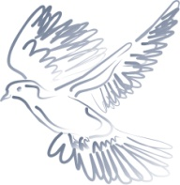 Sacred Music Concert and Dinner**

Join us on **Saturday, February 15th** at 6:30pm at Immaculate Conception Church for a concert featuring the Parish Choir, Contemporary Ensemble, Children’s Choir, and Handbells. Dinner will follow in the ICS gym. Tickets for this event are $10 per person. Please contact our Director of Music Ministry, Dana Brehany at [ICSJmusic@gmail.com](mailto:ICSJmusic@gmail.com) for more information or to register. This is sure to be a beautiful event!



**Readings for next week:**

***6th Sunday in Ordinary Time***

**First Reading: Sirach 15:15-20**

This passage from Sirach gives strong, unequivocal emphasis to free will in every person. Before each of us is set, sin or virtue, life or death, and each of us are free to choose the one or the other.

**Second Reading: 1 Corinthians 2:6-10**

Paul explains to the Corinthians that there are two different kinds of wisdom — the wisdom of God and the wisdom of the world. The wisdom of God is mysterious, but this wisdom has been revealed “to those who love him” through the Spirit.

**Gospel: Matthew 5:17-37**

In the Sermon on the Mount, Jesus tells the people he has come to fulfill the law. He speaks strongly against murder and anger, against adultery and lust, and against false oaths and lies. He warns the people that unless their virtue exceeds that of the Pharisees, they “will not enter the kingdom of God.”

**Daily Readings:**

***Fifth Sunday in Ordinary Time***

#### Sunday ......................... Is 58:7-10; 1 Cor 2:1-5; Mt 5:13-16

**Monday** ............................. 1 Kgs 8:1-7, 9-13; Mk 6:53-56

**Tuesday** ........................... 1 Kgs 8:22-23, 27-30; Mk 7:1-13

**Wednesday** ............................. 1 Kgs 10:1-10; Mk 7:14-23

**Thursday** ................................. 1 Kgs 11:4-13; Mk 7:24-30

**Friday** ......................... 1 Kgs 11:29-32, 12:19; Mk 7:31-37

**Saturday** ................. 1 Kgs 12:26-32; 13:33-34; Mk 8:1-10

**Fast and Abstinence**

Ash Wednesday is a day of total abstinence from meat and also a day of fast, that is, limited to a single meal. All Fridays of Lent are days of total abstinence from meat, a law which binds all Catholic over 14 years of age. The law of fasting binds all Catholics from their 21st year until their 59th birthday.

**THE CCPC BABY BOTTLE CAMPAIGN**

Thank you for participating in the CCPC Baby Bottle Campaign! The CCPC depends entirely on donations in its efforts to build a culture of life in Cecil County. The Baby Bottle Campaign began at all ICC/SJ Masses last weekend. Please consider taking a baby bottle home for a few weeks, using it to save your loose change and dollar bills. Checks are also very welcome. Then please return the bottle ICC/SJ this weekend! Thank you for your great generosity to the Center.

**Liturgical Ministers Next Week: *Feb 15th and 16th***

***5:00 pm*** Nathan S, AJ S •**EM’s:** Mary Ann E, Cheryl N •**Lector:** David T•**Ushers:**Eileen P, Bob E, William B, Pat C

***7:00 am***

•**Altar Servers**: **\*UNFILLED\*** •**EMs:** Alan S, Sandra H, Frank S • **Lector:** Mary K • **Ushers:** Charles M

***8:30 am***

**Altar Servers:** Jeremy M, Elizabeth R • **EMs:** Peter G, Cecilia G, Don H • **Lector:** Nora W • **Ushers:** Anthony D, Steve C, Wendel S, Anthony M

***9:00 am (SJ)***

**Altar Servers:** Robert H, Joseph H • **EM’s:** Chris H, Diane C, Peggy O, Tom V, Carol V • **Lector:** Michele C • **Ushers:** Jule V, William D, Kevin O

***10:15 am***

**Altar Servers:** Ariane S, Aila S • **EM’s:** Helen B, Richard L, Barbara R • **Lector:** Francis C • **Ushers:** Bob W, Steve A

**12:00 *noon***

**Altar Servers:** Claudia G, Carolena G •**EMs:** Mary L, Grace B, Charles C • **Lector:** Pat K •**Ushers:** Teresa G

****

**Does your child need to be Baptized?**

The next Baptism Class is **March 16th**, 7:00-8:30 pm in the Parish Center. It’s never too early to prepare for the Baptism of your child. Parents are required and Godparents are encouraged to attend. Contact the Parish Office to register at 410-398-1100.

**Children’s Liturgy of the Word**

CLW is for children 5-8 years old. Children under 5 are welcome if they are accompanied by a parent (not a sibling!)

**Children’s Liturgy**: We are looking for someone to take over coordinating Children’s Liturgy! If interested, please contact Vickie Eichler at 410-392-3551

**The Catechist for next Sunday, February 16th is:**

**Lynn O’Brien**

**Adoration for Vocations**

On the 1st Sunday of the month, exposition of the Blessed Sacrament occurs from 1pm-3pm in IC Chapel. Join us to pray for vocations. The next opportunity is **March 1st.** Contact Dermott at 410-398-3368.

**Immaculate Conception**

**School News**

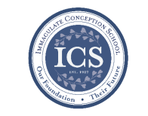

**In the spirit of Giving:** 7th and 8th grades are doing a fabulous job heading up donations for the Parish Outreach during the month of January!!

**Coming up…**



**Spring Musical: “*Seussical Jr”*** It’s not too late! If your child would like to participate in our Spring Musical, *“Seussical Jr,.”* please contact Mrs. Karleen at [kobrien@icschoolweb.org](mailto:kobrien@icschoolweb.org) or Mrs. Kathleen Davis at [office@iccparish.org](mailto:office@iccparish.org). We are so excited about this fun and exciting musical!

**Special Person’s Lunch:** Family and loved ones are asked to join 3rd and 4th grade Special Person’s lunch on Thursday, **February 13th** at 11:00am.

**President’s Day:** School will be CLOSED on Monday, **February 17th** for president’s day. Enjoy a well-deserved day off!

**Robbi Behr and Matt Swanson** will come to visit ICS on Wednesday, **February 19th**. They are a husband/wife duo who write and illustrate children’s books together. They also speak to schools on topics such as collaboration, creative entrepreneurship, and running a small press. Some of their books include *The Real McCoys, Babies Ruin Everything, and Everywhere, Wonder.* This will be a fun and interesting day for our students!!

**2nd Trimester:** The end of the 2nd Trimester is **Friday, March 6th.** Report cards will go out **Monday, March 16th.**

**There will be no school** on **Friday, March 20th** due to a staff retreat! We hope you have a fun and well deserved day off!

**Special Person’s Lunch:** Family and loved ones are asked to join 2nd grade Special Person’s lunch on Thursday, **February 13th** at 11:00am.

**Faith Formation**

**Religious Education & Sacraments**

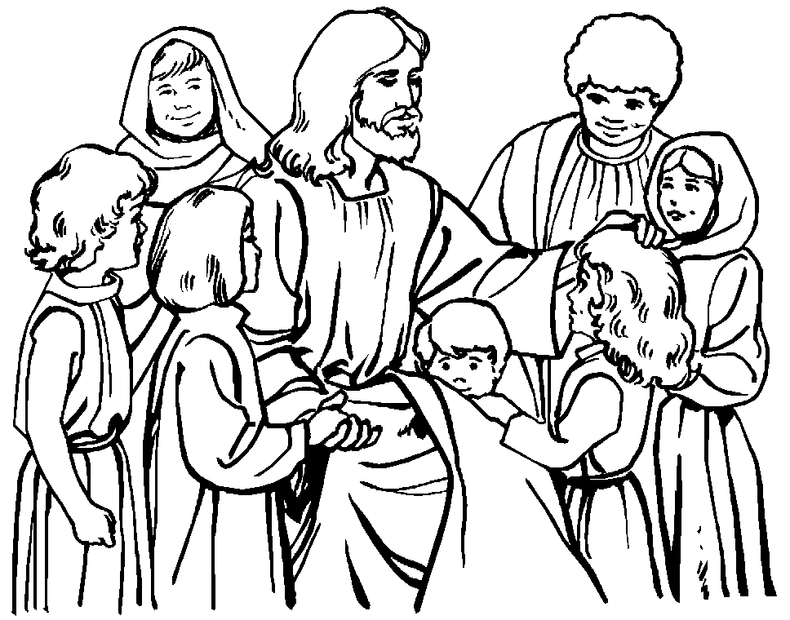

**First Communion:**  Parent/Child Meeting will be on Sunday, Feb. 16th at 2:00 pm at ICC

**Outreach:** January donations: Soup, Rice, & Instant Potatoes.

**Children’s Liturgy**: We are looking for someone to take over coordinating Children’s Liturgy for the 10:15 Masses.

**Rolling Lottery:**  Congratulations to all the winners!!

Ed R, Wendy V, Jane P, Frank T, Leo N, Liz O, Keri A, and Paula R. Thank you all who played!

**Youth Ministry & Confirmation**

#### whats-your-story

**CONFIRMATION**

#### Past due are Sponsor Eligibility Forms and Patron Saint Forms.

* Next class is Sunday, Feb. 9th & Wednesday, Feb. 12th.
* We are now accepting knitted red stoles for Confirmation; contact Cheryl at 410-392-3551 for information.

**YOUTH GROUP – Grades 9 thru 12**

**Meetings are 6 – 8 pm in the parish center**

Feb. 9th, we are cleaning out the Convent basement. Feb. 16th, we are having a Valentine celebration and Feb. 23rd is Mardi Gras.

Thank you to all who helped with the Rotating Shelter!!

**YOUTH MINISTRY WISH LIST:**

* We are asking for sodas (cans please!)

**JUNIOR YOUTH GROUP – Grades 6 thru 8**

**Join us to grow in faith through fun and fellowship!**

Meeting today, Sunday, Feb. 9th and all are invited to Mardi Gras on Feb. 23rd.

**ADULT EDUCATION**

**Interested in a study group?** Many opportunities are available. Call the Religion Office at 410-392-3551.

***Adult Education class:*** The Sacred That Surrounds Us – next class will be Monday, Feb. 10th at 6:30 pm and will repeat on Thursday, Feb. 13th at 9:15 am

**Book Study:** Tuesday, Feb. 11th at 9:15 am in the parish center.

**SOCIAL CONCERNS**

****

**Outreach**

**Please consider donating** to the Outreach! Thank you so much to all of the angels who have donated!! Thank you for your help, generosity, prayers, & donations to this essential ministry!!

**Please consider donating** to the Outreach! All of your help is greatly appreciated!

**Food Items:** tuna and mac and cheese

**Non-Food Items:** Toilet paper, dish detergent, and tooth paste

**PARISH EVENTS/INFORMATION**

****

**Weekly Church Collections: Week of Feb 2nd**

ICC $10,068

St. Jude $1,671

Online $3,899

Total Offertory $15,638

**Keep up with regular offerings by giving electronically!!**

Just as you rely upon receiving income on a regular basis, we rely on your regular contributions. We greatly appreciate the efforts of our parishioners to make consistent donations throughout the year! To assist you, the church provides a convenient electronic giving option for setting up regular contributions! Simply visit our website and click the Online Giving Button!

**How does Online giving benefit you?**

1. It’s easy, convenient, and safe
2. Allows you to give any amount, any time.
3. Allows you to track your giving

**How does Online giving benefit the parish?**

1. Creates consistency of giving
2. Increases efficiency of processing giving

**How to sign up?**

1. Visit www.iccparish.org
2. Click “Go to Online Giving”
3. Sign up! It’s that easy!

**PARISH & FAMILY LIFE**

**Parish Coffee**

Please join us at St. Jude’s for Parish Coffee **Feb 2nd** following the 9:00 Mass.

**Join us** for Parish Coffee, **Feb 9th** after 8:30am and 10:15am Masses at ICC!

**PARISH EVENTS/INFORMATION**

**Community Kitchen**

Many thanks to all of our Community Kitchen volunteers for providing a wonderful lunch on January 24th. They provided soup, sandwiches, fruit and desserts. In total we served 118 meals to 88 guests with leftovers shared with the Men's Shelter. Thank you to our new volunteers. We hope your first experience at Community Kitchen was awesome! We look forward to seeing you at our next service date on **April 24th**. Your support of this Ministry with prayer, service, edible and financial donations is a blessing to so many. May you experience a holy Lenten Season and a joyful Easter!

**Thank you from the Rotating Shelter!!**

We want to express our sincere thanks to all our faithful volunteers who helped make this past week a memorable one. We had a rewarding week partnering with Truth and Life Center and appreciate the hospitality they showed to the folks and our volunteers. The many volunteers who worked, came every morning, supervised the kitchen, stayed overnight, provided food or supplies, collected socks, and spent time in fellowship with the folks made this mission so successful. The folks were overwhelmed with everyone’s generosity! We had so much delicious food that we were able to share with others. A special thanks to TLC volunteers, ICC Boy Scouts and leaders, ICC Youth Group, TLC Youth Group, ICS students, and of course our mascots Lucy and Charlie Farrell! - Carol and Bill Dale

## VAL_1_1200x627._CB423657072_.png

**AmazonSmile:** Valentine's Day is just around the corner on February 14!! Will you be our Valentine? Shop at [smile.amazon.com](https://smile.amazon.com/gp/f.html?C=2FW00YO9Q8398&K=15GG5P8RFW6OS&M=urn:rtn:msg:202002031503115fa3050f8e1c43fb99fa4a38ec80p0na&R=NUX3AEQRD35P&T=C&U=http%3A%2F%2Fsmile.amazon.com%2Fch%2F52-6015220%3Fref_%3Dpe_732550_472158300&H=VZQMN10KIAP7ZDRZEWQW2JATFACA&ref_=pe_732550_472158300) and AmazonSmile donates to Immaculate Conception Church at no cost to you!

## KofC Logo

**Sunday, February 9**

8:20 AM - Confessions - SJ

8:30 AM - RCIA - CH

11:00 AM - Coffee Sunday - gym

1:30 PM - Baptisms - IC

4:00 PM - Junior Youth Group - PC

6:00 PM - HS Gathering - PC

Monday, February 10

9:30 AM - Novena - CH

6:00 PM - Adult Ed Program - PC

6:30 PM - Boys Varsity Basketball - gym

8:00 PM - AA Mtg -caf

Tuesday, February 11

9:00 AM - Holy Hour -CH

9:00 AM - Adult Ed Book study - PC

5:30 PM - Pre-JV Basketball - gym

6:30 PM - Girls Varsity Basketball -gym

6:30 PM - Handbell Rehearsal - IC

7:00 PM - Knights of Columbus - PC

7:30 PM - Contemporary Rehearsal - IC

Wednesday, February 12

9:00 AM - Rosary Crusade - IC

9:30 AM - Cantor Rehearsal - IC

1:00 PM - Leisure Club - PC

4:00 PM - Children’s Choir - PC

6:00 PM - Confirmation Class - PC

6:15 PM - Rel Ed

6:30 PM - JV Boys Basketball - gym

8:00 PM - Boys Varsity Basketball -gym

Thursday, February 13

9:00 AM - Rosary Crusade - CH

9:15 AM - Adult Ed Study program - PC

6:30 PM - Cantor Reh - IC

6:30 PM - Boy Scouts - PC

6:30 PM - Cub Scouts - Caf

7:00 PM - Parish Choir - IC

7:00 PM - RCIA - PC

Friday, February 14 ICS ½ Day

9:00 AM - Rosary Crusade - CH

7:00 PM - NA Mtg - Caf

**Saturday, February 15**

9:00 AM - Rosary Crusade - CH

4:15 PM - Confessions - IC

6:00 PM - Concert and dinner - IC & gym

7:00 PM - NA Mtg - Caf

**community EVENTS/INFORMATION**

**Knights of Columbus**

***Bishop Becker Council 2427***

**Meetings:** 2nd & 4th Tuesdays of the month at 7:00 pm at the Parish Center

**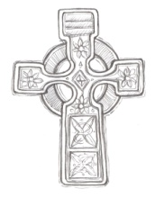**

**LAOH (The Ladies Ancient Order of Hibernians)**

The Ladies Ancient Order of Hibernians, Inc. Cecil County Division 1, an Irish Catholic Action group has meetings on the first Wednesdays of the month at 1:00pm in the Parish Center. Meetings run September through May. We are always looking for new members! If you are an Irish Catholic woman and want to serve your community, and learn more about your Irish heritage come join us! Please contact the historian, Betty Green at 410-392-5287

**DIOCESE OF WILMINGTON CATECHETICAL DAY**

***ATTENTION ALL CATECHISTS!***

The Office for Religious Education invites you to attend *Catechetical Day* on March 21 at St. Thomas More Academy with Bishop W. Francis Malooly.

*Catechetical Day* allows the opportunity to celebrate those who have been giving effective witness for years and are living the call within their religious education programs, families, and the larger community. Directors/Coordinators of Religious Education and Catechists will be honored for anniversary years of service. These years are: 5, 10, 15, 20, 25, 30, 35+.

This year's Catechetical Theme is**"Stay With Us."** Bob McCarty, D. Min. is the keynote speaker for the event.

For more information or to register, please call the Diocesan Office for Religious Education at 302-573-3130 or contact your Parish Religious Education Office. **The deadline for registration is March 2, 2020**. For more information please visit [www.cdow.org/CatecheticalDay2020](http://www.cdow.org/CatecheticalDay2020).

**Mardi Gras Party**

**Come experience Mardi Gras** right here in Delaware. Tuesday, February 25, 6-9pm. Holy Angels (in Fremont Hall), 82 Possum Park Road, Newark. Family friendly. Free admission. Drinks and food available to purchase at the event. 50/50 and Ragin’ Cajun Raffle drawings at 8:30pm. Contact the Parish for more information at 302-731-2219 or [Phyllis510@comcast.net](mailto:Phyllis510@comcast.net). RSVP encouraged but not required. “Laissez le bon temps rouler!”

**ST. DENNIS BLOOD DRIVE**

**BLOOD DRIVE UPDATE** -St. Dennis is sponsoring a blood drive on **Sunday, February 16 after the 8:00 am Mass.** We need a minimum of 40 donors. If you are willing and able to donate blood please register at **delmarvablood.org** and click on the Give Blood link at top of page. Click on Where to donate and enter 21635 for the zip code and enter Feb. 16 date. If you have any questions please contact **Cathy Stryker at 410-648-5370 or** [cathyliz59@gmail.com](mailto:cathyliz59@gmail.com)**.**