From Father Jim

“For if by the transgression of the one, death came to reign through that one, how much more will those who receive the abundance grace and of the gift of justification, come to reign in life through the one Jesus Christ. In conclusion just as through one transgression condemnation came upon all. So through one righteous act acquittal and life came to all.”

We begin the season of Lent, a time of prayer, fasting, sacrifice and good works. It is not just a time to shift gears and remember, but to allow the saving work of Jesus to take place in our hearts.

Do I see the need for the abundant grace of Jesus in the world today? Am I able to move from what is around me needing salvation in Jesus, and see my own personal need for His saving, His amazing grace?

I begin my Lenten journey in a serious way, asking that the next few weeks will find me caring for my soul, my spiritual life, the spiritual well being of others, my children. I ask forgiveness for what I have done and what I have failed to do.

Fr. Jim Yeakel, OSFS
Pastor

We extend a warm welcome to the families who are newly registered:
Mr. and Mrs.
WELCOME
Daniel Kahline

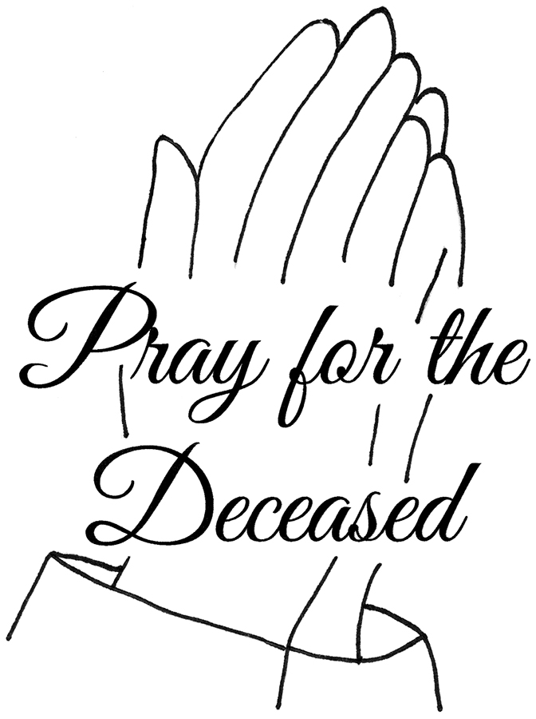
We extend our condolences and prayers to the families of those who have recently died:

Mr. Thomas Murphy
Mr. Thomas Kelly
Mr. Patrick O’Donnell

March 2, 2020
Lenten Weekday
8:30 am Nemerio and Lucia Silva
March 3, 2020
Lenten Weekday
8:30 am Donald Neil Sentman, Sr.
March 4, 2020
Lenten Weekday
8:30 am Mark Jenkins
March 5, 2020
Lenten Weekday
8:30 am Anthony Mallia
March 6, 2020
Lenten Weekday
8:30 am----------Kathryn Baker Ryan (Living Intention)
March 7, 2020
Lenten Weekday
8:30am-----------Fr. William Lawler (Living Intention)
5:00 pm----------Tony Sniadowski
March 8, 2020
Second Sunday of Lent
7:00 am Sr. John Marie
8:30 am People of the Parish
9:00 am SJ Joseph Nickle
10:15 am Laura Puccia
12:00 pm Hugh Eleanor and Christopher Reilly

Daily Readings:
First Sunday of Lent

Sunday..........Gn 2:7-9, 3:1-7; Rom 5:12-19 or 5:12, 17-19;

Mt 4:1-11
Monday..........Lv 19:1-2, 11-18; Mt 25:31-46
Tuesday..........Is 55:10-11; Mt 6:7-15
Wednesday..........Jon 3:1-10; Lk 11:29-32
Thursday..........Est C:12, 14-16, 23-25; Mt 7:7-12
First Friday..........Ez 18:21-28; Mt 5:20-26
First Saturday..........Dt 26:16-19; Mt 5:43-48
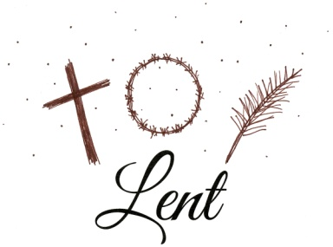

Lenten Opportunities

- Reconciliation Weekly- These times are available each weekend of Lent. There will be no confessions heard the weekend of Easter (April 11th and 12th).
- Saturdays - 4:10-4:50pm - ICC
- Sundays - 8:20-8:50am - SJ
- Lenten Penance Services- All are Welcome!
- March 10th (school) 10:00am
- March 11th (rel. ed) 6:30pm
- April 1st (Parish) 7:00pm
- By appointment: Call the Parish Center to schedule. There will be no confessions April 8th - 12th (Holy Week).
- Sunday Workshops- 1:30pm in IC Church-
“Anchored in the Scriptures”
- March 1st - Letter to Romans
- March 15th - Learn to Love the Bible
- April 5th - Letter to Peter
- Devotions- All are Welcome!
- Stations of the Cross - each Friday evening of Lent - 7:00pm - ICC
- Rosary - Daily after 8:30am mass
- Eucharistic Adoration - Sunday, March 1 & Sunday, April 5th from 1 -3pm
- Blessing of Food - Holy Saturday Morning - 11:00am - ICC Chapel

Please join us for Chrisim Mass on April 6th at 7pm at Holy Cross church in Dover, DE.

Liturgical Minister Schedules
Liturgical Ministers Next Week: March 7th and 8th

5:00 pm
•Altar Servers: Schall, AJ; Schall, N •EM’s: Clarke, M
•Lector: Tuckwell, D •Ushers: Peacock, E; Elwood, B;
Charshee, P; Bruekman, W

7:00 am
•Altar Servers: <in need of> •EMs: Moran, G; Homola, S; Slavin, F • Lector: Kirkwood, M • Ushers: Murphy, C

8:30 am
Altar Servers: <in need of> • EMs: Hicks, D; Gnanes, P; Gnanes, C • Lector: Guertin, J • Ushers: Dvorak, A; Schmitt, W; Maccari, A; Chicosky, S

9:00 am (SJ)
Altar Servers: Mishra, A; Mishra, D • EM’s: Smith, MA; Dhamer, D; D’Annunzio, P; Holland, C
• Lector: Conklin, H • Ushers: O’Donnell, K; Schaible, J;
Vaccarini, J; Dallas, W

10:15 am
Altar Servers: Simbulan, Hayden; Marandola, J •
EM’s: Ruhmann, B; Lonie, R; Chamberlin, K •
Lector: • Watkins, N Ushers: Whitman, B; Anguish, S

12:00 noon
Altar Servers: Gursky, C; Gursky, C •EMs: Brown, G; Kosman, P; Lagarelli, M • Lector: Esposito, F
•Ushers: Gustavson, T; Cole, C

Readings for next week:
Second Sunday of Lent

First Reading: Genesis 12:1-4a
God calls Abraham to leave his family and people and go to a new land. God promises to make the people of this new nation great and to bless Abraham.

Second Reading: 2 Timothy 1:8b-10
Paul, from his place of imprisonment in Rome, writes words of encouragement to Timothy, telling him that Christ is for them everlasting life.

Gospel: Matthew 17:1-9
Wishing to reveal His glory to Peter, James and John, Jesus takes them to a mountain where he is transfigured before them. When Peter exclaims that he will build three tabernacles here in honor of Jesus, Moses and Elijah, a voice from above proclaims: “This is My beloved Son on whom My favor rests. Listen to him.”

Immaculate Conception
School News
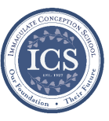
In the spirit of Giving: First and Second Grades are ready to head up donations for the Parish Outreach for the month of March!

Coming up…
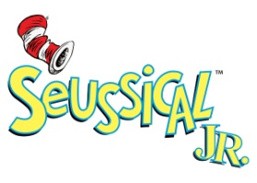
Spring Musical: “Seussical Jr” It’s not too late! If your child would like to participate in our Spring Musical, “Seussical Jr,.” please contact Mrs. Karleen at kobrien@icschoolweb.org or Mrs. Kathleen Davis at katdavis1202@gmail.com. We are so excited about this fun and exciting musical!
****
There will be no school on
Friday, March 20th
****
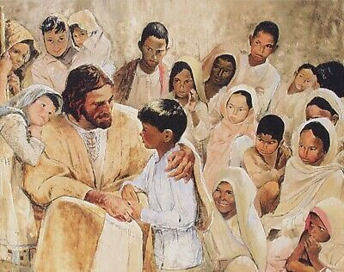

Students’ Prayer
Loving Father, thank you that you are my creator, you know me better than anyone else. Help me to use the mind you have given me to learn and study effectively. May I learn with humility and grace. May I grow in wisdom as well as knowledge. Let me live a life of integrity in everything I do. May I grow in grace, and in the knowledge of our Lord and Savior Jesus Christ. To you be glory both now and for ever. In the name of the Father, the Son and the Holy Spirit, Amen.

Religious Education & Sacraments

First Communion: Anyone who missed the Parent/Child Meeting must contact the office at 410-392-3551.
Outreach: February donations: Spaghetti-o’s, baked beans, mini raviolis. For March: cereal and instant milk.
Children’s Liturgy: Please join us! All children 5-8 years old (under 5 accompanied by a parent, not a sibling!) are welcome.
We are looking for someone to take over coordinating Children’s Liturgy for the 10:15 Masses. If interested, please call Vickie Eichler at 410.392.3551.

Youth Ministry & Confirmation

CONFIRMATION

Past due are Sponsor Eligibility Forms and Patron Saint Forms.
- Next class is Sunday, March 8th, 8-10am, &
Wednesday, March 11th, 6-8pm.
- We are now accepting knitted red stoles for Confirmation; contact Cheryl at 410-392-3551 for information.

YOUTH GROUP – Grades 9 thru 12
- Meeting tonight from 6 - 8pm.
YOUTH MINISTRY WISH LIST:
- We are asking for sodas (cans please!)

JUNIOR YOUTH GROUP – Grades 6 thru 8
Join us on March 8th from 4 – 6pm to grow in faith through fun and fellowship!

ADULT EDUCATION
Fr. Michael Connelly, OSFS will be here for a presentation on more of the letters from Peter, on Sunday, March 1st and April 5th at 1:30 at ICC.
Interested in a study group?
Several different opportunities are available. Call the Religion Office at (410) 392-3551. All Adult Education classes are over for the summer.
Adult Education classes –
Pivotal Players will start Monday, March 2nd at 6:30 pm and will repeat on Thursday, March 5th at 9:15 am. Please register for class and purchase your books ahead of time.

Book Study
Tuesday, March 3rd at 9:15 am in the parish center.

SOCIAL CONCERNS
O u t r e a c h
Thank you so much to all of the angels who have donated!! Please continue to refer to the parish bulletin and parish social media posts for guidance on what Outreach needs.
FOOD ITEMS: instant potatoes; Chef Boyardee ravioli
NON-FOOD ITEMS: diapers sizes 4 and 6; shampoo
Redners Receipts: Please save your Redners receipts and drop them off at Outreach!

PARISH EVENTS/INFORMATION

Weekly Church Collections: Week of Feb 23rd
ICC $8,047
St. Jude $1,396
Online $3,076
Total Offertory $12,519
2019 Annual Catholic Appeal Campaign
Final Report Summary
Campaign Closing January 8, 2020
*2019 census maintained by Development Office reflected 60,072 households; 2018 reflected 59,613
Here are a few key results from the 2019 Annual Catholic Appeal:
Diocesan wide collections surpassed the 2019 Annual Catholic Appeal target of $4,775,500 by 4.9%.
Overall pledges totaled $5,125,809; of which $5,009,463 was collected.
Forty-eight parishes (48) and the Korean Catholic Community exceeded assigned targets in pledges with forty-four (44) parishes and the Korean Catholic Community exceeding collections.
In comparison to 2018, overall results fell below in pledges by $201,101; collections by $201,734; and the number of gifts by 912. However, the average gift increased by $8.26 from $350.06 to $358.32.
Forty-four (44) parishes will receive rebates totaling $251,720. Parishes supporting a school receive 100% of collections over goal. Parishes that do not support a school receive 50%.
Immaculate Conception Parish’s goal was $92,500. Pledges totaled $94,085, of which $92,500 was collected. We met 100% of our target goal and 98% of our pledged goal. Thank you to all who participated either financially or prayerfully.
PARISH & FAMILY LIFE
Parish Coffee
Mar. 1st at St. Jude following 9am mass
and
Mar. 8th at ICC after 8:30 and 10:15 masses
Please join us!

PARISH EVENTS/INFORMATION
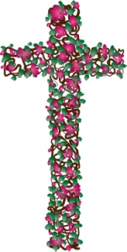
PRAYER VIGIL
On Saturday, March 7th, from 4 - 5pm in the ICC chapel, we will have a prayer vigil for the students, staff, families, and parishioners of Immaculate Conception School in it’s final year. All are welcome. Please join us!
TIME TO GET YOUR SHAMROCK ON!
State Line Liquors in Elkton is hosting IRISH FEST Saturday, March 14th from 5-8pm. Music by the Seven Rings, Irish food from Blue Crab Grill, Irish beer, and much more will be offered. 50/50 raffle items will round out this evening of fun. Cost is $25.00 in advance or $30.00 at the door. For more information or to reserve your spot, call 1-800-446-9463 or 410-398-3838 by March 13th. Proceeds benefit Immaculate Conception Parish.

Catholic Charities to Honor Mike Hare at Annual Tribute Dinner in April 2020
Mike Hare, Executive Vice President for Development at the Buccini Pollin Group will receive the Msgr. Thomas J. Reese Award at Catholic Charities Annual Tribute Dinner on Wednesday, April 1, 2020. Mike serves on Bishop Malooly’s Pastoral Council and on the Vocations Admissions Board for the Diocese of Wilmington.
To learn more about the Annual Tribute Dinner and our honoree, or to support the Tribute Dinner through sponsorship or ticket purchases, visit the Catholic Charities webpage for the dinner at www.cdow.org/charities. You may also call Catholic Charities at 302-655-9624.
“Do the little things, the small things
you’ve seen me doing.”

~Saint David of Wales

Parish Calendar
Sunday, March 1
8:00 AM - Confirmation Class PC
8:20 AM - Confessions - SJ
8:30 AM - Rel Ed.
8:30 AM - RCIA – CH
10:00AM – St. Jude Coffee Sunday
1:30 PM - Adoration for Vocations
6:00 PM - HS Gathering - IC
Monday, March 2
9:00 AM - Novena - CH
6:00 PM - Adult Ed Program - PC
6:30 PM - Boys Varsity Basketball - gym
8:00 PM - AA Mtg -caf
Tuesday, March 3
9:00 AM – Holy Hour -CH
9:00 AM - Adult Ed Book study - PC
5:30 PM - Pre-JV Basketball – gym
6:00PM – Liturgy Committee - PC
6:30 PM - Girls Varsity Basketball -gym
7:30PM – Contemporary Rehearsal - ICC
Wednesday, March 4
9:00 AM - Rosary Crusade - CH
9:30 AM - Cantor Rehearsal - IC
1:00 PM – LAOH - PC
6:15 PM - Rel Ed
6:30 PM - JV Boys Basketball - gym
8:00 PM - Boys Varsity Basketball -gym
Thursday, March 5
9:00 AM - Rosary Crusade - CH
9:15 AM - Adult Ed Study program - PC
5:30 PM - Pre JV Basketball
6:30 PM - Girls Varsity Basketball
6:30 PM - Cantor Reh - IC
6:30 PM - Boy Scouts - PC /Cub Scouts - Caf
7:00 PM - Parish Choir - IC
7:00 PM - RCIA - PC
Friday, March 6
9:00 AM - Rosary Crusade - CH
7:00 PM - NA - Caf
Saturday, March 7
9:00 AM - Rosary Crusade - Ch
4:15 PM - Confessions - IC
7:00 PM - NA – Caf

Sunday, March 1st is the Feast Day of
Saint David
community EVENTS/INFORMATION
CENSUS MARYLAND
The United States Census Bureau conducts a nationwide census every 10 years to count the people living in each state, county and town. Census forms should be arriving by mail at each home. There are nine questions about each person living in the home. All responses are kept strictly confidential. They are not allowed to give information about anyone and any private or government agency. This year, the Census Bureau will also be offering to respond online or by toll free telephone number. Responding to the Census is very important. The population statistics determine the amount of federal and state funding that comes to Cecil County. This has a direct effect on schools, libraries, and many federal program that help our families such as Medicaid, WIC, SNAP and CHP. The number of residents helps to ensure that Cecil County has adequate services such as public health, public safety and emergency planning. In 2010, more than one-fourth of Cecil County residents did not participate in the Census. As a result, Cecil County lost $1,800 for each person who was not counted. Please help our community by ensuring that your family is counted in the 2020 Census.
Please call the Cecil County Council for more information at 410.996.5201 or email at: council@ccgov.org

DIOCESE OF WILMINGTON CATECHETICAL DAY
ATTENTION ALL CATECHISTS!
The Office for Religious Education invites you to attend Catechetical Day on March 21 at St. Thomas More Academy with Bishop W. Francis Malooly.
Catechetical Day allows the opportunity to celebrate those who have been giving effective witness for years and are living the call within their religious education programs, families, and the larger community. Directors/Coordinators of Religious Education and Catechists will be honored for anniversary years of service. These years are: 5, 10, 15, 20, 25, 30, 35+.
This year's Catechetical Theme is "Stay With Us." Bob McCarty, D. Min. is the keynote speaker for the event.
For more information or to register, please call the Diocesan Office for Religious Education at 302-573-3130 or contact your Parish Religious Education Office. The deadline for registration is March 2, 2020. For more information please visit www.cdow.org/CatecheticalDay2020.

