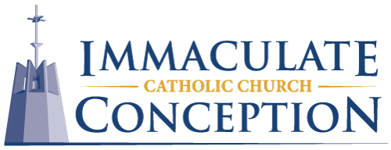
Director of Faith Formation
Immaculate Conception Catholic Church
Charles City, Iowa
Full-time/Exempt

Our church family is seeking a dedicated and passionate individual to join our ministry as the Director of Faith Formation (DFF). This role plays a crucial part in shaping and nurturing the spiritual growth and faith development of our Catholic Faith Community members.

Responsibilities:
- Utilizing approved curriculum sources, the DFF will implement, and direct comprehensive faith formation programs for our parishioners who are in different age groups and life stations.
- The DFF works closely with the pastor and other Parish Staff to establish and maintain program offerings, workshops, events, and prayer experiences designed to help our parishioners grown in their faith; as well as their knowledge and understanding of the Catholic Church and its teachings.
- This collaborative minister will lead co-educators and volunteers to create prayerful, engaging, and meaningful spiritual experiences to guide individuals and families on their faith journey and encourage full active participation in our faith community.
- Work with Archdiocesan Staff and fellow faith formation leaders to stay informed about current trends and best practices in faith formation for program integration in our parish.

Qualifications:
- Experience and/or education in the field of Religious Studies, or a related field is preferred; or previous leadership experience in a faith formation role or a similar position.
- Past participation in, or desire to participate in future lay formation training offered through the Archdiocese.
- Fully initiated and active Roman Catholic who knows and embraces the faith and the teachings of the Catholic Church, bringing a prayerful and joyful presence.
- Must be a self-starter and good listener and exhibit oral and written communication skills.
- Be proficient in using email, along with other computer skills including being proficient in Microsoft word, Excel, PowerPoint, and social media platforms.
- Be adept at planning, organizing, multitasking, and implementing systematic programming for faith formation.
- Strong interpersonal skills with the ability to lead and organize teams of diverse volunteers.
- Ability to work evenings and weekends when necessary.

How to Apply:
Interested candidates should complete an application and submit it to Fr. Tom Heathershaw, at tom.heathershaw@iccharlescity.org. Please include "Director of Faith Formation Application" in the subject line.

