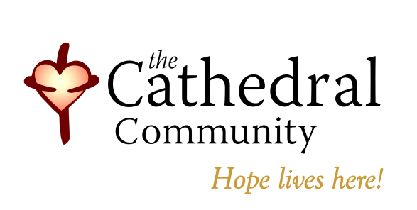

Dear Wedding Couple,

Congratulations on your decision to get married in the Church! We are happy that you have chosen the The Cathedral Community at Sacred Heart to celebrate your wedding.

To assist you in your marriage preparation, we would like to share a few things.

- Please consult the Cathedral Community Wedding Guidelines. The guidelines provide you basic information of what is expected of you during your preparation for the liturgy, the rehearsal and your wedding day.
- Fully Engaged and Pre-Cana are required by all couples being married in the Diocese of Rochester.

- Fully Engaged is an inventory that will help as a communication tool in your marriage. After taking the inventory and it is processed, you will meet one on one with the Deacon, from your wedding intake, to discuss the results. To sign up for a session, please call the Cathedral Main Office at 585-254-3221, ext. 104. All sessions are held on Sunday afternoons, from 12:45-1:45 in the Cathedral conference room.
January 12, 2020 June 7, 2020
February 9, 2020 September 13, 2020 March 8, 2020 October 11, 2020
April 19, 2020 November 8, 2020
May 3, 2020

Follow up dates are scheduled on the day you take the inventory.

- Pre-Cana is a parish-based marriage preparation program offered to engaged couples. At the session, mentor couples facilitate discussions on topics concerning Catholic Christian marriage. Pre-Cana sessions are scheduled on Saturday, April 25, 2020 and Saturday, October 24, 2020 location of Pre-Cana sessions are to be determined. Please contact the office at (585) 254-3221 x 104 for more information. The Cathedral Community at Sacred Heart Cathedral offers you prayerful support in this time of joy. May your marriage preparation and wedding celebration lead you to the fullness of love and life.

In Christ,

Fr. Kevin McKenna, Pastor
And The Cathedral Community Staff

