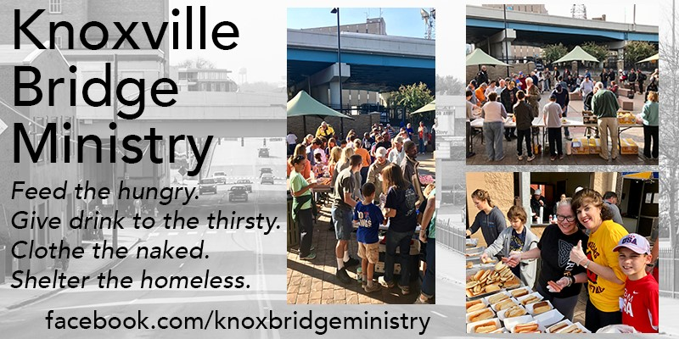
St. Thomas Life Teen Volunteer Day
June 25th 11:00am – 1:00pm
(Meet in St. Thomas Social Hall @ 10:15am)
Location: KARM 418 N Broadway Knoxville, TN 37917
Please fill out the attached authorization form.
We will meet at St. Thomas Social Hall at 10:15am and leave promptly at 10:15am for KARM via carpool. We will return to St. Thomas between 1:45 & 2:00pm and you will pick your student up in front of the PFLC.
If you have any questions, contact Joel: 865-201-3808 or jstuder@sthomaslc.com.

