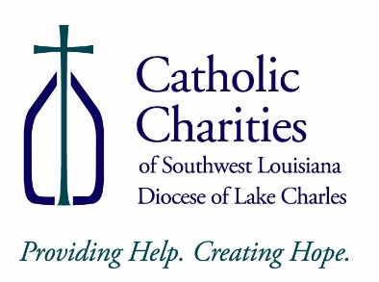
1225 2nd Street
Lake Charles LA 70601
337-439-7436
337-439-7435(fax)
RElease of information for
city of lake charles Water Division customer Account Information
to: | from Catholic Charities staff/volunteer:
company: | date:
City of Lake Charles Water Division
fax number or email address: | total no. of pages including cover:
337-491-1408 | 1
Phone number:
337-491-1307
information requested: | :
I authorize the City of Lake Charles Water Division to share my account information including the following: billing; deposit due; payment history; account balance; other service transactions; and copies of my bills to Catholic Charities of Southwest Louisiana. This would include written and verbal information about my account. I further authorize that this consent form may be a faxed or digital copy of an original signed by myself, or a faxed or digital copy where my permission was given verbally to the caseworker. The purpose of the information given will be to verify my account status to determine eligibility to receive assistance with my water bill account balance, connection fee, or deposit owed to the City of Lake Charles Water Division. This authorization will be valid for three months from the date it was signed, or verbal consent was given.
Signed by Customer or Verbal Consent Given:
Printed Name:
Date of Consent: |  | Account Number:
Social Security Number of Customer:
Service Street Address:
Apartment/Trailer #:
City, State, Zip Code: | Lake Charles, LA Zip Code:
Caseworker Signature:
Date:
Form Revised: 12/17/20

