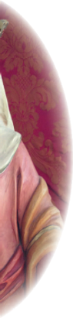
SAINT ADELAIDE PARISH

712 Lowell St.
Peabody, MA 01960
Phone: 978-535-1985 Fax: 978-535-4845
Email: parish@saintadelaide.org Website: saintadelaide.com

2021 - 22 RELIGIOUS EDUCATION PROGRAM
STATEMENT AND RENEWAL INFORMATION FORM
Family Name ____________________________________________________________________
Mother: ___________________________________ Father: _____________________________
Address_________________________________________________________________________
________________________________________________________________________________
Home phone #______________________________ Cell phone #:___________________________
Email Address: ___________________________________________________________________
Please list Students/Grade entering in the Fall:
Name:__________________________________________________Grade:___________________
Name:_________________________________________________ Grade: ___________________
Name: _________________________________________________Grade:___________________
Name: _________________________________________________ Grade: ___________________
Tuition: $150.00 per family
Teacher/Helper Volunteer – Contact Parish Center for information of cost
_______________I have paid my tuition on-line
_______________Attached is my tuition payment
_______________Unable to make payment now

Please indicate any special needs (learning or medical – food allergies, etc. ) or other information relevant to your child:
__________________________________________________________________________________
__________________________________________________________________________________
__________________________________________________________________________________

