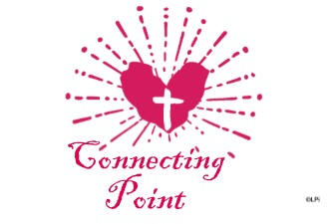
Connecting Point is a strong core group of women, who reflect upon the upcoming Sunday’s Gospel reading study concepts of faith in regard to being a wife and mother.
Connecting Point meets Monday morning in the Parish Hall from 9:45 a.m. to 11:00 am. Children are always welcome.
For questions please contact Nancy Anderson at 307-682-3319.

