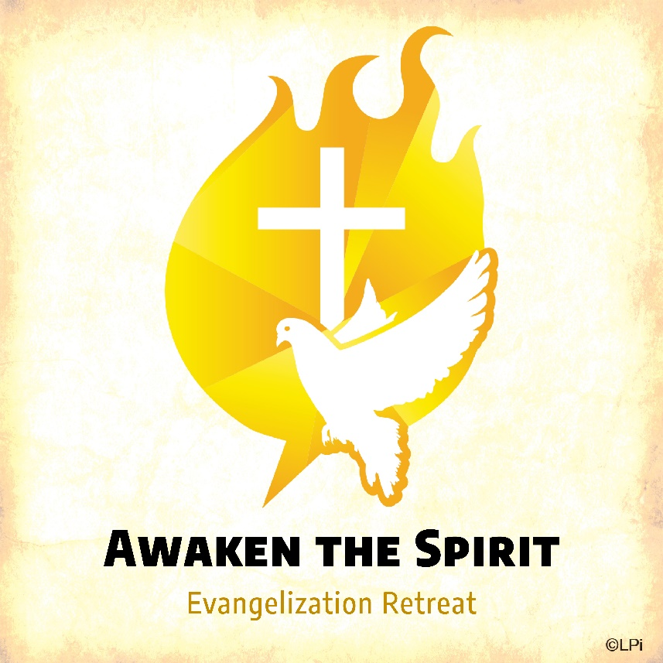
Evangelization Retreats were started in Boise, ID with the purpose of providing an intense encounter with the Risen Jesus and to foster the development of small faith communities. The retreat is a grace that has helped us focus upon the role of the Holy Spirit in the life of the Christian Community.
The retreat focuses upon the Sacraments of Initiation: BAPTISM, CONFIRMATION, and EUCHARIST. In keeping with the experiences of the early Church, lay Catholics share their stories of faith through a series of personal testimonies. Small group discussions give retreatants the opportunity to reflect upon who and what God means to them and how God has touched their lives. Through a special Liturgy of Consecration, the gifts of the Holy Spirit are rekindled and stirred within the lives of the people. The retreat uniquely moves from the basic foundations of initiation and conversion to specific actions necessary in one's walk to live the Christian life: prayer and study, suffering, community and witnessing. Christians of other denominations are also welcome to attend Evangelization Retreats.
Our next Evangelization Retreat is scheduled for October 18-20. Cost is $50 per person, which includes meals and t shirt. Registration form and information is available at the Family Life Center.

