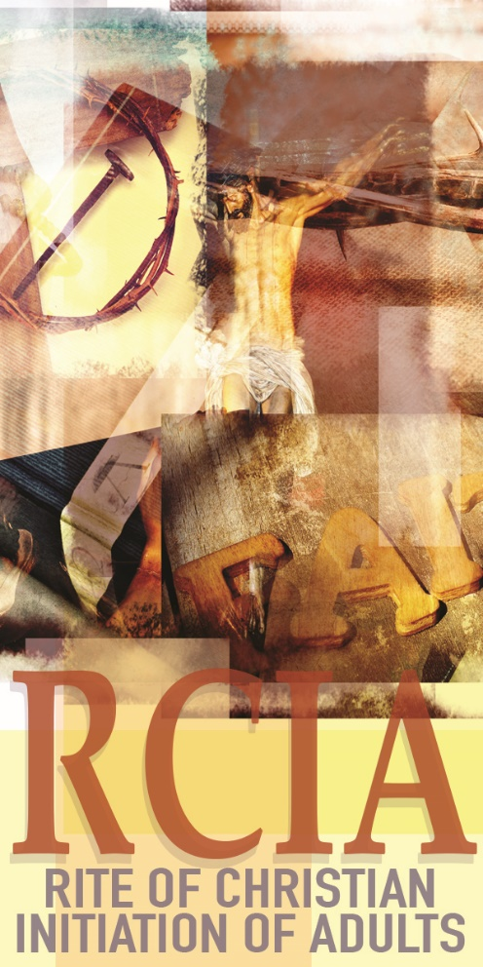

ARE YOU SOMEONE OR DO YOU KNOW SOMEONE WHO…
Has expressed an interest in becoming Catholic?
Has a child over the age of seven who has not been baptized?
Was baptized Catholic as a child, but has not celebrated the Sacraments of Confirmation and Eucharist?
Was baptized in another faith and want to learn more about the Catholic Church?
We offer an opportunity to come together in a small group to learn more about our faith. Sessions focus on the teachings and experience of Church and prepare individuals to celebrate the Sacraments of Baptism, Confirmation, and Eucharist during the Easter season. There are separate sessions for children or youth. You are welcome to participate in the process with your questions, your insights and your faith story in a warm accepting setting.
We will be gathering for this Rite of Christian Initiation (RCIA) on Wednesdays from 6-8 p.m. at St. Matthew’s Family Life Center/St. John Paul II Catholic School. RCIA begins September 4.
For information please contact St. Matthew’s office at 307-682-3319.

