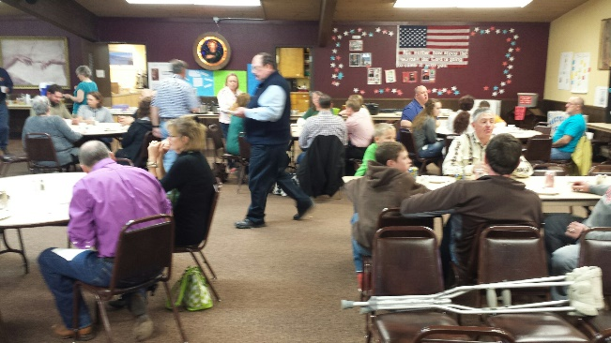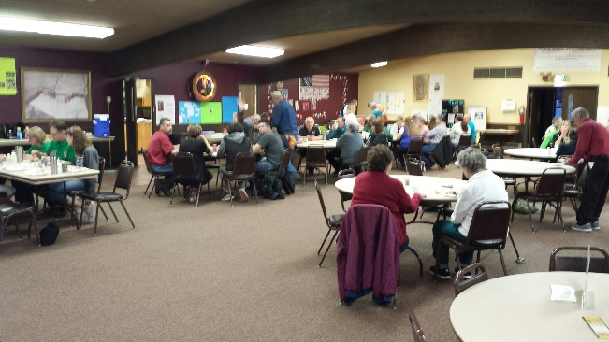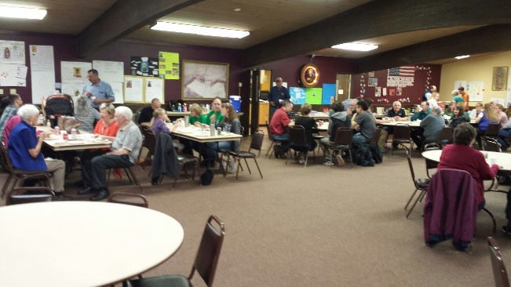
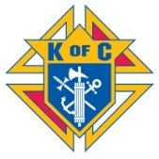

Our first family social sponsored by the Knights of Columbus with the parish was held on Saturday, March 18. Great turnout with the parish and Knights together. We will be holding this potluck dinner every third Saturday of the month at 6:00 p.m. directly after mass at the parish, with the exceptions of:
- April’s will be held on April 22
- none for May
- July’s will be held on July 15

Sponsored by the Knights for the entire parish, do not have to be a Knight. Bring your favorite dish to share and enjoy the social atmosphere. Thank you Mike Fulton and Mark Vetter for putting this together.

