YEAR 1

Mandatory once monthly classes for Parents/Sponsors/Teens

1 Interview/Orientation
2 Being a Sponsor
3 “I Am” – God Exists
4 “The Plan”–You’re in it!
5 “Mass & Sacraments”
6 “One, Holy, Catholic, Apostolic”
7 “Mary, the Saints, & Service

Also required in Year 1:
- Attend Weekly Sunday Mass
- attend Weekly YOUTH GROUP
- One RETREAT
- 5 mins. Daily Memory work
- 15 SERVICE hours
- Dov youth Rally
- Regular CONFESSION
- Attend 10th grade Confirmation Mass & Rite
- summer camp or mission Trip

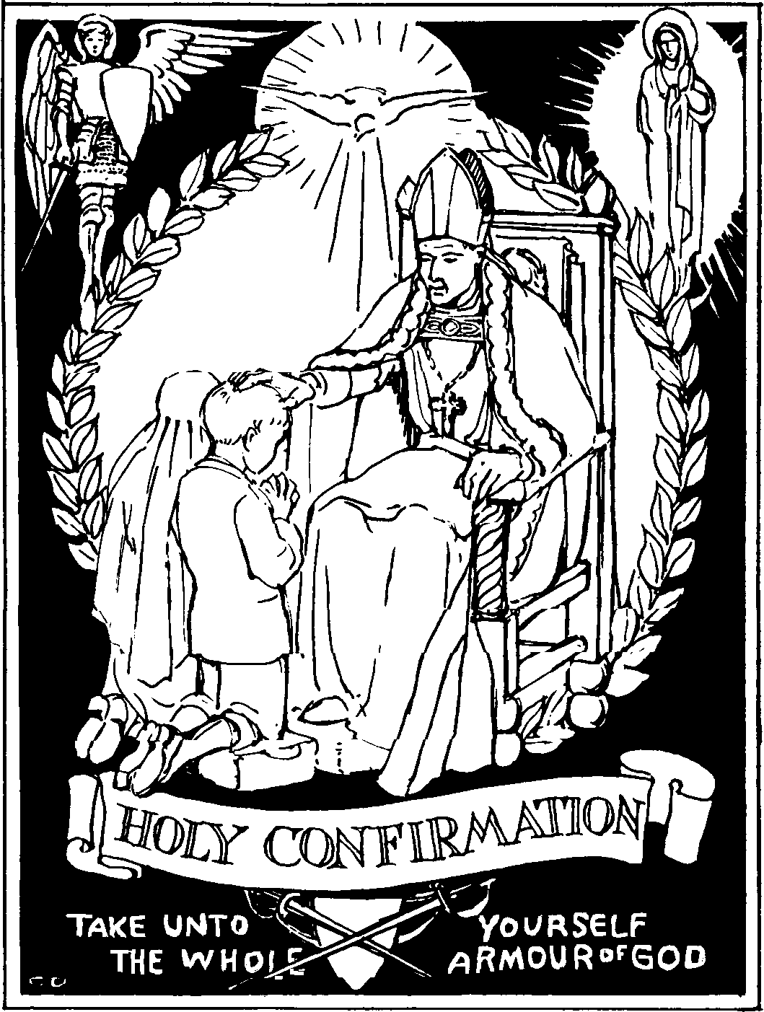

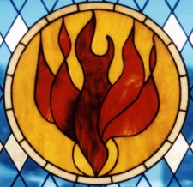

YEAR 2

Mandatory once monthly classes for Parents/Sponsors/Teens

8 “What is Confirmation?”
9 “Gifts of the Holy Spirit”
10 “Review/Exit Interview”

Also required in Year 2:
- Attend Weekly Sunday Mass
- attend Weekly YOUTH GROUP
- one RETREAT
- 5 mins. Daily Memory work
- 10 SERVICE hours
- Dov youth rally
- Confession
- Rehearsal for ceremony
- confirmation Mass & RITE

