Immaculate Conception: Faith Formation Online Portal Access Instructions

Step 1: go to the Immaculate Conception website- https://www.ic-ec.us
Step 2: Click on the “Faith Formation/Prep” tab at the top of the page
Step 3: Scroll down until you see “We use the "Spirit of Truth" program from the Sophia Institute. Click HERE to access the online portal. (It is shown here exactly as it appears on the IC website)
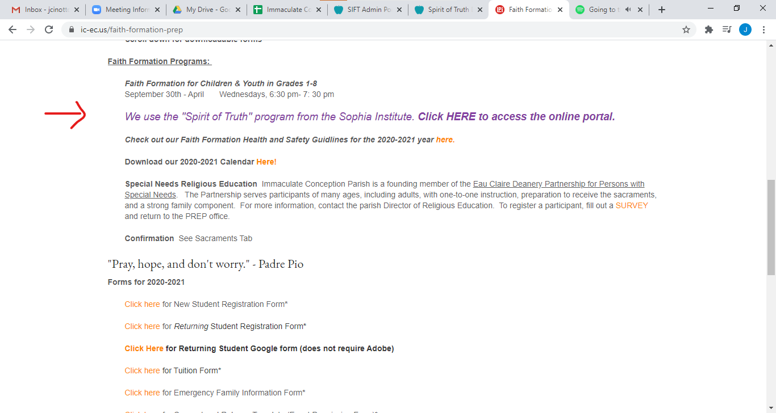
Step 4: Click on the “HERE”. This will take you to the Sophia Institute for Teacher’s Login
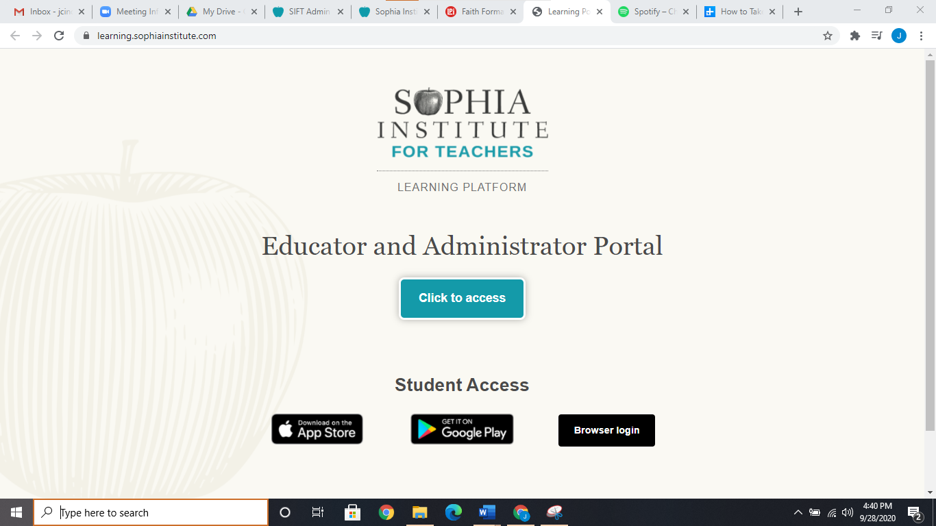

Step 5: Click on the “Educator and Administrator Portal” if you are homeschooling and want to view the catechist’s version of the program.
OR
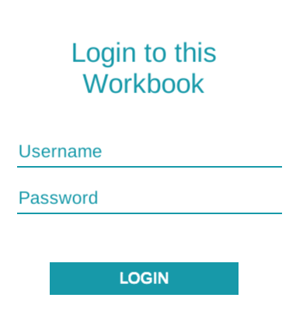
Step 5: Click on one of the “Student Access” buttons. Use the “App store” for ipads, “Googleplay” for chromebooks, and “Browser Login” for all other computers etc
***note: the apps and browser logins do NOT work on smartphones***
Step 6: You will see a login like the one pictured on the left. The first time that parent’s login, you will be prompted to change your password.
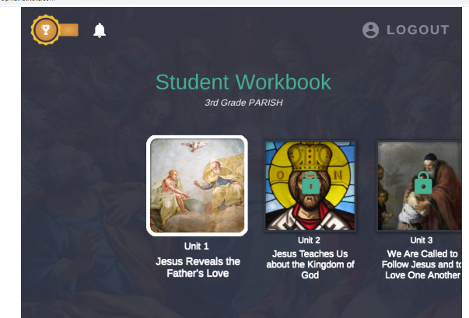
Step 7: Depending on your student’s grade, you will see something similar to the photo on the right. Students can go through any of the unlocked unit.

OR

Step 7: If you have logged in as a Catechist, then you will see a page similar to the below picture:
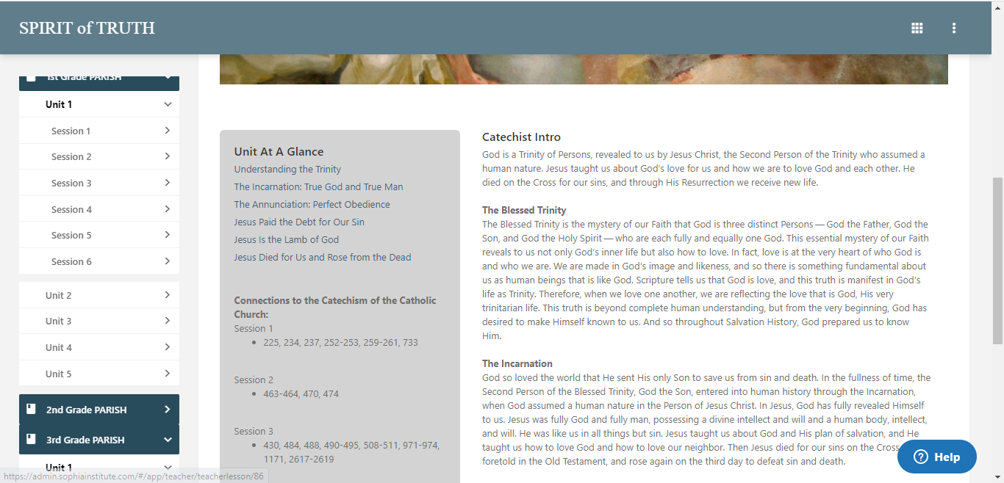

You can now scroll through your student’s assignments and see their progress!

