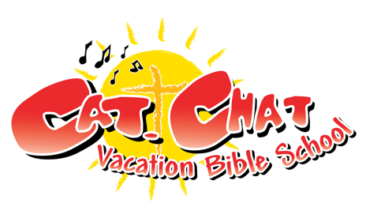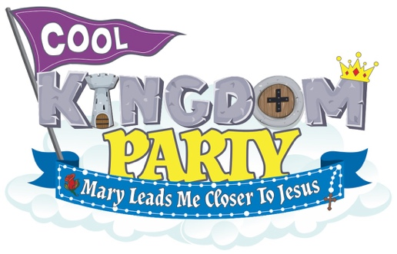
Child Registration Form
Holy Cross Catholic Church
Dates / Location: June 24th – June 28th 9:00am – 12:30pm / 505 26th St West Palmetto, FL 34221
Ages: 3 – 10 years old
===================================================================================
Child’s Information:

Name: _________________________________________________________________________
Gender: M F Age: ____________ Grade completed: _____________

Allergies or medical conditions: ______________________________________________________

Family Information:

Parent/Guardian Name: _____________________________________________________________

Address: ____________________________________ Email: _____________________________

Phone Numbers:
Home: __________________________ Cell: ____________________________

Emergency Contact:

Name: ____________________________________________ Phone: _______________________

I understand that reasonable precautions will be taken to safeguard the health and well being of the participants in this VBS and that I will be notified as soon as possible in the event of an emergency. In the case of sickness or an accident, I authorize and consent the VBS Team, or other associated volunteers of the VBS program to obtain medical care from a licensed physician, hospital, or medical clinic for my son/daughter in the event that myself or other legal guardian(s) cannot be reached. I hereby do release and forever discharge this Diocese, and Parish from all manners of actions, claims which I or the child named above shall or may have for any reason, arising during my child’s attendance of the VBS.
Unless other written instruction is submitted, I also consent to allowing my child’s image to be recorded, either by photograph or video, and used during the VBS week or for future advertisement of Parish VBS programs. Any other use will require your further consent.

Parent / Guardian Signature Date

