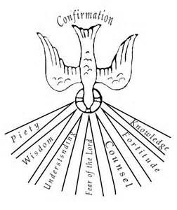
Holy Cross Religious Education
520 26th Street West Palmetto, FL 34221
941-729-3891

Letter To
Father Bernard P. Evanofski
Due By January 14, 2018

All 10TH Grade /2nd Year Candidates must write a brief letter to Father Bernie asking for his recommendation to the Bishop for Confirmation.
The Letter must be submitted to your teacher by January 14, 2018.
IT WILL NOT BE ACCEPTED IF THE LETTER IS LATE.
The letter should simply describe why the candidate wishes to be confirmed. You should introduce yourself and then ask Father Bernie for his recommendation. This letter should be short and simple.

