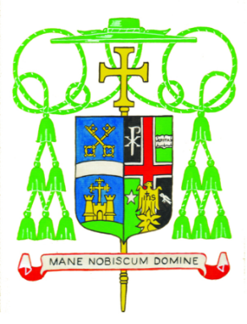

Diocese of Belleville
Office of the Apostolic Administrator

OFFICIAL APPOINTMENTS

His Excellency, The Most Reverend Edward K. Braxton, Ph.D., S.T.D., Apostolic Administrator of the Diocese of Belleville, is pleased to make the following appointments. Unless indicated otherwise, these appointments are effective on Tuesday, July 14, 2020, the Memorial of St. Kateri Tekakwitha, Lily of the Mohawks. However, due to the restrictions caused by the coronavirus pandemic, the moving day and the actual date for beginning these new ministries may be determined by the parties involved.

Pastor (canon 522)
(Six Year Term)

The Reverend Osang F. Idagbo, C.M., until now, Pastor of SS. Peter and Paul Parish, in Waterloo, is appointed Pastor of Holy Family Parish in Cahokia and Sacred Heart Parish in Dupo.

The Reverend Anthony O. Onyango, until now, Administrator of St. Bernard Parish in Albers and St. Damian Parish in Damiansville, is appointed Pastor of the same parishes.

The Reverend Linus Umoren, C.M., until now, Pastor of Holy Family Parish in Cahokia and Sacred Heart Parish in Dupo, is appointed Pastor of SS. Peter and Paul Parish, in Waterloo.

Parochial Vicar (Associate Pastor - canon 547)

The Reverend Iuvenis Iheme, C.M., until now, Parochial Vicar of Our Lady of Mount Carmel Parish in Herrin and Holy Spirit Parish in Carterville, is appointed Parochial Vicar of Mary Help of Christians Parish in Chester; St. Mary Church of Divine Maternity Parish in Ellis Grove; St. Boniface Parish in Evansville; and St. Joseph Parish in Willisville. He is to reside at St. Mary of Divine Maternity Parish.

Deacon

Deacon Kevin T. Templin, serving as Deacon at St. Bernard Parish in Albers and St. Damian Parish in Damiansville, is appointed as Personal Assistant to Bishop Braxton, effective July 23, 2020, while continuing to serve at St. Bernard and St. Damian parishes.

Deacon Retirement

Deacon Linus H. Klosterman, serving as Deacon at St. Dominic Parish in Breese, is granted retirement effective immediately.

Given from the Diocesan Curia on Saturday, the 19th day of June, in the Year of Our Lord 2020, the Most Sacred Heart of Jesus.

