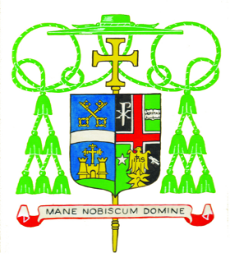
Diocese of Belleville
Office of the Bishop
April 3, 2020
ANNOUNCEMENT
Pope Francis appoints The Reverend Michael G. McGovern
as the Ninth Bishop of the Diocese of Belleville

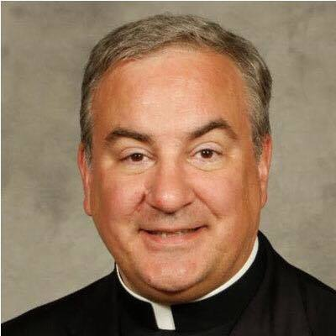

Bishop-Elect McGovern

Today, the Vatican announced that His Holiness, Pope Francis has appointed The Reverend Michael G. McGovern, S.T.B., M. Div., a Priest of the Archdiocese of Chicago, as the Ninth Bishop of the Diocese of Belleville.

Bishop-Elect McGovern, 55, is currently the Pastor of St. St. Raphael the Archangel Parish in Old Mill Creek, Illinois. He is also the Dean of Deanery 1A and Interim Episcopal Vicar of Vicariate 1.

He is well respected and admired by the priests, deacons, religious and Christian Faithful of the Archdiocese, where he has served in a wide variety of leadership positions, including as Pastor of St. Mary Parish, Lake Forest, as a member of the Presbyteral Council and the College of Consultors. He has a reputation as a Priest with abiding faith, pastoral zeal and genuine dedication to caring for the People of God. He will be the fourth Priest from the Archdiocese of Chicago to serve as Bishop of Belleville.

He is the youngest of eight children in devoutly Catholic family. A graduate of St. Ignatius College Prep, Loyola University and St. Mary of the Lake Seminary, he was ordained to the Priesthood of Jesus Christ by Joseph Cardinal Bernardin, Archbishop of Chicago, on May 21, 1994. Father McGovern has said he is a Chicago White Sox fan and enjoys Italian art and English literature.

Bishop-Elect McGovern succeeds The Most Reverend Edward K. Braxton, Ph.D., S.T.D., who on his seventy-fifth birthday, June 28, 2019, wrote to the Holy Father the canonically required letter of resignation. Bishop Braxton was installed as the Eighth Bishop of Belleville on the Feast of St. Thomas More, June 22, 2005.

Bishop Braxton issued the following statement on the occasion of the Vatican announcement.

“May the Peace of Jesus Christ be with all of you!

On Ash Wednesday, when we began our journey up to Jerusalem with Jesus of Nazareth for the celebration of the Easter mysteries, by which we are reborn, none of us realized that this would be a Lent like no other. We could not imagine our world, our country, and our Diocese brought low by the invisible menace of the coronavirus pandemic that has brought so much anxiety, suffering, and death to the world family. The coronavirus pandemic has brought us to Palm Sunday and Holy Week “sheltering at home” and practicing “social distancing,” which makes it impossible for us to celebrate together the Sacred Triduum, the heart of the Church’s Year of Grace, during which we commemorate the Passover of the Lord from life to death to risen glory. Paradoxically, the difficult circumstances in which we find ourselves have drawn us closer together in prayer, reflection and concern for one another.

In this unique time of Lenten prayerfulness and “social distancing,” I feel closer to the priests, deacons, seminarians, religious, faculty and students in our Catholic Schools, lay pastoral leaders, and the Christian Faithful of this Local Church than ever. It is in my name and in the name of all of the members of this Local Church that I have congratulated and welcomed the Bishop-Elect Michael G. McGovern, assuring him of our fervent prayers for fruitfulness in his ministry as the Spiritual Leader and Shepherd of the Catholic Church in southern Illinois.

I invite each of you to pray each day for Bishop-Elect McGovern. Pray that the Holy Spirit will empower him with the gifts that he will need as a Successor of the Apostles and as the Pastor of this Catholic community. Pray that, building on his natural talents and pastoral experiences, the new Bishop may faithfully and compassionately proclaim the Gospel of Jesus Christ to the Christian community and beyond. As you know, in this secular age, it is difficult to live as a faithful disciple of Christ and equally challenging to assume the mantel of Servant-Leadership in the Church. This may be particularly true of a small, largely rural Diocese with modest resources, such as ours.

Since I am formerly from the Archdiocese of Chicago, I already know Bishop-Elect McGovern and I am appreciative of the contributions he has made to the Church in his various pastoral responsibilities. He is also known to some of our Belleville priests from their days of studying together at St. Mary of the Lake Seminary. I am confident that they, with the entire college of priests, will welcome and support him, praying that God, who begins this new work in him will bring it to completion.

In anticipation of this public announcement, the Bishop-Elect and I have spoken often about a wide variety of topics, including my desire to assist him in every way I can. We have acknowledged that, because of the unique circumstances in which we find ourselves with the coronavirus pandemic and directives from Governor Jay Robert Pritzker, the Bishop-Elect cannot be present in the Diocese today to be personally introduced to you. We both regret this very much! However, he will be greeting all of you by means of written and electronic communications today and in the days ahead. And, as soon as it is safe for us to gather, even in small numbers, he will join us whenever it is possible.

In discussing our unique situation, Bishop-Elect McGovern and I agree that it is not possible to announce the date for the Liturgy of Episcopal Ordination and Installation in the Cathedral of St. Peter, at this time. However, we both agree that, due to the circumstances, it is unlikely that the date will be before late Summer.

Meanwhile, please continue to pray for me as I continue to pray for you and serve you during the months ahead. Pray for me especially on May 13th when I will celebrate the 50th anniversary of my Ordination to the Priesthood, on May 17th when I will celebrate the 25th anniversary of my Ordination to the Episcopacy, and on June 22nd when I will celebrate the 15th anniversary of my Installation as your Bishop. A transition such as this necessarily prompts prayers of grateful remembrance and introspection. It is a time for the inevitable quest to retrieve and control the past that forever slips away and a time to seek a future that is forever the unknown-unknown. I thank each of you for your life and ministry with me, for your cooperation, support and affection. With St. Paul I can say, when I think of you my memories will be happy ones and when I pray for you, my prayers will be full of joy! God is not God the way we would be God, if we were God! May the God of Our Lord Jesus Christ continue to bless you and those who are dear to you both now and forever. AMEN!”

****************************

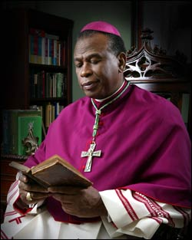
Bishop Edward K. Braxton

Prior to his appointment to Belleville, Bishop Edward K. Braxton, a former professor of theology at Harvard Divinity School, served as Auxiliary Bishop of the Archdiocese of St. Louis and Bishop of Lake Charles, Louisiana. During his fifteen year tenure in the Diocese of Belleville, the Bishop, who is in good health, has been actively engaged in every aspect of the ministry of the Diocese, giving a particular emphasis to Catholic education, the work for vocations to the Priesthood, concern for the welfare of the priests, ministry to the sick and the bereaved, the ongoing formation of deacons, and The Pastoral Plan for Parish Renewal and Restructuring. This is a decade-long undertaking to address the need to bring the parishes of the Diocese together in renewal and greater cooperation. The Pastoral Plan has resulted in decreasing the number of parishes, the appointment of priests to serve multiple parishes, and the introduction of a significant number of fidei donum missionary priests to assist the local priests in the pastoral care of the Christian Faithful. As an active theologian, the Bishop has published a variety of works in different areas of pastoral theology. In recent years, the Bishop has become a leading commentator on the Racial Divide in the United States and in the Catholic Church. His writings have led to frequent invitations to lecture nationally and abroad.

______________________________
Contact Person: Media contact person is the Reverend Monsignor John T. Myler, S.T.D., V.F., Rector of the Cathedral of St. Peter, 200 West Harrison Street, Belleville, Illinois 62220. He can be contacted at (618) 234-1166; jtm300@aol.com

