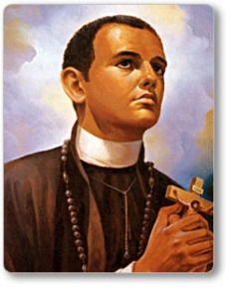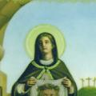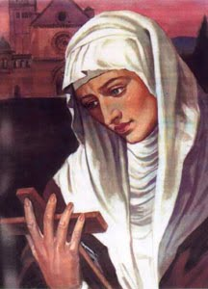

CONFIRMATION
PATRON SAINT RESEARCH REPORT
Please pray first and ask for guidance from the Holy Spirit. Then, begin your saint search. You will take the saint’s name whom you choose to be your Confirmation name. This may take a bit of research.
Once you have selected your Patron Saint, write your research paper. Be sure to include important facts and dates. Also, include the story of your saint and events that will help us get to really know your saint. Be sure to put in the reason you chose your saint.

Every student will turn in a written report on paper.
Every student will share their report during a Confirmation Prep Class. Be prepared to speak for 3 to 5 minutes, this is required. Please use an outline, do not read your report. **Be creative! Also, have at least one visual aid: a poster, statue, PowerPoint presentation, etc.
-Be sure to put your name on your paper
-Write a 2-page paper
-Double-spaced, Font #14
-Paragraph format, no outlines
-Please us and site at least 2 resources at the end of the paper

Ideas for Research
- Think about yourself. What is important to you? What are your hobbies and interests? Is there some topic that is dear to you or some experience that has helped shape you as a person?
- Use the resources around you. Your parents, your Confirmation sponsor, your grandparents, aunts, uncles, godparents, priests, deacons. Ask for their help with suggestions on whom to select.
- Please feel free to ask any catechist for help.
- Use the computer, but always use the word “Catholic” in your search words when googling!
- Go to the PSR office and ask for resources.

