Grade 2 Sacramental Prep Lesson 1 Eucharist
Week of January 10 Theme Baptism—Sacrament of Belonging

Prayer Table: Ordinary Time, green cloth. Holy water, candle, cross, Bible, Baptism robe and candle
Gather around the table and prayerfully make the Sign of the Cross with Holy water. When you were Baptized, the priest or deacon used these same words. Everytime we make the Sign of the Cross, it reminds us of our Baptism. Pray for those who are sick and for peace in our world.
Ponder:
Introduce the Sacrament of Baptism. Without Baptism, you cannot receive any other Sacraments. Sacraments are the way the Church meets Jesus. We become a member of God’s family. At Baptism we receive the gift of faith. God gave us a share in His life which we call grace. Adam and Eve committed the first sin and were banished from the Garden. That sin is called Original sin. Every human being except Mary are born with that sin on their soul. Baptism takes it away. We receive the gifts of faith, hope and charity(love).
Faith—faith helps us believe that God is always with us. It helps us to hear God speak to us and to believe what God tells us.
Hope—Hope helps us to trust that God will always be with us, helping us to do the things that will bring us to heaven.
Love—helps us to love God and others.
Scripture: Gospel Reading for this Sunday Mark Baptism of Jesus in the River Jordan.
Discuss the story.
Listening: The Baptism ceremony and the meaning of the symbols. I will do that as part of the lesson.
What are the effects of Baptism?
- Takes away original sin
- Makes us a child of God We belong to God’s family
- Receive the gift of the Holy Spirit who lives within us
- We receive grace and a share in God’s life
- We belong—we can now receive the other Sacraments
- Baptism makes us a follower of Jesus and a life of service

Prayer—a guided meditation on Baptism promises

Activity—complete the attached worksheets. Know the symbols of Baptism. Know the words of Baptism. “I baptize you in the name of the Father, and of the Son and of the Holy Spirit. Amen
Find your Baptism robe, candle and certificate. Know your Godparents. Find pictures of your Baptism—who was there? What Church?
https://www.catholicicing.com/catholic-baptism-video/

This video is a good follow-up to Peg Hicks talk on the Bible
https://catechistsjourney.loyolapress.com/2020/05/pop-up-catechesis-getting-to-know-your-bible-better/
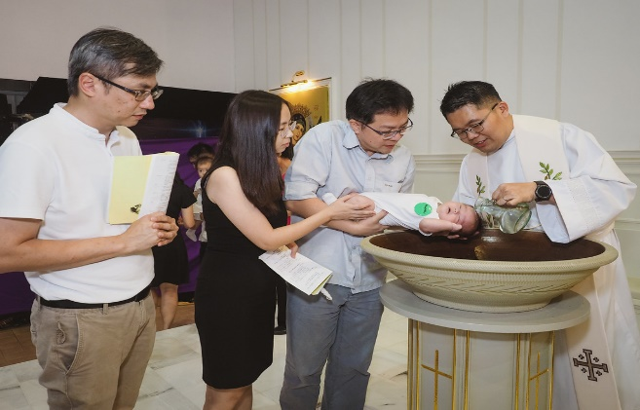
This Photo by Unknown Author is licensed under CC BY

