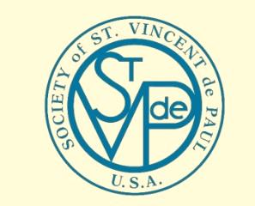

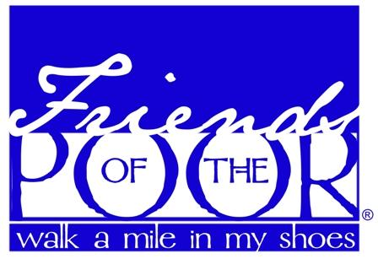
Society of St. Vincent de Paul – Friends of the Poor Walk
Westford Conference

Accident Waiver and Release of Liability Form
I recognize and acknowledge that there are inherent risks in my presence and participation in the St. Vincent de Paul Friends of the Poor® Walk/Run on November 11, 2021. I acknowledge that this Accident Waiver and Release of Liability form will be used by the event holders, sponsors and organizers, in which I may participate, and that it will govern my actions and responsibilities at said events. In consideration of my registration and participation in this event, I hereby take action for myself, my executors, administrators, heirs, next of kin, successors and assigns as follows:
(A) I hereby expressly agree that the Society of St. Vincent de Paul, its directors, officers, employees, volunteers, representatives and agents, event holders, event sponsors and event directors (all hereinafter referred to as St. Vincent de Paul) shall not be liable for any damages arising from personal and/or bodily injury, including death or property damage sustained by me or my guest while participating in the Friends of the Poor® Walk/Run. I assume full responsibility for any such injuries or damages that may occur to me or my guest. I also specifically agree that St. Vincent de Paul shall not be responsible for any such injuries, loss or damage even in the event of negligence or fault by St. Vincent de Paul. This waiver does not, however, apply to gross negligence or intentional torts by St. Vincent de Paul.
(B) Indemnify and Hold Harmless the entities or persons mentioned in this paragraph from any and all liabilities or claims made by other individuals and entities as a result of any of my actions during this event.
I am aware the Society of St. Vincent de Paul does not provide health and accident coverage for me and it is my responsibility to pay any medical bills from injuries sustained while participating in the Friends of the Poor® Walk/Run.
I hereby consent to receive medical treatment which may be deemed advisable in the event of injury, accident and/or illness during this event.
I understand that at this event or related activities, I may be photographed. I agree to allow my photo, video or film likeness to be used for any legitimate purpose by the event holders, producers, sponsors organizations and assigns.
I HAVE READ AND FULLY UNDERSTAND THIS WAIVER AND RELEASE OF CLAIM FORM.

Printed Name Signature Date
Emergency Contact Emergency Phone Number
If under 18 years old, parent or guardian must also sign below.
PARENT/GUARDIAN WAIVER FOR MINORS (IF UNDER 18 YEARS OLD)
The undersigned parent and natural guardian does hereby represent that he/she is, in fact, acting in such capacity and agrees to save and hold harmless and indemnify each and all the parties referred to above from all liability, loss, cost, claim or damage whatsoever which may be imposed upon said parties because of any defect in or lack of such capacity to so act and release said parties on behalf of the minor and the parents of legal guardian. I understand that the foregoing Accident and Release of Liability shall apply to my child. I hereby give permission for my child to participate in the Friends of the Poor® Walk/Run, with the understanding that every reasonable effort will be made to plan for safe participation in this event.
Print Participant’s Name Participant’s Age

Signature of Parent or Guardian Date

Emergency Contact Phone Number

