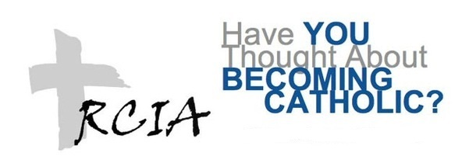
If you are:

- Someone who has not been baptized, but seeks spirituality in your life?
- A Baptized Christian who would like to learn about the Catholic faith?
- A Baptized Catholic who has not received the Sacraments of Holy Eucharist or Confirmation and desires to complete the Sacraments of Initiation?
- Married to a Catholic and trying to raise your children in the Catholic faith, but don’t know what that actually involves?

Classes will begin on Thursday, Sept. 6th.

We meet each Thursday evening
From
7:00pm – 8:30pm
Join Us!
You are invited to participate in the dynamic process called the Rite of Christian Initiation of Adults (RCIA). It is a wonderful opportunity to listen to the mystery of Christ’s invitation into a deeper relationship with Him.
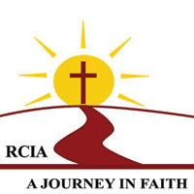

If you believe that God is calling you to discover the truth about the Catholic faith, please contact: Susan: 561-626-8626; or email susan@stpatrickchurch.org

