Henry Hosea House 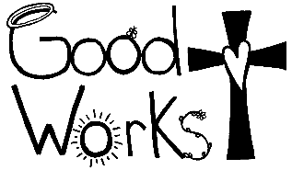service opportunity!

When: Monday November 14th 2:30-5:30pm
Where: Henry Hosea House
901 York St.
Newport KY

What: Space is limited for volunteers. Students who fill out and return in their Good Works choices first will be signed up for this service opportunity. If your student is signed up, but cannot go because of the limited space, we will be sure to give them first opportunity for the next offsite service opportunity if they choose. 7 students (5th -8th grade) will meet in the cafeteria at 2:30 to make “to go” food bags for the clients served. This will consist of a peanut butter and jelly sandwich, a bag of chips, apple or banana, and bottle of water. We will then go to the soup kitchen, where some students will serve food or drinks, work in the dish room, wipe tables, or pass out the “to go” bags as the clients leave. Your student will need to be picked up from the Henry Hosea House at 5:30 pm. As you pick them up, I will have a sign out sheet that needs to be signed. Also, a permission slip will be sent home with your child.

*If your student chooses to come remind them this is an evening of hard work!

We could use the following donations to make the “to go” bags. Any family can donate 1 or some of these items:

2 large containers of peanut butter
2 large containers of jelly
5 loaves of bread
100 small individual bags of chips
6 bags of apples
6 bunches of bananas
100 bottles of water
100 plastic grocery bags
100-quart sized baggies
