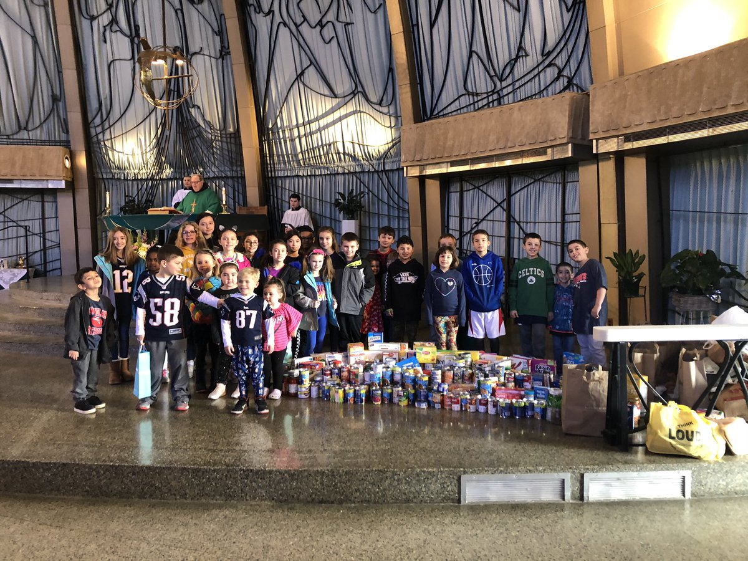
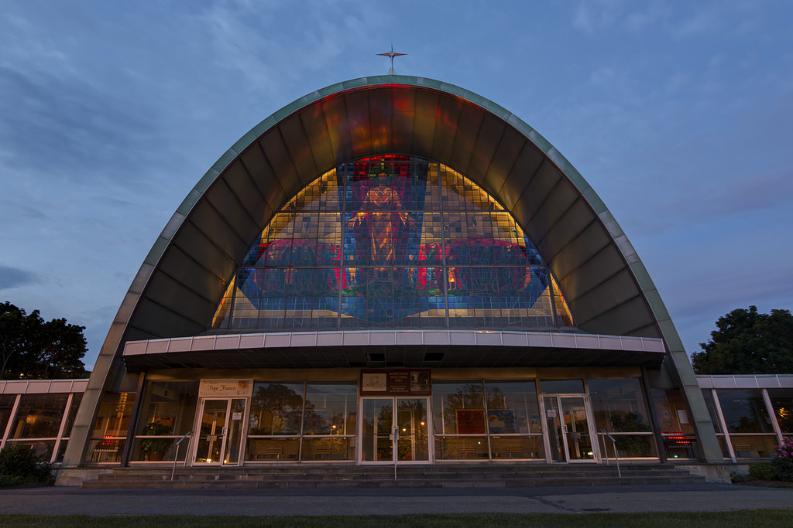
Religious Education Virtual Learning

Sacred Heart Church

April: The Sacraments
Dear Families,  Christ is Risen. Alleluia, Alleluia! I hope you had a blessed and happy Easter and are preparing for a week of rest and family time during the spring break. It is appropriate that your faith formation lesson on Sacraments of the Church comes just after Holy Week when we celebrate the institution of the Eucharist on Holy Thursday. Since the earliest days of the Church Jesus has touched the lives of all believers through the sacraments. Our celebrations of the sacraments are signs of Jesus’ presence in our lives and a means for receiving his grace. I always look forward to spring when we celebrate so many of the sacraments here in the parish: first Reconciliation, first Holy Communion, and Confirmation. I always look forward to celebrating the sacrament of Matrimony for couples who wish to marry in the Catholic Church. Throughout the year I am blessed to celebrate the Eucharist at Mass, welcome the newest members of the faith into God’s family through Baptism and administer Anointing of the Sick to those who are ill to give them strength to heal physically, spiritually, and emotionally. As a priest, the Sacrament of Holy Orders is near and dear to my heart, having accepted God’s call to serve His people. Next month, I will celebrate my 37th anniversary of my own ordination to the priesthood! The Sacraments of the Catholic Church play a valuable role in our faith; welcoming us into the life of Christ, calling us to serve one-another in love and charity and mirroring Christ’s mercy and forgiveness. I invite and encourage you to learn more about the Sacraments with your children this month. Consider ways in which you can help your children deepen their understanding while developing an appreciation for these gifts given by God.  Easter blessings, Father Dennis  Video Links |  | " The Sacraments are Jesus Christ’s presence in us. So it is important for us to go to Confession and receive Holy Communion.”- Pope Francis (@Pontifex Twitter Nov. 2013)  This past year we’ve often heard the term efficacy, when referring to vaccines and how effective they are for our physical well-being. The Catechism of the Catholic Church refers to the sacraments as “Efficacious (having an effect) signs of grace, instituted by Christ and entrusted to the Church”. Sacraments have an effect on our lives and on our spiritual well-being. Sacraments give us the grace we need to grow in holiness and respond to God’s call in our lives.  Jesus left the Church seven ways of receiving special grace to live our Christian lives. These seven sacraments instituted by Christ and entrusted to the Church, provide an opportunity for each of us who receive them to share in the life of Jesus. This month we will explore the Seven Sacraments though a series of short videos and through the curriculum noted for each student’s grade level. As we approach the sacramental season of the church, we hope that this teaching will help to enrich our understanding of the gifts of God’s grace that we receive through the sacraments of God’s Holy Church.

A Video Message from Sacred Heart: Click here to access our April Faith Formation Video
Videos for Adults, Teens & Kids: Sacrament of Initiation – Baptism, Eucharist, and Confirmation
Sacraments of Healing – Reconciliation and Anointing of the Sick
Sacraments of Service – Holy Orders and Matrimony
More for the Kids: Check out this catchy tune that will help you remember the sacraments!

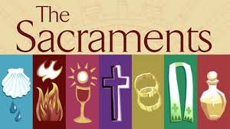 |  | The Lesson Plan  - View the videos with your family (links on page 1)  - Read “Our Sunday Visitor” The Sacraments (in binder)  - Review lessons listed for student textbook  - Take part in some or all of the family activities
Family Activities  Choose from some of these suggested activities to help better understand and celebrate the Sacraments.  - Look through old family photos of weddings, baptisms and first communions. Talk about the photos and those special days.  - Pray together for our second graders and tenth graders who are all preparing to receive the Sacraments of Eucharist and Confirmation in the next few weeks.  - Sacramentals are part of the prayer life of God’s people. These gestures and objects remind us of the sacramental life of the church. They include: Blessing of people, pets, places, food (for example, The blessing of the pets, saying Grace and the blessing of religious items like the rosary), objects (statues of Jesus, Holy Water, etc.) Actions (sign of the cross, sprinkling holy water). Look around your home and church for sacramentals and talk about them together. |  | 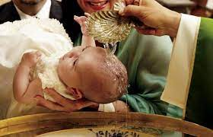
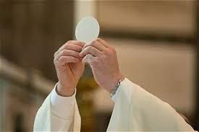 |  | For Children & Teens  Sadlier We Believe® textbook  Grade 1 Sadlier: We Celebrate the Sacraments -Lesson 16  Grade 2 Sadlier: We Celebrate God’s Love -Lesson 3  Grade 3 Sadlier: We Celebrate the Sacraments -Lesson 15  Grade 4 Sadlier: We Grow in Holiness -Lesson 24  Grade 5 Sadlier: The Church Celebrates the Seven Sacraments -Lesson 3  Grades 6-10 & Adults: Our Sunday Visitor “The Sacraments” (This 6 page color booklet can be found in the front or back pocket of your resource binder)
For Teens & Adults  Check out this LIFE TEEN blog.  Check out this website for a quick, easy breakdown of the seven sacraments and their purpose.  As you prepare for Confirmation, look around your house for photos from your Baptism and First Communion and create a little collage to keep in a favorite your Bible as a reminder of who you belong to and your call to serve and love others.  Interview a family member about your baptism and their faith journey and complete this Candidate Faith Check-in to see where you are in your journey right now and help think about where you are going. |  | 