Religious Education Virtual Learning

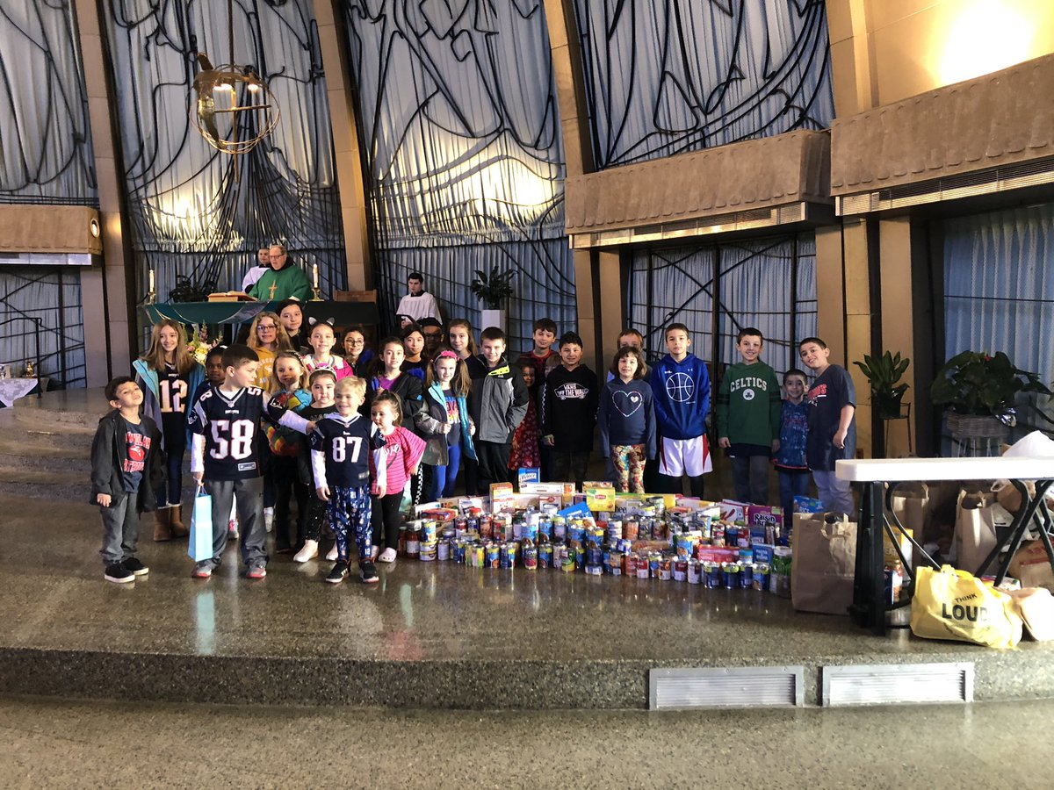
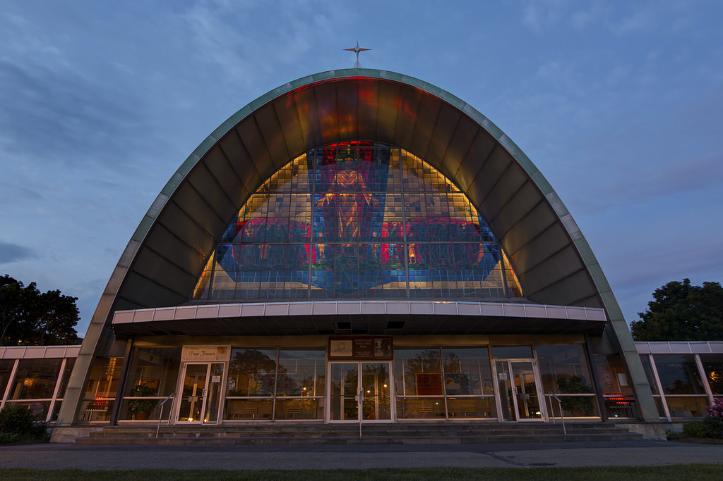
January: Prayer

A Video Message from Sacred Heart: Click here to access our January Faith Formation Video
For Parents, Kids & Teens: In a WORD-Prayer: Learn about how prayer is essential to our lives.
For Kids: Enjoy these 1 min. videos about prayer for kids. What is prayer? Why do we pray? How do we pray?
For Teens: and The Bible Geek on Prayer 2 min. and The Science of Prayer 5 min.

Let Us Pray by Steven Curtis Chapman - A song reflection for all. Be sure to listen to the words and use this as your challenge this month. “Let us pray, everywhere in every way. Every moment of the day, it is the right time.”

Sacred Heart Church

Dear Families,  Happy New Year! This month our Faith Formation curriculum will focus on prayer. If ever there was a time in our lives when prayer was needed, this is it! Many of you have dealt with this ongoing pandemic in ways that others might not imagine. Many are struggling with loss of employment, economic hardship, helping children with remote learning, working from home and the list goes on. For many others who are dinosaurs, like me, the pandemic has put us in a position to do things very differently like learning to master new forms of technology and celebrating Mass with streaming cameras always rolling! (There have been very challenging for me to say the least. I still need to call for help when opening a Zoom!) For all of us who have spent the last ten months isolated from family and friends, unable to travel or just go out and do things, this pandemic has left many of us feeling stressed, tired, and emotionally drained.  Couple all of this with these tumultuous times in which we live where there are so many divisions politically, racially, and economically. It’s apparent that we need prayer. In reference to prayer, Saint Therese of Lisieux said “For me, prayer is a surge of the heart; it is a simple look toward heaven, it is a cry of recognition and of love, embracing both trial and joy.” The Catechism of the Catholic Church defines prayer as a “vital and personal relationship with the living and true God.” I hope that you will take the opportunity, as you hand on this teaching of faith to your children, to make prayer part of your New Year’s resolution. Invite your family to pray even if just for a few minutes each day and even if it is just a “simple look toward heaven”. Finally, the best form of prayer is worship. Take time to attend Mass either by viewing streaming Mass online (ours airs live every Saturday at 4PM and plays again all weekend on YouTube) or by attending our “drive-Mass’ on Sunday morning at 10. Links for Mass are on the front page of our website (or so I’m told!) Please know I am praying for all of you and I ask you to pray for me as we look forward to a more hopeful year ahead.  God bless, Father Dennis  Video Links |  | Saint Teresa of Calcutta credited her extraordinary love, mercy, and ability to serve to her devotion to prayer.

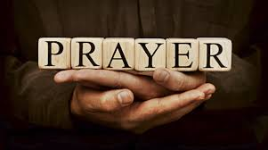 |  | The Lesson Plan  - View the videos with your family (links on page 1)  - Read from the How to Pray as a Catholic  - Assist children with the correlated lessons listed below  - Choose one “Family Activity” (below) for each week of Jan.  Bonus: Download a monthly prayer calendar for free.
Family Activities  Prayer Craft: Find the prayer craft kit in your resource bag and assist your child in creating a resource that will serve as a daily reminder to pray.  Discussion: Brainstorm ways that your family can add prayer to your daily schedule.  Pray for the needs of others: Think of people in your life who need prayers, place a picture of that person (or their name written down) in a visible place in your home so you can pray for them when you pass by it.  Try a new way to pray: Pray the rosary or a novena. If those aren’t new to you try a guided meditation (there is one included in your resource folder) or visit this Eucharistic Adoration link to pray before the Blessed Sacrament. You could also pray outside or make prayer a new year’s resolution! |  | 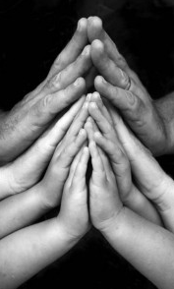
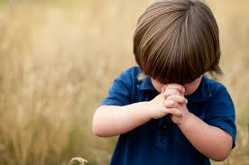 |  | For Young Children  To reinforce the Church’s teaching on the Eucharist with young children, you may refer to the lessons listed below which can be found in your child’s Sadlier We Believe® textbook.  Gr. 1-Lesson 8, Jesus had Many Followers/The Lord’s Prayer, page 75  Gr. 2-Lesson 24, We Pray, page 203  Gr. 3-Lesson 10, The Church Prays, page 91  Gr. 4-Lesson 24, We Grow in Holiness, page 203  Gr. 5-Lesson 12, Living as Prayerful People page 108  FIRST COMMUNION: Sadlier Sacramental Prep Eucharist (thin blue book) Review Pages 4 & 5 (Virtual Church Tour) and complete Lesson 2 in the Eucharist book which introduces the Mass.

For Teens & Adults
Check out these blogs, Prayer 101 and My Favorite Prayer Tools from LIFE TEEN. Think about trying one of the prayer suggestions provided. Need more ideas? Here’s a list of 90 ways to pray when you’re stuck in a rut!
Listen to a few of 2020’s Top Christian songs and reflect and pray on the lyrics and message. You could also challenge yourself to listen to Christian radio or Spotify’s Best Christian Songs.
Read about prayer in the Bible: Jeremiah 19:12, Philippians 4:6, 1 Thessalonians 5:16-18, Romans 12:12

