Religious Education Virtual Learning

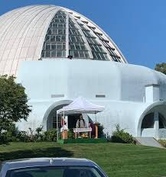
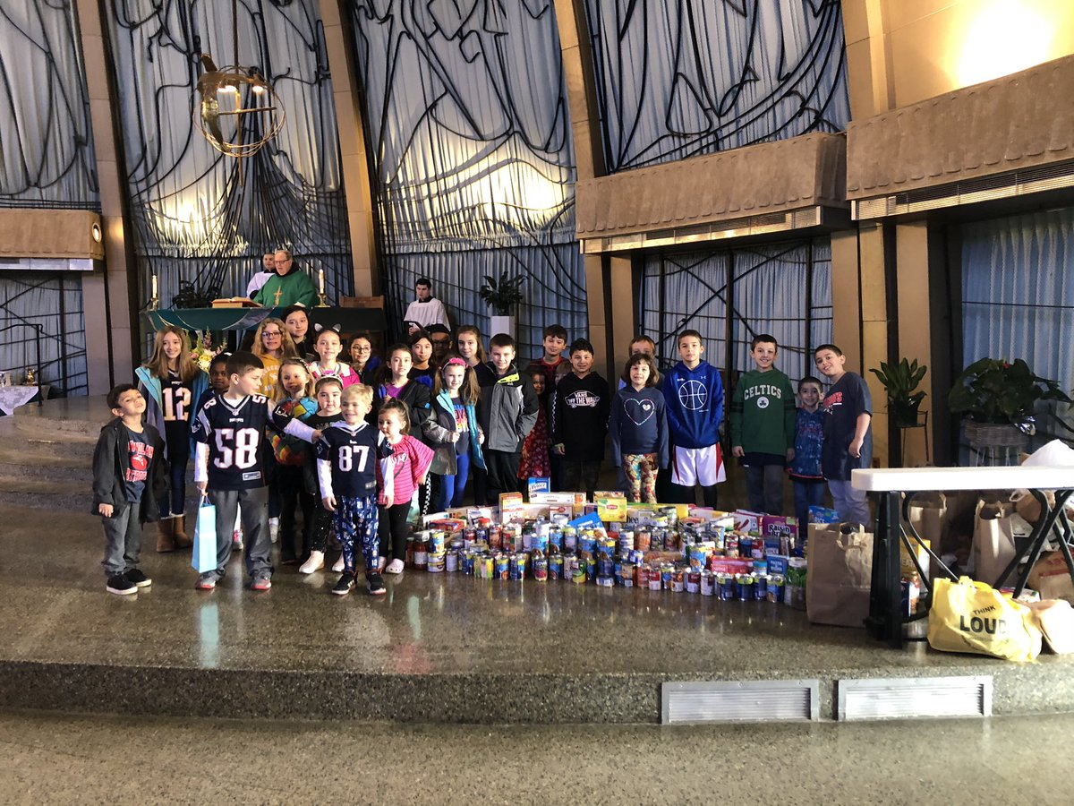
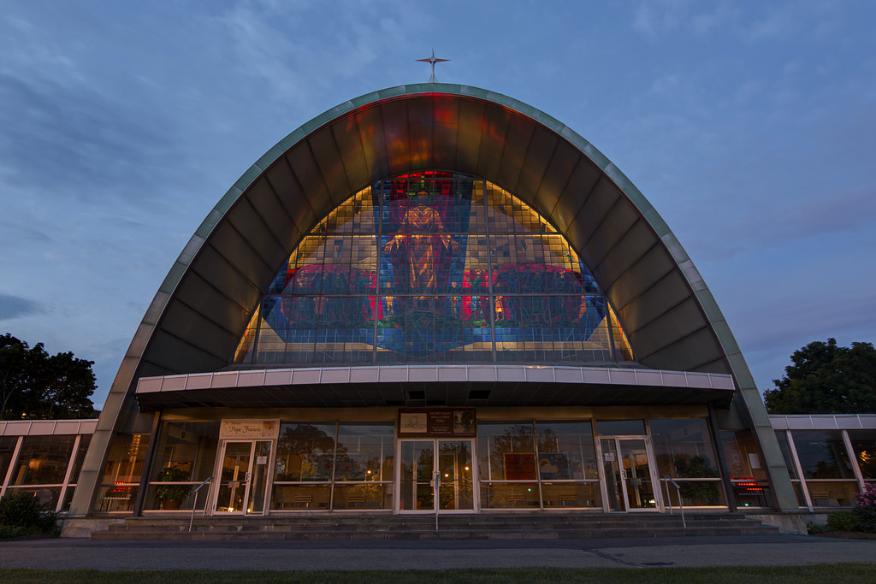
October: Mary and the Rosary
Dear Parishioners,
Welcome back to a new year of religious education. I know that this is very different than what we are used to, but I hope that this year’s home learning format might be a new way for families to grow in faith together. Our staff has made every effort to ensure that this program will not be a burden on family time and will fit into your busy schedules. I ask that you take just a little time each month to participate and grow in faith along with your children and teens.
I also ask that you take time to worship together with your family. For those comfortable coming back to Mass indoors we are now offering that option on Saturdays at 4:00PM. For those for whom indoor Mass is not possible or doesn’t feel safe, please note that we will continue our Drive-In Mass at 10:00AM on Sundays and our streaming Mass that you can view at your leisure on the weekend. In these challenging times it is more important than ever to pray, to worship and to rely on God and our faith. Know that each of you are in my prayers and I look forward to seeing you all in the months ahead.
God bless, Father Dennis

Sacred Heart Church

Dear Families,  We begin our remote Faith Formation by looking at the life and legacy of Mary, the Blessed Mother. Throughout the centuries, the Church has turned to the Blessed Virgin in order to come closer to Christ. Many forms of prayer and devotion to the Blessed Mother have evolved through the generations, each intended to bring us closer to Jesus through his Mother. The Catechism of the Catholic Church states “while the Mother is honored, the Son, through whom all things have their being and in whom it has pleased the Father that all fullness should dwell, is rightly known, loved and glorified and . . . all His commands are observed." The Church honors her as the Mother of God, looks to her as a model of perfect discipleship, and asks for her prayers to God on our behalf. Please take a few moments to view the following videos to learn more about Mary and hear how members of our own parish honor Mary and the rosary.  Video Message from Sacred Heart: Click here  For Parents & Teens: Busted Halo  For Kids “Let’s Discover the Rosary”  A Note from Fr Dennis |  | Mary is placed in the sanctuary of Sacred Heart Church during the month of May when we honor the Blessed Mother.

Lesson Plan
View the videos with your family (links on page 1)
Read the leaflets “Praying the Rosary” and/or “The Rosary for Teens”
Family Activities  Think of a person or petition to pray for and invoke the Blessed Mother to intercede and bring your prayer to her Son, Jesus.  Learn the prayers of the rosary: Creed, Hail Mary, Our Father, Glory Be.  Occasionally: Pray the rosary as a family. Not enough time? Pray just one decade. |  | 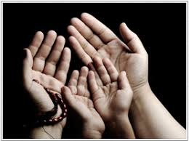
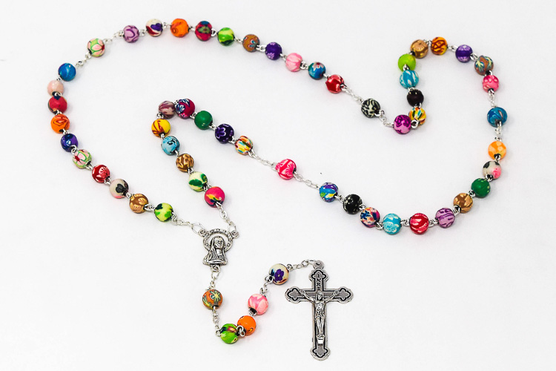 |  | For Young Children  Assemble the rosary kit provided in the resource packet.  You could also use the Sadlier We Believe® lesson to reinforce the Church’s teaching on Mary, the Blessed Mother. Lessons on Mary can be found in the student book for your child’s grade level listed below.  Gr. 1 We Honor Mary and the Saints, page 211  Gr. 2 Mary and the Saints page 211  Gr. 3 Mary is the Greatest of all Saints page 211  Gr. 4 Virtue and Mary as a Model of Discipleship 221  Gr. 5 Mary, Model of Discipleship page 163
For Teens & Adults:  Follow @manyhailmarysatatime on Instagram for and pray along with the live and taped Rosary.  Check out this LIFE TEEN Blog for a great reflection.  Read about Mary in the Bible: Start with Luke 1:38-45 or Luke 2:19, 51 |  | 