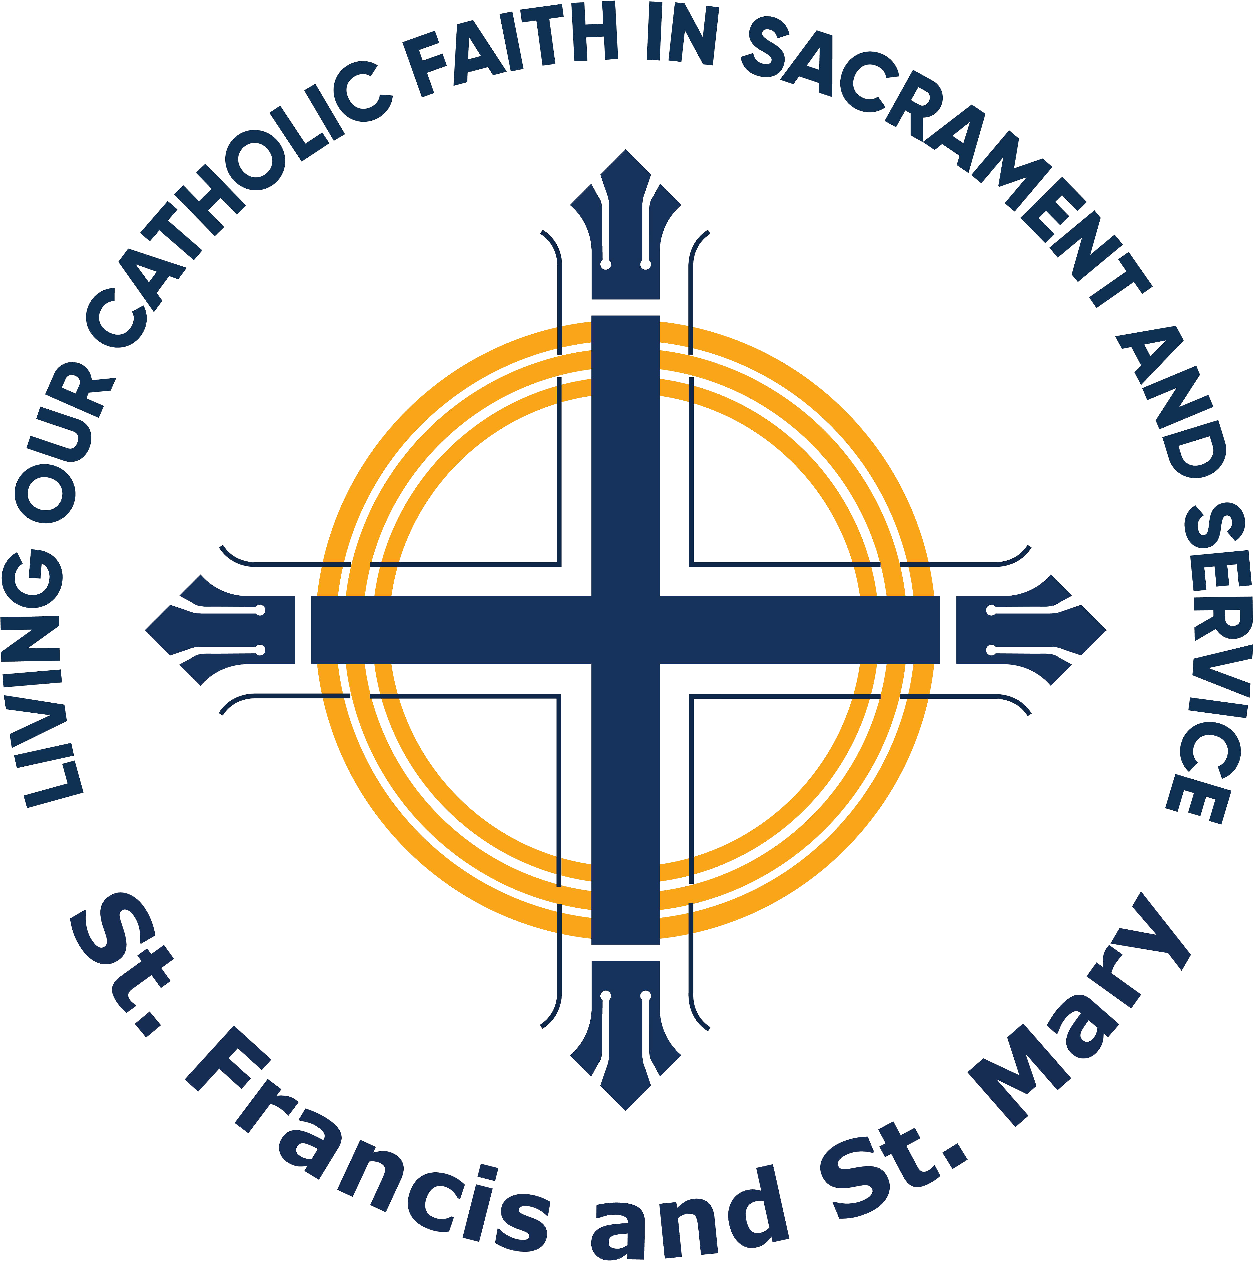CCD & Youth Group REGISTRATION FORM

St. Francis of Assisi

1049 Howard St. Sturgis, SD 57785

605-720-3579

**CCD CLASSES** ARE ON WEDNESDAY EVENINGS from SEPTEMBER to APRIL, from 6pm to 7pm. **CCD MEALS** OFFERED IN PARISH HALL (before class), from 5pm to 6pm.

|  |  |
| --- | --- |
| FAMILY LAST NAME:  ST. FRANCIS PARISHIONER: ◻ YES ◻ NO, NAME OF PARISH | |
| ◻FATHER ◻MOTHER ◻OTHER:  *NAME:* | ◻FATHER ◻MOTHER ◻OTHER:  *NAME:* |
| *ADDRESS:* | *ADDRESS:* |
| *CITY:*  *ZIP:* | *CITY:*  *ZIP:* |
| *CELL:*  *HOME:*  *EMAIL:* | *CELL:*  *HOME:*  *EMAIL:* |
| EMERGENCY CONTACT INFORMATION  *Please designate an emergency contact in the event of a medical emergency or unscheduled dismissal, to be contacted if legal guardians cannot be reached.*  *EMERGENCY CONTACT:*  *RELATIONSHIP:*  *CELL:*  *OTHER:* | |

|  |  |
| --- | --- |
| REGISTRATION FEES |  |
| ONE CHILD: | $20 |
| TWO CHILDREN: | $40 |
| THREE+ CHILDREN: | $50 |
| CONFIRMATION STUDENT (8TH):  YOUTH GROUP: | $25  $10 |
| TOTAL PAYMENT: | $ |

*FOR OFFICE USE ONLY*

*Date Payment Received:*

*Cash: $*

*Check No:*  *Amount: $*

*Return this form with payment to St. Francis of Assisi's parish office. If paying by check, please note "CCD Registration" in the memo line.*

Registration is due by August 31, 2025

CLASSES BEGIN SEPTEMBER 3, 2025

|  |  |  |  |  |  |  |  |
| --- | --- | --- | --- | --- | --- | --- | --- |
| STUDENT NAME  ***(First & Last)*** | M/F | 2025-26  Grade | DOB | Baptized | Penance | Eucharist | Allergies/Special Needs |
|  |  |  |  | Y / N | Y / N | Y / N |  |
|  |  |  |  | Y / N | Y / N | Y / N |  |
|  |  |  |  | Y / N | Y / N | Y / N |  |
|  |  |  |  | Y / N | Y / N | Y / N |  |
|  |  |  |  | Y / N | Y / N | Y / N |  |
|  |  |  |  | Y / N | Y / N | Y / N |  |

† Please note: 8th grade students will receive Confirmation Catechism.

Photo Release

Photos will be taken during class times as well as special events. These photos maybe put on our Facebook, Instagram, flyers or webpage. I_______________________ consent to allow all pictures and videos taken of my minor child(ren) to be used and hold the above organization harmless against any and all claims or damages arising out of taking and/ or use of any pictures, video, and/or names of said minor child. St. Francis of Assisi does not identify minor children by full name in any of its publications.

**ONE PARENT (per family) REQUIRED TO VOLUNTEER (at least) 1 CCD NIGHT**

**VOLUNTEER PREFERENCE***:* **□ TEACHER'S HELPER OR □ CCD MEAL HELPER**

**Note: Your child’s teacher or the DRE will contact you regarding the CCD night you will be needed to Help. Thank you!**

**VOLUNTEER’s NAME: BEST CONTACT: □ PHONE □ EMAIL**

**VOLUNTEER’s NAME: BEST CONTACT: □ PHONE □ EMAIL**

**† Note:** **Teachers & Substitute Teachers MUST complete “Safe Environment Training” (SET) and a background check.**

* **I am currently in compliance with the volunteer requirements for the Diocese of Rapid City.**
* **I need to complete my background check and complete SET training.**