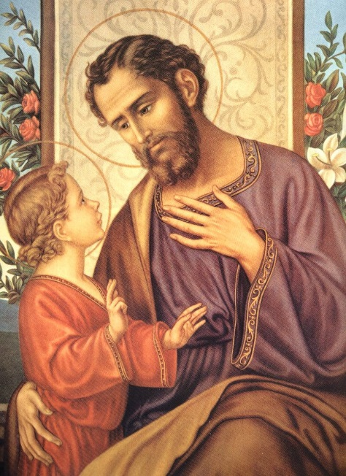
St. Joseph – Protector of Marriage & Family
This is the ‘Year of St. Joseph’ - announced by Pope Francis in December, 2020. As we learn more about St. Joseph each week, we will better understand the titles referring to him: Spiritual Father, Patron & Protector of the Church, Guardian & Head of the Holy Family, Spouse of the Mother of God, Zealous Defender of Christ….
St. Joseph is the Protector of Marriage and Families. He sees the attacks we currently face not only in our country, but throughout the world. Many are confused by what it really means to be a man or a woman. Many want to redefine marriage as any two people who love each other and family as a group of people living together for common interest. St. Joseph will cut through the confusion on these matters.
Who knows better than St. Joseph about how to love, protect, nourish and teach than the father of Jesus, spouse of Mary? His was a chaste love as his spouse was chaste. He left the comfort of his home in Nazareth to flee with his family to Egypt to protect them from Herod. There he provided a home for years, in a strange land. In that foreign land, he taught his son, Jesus, how to walk and talk, to play and to pray. When it was safe, he returned home and started over again, teaching Jesus a carpenter’s trade. Joseph taught Jesus what it means to be fully human – what it means to be part of a family.
When Jesus began his ministry, he knew the importance of a strong marriage and a strong family from this human experience. Pray to St. Joseph to strengthen your marriage and your family!

