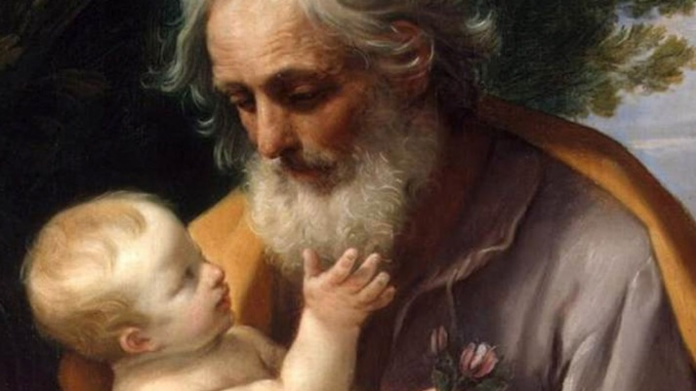
The Hidden Life of St. Joseph
In the 17th century, Bishop Bossuet of France contrasted the apostles’ mission with the hidden life of St. Joseph.
The apostles were to announce Jesus throughout the world; Joseph was to remain silent and keep Jesus hidden, safe within his home. “The apostles are lights to make the world see Jesus; Joseph is a veil to cover Him and under that mysterious veil are hidden from us the virginity of Mary and the greatness of the Savior of souls. He who makes the apostles glorious with the glory of preaching, glorifies Joseph by the humility of silence.”
The glory of St. Joseph was his hidden, silent life, following only the direction of his creator. Little wonder that it has taken the church a long time to honor this humble man! In the chaos of our everyday lives, maybe we can take time to reflect and learn from St. Joseph – to pray, be silent and listen to the Lord. Maybe this is what we can learn from this strong, silent, hidden saint. St. Joseph, lead us to Jesus!

