St. Joseph “Terror of Demons”
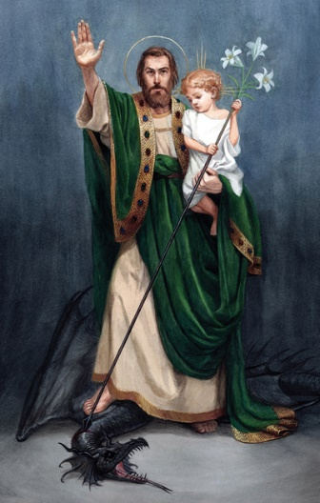
Terror of Demons is not the usual mental picture we have of St. Joseph. Why exactly would we think that St. Joseph would be described as such? St. Joseph is mentioned in scripture with two major events. First is his discernment to marry, Mary the mother of Jesus and be the foster father. Second is his taking the Holy Family on the flight into Egypt. How does all that Terrorize Demons?
Let’s examine the first instance. Another man would have refused to marry a woman who was pregnant with someone else’s child. St. Joseph through prayer and meditation and by leading a virtuous life did not follow conventional wisdom but followed the wisdom of God. He had conditioned his will through prayer and meditation on God’s word to reject the world’s values for God’s. This took a strong man who could face his demons, chastise and defeat them.
The implications for us to are many. To defeat our demons we must prepare ourselves for the fight. Prayer, meditation on God’s word, personal sacrifice all terrorizes the demons who prod us for our weaknesses. Follow the example of St Joseph – St. Joseph Terror of Demons pray for us!

