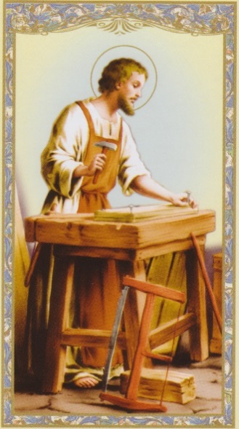
ST. JOSEPH – MODEL OF WORKMEN, PRAY FOR US….
In today’s work-world, many are considered successful because of their unique talents, wealth or possessions. In contrast, St. Joseph presents a much simpler model for us to aspire to. As builders and developers confirm that “great models” are meant to be replicated, St. Joseph is worthy of serving as our model. By imitating his virtues-faithfulness, courage, patience, and obedience, we can have a tremendous impact in our professions and the people we serve. It has been stated that the devil hates an honest and diligent worker. Hard work brings the light of God into the minds and hearts of workers, families and nations. But St. Joseph was not a workaholic, he balanced faith, family and work.
St. Joseph has so many traits of us ordinary hard-working mortals, let us be like him. Pray the words of the Memorial of St. Joseph the Worker: “God our Father, creator and ruler of the universe, in every age you call man to develop and use his gifts for the good of others. With St. Joseph as our example and guide, help us to do the work you have asked and come to the rewards you have promised.”

