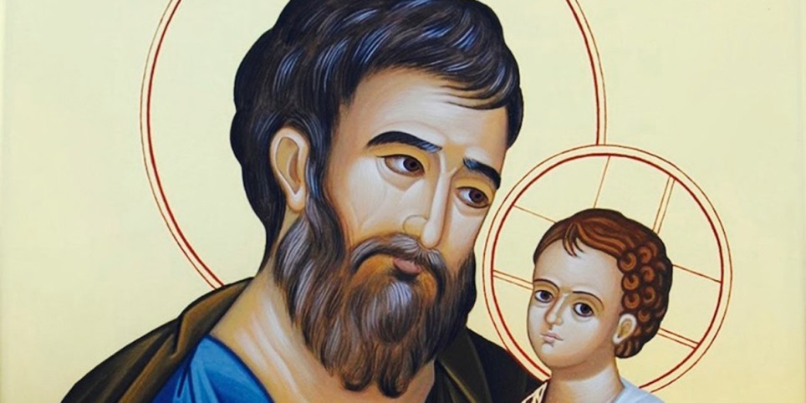

Consecration Prayer to St. Joseph for the Individual
O dearest St. Joseph, I consecrate myself to thy honor and give myself to thee, that thou mayest always be my father, my protector, and my guide in the way of salvation. Obtain for me a great purity of heart and a fervent love of the interior life. After thine example, may I do all my actions for the greater glory of God, in union with the Divine Heart of Jesus and the Immaculate Heart of Mary! And do thou, O Blessed St. Joseph, pray for me that I may share in the peace and joy of thy holy death Amen.

Act of Consecration to St. Joseph for our Parish
O Glorious Patriarch and Patron of the Church! Spouse of the Virgin Mother of God and Father of the Word Incarnate! In the presence of Jesus and Mary, we choose you this day to be our father, guardian and protector.
O great St. Joseph, whom God has made the Head of the Holy Family, accept us to be members of your “Holy House” and present our parish, St. Stephen the Martyr, to your Immaculate Spouse. Mary, adopt each of our parishioners as your children to help guide our lives to serve Jesus, your Son. Holy Family, protect all parishioners from the evil one and help us to avoid offending God in any way.
St. Joseph, our Spiritual Father, we hereby consecrate our parish, St. Stephen the Martyr to you. To you, after Jesus and Mary, we consecrate our bodies and souls, all our faculties, our spiritual growth, all our affairs and undertakings. Never depart from our parish life. Nourish our parish family with the Bread of Life, instruct us in the wisdom of the saints, help each of us to carry our crosses and keep us always to remain faithful to the one, holy, Catholic and Apostolic Church. We offer all of our parish life to you St. Joseph! Please take us under your paternal cloak and lead us home to your Son!

